Jimmy Yeung

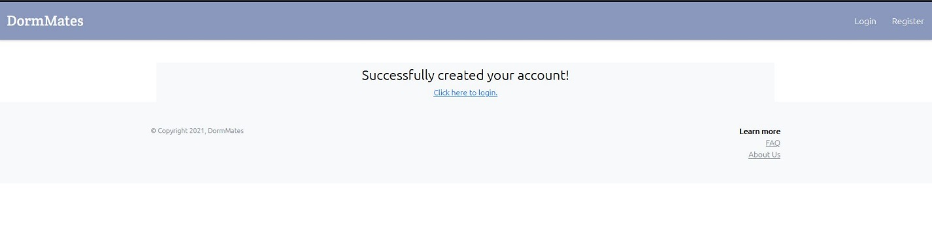

This shows up after I successfully create an account named DormDweller.

I used a simple password 12345670Q to create an account.

Then, I tried out another account named basementDweller, made up an email named [basementDweller@edu.com](mailto:basementDweller@edu.com) , and password was 12345670Q. This means that account creation takes any made up email that does not exist; there goes simple password too.

The successful login goes back here.

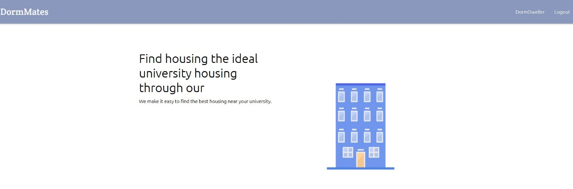

After I found create and login my account, I went to search an institution and then have a new account again by clicking find awesome roommates.

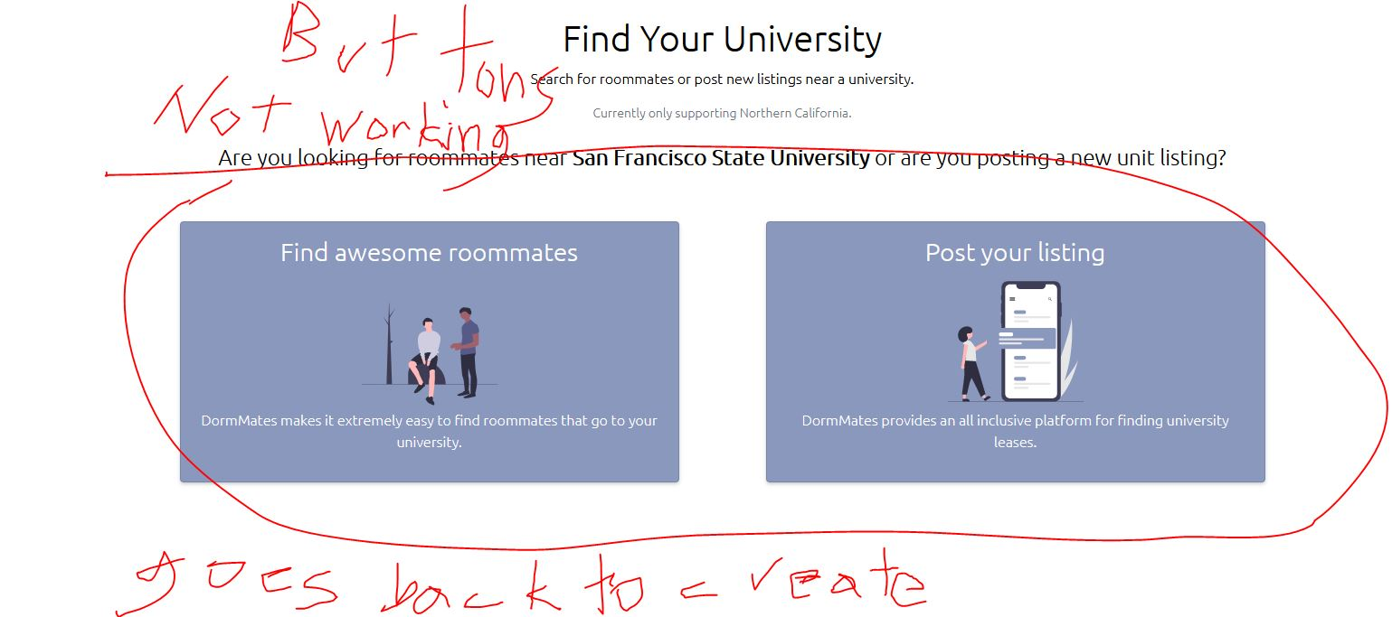

The circle buttons goes back to create account.

Therefore, everything went smooth that there is no lag. We are missing features. Account creating was a success. The pictures look good and tells me what is happening.