Fairground Discount Beverages

Tutorial & User Guide



By: Richard Bell

       James Miller

           Nahom Negash  
                         Derrick Witherspoon

# Table of Contents

Overview 2

Glossary 3

Main Page 5

Inventory Search 7

Inventory Detail 9

Sale Details 12

Apply Sale 13

Manage Sale 17

Staff Details 19

# Overview

The Fairground Discount Beverages Inventory and Staff Database is an application to help employees of the store perform a variety of functions to assist customers, make modifications to inventory, and to manage employees.

To open the application, double click on the LiquorDB .jar file on the desktop. Ensure the machine is connected to the network in order to receive data from the server.

When opening the application from your desktop you will first arrive at the Main Menu. From the main menu users can access all major functions of the application via the item search box or the navigation options at the bottom of the page. From most pages in the application, an item can be looked up by UPC

# Glossary

Before staring, opportunity should be taken to familiarize potential users with a knowledge base of the terms necessary to utilize the application effectively.

**ABV:** Appears on the inventory search and detail forms. Indicates the alcohol by volume of each product.

**Bond Wine:** Appears as a default sale type on sale details form. Represents a wine tasting promotional sale.

**Certifications:** Appears on staff details form. Represents the certifications granted by the state liquor board to store employees.

**Clearance:** Appears as a default sale type on sale details form. Represents items flagged for liquidation to make room for other items. Any percentage off can be applied to clearance items.

**Cost:** Appears on inventory search and detail forms. Indicates how much the store pays wholesale for a particular item.

**Distributor:** Appears on the inventory search and detail forms. Represents the company who is in charge of the delivery of the item.

**DOB:** Found on staff details page. Represents the date of birth of an employee.

**Every Day #:** Appears as a default sale type as "Every Day 10", etc. on the sale page. Indicates a flat sale of 10, 15, or 25 percent off the sale. Normally applied to discounts that are applied by the store for a longer period of time.

**Monthly Sale:** Appears as a default sale type on the sale form. A promotion that runs from the beginning to the end of the month on a single item.

**Region:** Found on the inventory search and detail forms. Indicates the country or region of a country that an item is produced.

**SSN:** Found on the staff details form. Social Security Number of the employee.

**UPC:** Unique identifier of an item. Found of the sale detail, inventory detail, and inventory search forms.

**Wage:** Found on the staff details form. Wage of an employee. Recommended entry - hourly and yearly. E.g. (12.45/hr, 32350/yr).

# Main Page

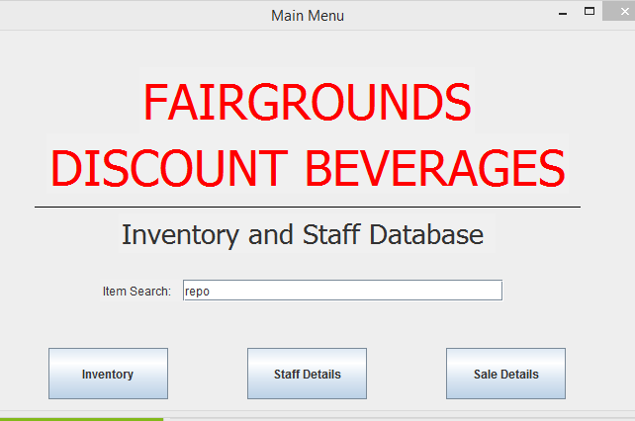

As previously stated, the main page is the hub that can navigate a user anywhere in the application. From the main page, staff details, sale details, inventory, and item search can be accessed.

To access the item search, enter a description or number into the item search textbox and press ENTER. To access other aspects of the application, there are navigation buttons at the bottom of the screen.

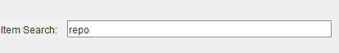

This function will open the Item Search Form in a separate window, which will be explained in detail in the next section.

To access the Inventory detail screen, click the “Inventory” navigation button. The Inventory Detail screen will spawn in a separate window.

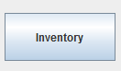

To access the Staff detail screen, click the “Staff Details” button. The Staff Detail screen will spawn in a separate window.

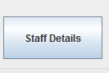

To access the Sale detail screen, click the “Sale Details” navigation button. The Sale Detail screen will spawn in a separate window.

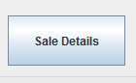

# Inventory Search

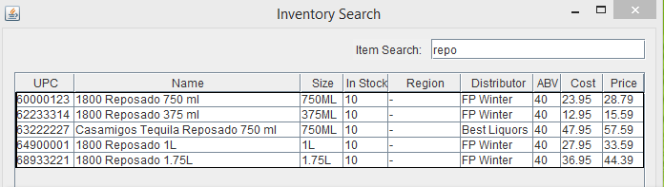

A customer walks into the store and inquires whether you have a certain item, a different but similar item from something they had in mind, or a different size of an item they’ve found. The typical response may be to walk to the item’s location in the stock room or sales floor and browse the shelves to see if you can find the item.

The Inventory Search is a helpful tool to assisting customers with locating merchandise, among other things. The Inventory Search is a view of all matching entries for the search criteria entered in the “Item Search” boxes found around the application. Items can be queried by distributor, UPC, region, or item name.

A search on the text “repo” (this example taken from the main page)



Will generate a result set that looks like

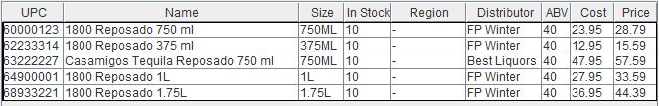

This numeric search



Will produce



You can also search by Distributor. A search like this



Produces

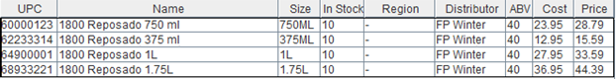

The grid generated from the search display information about each item that matches the search criteria. Any questions about the meanings of the columns can be answered in the glossary of this tutorial. Double clicking on any row will open detailed information about the row clicked and close the Inventory Search Window. The Inventory Detail View will be explained in detail in the next section.

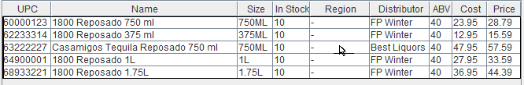

# Inventory Detail

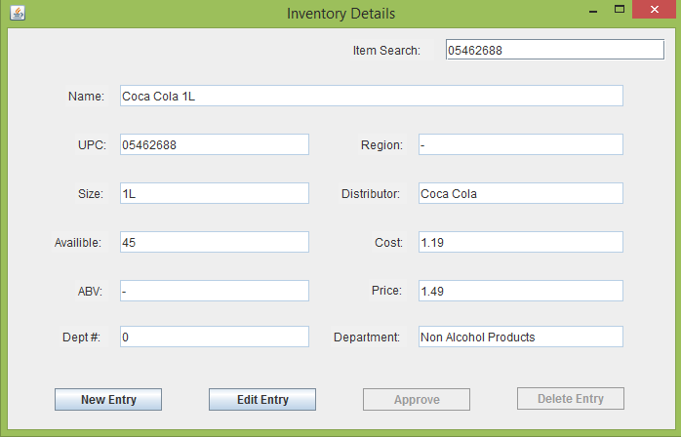

The Inventory Detail view allows users to modify information about an item. It is particularly useful for updating item descriptions or on-hand inventory after an audit, or to add an item to inventory. As you can see above, when first viewing the Inventory Detail, all fields are disabled by default. If you want to add an item to inventory, click the “New Entry” button.



Clicking this button will clear all fields, disable all buttons other than “Approve” and allow you to enter an entry.

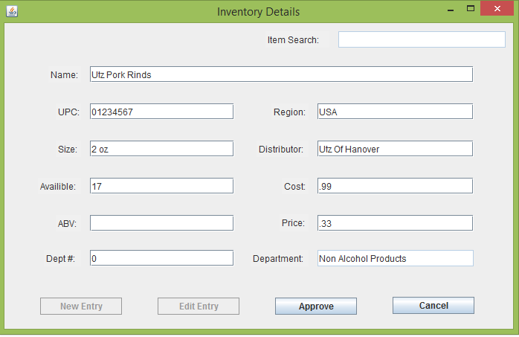

Clicking the “Approve” button will commit the item to inventory after confirming whether this was the intended action.

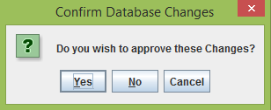

Clicking “Yes” saves the item to the database. The item can now be found in the Inventory Search.

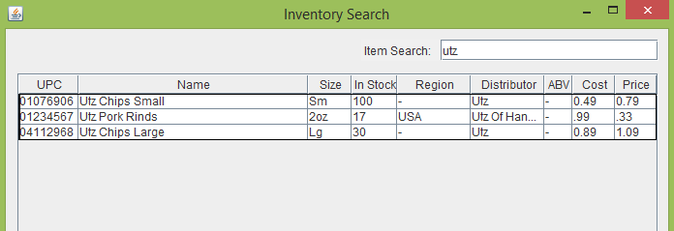

Double clicking the item will redirect to the Inventory Detail screen again, where information can be modified by clicking the “Edit Entry” button.



The same steps as creating a new entry can be followed to update your entry.

# Sale Details

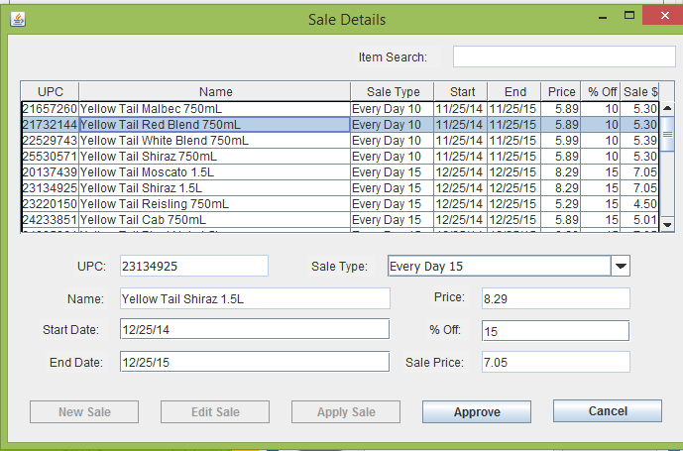

The Sale Details screen allows for additions, modifications, and removals of discounted items. By default, all items in the store currently on sale will show in the grid when the screen loads. This form allows for existing sales to be applied to an item, or for sales to be modified.

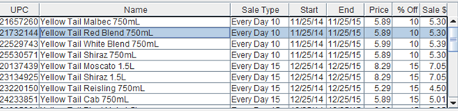

## Apply Sale

To apply a sale to an item any item, click the “Apply Sale” button.



At this point you can select an item to apply a sale to. The grid above lists items that are already discounted, you can also import an item that is not discounted searching for an item in the Item Search in the upper right hand corner and hitting ENTER.

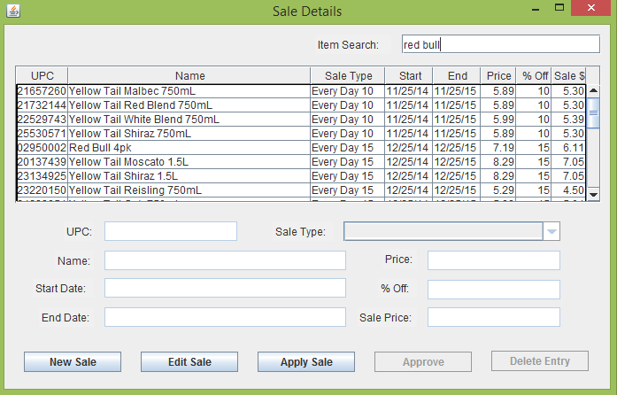

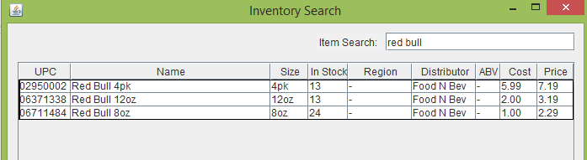

Double clicking an item will import it into the Sale Details screen, where a sale can be selected from the drop down list and applied to the item.

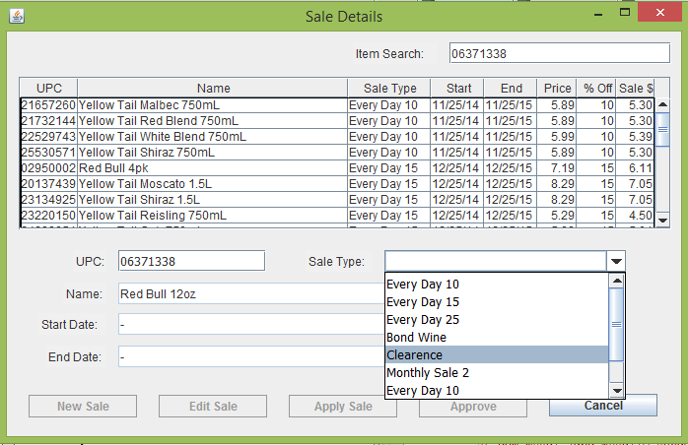

Selecting a sale type enables the “Approve” button.

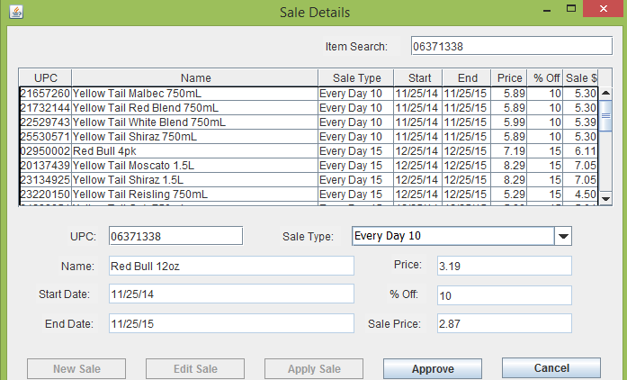

Clicking “Approve” will commit the sale after confirming the action was intended.

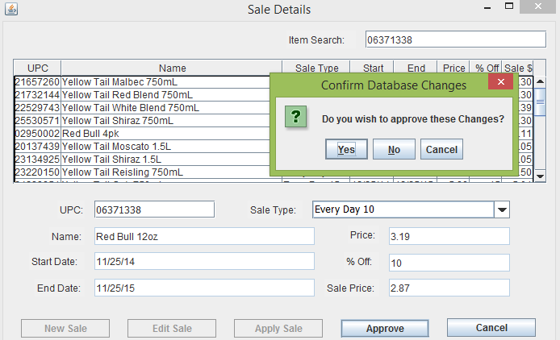

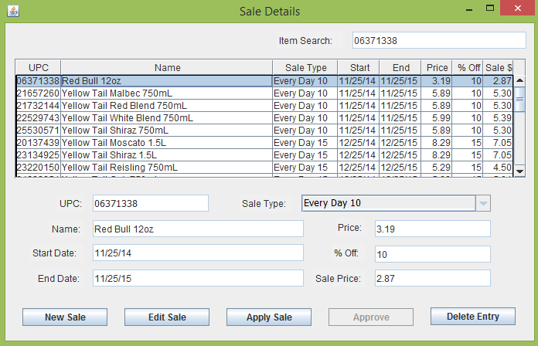

Double clicking on any entry in the table will populate the detail form below. For example, the selected row will produce a screen that looks like this:

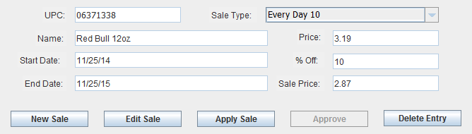

The “Delete Entry” button will remove the sale from the item, after confirming the action is intended.

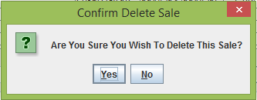

The sale has been removed from the display table.

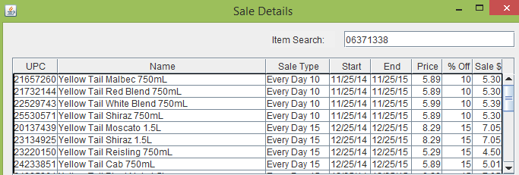

## Manage Sales

New sales can also be created from the Sales Details form. Clicking “New Sale” will clear the form and allow a new sale to be entered.

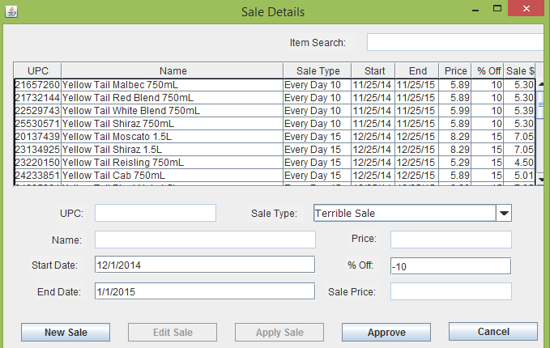

Clicking “Approve” will commit the new sale, after confirming the action was intended.

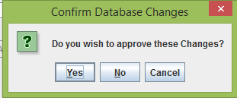

The new sale can now be applied to an item.

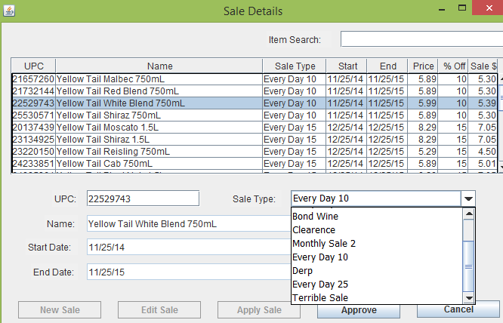

The “Edit Sale” button allows existing sales to be modified.



Select a sale from the dropdown list to modify its properties. From there, the same steps can be taken as when a new sale is created.

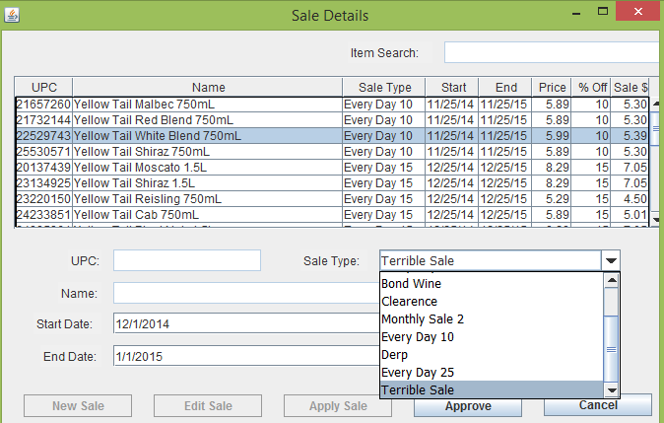

# Staff Details

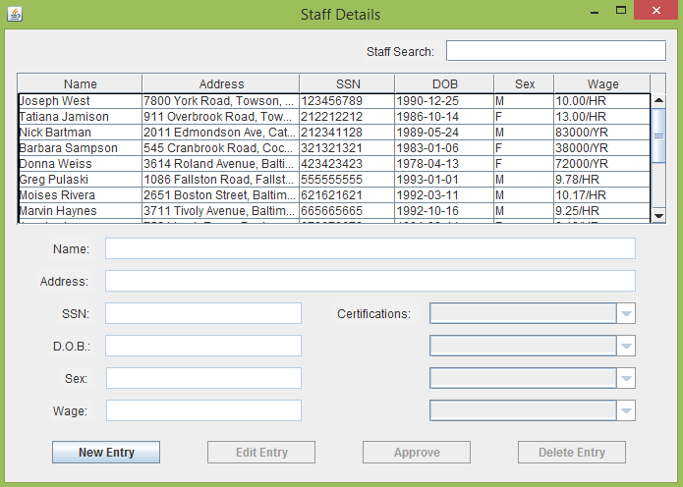

The Staff Details form allows users to update information about current staff or insert new staff. Clicking the “New Entry” button allows a staff member to be created. 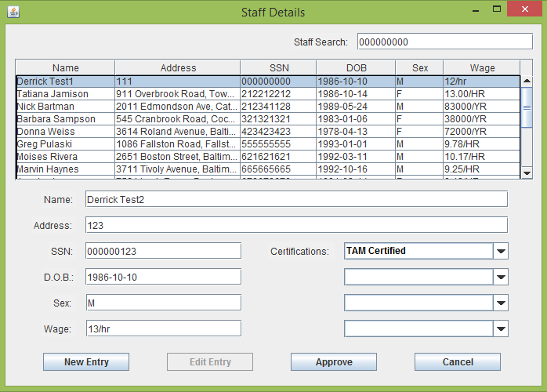

Similar to the Inventory Detail, the “Approve” button commits your entry after confirming your action was intended.

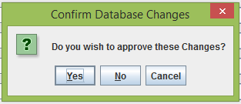

Your new employee is now found in the staff list above the form.

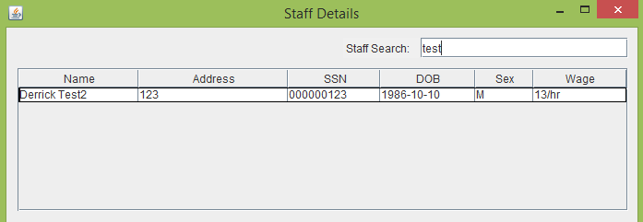

Double clicking will open the editor. The “Edit Entry” button performs the same workflow as the “New Entry” button for an existing employee.



Follow the same steps as above to update employee information.

Employees can also be deleted by clicking the “Delete Entry” button.



After confirming delete was the intended action, the employee is removed from the database and no longer appears in searches.

