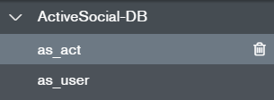

Activity DB (as_act)

Activity _id uuidv4 str

Activity title str

Activity type str

(type=icon lge = language & culture | frm = friend making | boa = board game | mus = music event |

spo = sports | oth = other)

Activity place str

Activity date str

Activity time str

Activity description str

Activity creator str

Activity enroll Array

Activity safe (for now 1=friend 0 = not) str

User DB (as_user)

U id uuidv4 str

U pw str

U **fName** str

U **LName** str

U photo str

U intro str

U enroll_ev array object(eventId, title, date, time) (change from enrolled_ev to enroll_ev)

U friends array object need to complete

U safe_mode 1