Contents

Part 1 – Setting up Database and Admin Web Portal 1

Task 0: Running script to populate student table: 1

Task 1: Screenshot of deleting entry from database using webpage: 3

Task 2: Screenshot to add your record with ID=7 5

Part 2 – Setting up Authentication for Admin and Students 7

Task 3: Screenshots of users3 table in MySQL 8

Task 4: Screenshots of the run of the login process by a student 9

Task 5: Screenshots of the run of the login process by admin 10

# Part 1 – Setting up Database and Admin Web Portal

Design and implement a web page for a manager to list all the students the school, to add a student, or to delete a student from the database.

|  |
| --- |
| Task 0: Running script to populate student table:   Screenshot of student table: |

### Task 1: Screenshot of deleting entry from database using webpage:

|  |
| --- |
|  |

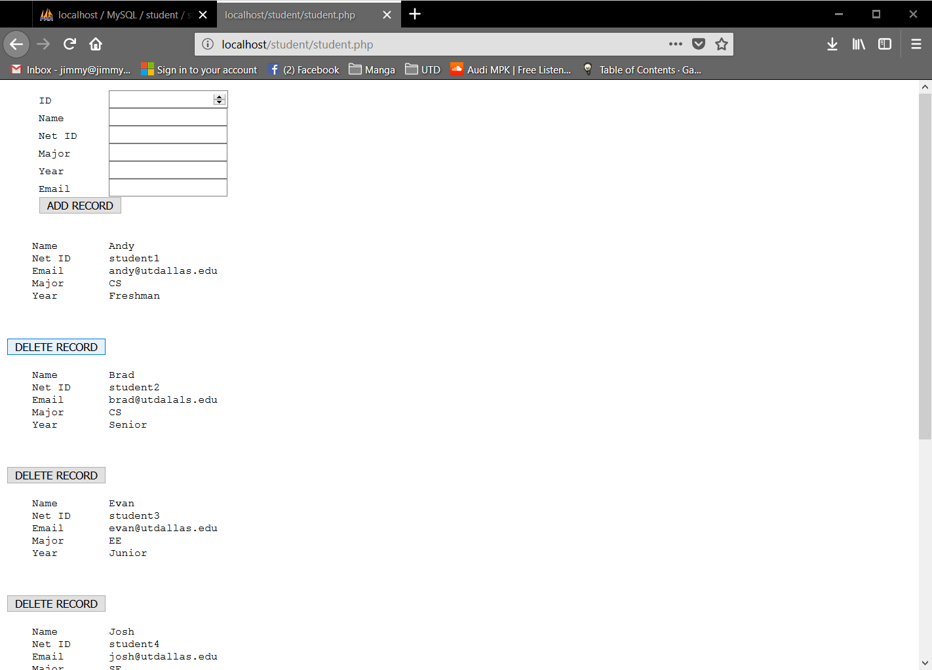

|  |
| --- |
|  |

### Task 2: Screenshot to add your record with ID=7

|  |
| --- |
|  |

# Part 2 – Setting up Authentication for Admin and Students

Add authentication in place so that a Web user or a Web administrator can log in with some security with userid and password authentication. The web system should have a php script for login process for the students.

Your first task is to design and implement "setupusers3.php" script. (You may use the code example of setupusers.php in www13 folder, as your base code.) The "setupusers3.php" script will be run to create users3 table which contains three columns for each record: (1) userid, (2) encrypted password, (3) role (either "student" or "administrator" for each record).

Each student's userid is userid as shown in student table in Part 2, and its password is set same as the userid (student1/student1). The administrator's userid is "admin1" and its password is "admin1".

After running setupusers3.php script, all the userids and their encrypted passwords are saved in sql table named users3.

Your second task is to design and implement "authenticate3.php" script. (You may use the code example in www13 folder, as your base code.) If one is logged in as a student, then the system will show a web page saying a welcome to the student information of the login user (student ID, Name, Email, etc.). If one is logged in as an administrator, then the system will show a web page of all the student records by running the student.php script in Part2.

### Task 3: Screenshots of users3 table in MySQL

|  |
| --- |
|  |

### Task 4: Screenshots of the run of the login process by a student

|  |
| --- |
|  |

### Task 5: Screenshots of the run of the login process by admin

|  |
| --- |
|  |

Submit (upload) two files: (1) this word document with your answers and (2) separately a zip file (containing all the program codes including php programs, sql files, and screenshots of the runs).