

Insert the client logo here. If the logo is not applicable, remove this placeholder.

MOTOR HULL & MTPL
(Master Policy)

BUSINESS SOLUTION DOCUMENT
{{DDMMYYYY}}
www.peak3.com
PRIVATE & CONFIDENTIAL
INCOME RFI
Table of Content
Document History 3
1 Introduction 4
1.1 Overview 4
1.2 Assumptions 4
1.3 End Users 4
1.4 Glossary 4
2 Requirement(s) 5
3 Business Solutions 5
3.1 Business Solution Overview/Summary 5
3.2 Function 1 5
3.2.1 Process Flow 6
3.2.2 Function Description 6
3.2.3 Business Rules 7
3.2.4 User Experience 8
3.2.4.1 UI_PRD_PRD_BasicInfo 8
4 Non-functional Requirement 9
5 Reference 9
Disclaimer 9

Document History

Date | Author | Version | Note | Reviewer

Introduction

Overview
Purpose of this document is to define product & pricing details, including policy issuance process for ABC client. XYZ product will be implemented in France, Spain, Italy and Germany. BSD will cover Liability, Coverage, Product and Plan definition….

Assumptions
API specifications will be covered in another document: link
Medical questionnaire will be defined in the Day 2 phase.

End Users
Call Center Agent, Agent, Policy Administrator, Claim Handler..

Glossary

Acronyms | Description
B2C | Business-to-Consumer – Refers to the direct sales journey for XYZ product
API | Application Programming Interface – Enables communication between systems for data exchange
Client | Refers to the insurance provider offering insurance products in France, Spain, Italy and Germany
Graphene | Central system managing workflow, product configuration, quotations, premium calculations, and integrations
Integration AAA | External system used to retrieve insurance benefits provided by credit cards
Integration BBB | External system that processes medical questionnaire responses to assess risk (France only)
Integration CCC | External system that processes medical questionnaire responses to assess risk (Italy only)

Requirement(s)
Jira Key | Version | Requirment
- | - | -
 |  | -

Business Solutions

Business Solution Overview/Summary
{{business_solution_overview}}

Function 1
Description

Process Flow
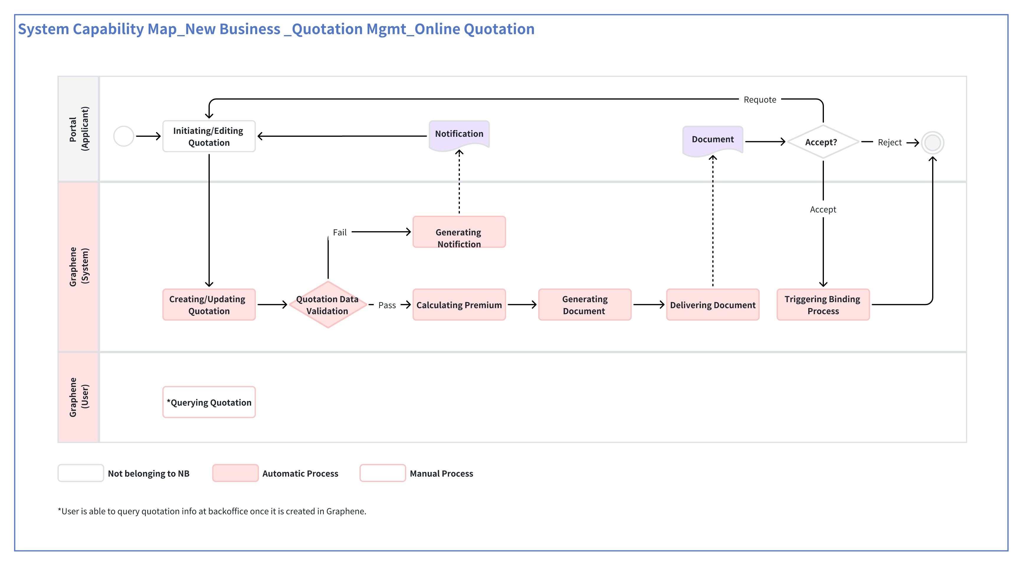

Function Description
- The user enters Product Management - Product Agreement page - Product Basic Info
Liability.
Please refer to UI_PRD_PRD_BasicInfo_ProductLiability
- If "Using Upgrade P&C Structure" is "Yes". Please refer to PRD_Interest_(Demo Only)_TBC.
End.
- If "Using Upgrade P&C Structure" is "No" or empty.
- The user adds, edits or deletes Liability.
For "Add":
- The user clicks the "Add New" button.
- The system shows the "Add New" drawer.
- Please refer to UI_PRD_PRD_BasicInfo_AddProductLiability
- The user selects a liability, and fills in required information.
- Please refer to BR_PRD_PRD_BasicInfo_AddProductLiability
- The user can click the "Add" button in the liability name dropdown to create a new liability.
Please refer to PRD_Liability Management_v2.80 (3.2 Add a new Liability)
For "Edit":
- The user clicks the "Edit" button.
- The system shows the "Edit" drawer.
- The user edits the product liability information.
- Please refer to BR_PRD_PRD_BasicInfo_EditProductLiability
- The system saves changes.
- End.

Business Rules
Rule Number &  Rule Name | Description

User Experience
First Level Menu | Second Level Menu | Third Level Menu | Page Name

UI_PRD_Module_BasicInfo
<Screenshot or Figma UI>

Field Description
Lorem ipsum dolor sit amet, consectetuer adipiscing elit, sed diam nonummy nibh euismod tincidunt ut laoreet dolore magna aliquam erat volutpat. Ut wisi enim ad minim veniam, quis.

Information | Is this mandatory?  (Y/N) | Can it override an individual policy? (Y/N) | Rules
- | - | - | -
- | - | - | -

Non-functional Requirement(s)
< Event Tracking, Performance, Security, Compatibility, Legal Compliance, etc.>

Reference

NA

Disclaimer

The materials contained in this document are designed for the sole use by the designated recipient (“Recipient”) and solely for the limited purposes described in the document. The materials shall not be copied or given to any person or entity other than the Recipient (“Third Party”) without the prior written consent of Peak3.

Peak3 has made no undertaking to update these materials after the date hereof, notwithstanding that such information may become outdated or inaccurate. Further, Third Parties may not, and it is unreasonable for any Third Party to, rely on these materials for any purpose whatsoever. Peak3 shall have no liability whatsoever to any Third Party, and any Third Party hereby waives any rights and claims it may have at any time against Peak3 with regard to the services, this presentation, or other materials, including the accuracy or completeness thereof.

Receipt and review of this document shall be deemed agreement with and consideration for the foregoing.

