Competitive Positioning of UNIQLO and ZARA
A Section Draft | China Mainland Focus
Working draft: approximately 750 words across A’s assigned sections. The abstract and conclusion should be revised after the other sections are integrated. Citation style is provisional pending confirmation of the course guide.

Abstract
This report compares the competitive positioning of UNIQLO and ZARA in the China mainland apparel market. It considers the needs each brand addresses, the value propositions communicated through products and brand materials, and the extent to which the two positions overlap. The analysis draws on segmentation and differentiation, perceived value, and customer-based brand equity to interpret the available evidence. Current materials indicate a difference in emphasis: UNIQLO foregrounds everyday functionality and comfort, while ZARA foregrounds fashion design and self-expression. However, both brands make claims that complicate a simple functional-versus-fashion distinction. The comparison therefore treats positioning as a difference in the relative emphasis of value propositions, rather than as exclusive market territories. Evidence on brand claims and selected store experiences does not establish actual consumer perceptions or the effects of engagement. The report’s recommendations should address this evidence gap and be evaluated using comparable consumer and performance measures.

Introduction
UNIQLO and ZARA compete in apparel while communicating different combinations of practical, aesthetic, and experiential value. This report focuses on their apparel businesses in mainland China, using recent brand materials and selected historical evidence where relevant. The analysis asks which consumer needs each brand emphasizes, how their value propositions differ, and where they overlap. Smith’s (1956) distinction between market segmentation and product differentiation helps separate the needs a brand serves from the features it uses to stand apart. Zeithaml’s (1988) perceived-value framework directs attention to the benefits and costs consumers may weigh, while Keller’s (1993) customer-based brand-equity model helps frame brand associations. These theories organize the comparison; they do not substitute for evidence about Chinese consumers.

Competitive Positioning
The positioning map compares everyday functional value with fashion and self-expression. These dimensions represent communicated reasons to choose a brand, not mutually exclusive customer groups or measured consumer scores. The classification is qualitative: a brand is placed under “core emphasis” only when brand materials and independent commentary point in a consistent direction. A product line or store example can establish that a value is present, but does not by itself show that the value defines the whole brand.
UNIQLO’s LifeWear materials connect technology, utility, quality, and culture with everyday clothing needs (UNIQLO, n.d.). Its China-facing life-and-sport range presents features such as quick drying, cooling, stretch, and sun protection for both exercise and daily wear (UNIQLO China, 2025b). This supports an interpretation of everyday functionality as a prominent value proposition. The evidence remains brand communication, however, and product claims should be restricted to the relevant items and conditions. UNIQLO also offers expressive value: its UT collaborations and UNIQLO:C collections are presented through cultural references and personal expression (UNIQLO China, 2025a). Kantar’s apparel commentary similarly describes UNIQLO through both fashionable products and accessible, good-quality basics (Kantar, 2024, p. 110). Functionality is therefore a core emphasis in this comparison, not the brand’s only source of value.
ZARA’s China evidence points more strongly toward design and fashion expression. The company’s 2025 Nanjing flagship announcement describes a designer collaboration and special collections, including Andersson Bell (ZARA, 2025, pp. 6–7). Kantar’s apparel discussion also associates ZARA with on-trend product ranges and online-to-store experience (Kantar, 2024, p. 110). These sources support a fashion-led interpretation, but neither proves that every ZARA product is trend-driven or that Chinese consumers uniformly perceive the brand this way. The Nanjing announcement also presents Origins as a functional, contemporary wardrobe collection (ZARA, 2025, p. 6). This is a relevant counterexample: ZARA offers everyday wardrobe value alongside fashion expression.
Taken together, the evidence supports a distinction in emphasis rather than a strict separation. UNIQLO places greater weight on practical, everyday benefits while retaining design and cultural expression; ZARA places greater weight on fashion-led design while retaining functional wardrobe lines. In perceived-value terms, the brands foreground different combinations of benefits, but the available sources do not provide a matched comparison of price, quality, durability, or consumer evaluations. Keller’s framework also cautions against treating brand-controlled messages as proof of strong or distinctive consumer associations. Figure 1 should therefore be read as a transparent synthesis of available materials, not a map of market share, customer demographics, or competitive advantage.
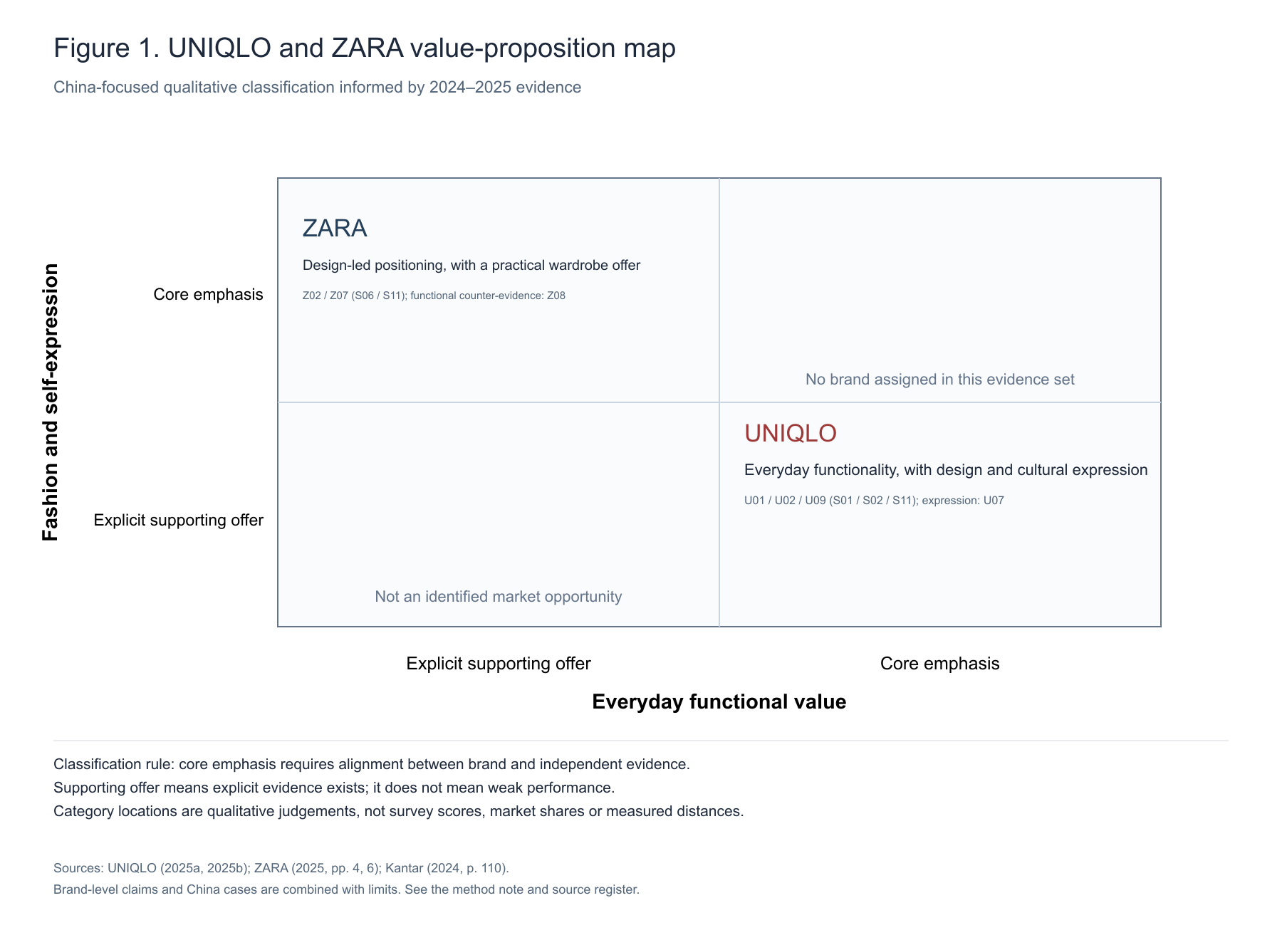
Note. The map reflects a qualitative interpretation of brand materials and industry commentary. Position and distance do not represent survey scores or the magnitude of competitive advantage. Sources: UNIQLO China (2025a, 2025b); ZARA (2025, pp. 6–7); Kantar (2024, p. 110).

Conclusion
The available evidence suggests that UNIQLO and ZARA compete through overlapping value portfolios with different centres of emphasis. This comparison avoids assigning exclusive consumer groups or inferring actual purchase motives from brand communications. The evidence is strongest for stated propositions and selected product or store examples; it is weaker for consumer response and business outcomes. The wider report should connect this positioning analysis to the brands’ marketing strategies and engagement mechanisms, then assess proposed improvements against comparable evidence rather than assuming that a brand activity produces loyalty or sales.

References
Smith, W. R. (1956). Product differentiation and market segmentation as alternative marketing strategies. Journal of Marketing, 21(1), 3–8. https://doi.org/10.1177/002224295602100102
Keller, K. L. (1993). Conceptualizing, measuring, and managing customer-based brand equity. Journal of Marketing, 57(1), 1–22. https://doi.org/10.1177/002224299305700101
Zeithaml, V. A. (1988). Consumer perceptions of price, quality, and value: A means-end model and synthesis of evidence. Journal of Marketing, 52(3), 2–22. https://doi.org/10.1177/002224298805200302
Fast Retailing Co., Ltd. (2025, October 9). FY2025 results: UNIQLO International. https://www.fastretailing.com/eng/ir/news/2510091800.html
Kantar. (2024). BrandZ most valuable global brands 2024 (p. 110).
UNIQLO. (n.d.). LifeWear. https://www.uniqlo.com/uk/en/contents/lifewear/sp/
UNIQLO China. (2025a, March 3). 2025 Spring/Summer launch and customer activities. https://www.uniqlo.com/cn/news/topics/2025030301/
UNIQLO China. (2025b, July 4). Life and sport collection. https://www.uniqlo.com/cn/news/sp/topics/2025070401/
ZARA. (2025, March 20). ZARA Nanjing Xinjiekou flagship store press release (pp. 4, 6–7). https://static.zara.net/assets/public/ef68/131f/278c4186be44/74c155545c39/ZARA_NANJING_XINJIEKOU_PRESS_RELEASE_EN.pdf?ts=1742432518731

