Academic Integrity and Use of AI Tools (2026-27)

Academic Integrity
The University expects that all students will undertake their studies with integrity and will submit assessments that have been prepared by themselves. To do otherwise, to act dishonestly and cheat in an assessment, is classed as academic misconduct and will incur penalties.
The Academic Integrity webpages has numerous resources to help you understand the meaning of academic misconduct, how you can avoid it and what the penalties are should you act dishonestly.

Common Types of Academic Misconduct
Plagiarism, which means using someone else’s work or ideas (whether that is a written source, image, table or graph) and giving the impression that they are your own.
Plagiarism also includes the use of generative artificial intelligence (GenAI) tools to generate content without appropriate acknowledgment of the source. Plagiarism also covers ‘self-plagiarism’, which occurs when you submit an assignment containing materials identical or very similar to work that you have previously submitted for another assessment, whether at this university or another.
Collusion, which is defined as unauthorised collaboration between students in an assignment. However, this does not refer to authorised group work (as approved by your tutor) that is assessed by a single group report, or group presentation.
Contract cheating is when you submit work that is not your own with the intention of deceiving the grader. For example, this could be an assignment written by a friend, family member, third party or by a commercial service, such as an online essay writing website. It does not matter whether this has been paid for or not.
Data falsification involves intentionally altering or fabricating data to support desired outcomes or conclusions. The consequences of data falsification are severe: academic penalties, damaged credibility, and the loss of trust.

Permitted Use of AI in Assessments

What do we mean by AI?
Artificial intelligence (AI) refers to a broad range of computational systems that use rules, statistical methods, machine learning, or large language models to perform tasks such as recognising patterns, making predictions, generating content, recommending actions, or supporting decisions. What matters is not which AI tool you use, but what capability you are using it for. The three categories below describe the AI capabilities relevant to your work.

Categories of AI capability
Automated AI tools  Tools that use rule-based or statistical processes to perform a specific, bounded task. These tools modify, format or correct existing user content rather than generating it from scratch.  Examples: Spell-checkers in Word or Google Docs, citation formatters (Zotero, EndNote), grammar highlighting (not rewriting), screen readers, text-to-speech software  ⚠ Important: some tools combine automated and generative AI capabilities. Grammarly, Microsoft Editor, and Microsoft Copilot in Word offer both grammar-checking (automated AI) and text-rewriting or drafting features (generative AI). The category that applies depends on which capability you are using, not which tool. | Generative AI tools  Tools that create or substantially transform content – text, images, code, data, audio or video – in response to a prompt or instruction from the user. While the output is newly generated, it is based on existing training data patterns and may contain inaccuracies or unverified facts.  Examples: ChatGPT, Microsoft Copilot, Google Gemini, Claude, DALL-E, Midjourney, GitHub Copilot, Grammarly AI  ⚠ Important: This includes the generative AI features within tools that also have automated AI functions: the composing and text-rewriting features in Grammarly, Copilot suggestions in Word, are all generative AI use, regardless of the tool's primary purpose. | Autonomous AI tools  Tools – sometimes called AI agents – that independently plan and carry out a sequence of tasks on the user's behalf, taking actions and making decisions across multiple steps without requiring human direction at each step. Unlike generative AI tools, where a user directs each step, autonomous tools can browse the web, write and execute code, manage files, and chain complex actions to complete a goal.  Examples: Claude Code, OpenAI Codex, GitHub Copilot Workspace, AutoGPT  ⚠ Important: If a tool can take actions, make decisions, or produce outputs across multiple steps without you directing each step, treat it as an autonomous AI tool.

What AI tools are supported by the university?
Use of the institutional writing aid Draft Coach is permitted. If tools with generative AI capabilities are permitted for specified tasks or purposeful use of AI, the university recommends using your University MS365 account to use Microsoft Edge Copilot Chat, as this has enterprise protection ensuring your data is not used to train the models.

Permitted level of AI Use in Assessment
Your Course Coordinator will state in your assessment brief whether you can use AI tools and the extent to which you can use such tools. If you cannot find a statement in your assessment brief (assessment instructions, guidelines), that states the extent to which you can use such tools, it is your responsibility to ask your Course Coordinator to provide this guidance.
Your Course Coordinator may refer to the levels/categories described below, which provide a useful framework for communicating what is permitted:

AI Level 0 – No AI-generated content
No generative AI capabilities may be used in this assessment. This includes all generative AI tools (such as ChatGPT, Microsoft Copilot, Google Gemini, Claude), all autonomous AI tools and the generative AI capabilities within automated AI tools (such as rewriting or drafting features in Grammarly or Microsoft Editor).
Assistive technologies, such as screen readers, text to speech and speech to text software, and reading support tools – tools that do not generate content – are permitted.

AI Level 1 – Specified AI Use
You may use tools with generative AI capabilities for specified assessment activities only. Read the additional guidance on using AI tools for assessment activities that are specified in your assessment brief.
You must not use generative AI to draft, write, paraphrase, or substantially produce any assessed content. You must not use AI tools to do the intellectual work that the assessment is designed to measure.
Autonomous AI tools are not permitted.

AI Level 2 – Purposeful AI Use
Your use of generative AI is not restricted to specific tasks. However, your ability to use AI critically and purposefully is part of what is being assessed. You must submit a process record alongside your work.
Autonomous AI tools are not usually permitted but consult your assessment brief for further information on the use of autonomous AI tools.
You remain fully responsible for the accuracy, integrity, and academic quality of everything you submit

What if it isn't clear what level of AI use is permitted?
Where no AI level is stated, treat the assessment as AI Level 0 and seek clarification from your Course Coordinator.
Please read the assessment brief for each assessment, which makes it clear if the use of AI tools is permitted and in what way.
If the use of AI tools is permitted, please read the Student Guidance on the Use of AI in Assessment, which provides further details on the three AI levels/categories described above, and your responsibilities whenever AI use is permitted (AI Level 1 and 2)
Please note, using AI tools with generative AI capabilites to generate content for work submitted for assessment, without authorisation or acknowledgement, will be regarded as academic misconduct and investigated as a plagiarism offence under the Code of Practice on Student Discipline (Academic).

Translation Tools
Translation tools may only be used to translate individual words or short phrases to aid comprehension; using such tools to rephrase or rewrite text constitutes unacceptable assistance and may be considered academic misconduct. If you are unsure as to how you can use translation tools/software for work submitted for assessment, please consult your Course Coordinator.

Assessment 1 Brief: Group Report [30%] (2026-27)

Assessment Title and Weighting
Group Report ( 30% weighting)

Description of the Assessment Task

Produce a group report analysing the competitive positioning of two rival brands in the same industry. Evaluate their marketing strategies and customer engagement. Provide recommendations on how one brand could improve its competitive advantage.

Word Count: 2,000 words. This excludes the Cover page, Table of Contents, References and Appendices. Word count should not be exceeded (an allowance of +/ - 10% of the stated value is allowed).
Cover page: The title, names of individual members, student ID, and word count must be included.
Format: Times New Roman 12pt. The line spacing should be 1.5, and the paragraphs should be justified.
Figures & Tables: All figures and tables should be numbered and clearly described. If you include statistical data or images, these must also be correctly referenced, and these sources, together with any academic or reported material, must be included in a reference section attached to your report.
Referencing: You should, where appropriate, refer to academic journal articles or examples derived from contemporary marketing practice where insight may support your analysis. You must provide at least 10 scholarly references. All sources on the reference list must be cited in-text. The Harvard system (APA 7th edition) should be used for all submissions. For guidance on use, please see Referencing and citing— Referencing for Business Students.
Appendices: Appendices can be used to provide additional supporting material [must not exceed two pages], although it is not required.

AVOID LATE SUBMISSIONS!
Please note that 1 second late is late, and late penalties will be rigorously applied to any submission received after the deadline. Late submissions will be penalised per the University's Regulations and Guidelines.
Always retain an electronic copy of your assignment!

Use of GenAI
Please review the information provided for students on Academic Integrity and Use of GenAI tools in the Course Assessment folder. If the use of GenAI tools is permitted, please read the guidance on how to acknowledge the use of GenAI tools.
[If you are using the GenAI levels, edit and delete the text below, as appropriate. It is helpful to provide students with further guidance on what constitutes acceptable use of GenAI tools. A useful starting point is this document on acceptable use of GenAI.]
The permitted level of GenAI tool use is detailed below:
GenAI Level 0 – Not Permitted
GenAI Level 1 – Limited Use Permitted
GenAI Level 2 – Wider Use Permitted

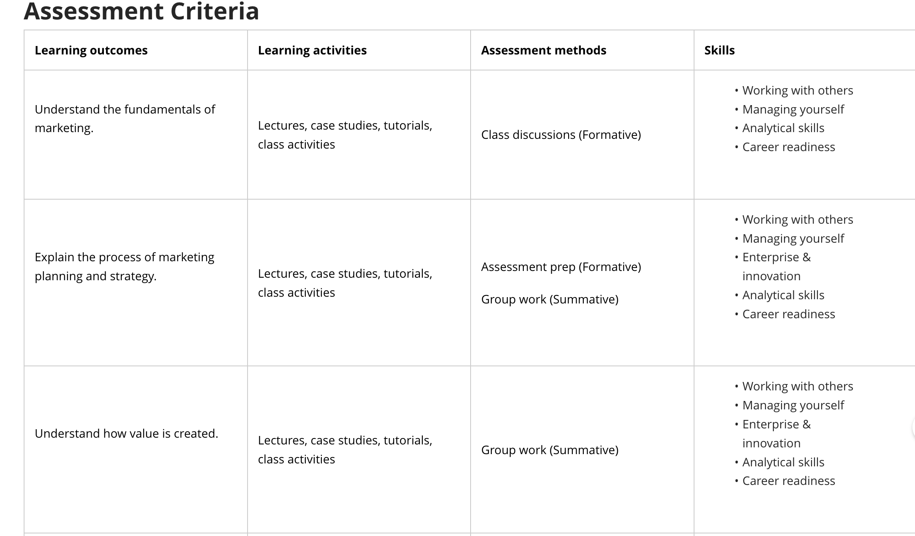

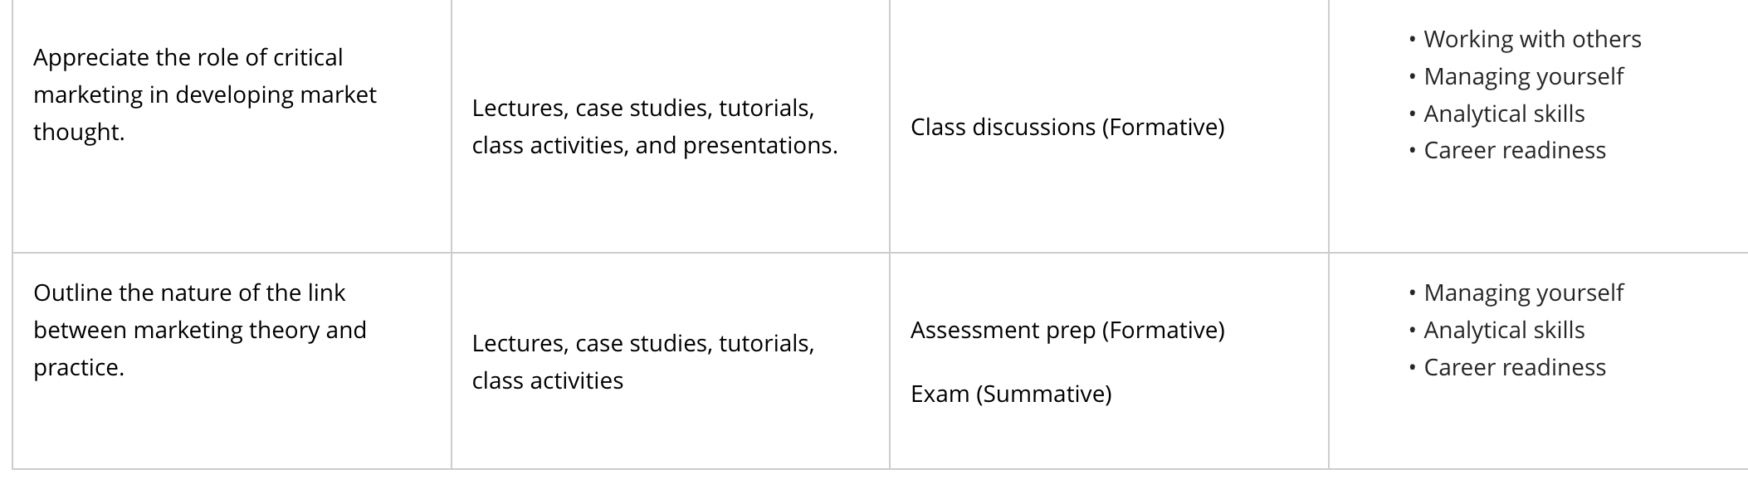

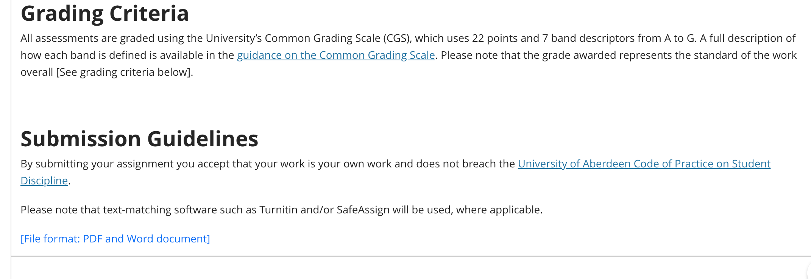
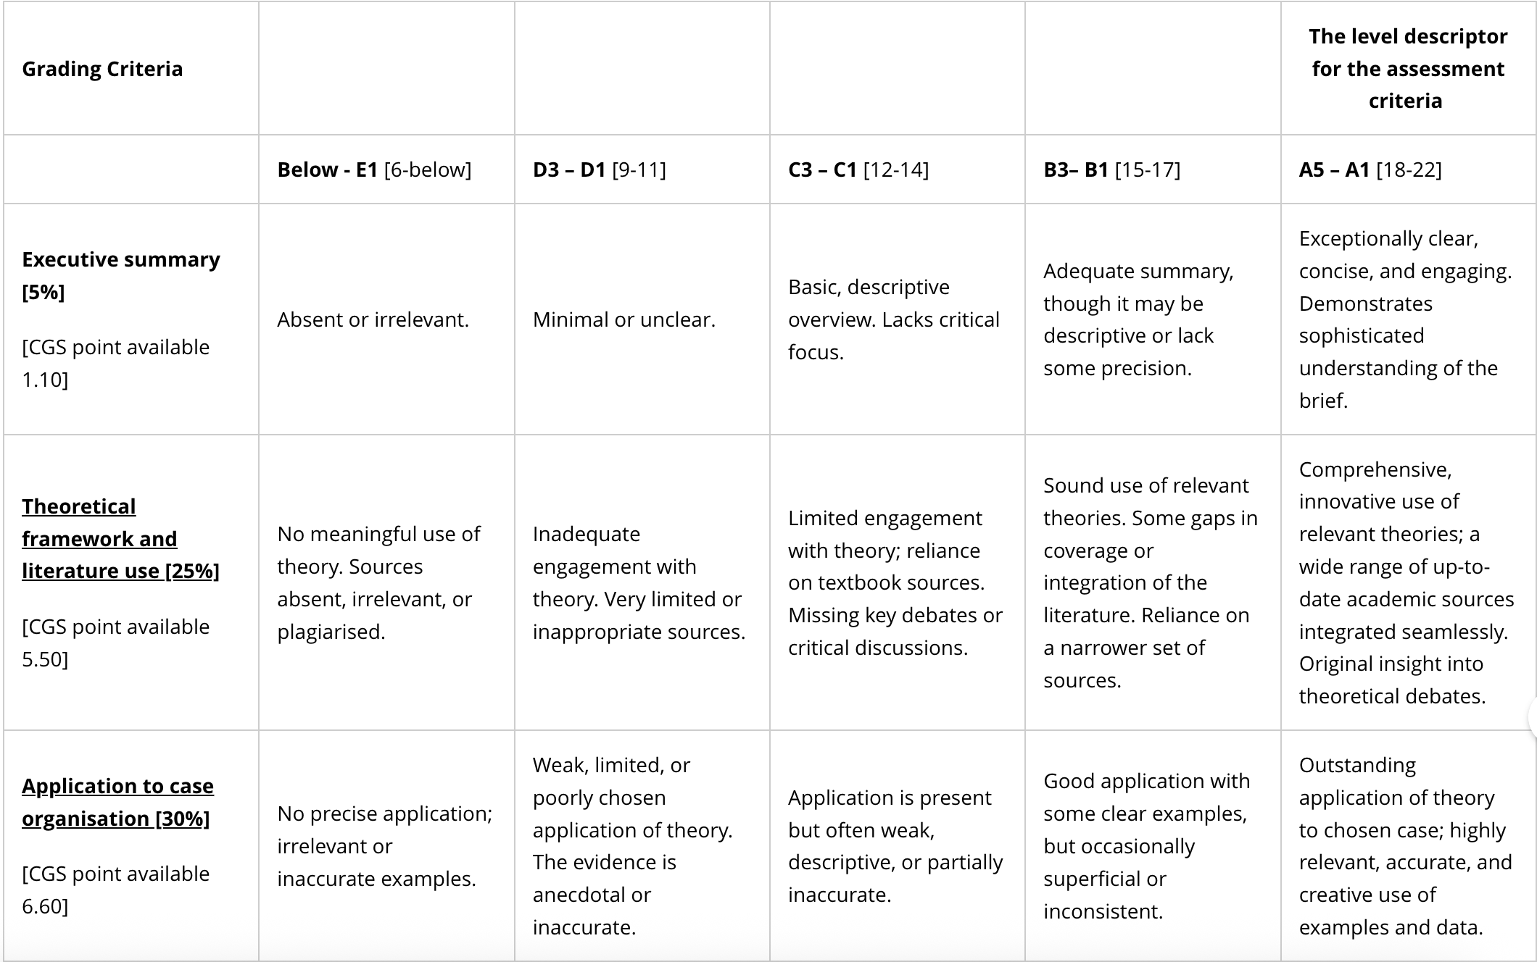
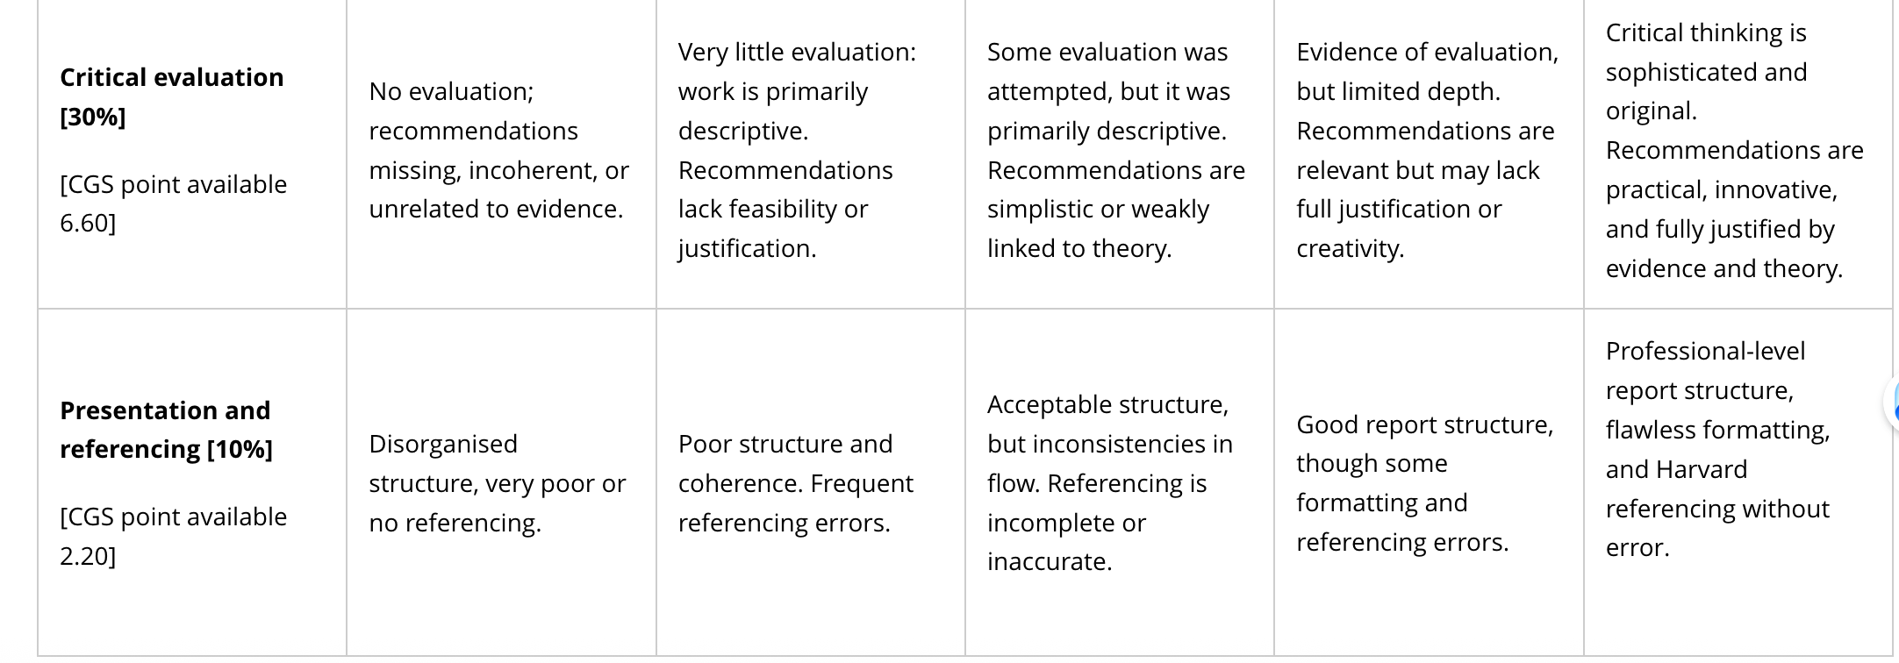

Grading, Feedback, Extensions and Late Penalties (2026-27)

Grading and Moderation Procedures
All assessments are graded anonymously, where possible, and are subject to robust grading and moderation procedures. This means that a representative sample of assessments are moderated to ensure that the grading is fair, valid and reliable, and that grading criteria have been appropriately applied. For major pieces of work, such as dissertations, theses and projects, all assessments are double graded. This is done to ensure that there is consistency across graders and that graders are awarding CGS grades in a similar way. These procedures are overseen by the Examiners' Meeting and our External Examiners who assess whether our grading and moderating procedures have been carried out correctly. We are confident that all our grading is fair and consistent and therefore students cannot appeal if they are dissatisfied with their grade.

Provision of Grades and Feedback
If you submit work on time, grades and feedback will normally be provided within three working weeks (excluding vacation periods) of the assessment due date.
You can access all your grades and feedback through your course Gradebook. Feedback will include comments on your strengths, areas for improvement, and suggestions for enhancing your future work.
Please note that all grades displayed in MyAberdeen are provisional until all results are ratified at Examiners' Meetings.
Your final overall course grade is what is shown on your Student Record, which you access through the Student Hub.

Extensions and Penalties for Unauthorised Late Submission of Coursework
We are committed to supporting you during your studies. Whilst you are expected to submit all coursework by the due date, there may be times when you require a short extension for your coursework.
The university has a policy for the consideration of and, where appropriate, granting of extensions for pieces of assessment. Agreed extensions will be for the shortest reasonable time to allow the student to complete their assignment while minimising impact on their subsequent studies, and will usually not exceed seven calendar days.
You should apply for extensions via the Report and Request tool on the Student Hub or, where you are unable to access the Student Hub, the extension request should be sent directly to your School. In some instances, an alternative tool may be used. Where this is the case, you should follow the procedures outlined in your School's MyAberdeen Organisation area (Information/Resource Centre).

What Qualifies for an Extension?
While students should be aware that each request will be judged on its own merit, the policy includes an indicative and non-exhaustive list of circumstances that may considered mitigation for an extension, such as:
- Illness (whether physical or mental) shortly before a coursework deadline that has a notable impact on ability to complete the assessment;
- Bereavement;
- Sudden illness or emergency involving a close family member, including unforeseen caring commitments;
- Unexpected and exceptional personal circumstances (for example, a serious or traumatic event, being the victim of a crime, etc.);
- Exceptional, unforeseen and unavoidable changes in work commitments;
- Previously agreed upon inclusion adjustments for extensions to deadlines.
A list of support services available to students is included in the policy and students are encouraged to contact the relevant service for further support and guidance. For more details, please refer to the university Policy and Procedures on Extensions and Penalties for Unauthorised Late Submissions of Coursework.

Late Submission Penalties
If a piece of work has been submitted late without an extension (or beyond the agreed extension date) penalties will be applied in the following way:
- For coursework submitted up to 24 hours late, we will deduct 2 CGS points from your grade;
- For each subsequent day, up to a maximum of seven days total, a further one CGS point will be deducted for each day, or part of a day, up to a maximum of seven days late;
- For work that is up to seven calendar days late, if the assignment was graded above a passing grade but the penalty awarded takes the grade below the pass grade, the student will be awarded the minimum passing grade, i.e. D3
- Over seven days late, a grade of G3 will be awarded
When a penalty has been applied, this will be clearly shown on the piece of work.

