How are youQ1. Entity Relationship (10 points)
Create an ERD for a car service facility.
Base your design on the following business rules
- When a customer takes one or more cars in for repair or service, one service ticket is written for each car
- The ticket contains the needed and recommended services for the car.
- A services book records the number of hours needed for each service based on the car model and year. We maintain a service history for each of the cars serviced. The service records are referenced by the cars serial number
- A car brought in for service can be worked on by many mechanics, and each mechanic may work on many cars. We need to record the time spend by each mechanic on each car. Specifically, we record when mechanic start working on a car and when he (she) finish working.
- For each mechanics, we keep track of name, address, and the hourly wage.
- A car that is serviced may or may not need parts (e.g., adjusting a carburetor or cleaning a fuel injector nozzle does not require providing new parts).
- Parts can be bought by the customers and handed to the service facility, or the service facility can obtain these parts purchased and added it to the bill. We record the date of purchase and when the warranty would expire.
- For each bill, we record the date and ticket corresponding to this bill, number of the total hours and the parts bought (if any), and the total cost of the bill.
- We compute the percentage that each mechanics worked on each car. Note that a mechanics can work on more than one car in the same time.
- We compare the hours accounted for each car services and the total allocated weighted works by mechanics

Draw an ER diagram that captures the preceding information. Identify any constraints not captured by the ER diagram

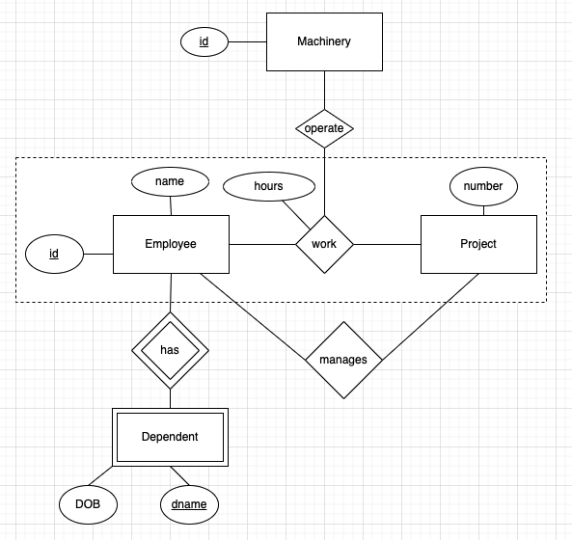
Q2. (10 points)
Convert the above ERD to relational model

Q3 (20 points). Assume we have three relations R(A,B), S(B,C) and Z(C). All three attributes (A, B, and C) are integer attributes

  - Relation R(A,B) contains the following tuples: (1,2), (2,3), (3,2), (4,1) and (5,4).
  - Relation S(B,C) contains the following tuples (1,2), (2,1), (2,3), (4,1), (4,3), (4,6) and (5,1).
  - Relation Z(C) contains the following tuples (1), (3)

Recall that a key is a minimal superkey, and that a key is not a superkey
(a) Give an example of an attribute that cannot be a key for relation
(b) Write the number of the results of the relational expression: $R X S$?
(c) Write the results for the following relational algebra expression: ($R$⋈$S$)
(d) Write the results for the following relational algebra expression: $π_{B}(S)$
(e) Write the results for the following relational algebra expression: $σ_{A>2 }\left(R\right)$
(f) Write the results for the following relational algebra expression:: γ_{B, sum(C)}(S)
This is equivalent of
select B, sum(C) from S group by B
(h) Write the results for the following relational algebra expression: $S÷Z$

Note that: γ is for group by

Q4. (10 points) Consider the following table Xbox Games(id, name, price) and assume that these values already exist in the database:
(1,‘Bad game’, 10), (2,‘Ok game’, 20), (2, 'good game, 30), (4,'AWESOME game', 50).
We have the following two transactions:
TI: BEGIN TRANSACTION SI
UPDATE Xbox Games SET Price =40 WHERE name=’good game’
INSERT INTO Xbox Games VALUES (' Terrific Game’, 60);
COMMIT;

T2: BEGIN TRANSACTION
SELECT AVG (price) AS average price FROM Xbox Games ;
COMMIT;

T3: BEGIN TRANSACTION
UPDATE Xbox Games SET Price=price* 1.10 ;
COMMIT;
Above three transactions are hitting the DBMS roughly at the same time.

What are the possible values for Transaction 2.

Q5. (5 points)
For relation (R), its attributes and its functional dependencies :
R(A, B, C, D, E, F)
F DE
E AC
DE ABC
CE
Decompose the above relation to 2NF, 3NF, and BCNF (step by step).

Q6 (5 points). relation (R), its attributes, and its functional dependencies (F):
R(A, B, C, D, E, F, G)
BC → DG
CD → F
F→ A

1-Compute the closure of {ACD}+
2-Compute the closure of {BCD}+
3-What are the keys of R?

Q7. (5 points)
What are the conflicts and implied transaction precedence for the following schedule?
S: R3(A); R1(C); W1(A); W2(B); R4(A);R2(A);W3(B); R4(C)
Draw the Precedence Graph for the schedule and indicate if it is conflict-serializable.

Q8 (25 points)
Consider the following schema (keys are underlined):
Product(pid, name, manufacture, price),
Buys(cid, pid),
Customer(cid, cname, gender)

Write the following query in relational algebra and SQL
(For relational algebra use pi for π, sigma for σ, join for ⋈, div for ÷, group by γ )
- Find customer who bought any product that customer 1 has purchased.
- “Find the names of all customers who have purchased all products manufactured by XYZ.”
- “Find. the names of all customers who have not purchased the most expensive product.”
- Find the total price of purchased product by each customer. Make sure to include all customers, even those with no purchase.
- Find the similarity between each pair of customers. The similarity is the ratio between number of products that both customers bought and the sum of the total purchased products.

