Question 1 [10 points]
Products
Id | name | description | price | Quantity
1 | T-shirt | 100% cotton, available in various colors and sizes | 19.99 | 50
2 | Hoodie | Soft and warm, available in various colors and sizes | 39.99 | 25
3 | Hat | Baseball cap style, available in various colors | 9.99 | 100
Customers
id | Name | email | phone | address
1 | John Smith | john.smith@example.com | 555-1234 | 123 Main St, Anytown, USA
2 | Jane Doe | jane.doe@example.com | 555-5678 | 456 Maple Ave, Anytown, USA
3 | Bob Johnson | bob.johnson@example.com | 555-9012 | 789 Oak Rd, Anytown, USA

Orders | Order Lines
  id | date | customer_id
  1 | 1/15/22 | 1
  2 | 2/20/22 | 1
  3 | 2/25/22 | 3
  id | order_id | product_id | quantity
  1 | 1 | 1 | 2
  2 | 2 | 2 | 1
  3 | 2 | 3 | 1
  4 | 3 | 1 | 1

Write the results of the following queries:

1-SELECT * FROM CUSTOMERs where name like '%John%';

2-Select * from Customers where
id not in (select customer_id from orders)

3-select customer.name, count(*) from orders o, customers c where
o.customer_id=c.id
group by customer.name;

4- SELECT p.name, sum(p.price * l. quantity) from orders o, order_lines l, Products p
where p.id=l.product_id and l.order_id=o.id
GROUP BY p.name

5- SELECT customer_id, SUM(l.quantity*p.price) as total_revenue
FROM Orders o, order_line l, products p
WHERE customer_id IN (
SELECT customer_id
FROM Orders
GROUP BY customer_id
HAVING COUNT(DISTINCT order_id) > 1
) and p.id=l.product_id and l.order_id=o.id
GROUP BY customer_id;

Question 2 [10 points]
Convert the following diagram to relational model

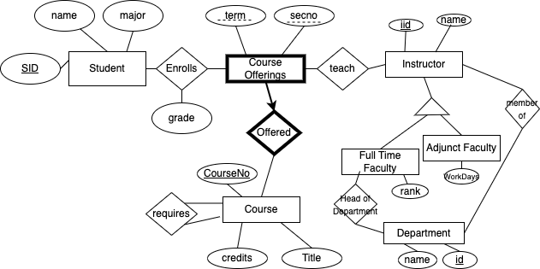

Question 3 [10 points]:
Draw ERD for the following scenario inspired by AWS (This is over simplified):

- AWS provides hundreds of services. Two popular services are AWS EC2 and S3 services. EC2 instances represent virtual servers that can be launched on demand, while S3 buckets represent object storage in the cloud.
- Each AWS service may have several resources configurations. Each configuration is identified by name. Resource configuration has a type (for example, computing, storage, ..), and a unit (if applicable)
- Accounts are needed to access the AWS services. Account can be either personal or business.
- Account has an account id, and balance. Several users can be within the same business account, where each user would have a separate budget. While personal accounts allow only one user.
- Users are identified by an id. We store the email address and a password hash.
- The cost of a service depends on (1) subscription type (on-demand, pre-allocated), (2) Account Type, and (3) resource configurations.

Question 4 [10 points]
Consider the following schema (keys are underlined):
Product(pid, name, type, manufacturer, price),
Buys(cid, pid)
Customer(cid, cname, age, gender)

Write the following queries in SQL
- Find the names of customers who have not purchased any products manufactured by Apple.
- Find the average age of the customers who buys Nike sneakers
- Find price of the most expensive product
- Find the names of customers who have purchased the most expensive product.
- Find customer who bought a product manufactured by Apple, and a product manufactured by Dell.
- Find the customer names who bought at least two products manufactured by Apple, and a product from Dell
- Find the most expensive product that has been bought [Note this is different than the previous query]
- Find the names of customers who have purchased the most expensive product.
- Find the names customers who have purchased the 2nd most expensive product.

