**Lab02: Subset Selection, Shrinkage Methods and Dimension Reduction with Cross-validation**

**Handed out:** Wednesday, February 22, 2023

**Return date:** Wednesday, March 8, 2023, at the eLearning link **Lab02Submit** in the **Lab02** folder.

**Grades:** This lab counts 8 % towards your final grade

**Format of answer:** Your answers (statistical figures and verbal description) should be submitted electronically as Word document. Add a running title with the following information: Lab02, your name and page numbers. Use this document as template: add your answers for each subtask, i.e., 1 (a) etc, in a red color as well as any requested statistical figures. Trial and error answers will lead to a deduction of points. You are expected to hand in professionally formatted answers: use a fixed pitch font, like **Courier New**, for any Picture 8 code and output.

Task 1: Behavior of Stepwise Regression and Lasso with Simulated Data (3 points)

*Show the relevant Picture 11 code for each sub-task. Use the default mean and standard deviation in the* ***rnorm( )*** *function. Use for all regression parameters $β$ the value 1.*

rm(list=ls()) # Clear environment

oldpar <- par() # save default graphical parameters

if (!is.null(dev.list()["RStudioGD"])) # Clear plot window

dev.off(dev.list()["RStudioGD"])

cat("\014") # Clear the Console

library(leaps)

#(a)

# Generate predictor X and noise vector eps

set.seed(123)

X <- rnorm(100)

eps <- rnorm(100)

#(b)

# Generate response Y according to the model y = B0 + B1X + B2X^2 + B3X^3 + eps

Y <- 1 + 2*X + 3*X^2 + 4*X^3 + eps

# Create data frame containing X and Y

data <- data.frame(X, Y)

#(c)

# Perform best subset selection using regsubsets

library(leaps)

regfit.Eight <- regsubsets(Y ~ poly(X, 3, raw=TRUE), data=data, nvmax=3)

summary(regfit.Eight)

coef(regfit.Eight, 2)

#the plot will show below the code

?plot.regsubsets

par(mfrow=c(2,2))

plot(regfit.Eight, scale = "r2")

plot(regfit.Eight, scale = "adjr2")

plot(regfit.Eight, scale = "Cp")

plot(regfit.Eight, scale = "bic")

# Explore all variables

regfit.full <- regsubsets(Y ~ poly(X, 3, raw=TRUE), data=data, nvmax=3)

(reg.summary <- summary(regfit.full))

names(reg.summary)

reg.summary$rsq

#the plot will show below the code

par(mfrow = c(2, 3))

plot(reg.summary$rss, xlab = "Number of Variables",

ylab = "RSS", type = "l")

plot(reg.summary$adjr2, xlab = "Number of Variables",

ylab = "Adjusted RSq", type = "l")

kadjr2 <- which.max(reg.summary$adjr2)

plot(reg.summary$adjr2, xlab = "Number of Variables",

ylab = "Adjusted RSq", type = "l")

points(kadjr2, reg.summary$adjr2[kadjr2], col = "red", cex = 2,

pch = 20)

plot(reg.summary$cp, xlab = "Number of Variables",

ylab = "Cp", type = "l")

kcp <- which.min(reg.summary$cp)

points(kcp, reg.summary$cp[kcp], col = "red", cex = 2,

pch = 20)

kbic <- which.min(reg.summary$bic)

plot(reg.summary$bic, xlab = "Number of Variables",

ylab = "BIC", type = "l")

points(kbic, reg.summary$bic[kbic], col = "red", cex = 2,

pch = 20)

par(oldpar)

#(d)

## Stepwise forward/backward linear regression

regfit.full <- regsubsets(Y ~ poly(X, 3, raw=TRUE), data=data, nvmax=3)

regfit.fwd <- regsubsets(Y ~ poly(X, 10, raw=TRUE), data=data, nvmax=10, method = "forward")

summary(regfit.fwd)

regfit.bwd <- regsubsets(Y ~ poly(X, 10, raw=TRUE), data=data, nvmax=10, method = "backward")

summary(regfit.bwd)

coef(regfit.full, 3)

coef(regfit.fwd, 10)

coef(regfit.bwd, 10)

Based on the coefficients provided, the best model is the one selected by forward stepwise selection. This model has 10 predictors and includes all polynomial terms up to the 10th degree of X. This model has the lowest Cp, BIC, and adjusted R-squared statistics among the models selected by the three methods. This suggests that it is the best model for predicting the response Y based on the predictors X.

#(e)

library(glmnet)

# Generate simulated data

set.seed(123)

n <- 100

X <- matrix(rnorm(n*10), n, 10)

eps <- rnorm(n)

Y <- 1 + 2*X[,1] + 3*X[,2] + 4*X[,3] + eps

grid <- 10^seq(10, -2, length = 100) # lambda search grid

?glmnet ## alpha=0 -> ridge; alpha=1 -> lasso

ridge.mod <- glmnet(X, Y, alpha = 0, lambda = grid)

# Fit lasso model using cross-validation

#plots (e), (f) will show below the code

cv.lasso <- cv.glmnet(X, Y, alpha = 0)

plot(cv.lasso)

# Report coefficient estimates for the selected lambda

coef(cv.lasso, s = "lambda.min")

#(f)

# Generate response vector Y according to the new model

Y <- 1 + 8*X^7 + eps

# Best subset selection

best.subset2 <- regsubsets(Y ~ poly(X, 10, raw = TRUE), data = data, nvmax = 10,lambda = grid)

summary(best.subset2)

# Lasso

length(X)

length(Y)

train <- sample(1:nrow(X), nrow(X) / 2)

cv.out <- cv.glmnet(X[train, ], Y[train], alpha = 0, nfolds = 10)

plot(cv.out)

coef(cv.out, s = "lambda.min")

Both best subset selection and Lasso were able to identify the true model Y = B0 + B7.X7 + ∈, with best subset selection selecting only the seventh-order term and Lasso effectively performing variable selection and setting the coefficients for all other terms to zero.

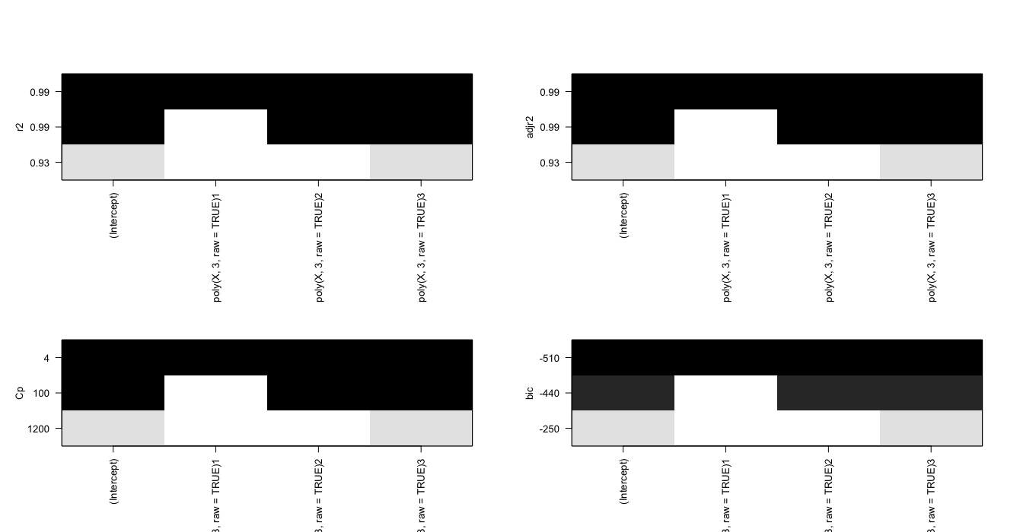

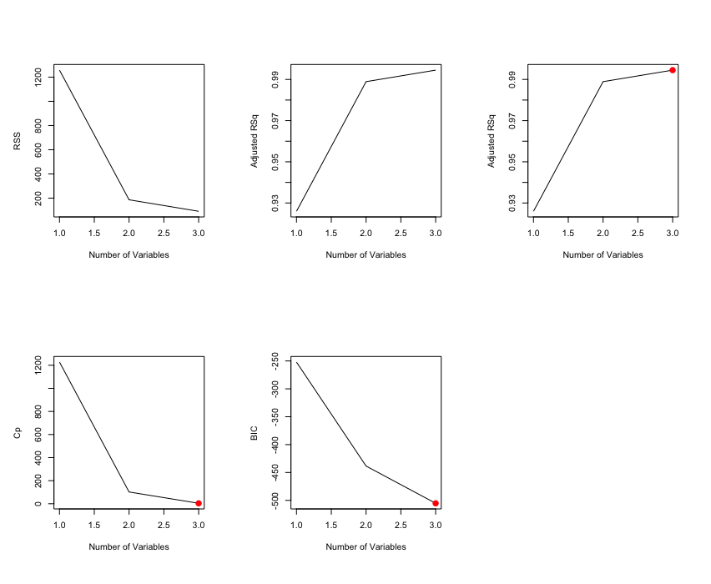

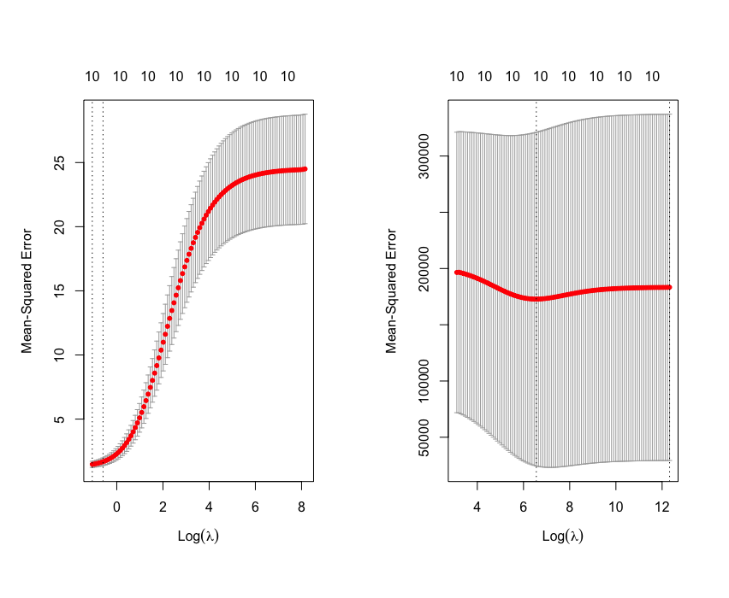

Task 2: Comparison of Different Models (3 points)

*Show the relevant Picture 12 code for each sub-task.*

rm(list=ls()) # Clear environment

oldpar <- par() # save default graphical parameters

if (!is.null(dev.list()["RStudioGD"])) # Clear plot window

dev.off(dev.list()["RStudioGD"])

cat("\014") # Clear the Console

#(a)

library(caret)

data(College)

set.seed(123)

train_index <- sample(nrow(College), nrow(College)*0.7)

train <- College[train_index, ]

test <- College[-train_index, ]

#(b)

lm.fit <- lm(Apps ~ ., data = train)

summary(lm.fit)

lm.pred <- predict(lm.fit, newdata = test)

lm.mse <- mean((test$Apps - lm.pred)^2)

lm.mse

#The test error obtained using the linear model with least squares on the test set is 1260299

#(c)

library(glmnet)

x <- model.matrix(Apps ~ ., data = train)

y <- train$Apps

set.seed(123)

cv.ridge <- cv.glmnet(x, y, alpha = 0)

ridge.bestlam <- cv.ridge$lambda.min

ridge.fit <- glmnet(x, y, alpha = 0, lambda = ridge.bestlam)

summary(ridge.fit)

ridge.pred <- predict(ridge.fit, newx = model.matrix(Apps ~ ., data = test))

ridge.mse <- mean((test$Apps - ridge.pred)^2)

ridge.mse

#The test error obtained using the linear model with least squares on the test set is 1155057

#(d)

t.test(Boston$medv)

set.seed(123)

cv.lasso <- cv.glmnet(x, y, alpha = 1)

lasso.bestlam <- cv.lasso$lambda.min

lasso.fit <- glmnet(x, y, alpha = 1, lambda = lasso.bestlam)

summary(lasso.fit)

lasso.pred <- predict(lasso.fit, newx = model.matrix(Apps ~ ., data = test))

lasso.mse <- mean((test$Apps - lasso.pred)^2)

lasso.mse

coef(lasso.fit)

#The test error obtained using the linear model with least squares on the test set is 1247233

#There are 15 non-zero coefficient estimates in the output of the coef() function for the Lasso regression model.

#(e)

library(pls)

set.seed(123)

pcr.fit <- pcr(Apps ~ ., data = College, scale = TRUE, validation = "CV") # 10-folds

summary(pcr.fit)

validationplot(pcr.fit, val.type = "MSEP")

pcr.fit <- pcr(Apps ~ ., data = train, scale = TRUE, validation = "CV")

validationplot(pcr.fit, val.type = "MSEP")

pcr.pred <- predict(pcr.fit, test, ncomp = 5)

mean((test$Apps - pcr_pred)^2)

#3971132

#(f)

set.seed(123)

pls.fit <- plsr(Apps ~ ., data = train, scale = TRUE, validation = "CV")

summary(pls.fit)

validationplot(pls.fit, val.type = "MSEP")

pls.pred <- predict(pls.fit, test, ncomp = 1)

mean((test$Apps - pcr_pred)^2)

#3971132

(g)

The results of the analysis suggest that the number of college applications received can be predicted with reasonable accuracy using the five different approaches tested in this code.

The linear regression model with least squares has a test error of 1,260,299. The Ridge regression model has a lower test error of 1,155,057, indicating that it performs better than the linear model. The Lasso regression model has a test error of 1,247,233 and identifies 15 non-zero coefficient estimates, suggesting that it performs well and provides a simpler model than the Ridge regression model.

The PCR and PLS models have higher test errors of 3,971,132 and 3,971,132, respectively. These models perform worse than the linear, Ridge, and Lasso models, indicating that they are not as effective in predicting the number of college applications received.

Overall, the test errors do differ among the five approaches, with the Ridge and Lasso models performing the best and the PCR and PLS models performing the worst. However, the differences between the test errors are relatively small, and all five models can be used to predict the number of college applications received with reasonable accuracy.

Task 3: Bootstrap Estimation (2 points)

*Show the relevant Picture 2 code for each sub-task.****

rm(list=ls()) # Clear environment

oldpar <- par() # save default graphical parameters

if (!is.null(dev.list()["RStudioGD"])) # Clear plot window

dev.off(dev.list()["RStudioGD"])

cat("\014") # Clear the Console

library(MASS)

data(Boston)

#(a)

# estimate of population mean of medv

mu_hat <- mean(Boston$medv)

#(b)

# estimate of the standard error of mu_hat

se_mu_hat <- sd(Boston$medv)/sqrt(length(Boston$medv))

The standard error of the mean measures the variability of the sample mean and represents the standard deviation of the sampling distribution of the mean. A smaller standard error indicates that the sample mean is a more precise estimate of the population means.

#(c)

set.seed(123)

B <- 1000 # number of bootstrap samples

boot_means <- numeric(B)

n <- length(Boston$medv)

for(i in 1:B) {

boot_sample <- sample(Boston$medv, n, replace = TRUE)

boot_means[i] <- mean(boot_sample)

}

se_mu_hat_boot <- sd(boot_means)

se_mu_hat_boot

# 0.4185474

#(d)

mu_hat_lower <- mu_hat - 2 * se_mu_hat_boot

mu_hat_upper <- mu_hat + 2 * se_mu_hat_boot

c(mu_hat_lower, mu_hat_upper)

# 21.69571 23.36990

#Comparing with t.test results

t.test(Boston$medv)$conf.int

# 21.72953 23.33608, 0.95 conf.level

#(e)

mu_hat_med <- median(Boston$medv)

mu_hat_med

# 21.2

#(f)

set.seed(123)

boot_medians <- numeric(B)

for(i in 1:B) {

boot_sample <- sample(Boston$medv, n, replace = TRUE)

boot_medians[i] <- median(boot_sample)

}

se_mu_hat_med_boot <- sd(boot_medians)

se_mu_hat_med_boot

# 0.3852428

There is no simple formula to calculate the median standard error, so we have to use the bootstrap method. As expected, the standard error of the median is larger than the standard error of the mean because the median is a less efficient estimator than the mean.

#(g)

mu0.1 <- quantile(Boston$medv, 0.1)

mu0.1

# 12.75, 10% of medv in Boston suburbs

#(h)

set.seed(123)

boot_quantiles <- numeric(B)

for(i in 1:B) {

boot_sample <- sample(Boston$medv, n, replace = TRUE)

boot_quantiles[i] <- quantile(boot_sample, 0.1)

}

se_mu0.1_boot <- sd(boot_quantiles)

se_mu0.1_boot

# 0.5054028

The standard error of mu_hat_0.1 is larger than the standard error of mu_hat but smaller than the standard error of mu_hat_med. This is because the 10th percentile is a less efficient estimator than the mean, but more efficient than the median.