

**ATILIM UNIVERSITY**

**FACULTY OF ENGINEERING**

**COMPE 341 PUBLIC TRANSPORTATION SYSTEM’S DATABASE REPORT**

### Prepared By

**Yusuf Ali Koyuncu 150302021**

**INSTRUCTOR: İbrahim Cereci**

**December , 2019**

**TABLE OF CONTENTS**

1. INTRODUCTION

2. REQUIREMENT ANALYSIS

3. CONCEPTUAL DESIGN

**3.1.ER Diagram**

**3.2. Description Of ER Diagram**

4. LOGICAL DATA MODEL

**4.1. Mapping**

**4.2.Normalization**

5. DATABASE CHOICE and IMPLEMENTATION

**5.1. Data Inserting**

**5.2. Created Tables**

**5.3. Query Design**

6. INTERFACE

**6.1. Screenshots**

***LIST OF TABLES AND FIGURES***

TABLE 1

1. ***INTRODUCTION***

Public transportation system database is created for control . We intend to create this for relevant institution to control the elements of the public transportation . Every information can be accessed with the database . We wanted to resolve a important problem . Public trasportation is a very important thing for today’s world and it should be controlled by government because of that we decided to create this Project. For creating this we had a lots of resarch with the topic , we searched it on the internet , we study relavant journal etc.It was a very good experience for us , we learned lots of information while doing the Project . As a result , we create a usefull database system for checking the elements of the public transportation .

***2. REQUIREMENT ANALYSIS***

First we create this , we need to determine the requirements of the Project . We follow these keywords to detect requirement analysis . needed things , information finding , ease of use , content .We started our research in public transformation’s formal website. Later, we research the key factors of the public transportation.After that we thought about the necessary factors in the Project.We thought and create the necessary entities ; employee should have a table in the table name of this entity as EMPLOYEE. It has salary , account no , SSN, name , age , surname , sex . For counting the dependents , DEPENDENT entity has sex,dep_name , dep_surname , relationship . For represent the route ROUTE entity has route_price , route_id , route_name . PASSANGER entity is show the passangers informations and the fee and it has fee , passanger_id . In PASSANGER_TYPE we have typename and type_id . MEMBERCARD has card_id to show people’s card id numbers . SELLING_POINT entity has sellpoint_id , sellpoinlocation.Another one is GARAGE , it has garage’s elements like garage_id , garage_name , garage_location , mec_id . DRIVER entity has driver_id . VEHICLE entity has vehicle_id and model for represent the vehicle informations .STATION entity has station_location , st_name , st_id .MOVING TIME has move_id , dep_time , ar_time . In PLATE table we have plate_id for showing vehicle’s plate numbers .We need DEPARTMENT entity to show departments and it has dep_name and dep_id .FOOD table has cooker_id . MENU entity has many attributes to show the menu completely and they are main_food , hepler_food , ddate , menu_id , soap , salat/desert . ACCOUNTING table has accountant_id . We have a weak entity which name is OUTGOING and it has salary , maintenance_expense , fuel , tax . Other weak entity is REVENUE which has voyage_income , bid_income , payment to show where the money is come from . These are key factors for our project .

***3. CONCEPTUAL DESIGN***

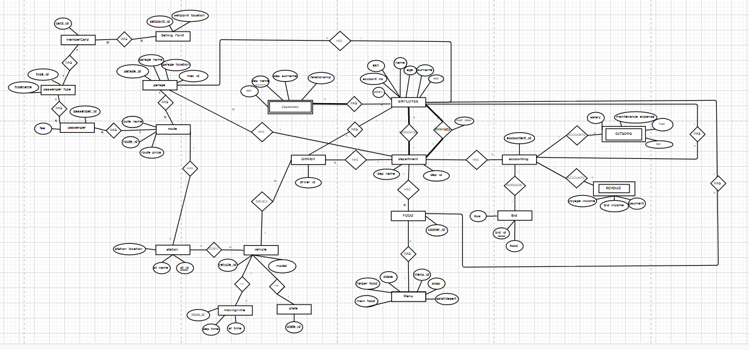In our system, users enter the system with anemail and password . The authorized person can enter the system and check the database . Database store and show the public transportation system’s informations .

Table 1 – Entity relationship diagram

In employee entity ssn is the primary key , it has many to many relation with dependent entity and relation name is “has” . The relation is many to many because one employee can be relavent with many dependent person . It has one to many relationship ( has ) with food entity and garage entity . Another relationship is also one to many with department entity which name is worksfor . One department can have lots of employee .Last relationship is necessary for both entity . It is one to one relationship with department again , the relationship’ name is manages . Every department should manage employee .Dependent entity has one relation that we mention about employee entity part , it has many to many relation with employee , relationship name is “has” dependent person can be relavent with many employee . Dependent entity also has a weak attribute which name is dep_name.In route entity we have route_id as a primary key . It has three relationship . First one is one to many with station and relationship name is “has” . One route can has lots of station . Route’s other relationships are one to many relationship with passanger entity and garage entity and relationship named as “has” also . One route can has many passanger and garage.Passanger entity has two relationship , first one is many to many and the other one is one to many .

Both relation is named as has . The first relationship is between passanger and route entities . Many passanger can use one route . In other relationship we have one to many relationship and it is between passanger and passanger_type entities . One passanger can have one passanger_type . In Passanger_type entity primary key is typename . It has one to many relationship with passanger like we mention in passanger entity part . It has another one to many relationship with memberCard .MemberCard entity has a primary key that name is card_id.It’ first relationship is with passanger_Type entity and the other is with SellingPoint entitiy . The relation with SellingPoint entity is many to many .Many SellingPoints can sell many membercards . SellingPoint entity’s primary key is sellpoint_id attribute . It has only one relationship and it is with memberCard . In garage entity we have garage_id attribute as a primary key . Garage entity has three relationship . All of them are one to many and the relationships name is “has” . First one is with route entity , other one is between garage and department entities and the last one is with employee entity .

In station entity , we have a primary key which name is st_id attribute . We have two type of relationship and they are one to many and many to many relationships . One to many relationship is with route entity , a route can has many sitations as we mentioned before . Many to many relation is with vehicle entity and the relationship name is stops . Many vehicles can stops in many stations.Vehicle entity vehicle_id attribute as a primary key . This entity has four relationship . Two of them many to many and one to one relationship and one to many relationship. First many to many relationship is with station entity and the relationship name is stops . Many vehicles can stop in many station so it is suitable . Other many to many relationship is with movingTime entity . More than one vehicle can have more than one moving time . Vehicle entity has one to one relationship with plate entity . Each vehicle can has one plate . And the last relationship is with driver entity and it is one to many relation . The relation name is drives .One vehicle can be used by many drivers .In movingTime entity move_id attribute is our primary key . It has only one relationship with vehicle and the type is many to many .Many vehicle can have many movingTime so it is proper.When we came the Plate entity we see that plate_id attribute is the primary key .

It has one to one relationship with vehicle. Each plate can be owned by one vehicle .Driver entity has three one to many relationship between vehicle , department and employee entitites .Department can have lots of driver also the employee part.Department entity has three one to many relationship too . The relationships are between driver , accounting , employee entites. The relationship between employee is necessary . In food entity cooker_id attribute is the primary key . Food entity has three one to many relationship between menu , department and employee entites . One Menu , department and employee can have many food .Menu entity has menu_id attribute as a primary key . It also has one to many relationship with food entity . In Bid entity bid_id is a primary key and it has a one to one relationship with accounting and the relationship’s name is works on . In one bid there is only one accounting . Accounting entity has primary key as named as accountant_id ,and it has four relation ship . First one is one to many relationship with department entity .Another is one to one relationship between bid as we mentioned before . The third relationship is one to many relationship with outgoing . The last one is one to many with revenue entity . Outgoing and revenue are weak entities of the diagram .

4. LOGICAL DATA MODEL

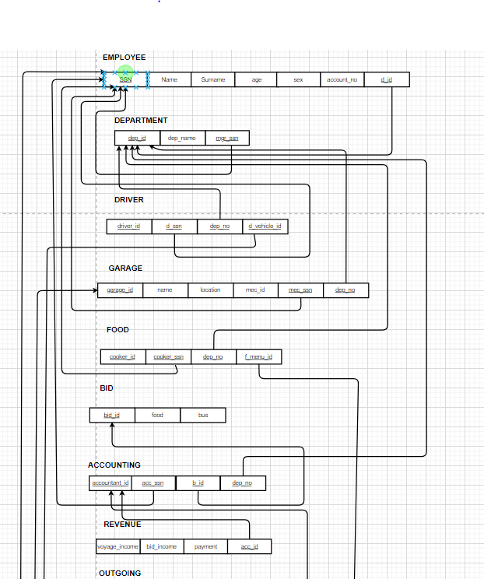**4.1. Mapping**

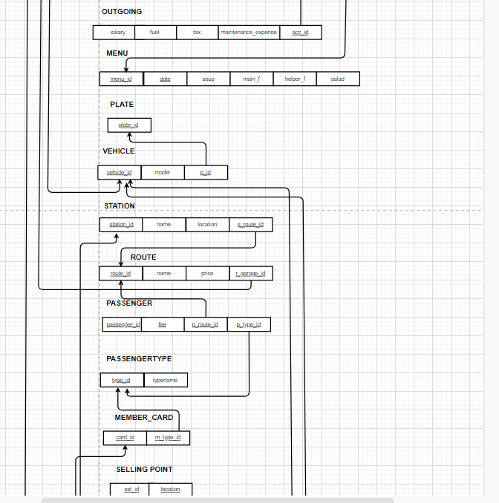

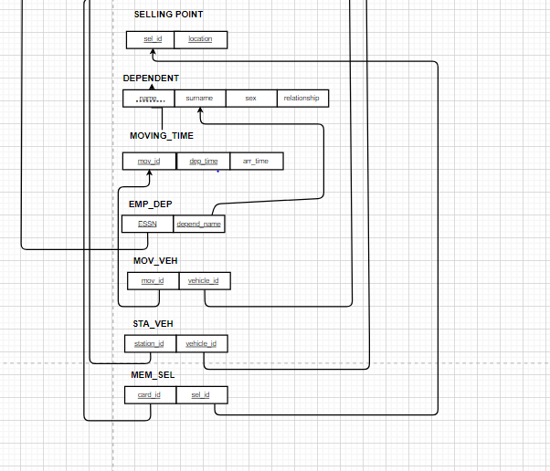

**4.2. Normalization**

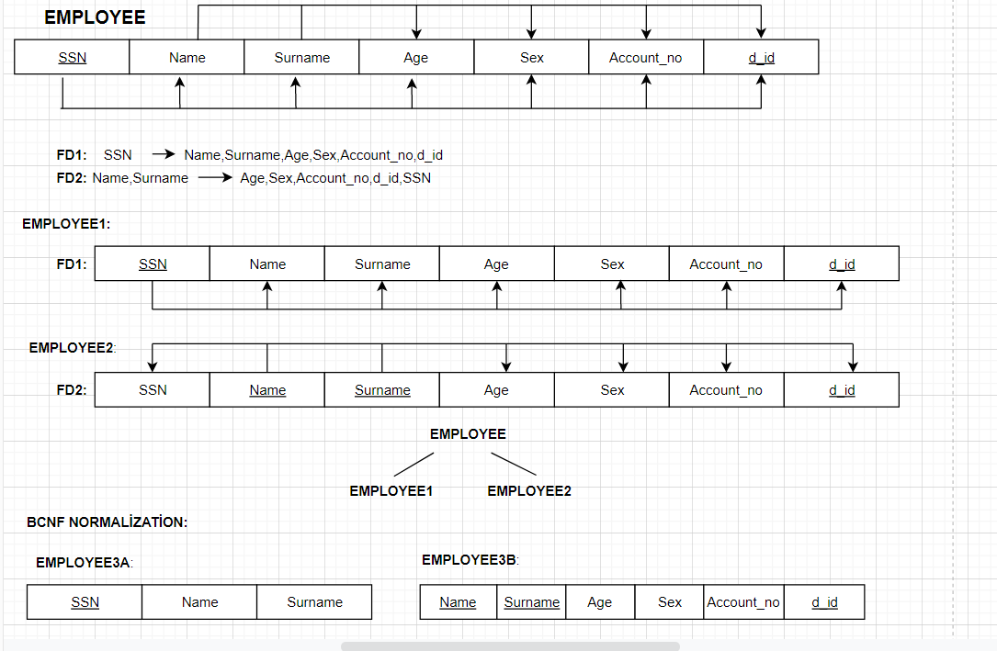

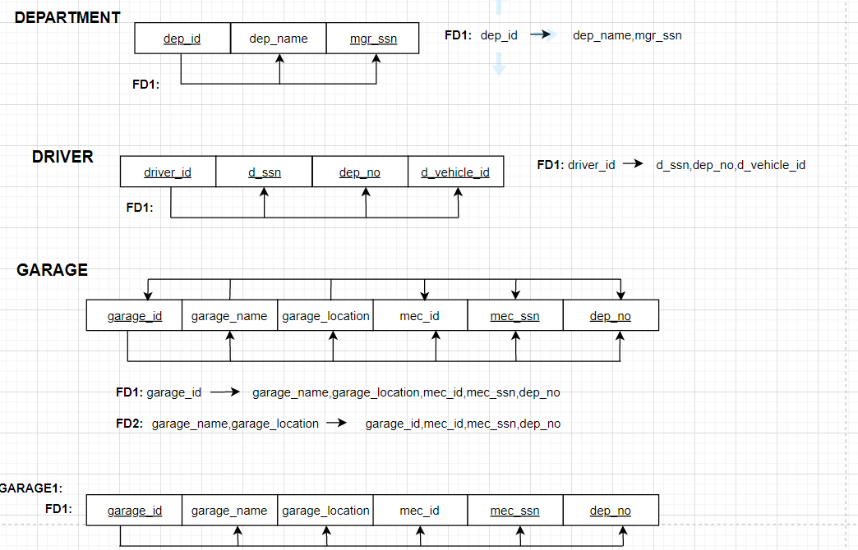

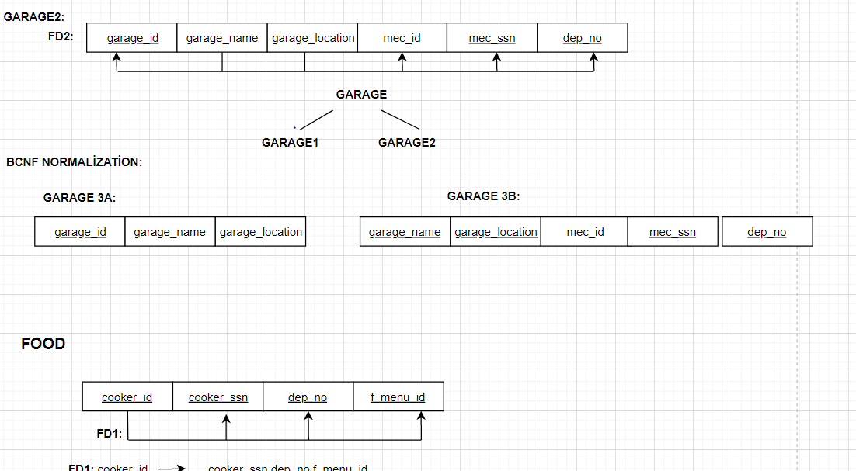

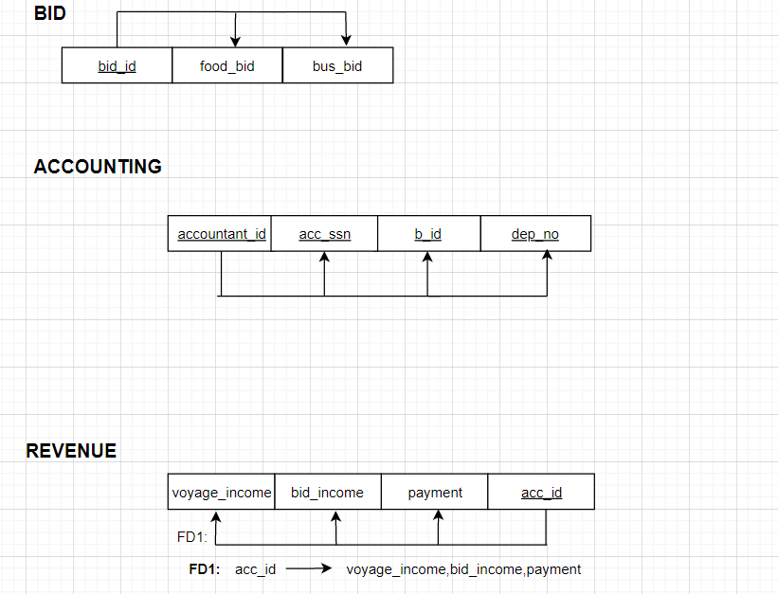

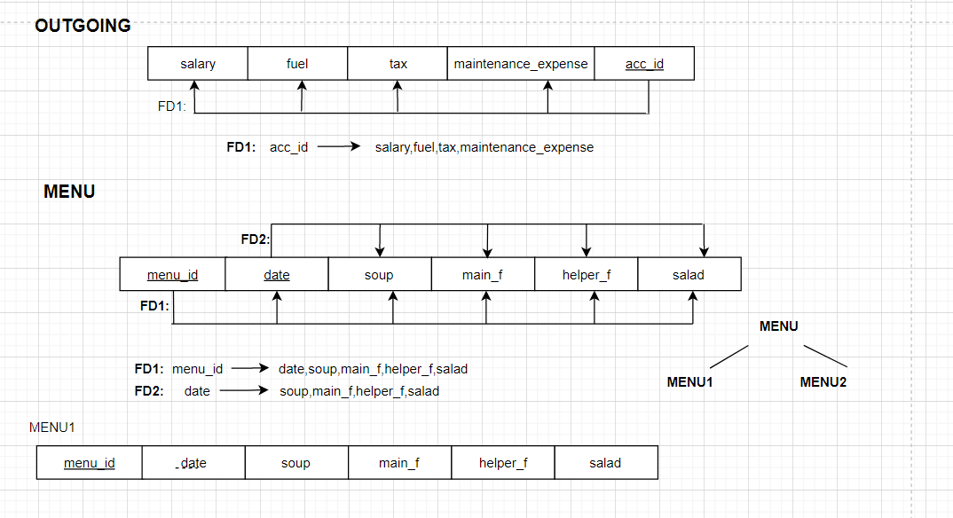

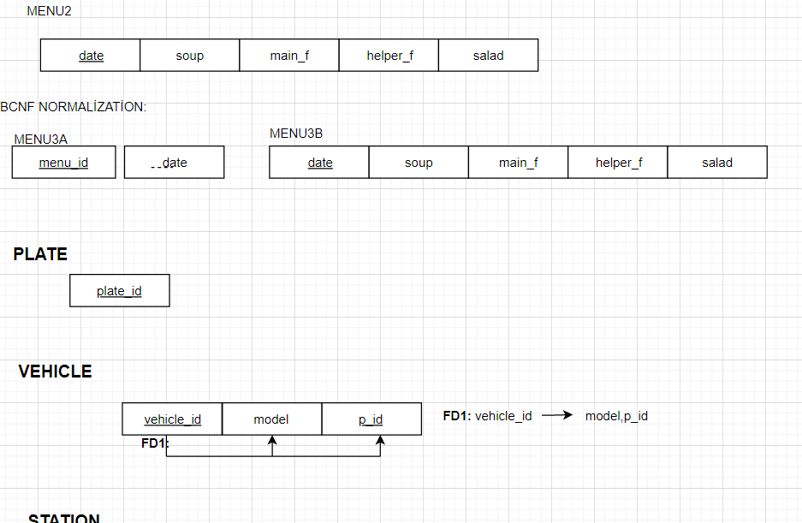

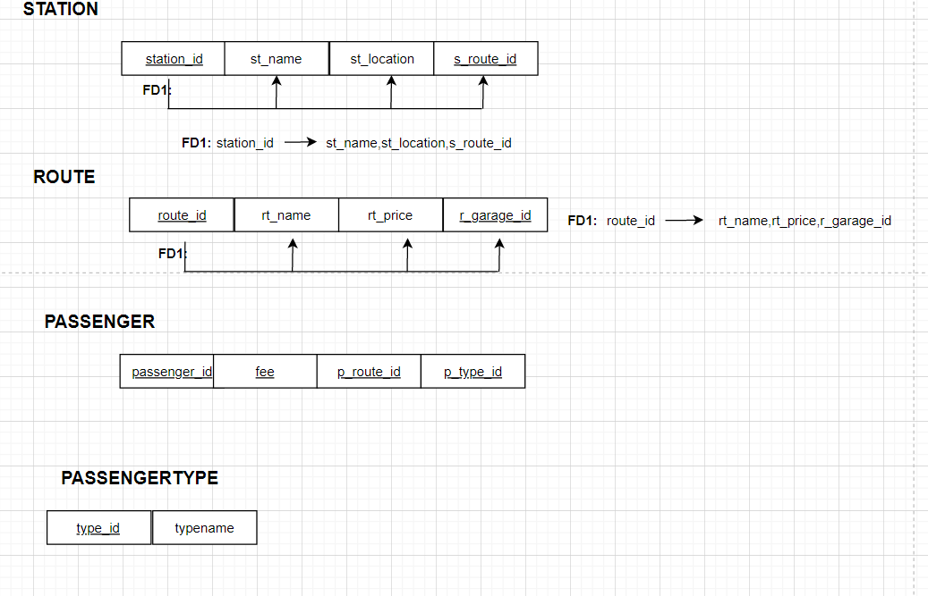

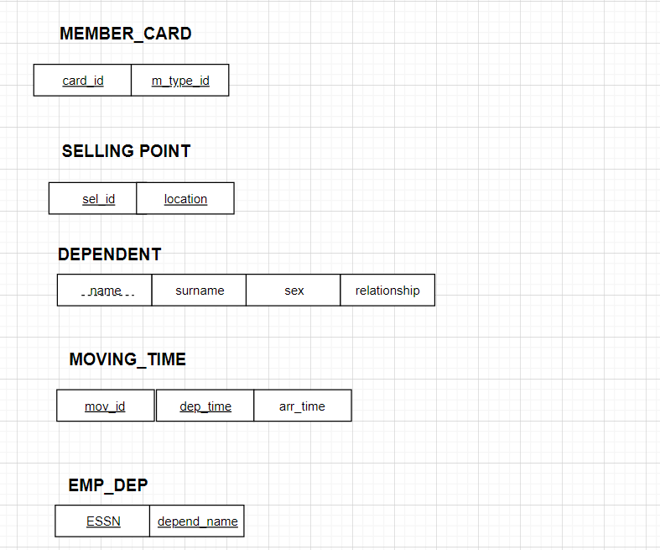

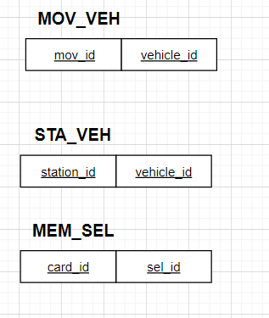

5. DATABASE CHOICE and IMPLEMENTATION

**5.1. Data Inserting**

**5.2. Created Tables**

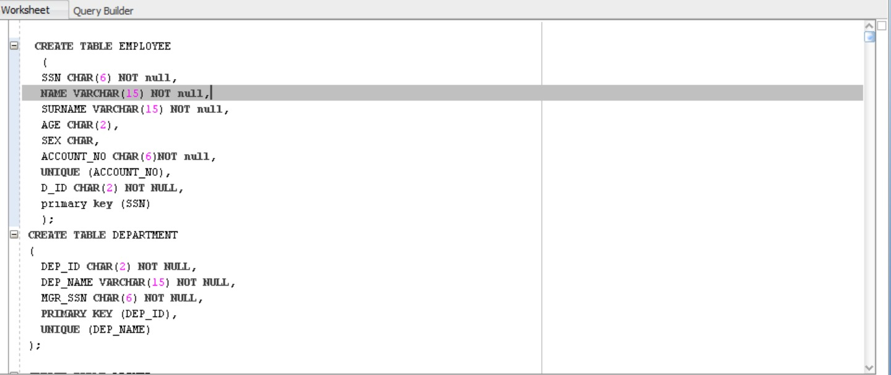

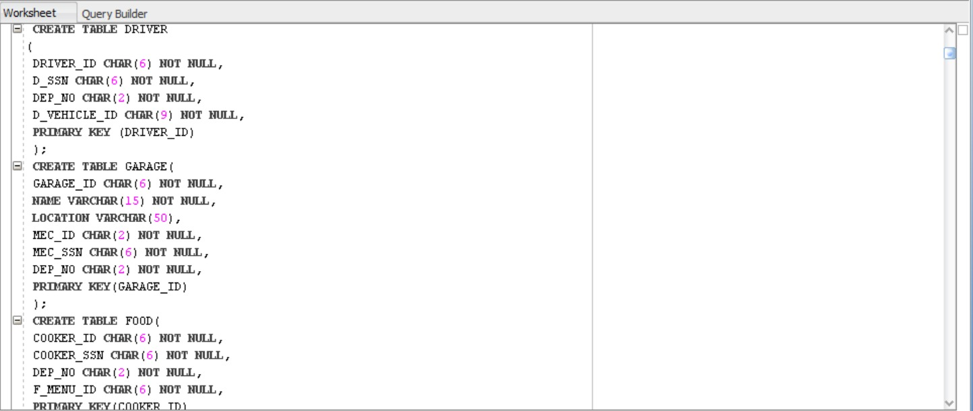

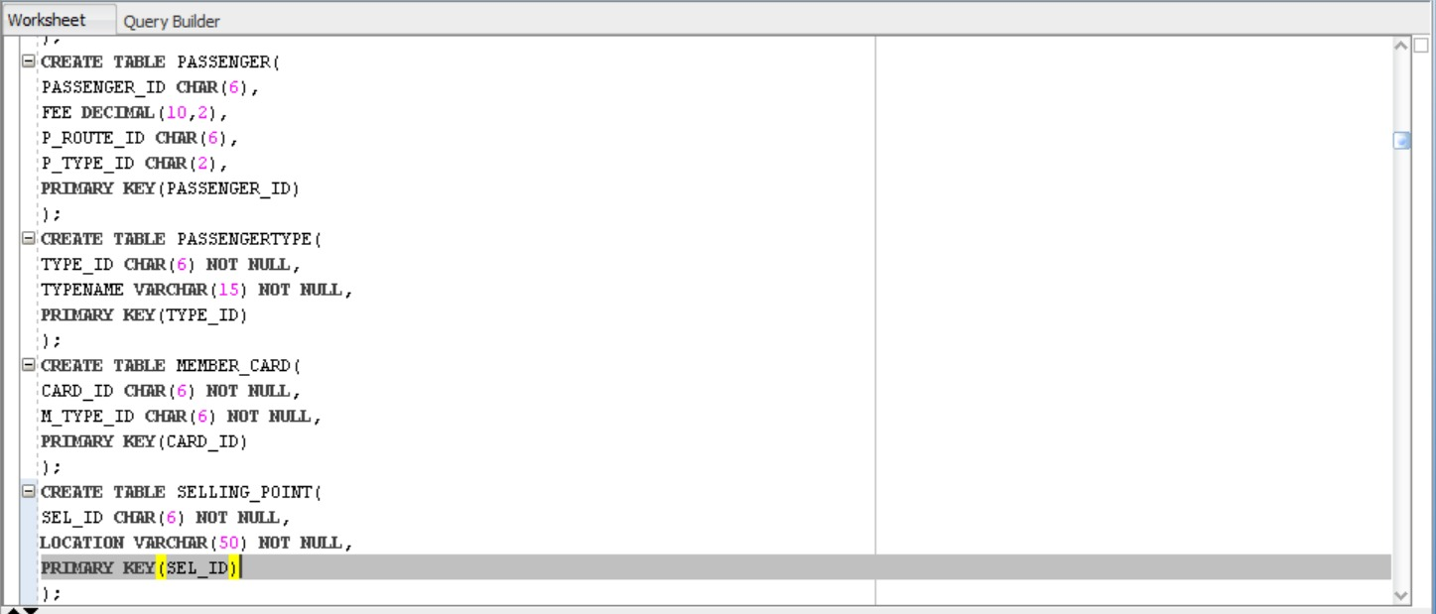

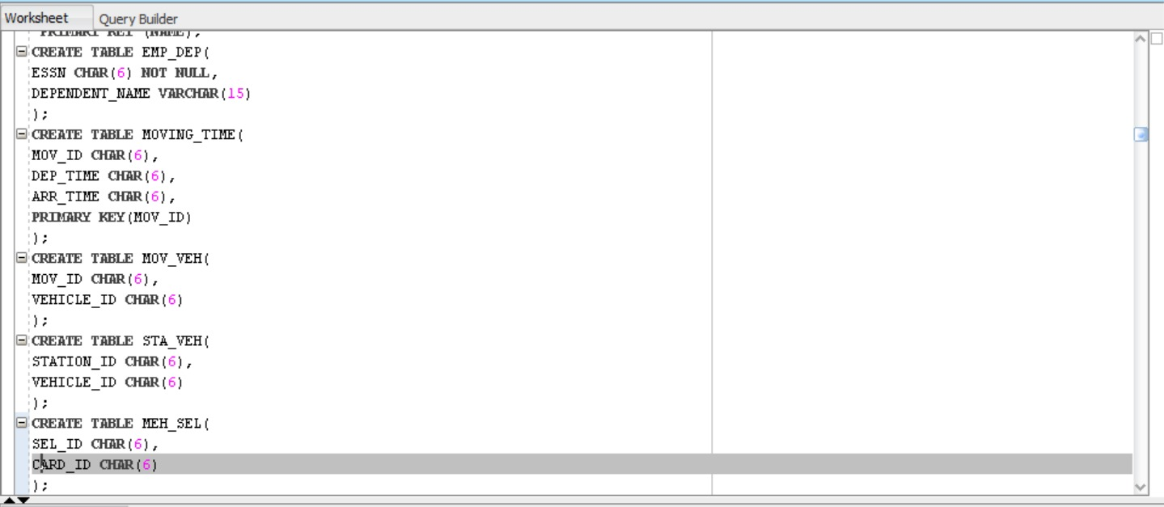

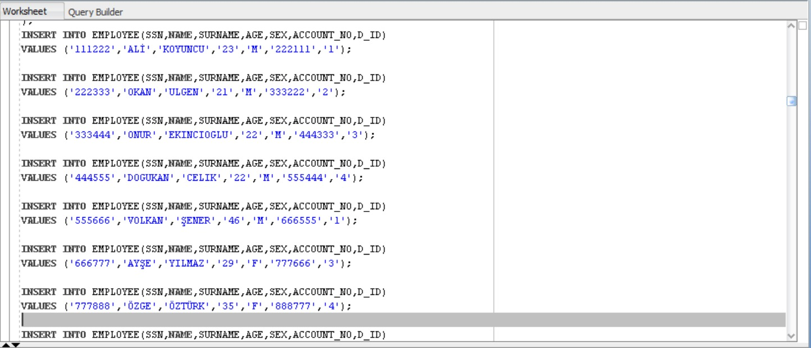

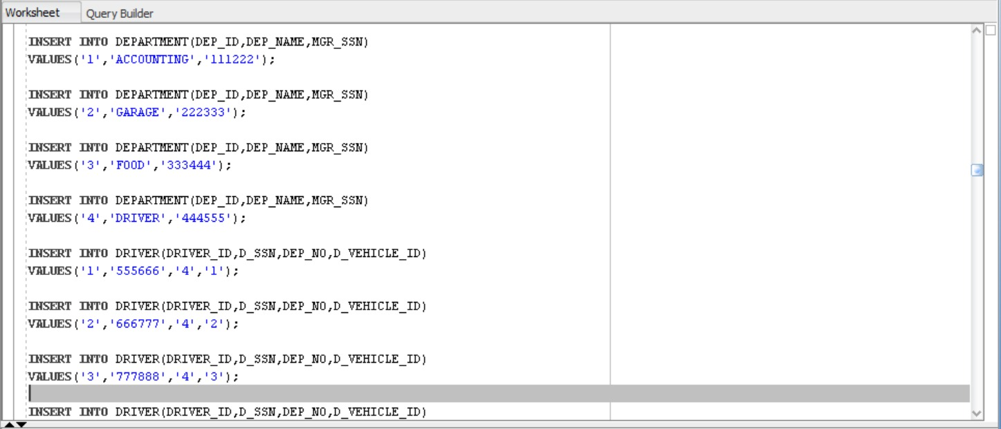

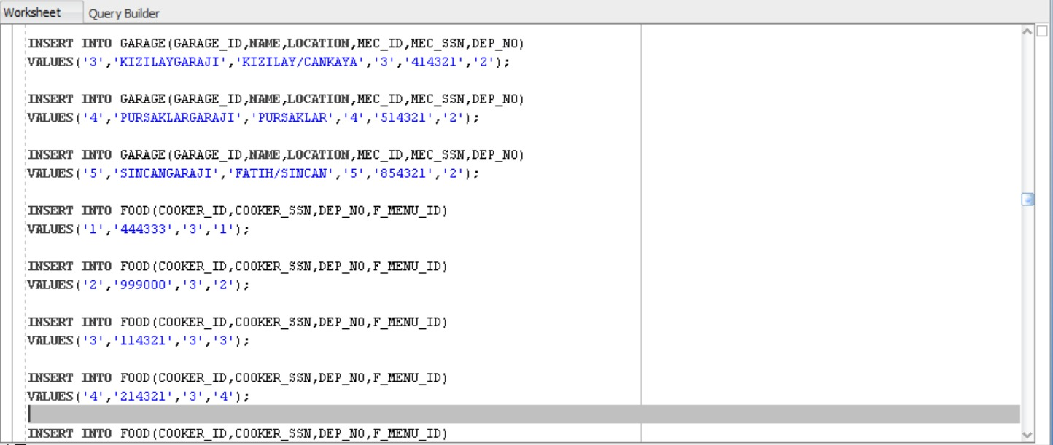

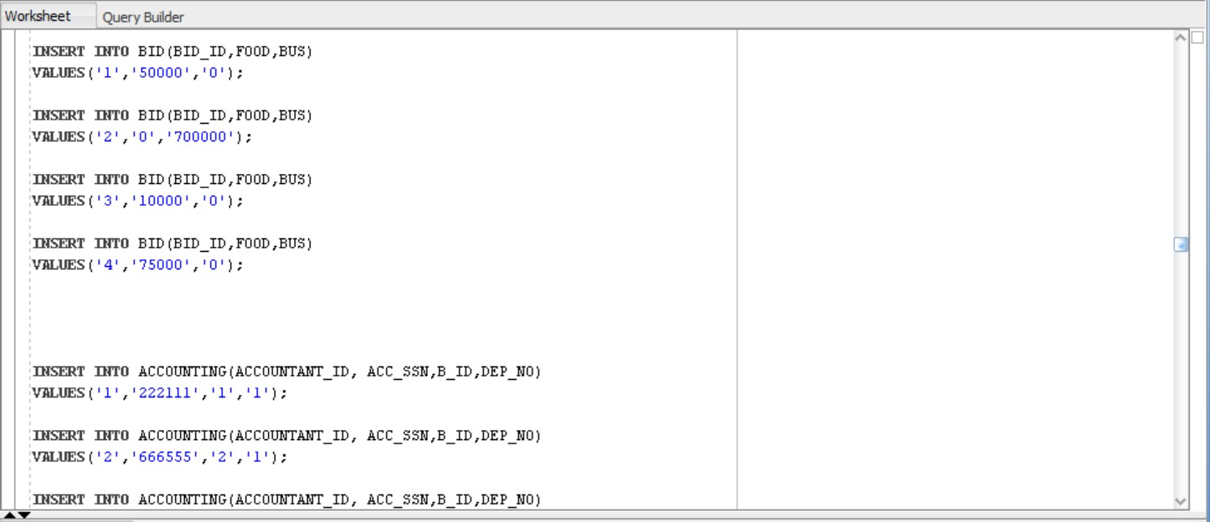

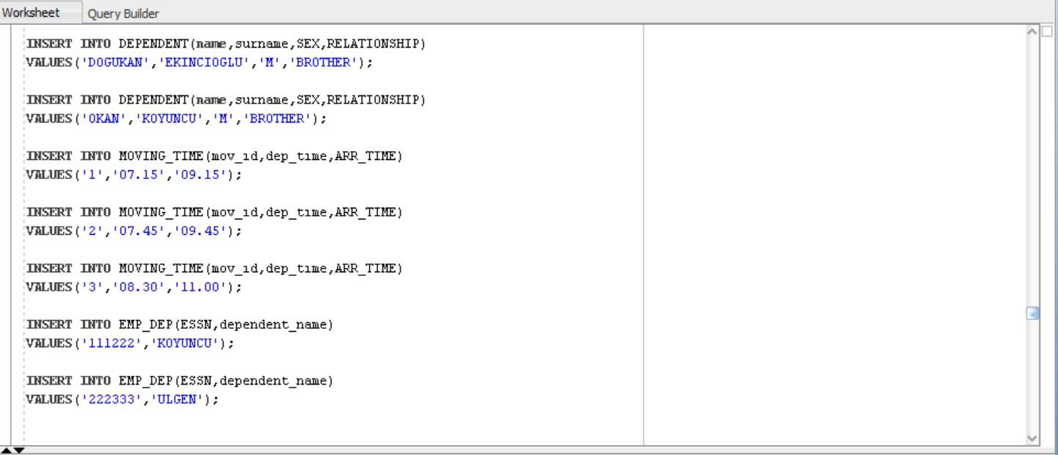

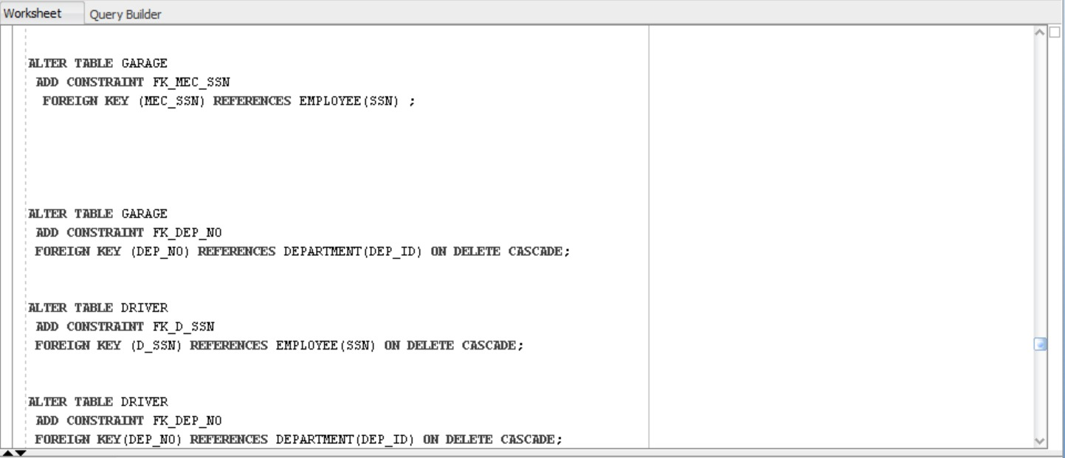

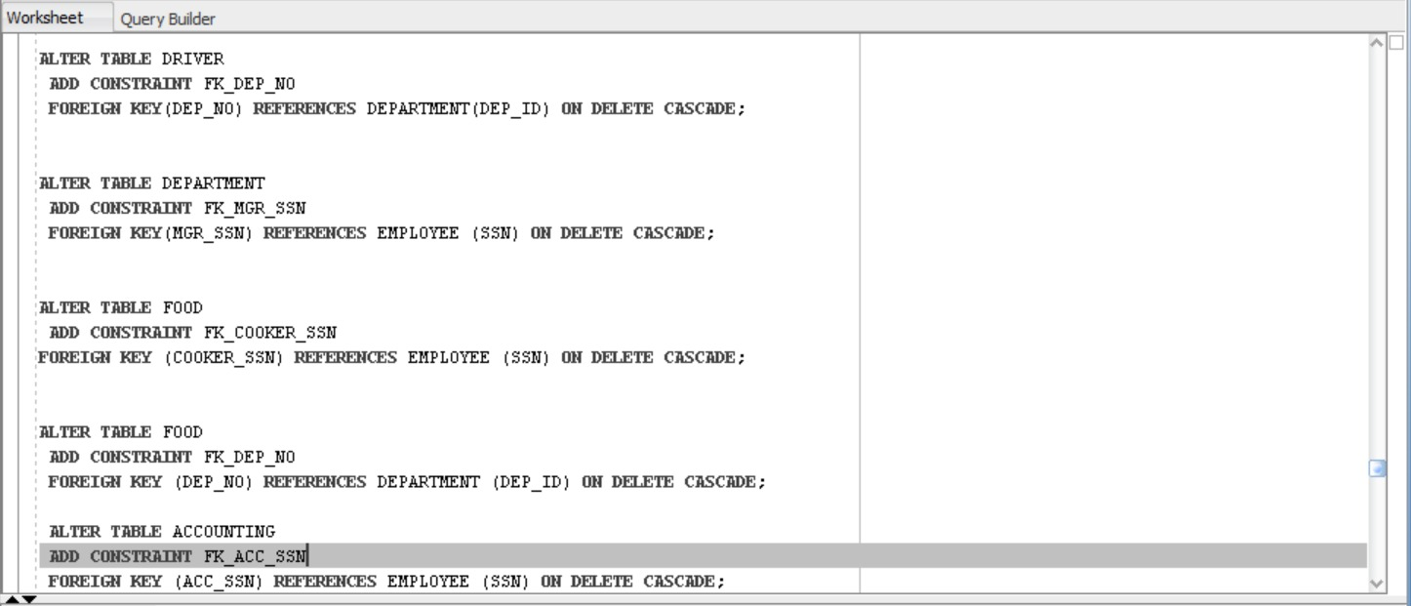

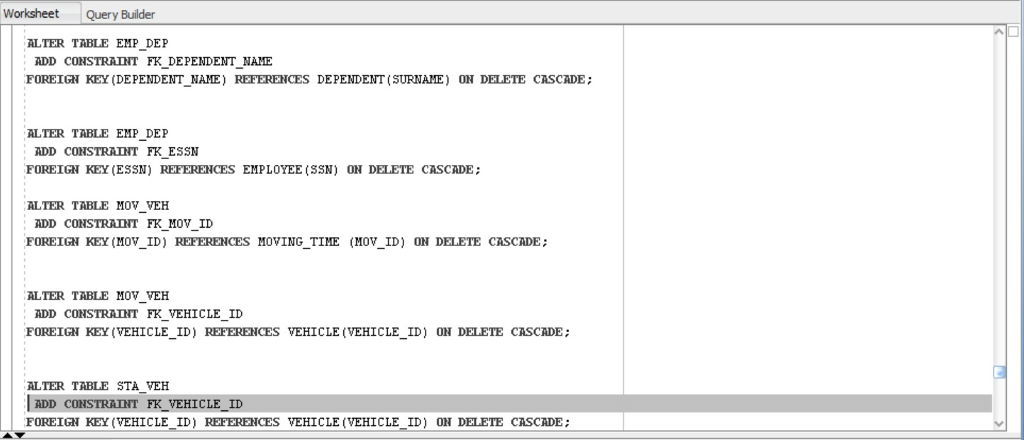

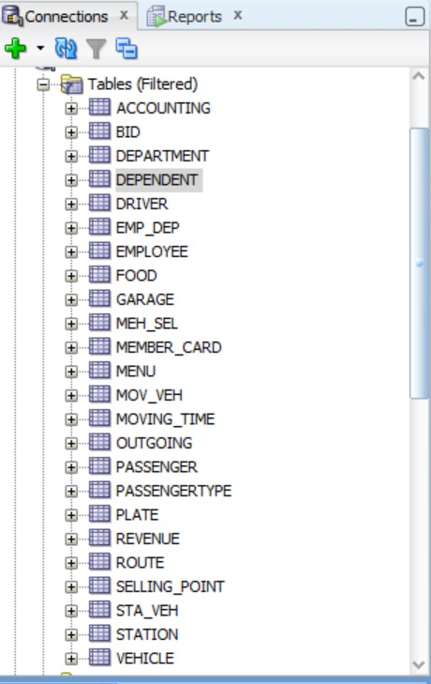

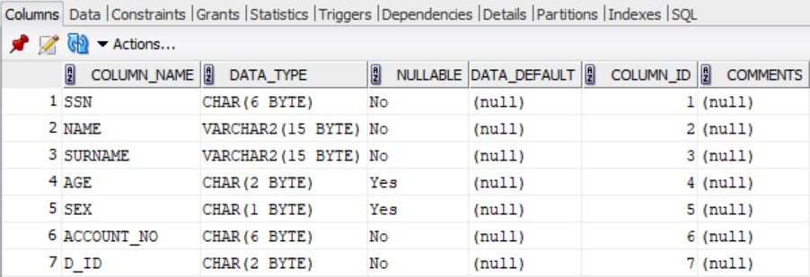

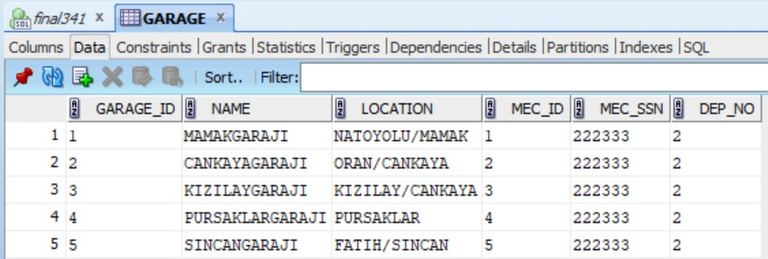

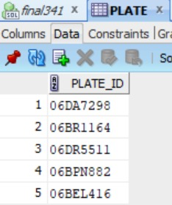

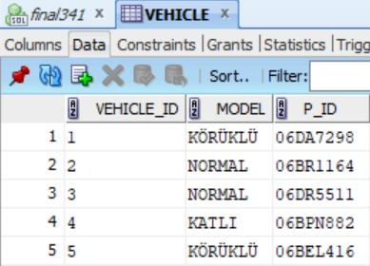

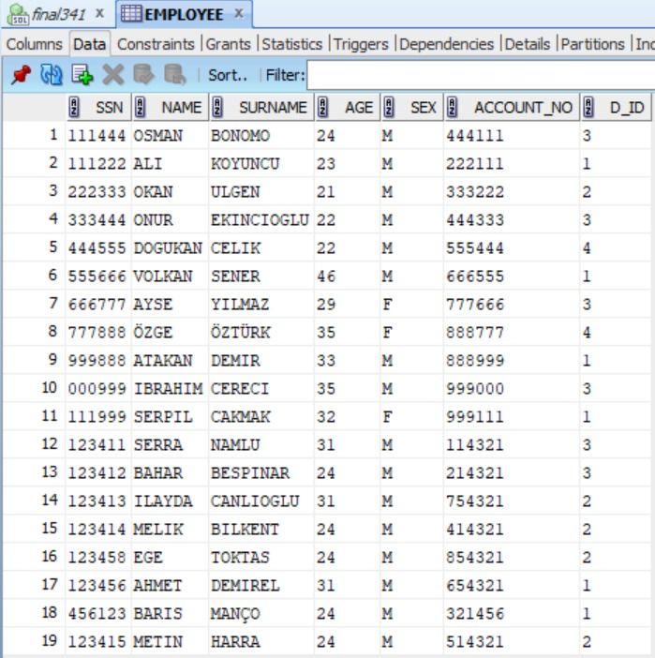

**5.3. Query Design**

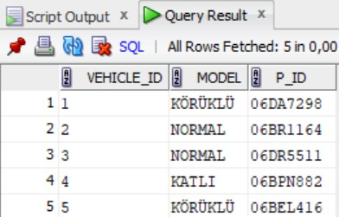

C:\Users\OKAN\Music\Desktop\48b7bf7e-6f7f-4bad-a600-72ed9865ef10.jpg

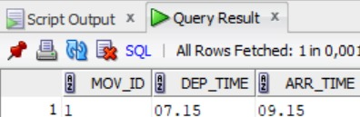

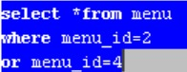

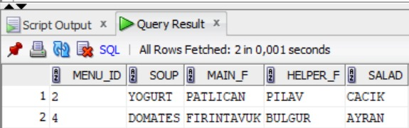



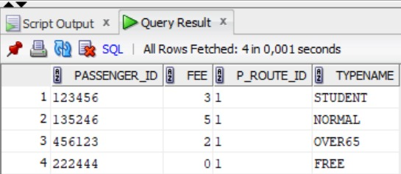

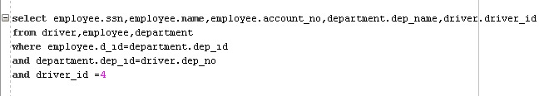

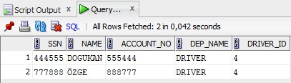

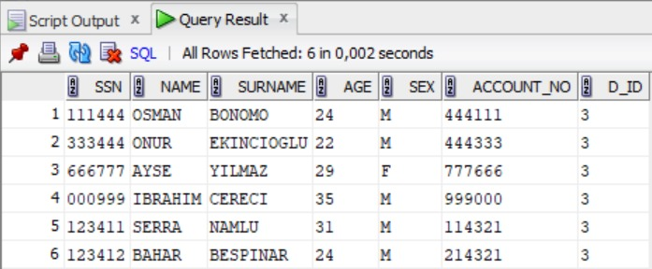

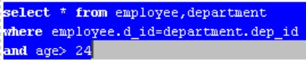

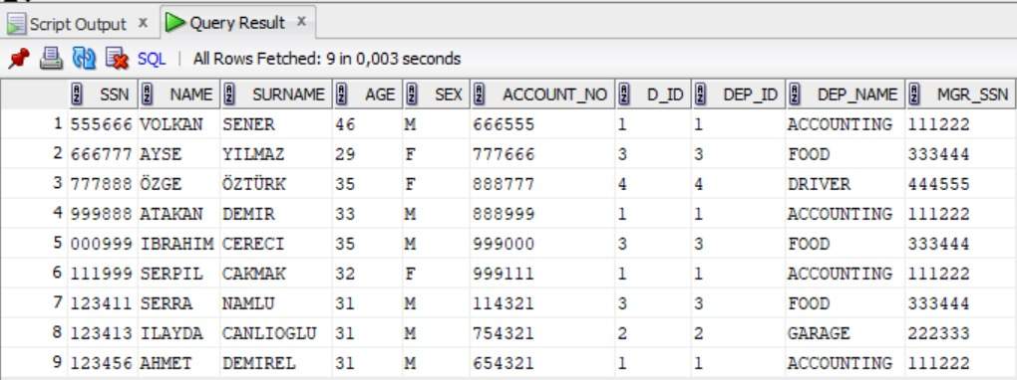

C:\Users\OKAN\Music\Desktop\68aaf242-0901-457f-bcdd-0201e99767f5.jpg

CREATE TABLE EMPLOYEE

(

SSN CHAR(6) NOT null,

NAME VARCHAR(15) NOT null,

SURNAME VARCHAR(15) NOT null,

AGE CHAR(2),

SEX CHAR,

ACCOUNT_NO CHAR(6)NOT null,

UNIQUE (ACCOUNT_NO),

D_ID CHAR(2) NOT NULL,

prımary key (SSN)

);

CREATE TABLE DEPARTMENT

(

DEP_ID CHAR(2) NOT NULL,

DEP_NAME VARCHAR(15) NOT NULL,

MGR_SSN CHAR(6) NOT NULL,

PRIMARY KEY (DEP_ID),

UNIQUE (DEP_NAME)

);

CREATE TABLE DRIVER

(

DRIVER_ID CHAR(6) NOT NULL,

D_SSN CHAR(6) NOT NULL,

DEP_NO CHAR(2) NOT NULL,

D_VEHICLE_ID CHAR(9) NOT NULL,

PRIMARY KEY (DRIVER_ID)

);

CREATE TABLE GARAGE(

GARAGE_ID CHAR(6) NOT NULL,

NAME VARCHAR(15) NOT NULL,

LOCATION VARCHAR(50),

MEC_ID CHAR(2) NOT NULL,

MEC_SSN CHAR(6) NOT NULL,

DEP_NO CHAR(2) NOT NULL,

PRIMARY KEY(GARAGE_ID)

);

CREATE TABLE FOOD(

COOKER_ID CHAR(6) NOT NULL,

COOKER_SSN CHAR(6) NOT NULL,

DEP_NO CHAR(2) NOT NULL,

F_MENU_ID CHAR(6) NOT NULL,

PRIMARY KEY(COOKER_ID)

);

CREATE TABLE BID

(

BID_ID CHAR(6) NOT NULL,

FOOD DECIMAL(10,2),

BUS DECIMAL(10,2),

PRIMARY KEY(BID_ID)

);

CREATE TABLE ACCOUNTING(

ACCOUNTANT_ID CHAR(6) NOT NULL,

ACC_SSN CHAR(6) NOT NULL,

B_ID CHAR(6) NOT NULL,

DEP_NO CHAR(2) NOT NULL,

PRIMARY KEY (ACCOUNTANT_ID)

);

CREATE TABLE REVENUE(

VOYAGE_INCOME VARCHAR(15),

BID_INCOME DECIMAL(10,2),

PAYMENT DECIMAL(10,2),

ACC_ID CHAR(6)

);

CREATE TABLE OUTGOING(

SALARY DECIMAL(10,2) NOT NULL,

FUEL DECIMAL(10,2),

TAX DECIMAL(10,2) NOT NULL,

MEINTENANCE_EXPENSE DECIMAL(10,2),

ACC_ID CHAR(6)

);

CREATE TABLE MENU(

MENU_ID CHAR(6) NOT NULL,

DDATE DATE,

SOUP VARCHAR(15),

MAIN_F VARCHAR(15),

HELPER_F VARCHAR(15),

SALAD VARCHAR(15),

PRIMARY KEY(MENU_ID)

);

CREATE TABLE PLATE(

PLATE_ID CHAR(9),

PRIMARY KEY (PLATE_ID)

);

CREATE TABLE VEHICLE(

VEHICLE_ID CHAR(6) NOT NULL,

MODEL VARCHAR(15),

P_ID CHAR(9) NOT NULL,

PRIMARY KEY(VEHICLE_ID)

);

CREATE TABLE STATION(

STATION_ID CHAR(6) NOT NULL,

NAME VARCHAR(15),

LOCATION VARCHAR(50),

S_ROUTE_ID CHAR(6),

PRIMARY KEY (STATION_ID)

);

CREATE TABLE ROUTE(

ROUTE_ID CHAR(6) NOT NULL,

NAME VARCHAR(15),

PRICE DECIMAL(10,2),

F_GARAGE_ID CHAR(6) NOT NULL,

PRIMARY KEY (ROUTE_ID)

);

CREATE TABLE PASSENGER(

PASSENGER_ID CHAR(6),

FEE DECIMAL(10,2),

P_ROUTE_ID CHAR(6),

P_TYPE_ID CHAR(2),

PRIMARY KEY(PASSENGER_ID)

);

CREATE TABLE PASSENGERTYPE(

TYPE_ID CHAR(6) NOT NULL,

TYPENAME VARCHAR(15) NOT NULL,

PRIMARY KEY(TYPE_ID)

);

CREATE TABLE MEMBER_CARD(

CARD_ID CHAR(6) NOT NULL,

M_TYPE_ID CHAR(6) NOT NULL,

PRIMARY KEY(CARD_ID)

);

CREATE TABLE SELLING_POINT(

SEL_ID CHAR(6) NOT NULL,

LOCATION VARCHAR(50) NOT NULL,

PRIMARY KEY(SEL_ID)

);

CREATE TABLE DEPENDENT(

NAME VARCHAR(15) NOT NULL,

SURNAME VARCHAR(15),

SEX CHAR,

RELATIONSHIP VARCHAR(15) NOT NULL

);

ALTER TABLE DEPENDENT

ADD CONSTRAINT PK_NAME

PRIMARY KEY (NAME);

CREATE TABLE EMP_DEP(

ESSN CHAR(6) NOT NULL,

DEPENDENT_NAME VARCHAR(15)

);

CREATE TABLE MOVING_TIME(

MOV_ID CHAR(6),

DEP_TIME CHAR(6),

ARR_TIME CHAR(6),

PRIMARY KEY(MOV_ID)

);

CREATE TABLE MOV_VEH(

MOV_ID CHAR(6),

VEHICLE_ID CHAR(6)

);

CREATE TABLE STA_VEH(

STATION_ID CHAR(6),

VEHICLE_ID CHAR(6)

);

CREATE TABLE MEH_SEL(

SEL_ID CHAR(6),

CARD_ID CHAR(6)

);

INSERT INTO EMPLOYEE(SSN,NAME,SURNAME,AGE,SEX,ACCOUNT_NO,D_ID)

VALUES ('111222','ALİ','KOYUNCU','23','M','222111','1');

INSERT INTO EMPLOYEE(SSN,NAME,SURNAME,AGE,SEX,ACCOUNT_NO,D_ID)

VALUES ('222333','OKAN','ULGEN','21','M','333222','2');

INSERT INTO EMPLOYEE(SSN,NAME,SURNAME,AGE,SEX,ACCOUNT_NO,D_ID)

VALUES ('333444','ONUR','EKINCIOGLU','22','M','444333','3');

INSERT INTO EMPLOYEE(SSN,NAME,SURNAME,AGE,SEX,ACCOUNT_NO,D_ID)

VALUES ('444555','DOGUKAN','CELIK','22','M','555444','4');

INSERT INTO EMPLOYEE(SSN,NAME,SURNAME,AGE,SEX,ACCOUNT_NO,D_ID)

VALUES ('555666','VOLKAN','ŞENER','46','M','666555','1');

INSERT INTO EMPLOYEE(SSN,NAME,SURNAME,AGE,SEX,ACCOUNT_NO,D_ID)

VALUES ('666777','AYŞE','YILMAZ','29','F','777666','3');

INSERT INTO EMPLOYEE(SSN,NAME,SURNAME,AGE,SEX,ACCOUNT_NO,D_ID)

VALUES ('777888','ÖZGE','ÖZTÜRK','35','F','888777','4');

INSERT INTO EMPLOYEE(SSN,NAME,SURNAME,AGE,SEX,ACCOUNT_NO,D_ID)

VALUES ('999888','ATAKAN','DEMIR','33','M','888999','1');

INSERT INTO EMPLOYEE(SSN,NAME,SURNAME,AGE,SEX,ACCOUNT_NO,D_ID)

VALUES ('000999','IBRAHIM','CERECI','35','M','999000','3');

INSERT INTO EMPLOYEE(SSN,NAME,SURNAME,AGE,SEX,ACCOUNT_NO,D_ID)

VALUES ('111222','ALİ','KOYUNCU','23','M','222111','1');

INSERT INTO EMPLOYEE(SSN,NAME,SURNAME,AGE,SEX,ACCOUNT_NO,D_ID)

VALUES ('222333','OKAN','ULGEN','21','M','333222','2');

INSERT INTO EMPLOYEE(SSN,NAME,SURNAME,AGE,SEX,ACCOUNT_NO,D_ID)

VALUES ('333444','ONUR','EKINCIOGLU','22','M','444333','3');

INSERT INTO EMPLOYEE(SSN,NAME,SURNAME,AGE,SEX,ACCOUNT_NO,D_ID)

VALUES ('444555','DOGUKAN','CELIK','22','M','555444','4');

INSERT INTO EMPLOYEE(SSN,NAME,SURNAME,AGE,SEX,ACCOUNT_NO,D_ID)

VALUES ('555666','VOLKAN','ŞENER','46','M','666555','1');

INSERT INTO EMPLOYEE(SSN,NAME,SURNAME,AGE,SEX,ACCOUNT_NO,D_ID)

VALUES ('666777','AYŞE','YILMAZ','29','F','777666','3');

INSERT INTO EMPLOYEE(SSN,NAME,SURNAME,AGE,SEX,ACCOUNT_NO,D_ID)

VALUES ('777888','ÖZGE','ÖZTÜRK','35','F','888777','4');

INSERT INTO EMPLOYEE(SSN,NAME,SURNAME,AGE,SEX,ACCOUNT_NO,D_ID)

VALUES ('999888','ATAKAN','DEMIR','33','M','888999','1');

INSERT INTO EMPLOYEE(SSN,NAME,SURNAME,AGE,SEX,ACCOUNT_NO,D_ID)

VALUES ('111999','SERPIL','CAKMAK','32','F','999111','1');

INSERT INTO EMPLOYEE(SSN,NAME,SURNAME,AGE,SEX,ACCOUNT_NO,D_ID)

VALUES ('123411','SERRA','NAMLU','31','M','114321','3');

INSERT INTO EMPLOYEE(SSN,NAME,SURNAME,AGE,SEX,ACCOUNT_NO,D_ID)

VALUES ('123412','BAHAR','BEŞPINAR','24','M','214321','3');

INSERT INTO EMPLOYEE(SSN,NAME,SURNAME,AGE,SEX,ACCOUNT_NO,D_ID)

VALUES ('123413','İLAYDA','CANLIOĞLU','31','M','754321','2');

INSERT INTO EMPLOYEE(SSN,NAME,SURNAME,AGE,SEX,ACCOUNT_NO,D_ID)

VALUES ('123414','MELİK','BİLKENT','24','M','414321','2');

INSERT INTO EMPLOYEE(SSN,NAME,SURNAME,AGE,SEX,ACCOUNT_NO,D_ID)

VALUES ('123457','DORUK','DOĞAN','31','M','754321','2');

INSERT INTO EMPLOYEE(SSN,NAME,SURNAME,AGE,SEX,ACCOUNT_NO,D_ID)

VALUES ('123458','EGE','TOKTAŞ','24','M','854321','2');

INSERT INTO EMPLOYEE(SSN,NAME,SURNAME,AGE,SEX,ACCOUNT_NO,D_ID)

VALUES ('123456','AHMET','DEMİREL','31','M','654321','1');

INSERT INTO EMPLOYEE(SSN,NAME,SURNAME,AGE,SEX,ACCOUNT_NO,D_ID)

VALUES ('456123','BARIŞ','MANÇO','24','M','321456','1');

INSERT INTO EMPLOYEE(SSN,NAME,SURNAME,AGE,SEX,ACCOUNT_NO,D_ID)

VALUES ('123457','DORUK','DOĞAN','31','M','754321','1');

INSERT INTO EMPLOYEE(SSN,NAME,SURNAME,AGE,SEX,ACCOUNT_NO,D_ID)

VALUES ('123415','METİN','HARRA','24','M','514321','2');

INSERT INTO EMPLOYEE(SSN,NAME,SURNAME,AGE,SEX,ACCOUNT_NO,D_ID)

VALUES ('123415','METİN','HARRA','24','M','514321','2');

INSERT INTO DEPARTMENT(DEP_ID,DEP_NAME,MGR_SSN)

VALUES('1','ACCOUNTING','111222');

INSERT INTO DEPARTMENT(DEP_ID,DEP_NAME,MGR_SSN)

VALUES('2','GARAGE','222333');

INSERT INTO DEPARTMENT(DEP_ID,DEP_NAME,MGR_SSN)

VALUES('3','FOOD','333444');

INSERT INTO DEPARTMENT(DEP_ID,DEP_NAME,MGR_SSN)

VALUES('4','DRIVER','444555');

INSERT INTO DRIVER(DRIVER_ID,D_SSN,DEP_NO,D_VEHICLE_ID)

VALUES('1','555666','4','1');

INSERT INTO DRIVER(DRIVER_ID,D_SSN,DEP_NO,D_VEHICLE_ID)

VALUES('2','666777','4','2');

INSERT INTO DRIVER(DRIVER_ID,D_SSN,DEP_NO,D_VEHICLE_ID)

VALUES('3','777888','4','3');

INSERT INTO DRIVER(DRIVER_ID,D_SSN,DEP_NO,D_VEHICLE_ID)

VALUES('4','888999','4','4');

INSERT INTO DRIVER(DRIVER_ID,D_SSN,DEP_NO,D_VEHICLE_ID)

VALUES('5','444555','4','5');

INSERT INTO GARAGE(GARAGE_ID,NAME,LOCATION,MEC_ID,MEC_SSN,DEP_NO)

VALUES('1','MAMAKGARAJI','NATOYOLU/MAMAK','1','333222','2');

UPDATE GARAGE

SET MEC_SSN='123413'

WHERE 'GARAGE_ID'='KIZILAYGARAJI';

INSERT INTO GARAGE(GARAGE_ID,NAME,LOCATION,MEC_ID,MEC_SSN,DEP_NO)

VALUES('2','CANKAYAGARAJI','ORAN/CANKAYA','2','754321','2');

INSERT INTO GARAGE(GARAGE_ID,NAME,LOCATION,MEC_ID,MEC_SSN,DEP_NO)

VALUES('3','KIZILAYGARAJI','KIZILAY/CANKAYA','3','414321','2');

INSERT INTO GARAGE(GARAGE_ID,NAME,LOCATION,MEC_ID,MEC_SSN,DEP_NO)

VALUES('4','PURSAKLARGARAJI','PURSAKLAR','4','514321','2');

INSERT INTO GARAGE(GARAGE_ID,NAME,LOCATION,MEC_ID,MEC_SSN,DEP_NO)

VALUES('5','SINCANGARAJI','FATIH/SINCAN','5','854321','2');

INSERT INTO FOOD(COOKER_ID,COOKER_SSN,DEP_NO,F_MENU_ID)

VALUES('1','444333','3','1');

INSERT INTO FOOD(COOKER_ID,COOKER_SSN,DEP_NO,F_MENU_ID)

VALUES('2','999000','3','2');

INSERT INTO FOOD(COOKER_ID,COOKER_SSN,DEP_NO,F_MENU_ID)

VALUES('3','114321','3','3');

INSERT INTO FOOD(COOKER_ID,COOKER_SSN,DEP_NO,F_MENU_ID)

VALUES('4','214321','3','4');

INSERT INTO FOOD(COOKER_ID,COOKER_SSN,DEP_NO,F_MENU_ID)

VALUES('5','111444','3','5');

INSERT INTO BID(BID_ID,FOOD,BUS)

VALUES('1','50000','0');

INSERT INTO BID(BID_ID,FOOD,BUS)

VALUES('2','0','700000');

INSERT INTO BID(BID_ID,FOOD,BUS)

VALUES('3','10000','0');

INSERT INTO BID(BID_ID,FOOD,BUS)

VALUES('4','75000','0');

INSERT INTO ACCOUNTING(ACCOUNTANT_ID, ACC_SSN,B_ID,DEP_NO)

VALUES('1','222111','1','1');

INSERT INTO ACCOUNTING(ACCOUNTANT_ID, ACC_SSN,B_ID,DEP_NO)

VALUES('2','666555','2','1');

INSERT INTO ACCOUNTING(ACCOUNTANT_ID, ACC_SSN,B_ID,DEP_NO)

VALUES('3','888999','3','1');

INSERT INTO ACCOUNTING(ACCOUNTANT_ID, ACC_SSN,B_ID,DEP_NO)

VALUES('4','999111','4','1');

INSERT INTO ACCOUNTING(ACCOUNTANT_ID, ACC_SSN,B_ID,DEP_NO)

VALUES('5','654321','5','1');

INSERT INTO REVENUE(VOYAGE_INCOME,BID_INCOME,PAYMENT,ACC_ID)

VALUES('500','7500','20000','1');

INSERT INTO REVENUE(VOYAGE_INCOME,BID_INCOME,PAYMENT,ACC_ID)

VALUES('2500','1000','15000','2');

INSERT INTO REVENUE(VOYAGE_INCOME,BID_INCOME,PAYMENT,ACC_ID)

VALUES('70000','25000','15000','3');

INSERT INTO REVENUE(VOYAGE_INCOME,BID_INCOME,PAYMENT,ACC_ID)

VALUES('25000','23000','700000','4');

INSERT INTO REVENUE(VOYAGE_INCOME,BID_INCOME,PAYMENT,ACC_ID)

VALUES('33000','255000','2000','5');

INSERT INTO OUTGOING(SALARY,FUEL,TAX,MEINTENANCE_EXPENSE,ACC_ID)

VALUES('60000','10000','2500','1000','1');

INSERT INTO OUTGOING(SALARY,FUEL,TAX,MEINTENANCE_EXPENSE,ACC_ID)

VALUES('60000','10000','2500','1000','2');

INSERT INTO OUTGOING(SALARY,FUEL,TAX,MEINTENANCE_EXPENSE,ACC_ID)

VALUES('60000','10000','2500','1000','3');

INSERT INTO OUTGOING(SALARY,FUEL,TAX,MEINTENANCE_EXPENSE,ACC_ID)

VALUES('60000','10000','2500','1000','4');

INSERT INTO OUTGOING(SALARY,FUEL,TAX,MEINTENANCE_EXPENSE,ACC_ID)

VALUES('60000','10000','2500','1000','5');

INSERT INTO MENU(MENU_ID,DDATE,SOUP,MAIN_F,HELPER_F,SALAD)

VALUES('1','SALI','MERCIMEK','KABAKDOLMASI','MAKARNA','COBAN');

INSERT INTO MENU(MENU_ID,DDATE,SOUP,MAIN_F,HELPER_F,SALAD)

VALUES('2','PAZARTESI','YOGURT','PATLICAN','PILAV','CACIK');

INSERT INTO MENU(MENU_ID,DDATE,SOUP,MAIN_F,HELPER_F,SALAD)

VALUES('3','CARSAMBA','EZOGELIN','ISPANAK','YOGURT','MEVSIM');

INSERT INTO MENU(MENU_ID,DDATE,SOUP,MAIN_F,HELPER_F,SALAD)

VALUES('4','PERSEMBE','DOMATES','FIRINTAVUK','BULGUR','AYRAN');

INSERT INTO MENU(MENU_ID,DDATE,SOUP,MAIN_F,HELPER_F,SALAD)

VALUES('5','CUMA','MERCIMEK','KAVURMA','PILAV','TATLI');

INSERT INTO PLATE(PLATE_ID)

VALUES('06DA7298');

INSERT INTO PLATE(PLATE_ID)

VALUES('06BR1164');

INSERT INTO PLATE(PLATE_ID)

VALUES('06DR5511');

INSERT INTO PLATE(PLATE_ID)

VALUES('06BPN882');

INSERT INTO PLATE(PLATE_ID)

VALUES('06BEL416');

INSERT INTO VEHICLE(VEHICLE_ID,MODEL,P_ID)

VALUES('1','KÖRÜKLÜ','06DA7298');

INSERT INTO VEHICLE(VEHICLE_ID,MODEL,P_ID)

VALUES('2','NORMAL','06BR1164');

INSERT INTO VEHICLE(VEHICLE_ID,MODEL,P_ID)

VALUES('3','NORMAL','06DR5511');

INSERT INTO VEHICLE(VEHICLE_ID,MODEL,P_ID)

VALUES('4','KATLI','06BPN882');

INSERT INTO VEHICLE(VEHICLE_ID,MODEL,P_ID)

VALUES('5','KÖRÜKLÜ','06BEL416');

INSERT INTO STATION(STATION_ID,NAME,LOCATION,S_ROUTE_ID)

VALUES('11550','NATAVEGA','MAMAK','1');

INSERT INTO STATION(STATION_ID,NAME,LOCATION,S_ROUTE_ID)

VALUES('11551','NATOYOLU','MAMAK','1');

INSERT INTO STATION(STATION_ID,NAME,LOCATION,S_ROUTE_ID)

VALUES('11552','ABIDINPASA','MAMAK','1');

INSERT INTO STATION(STATION_ID,NAME,LOCATION,S_ROUTE_ID)

VALUES('11553','DIKIMEVI','CANKAYA','1');

INSERT INTO STATION(STATION_ID,NAME,LOCATION,S_ROUTE_ID)

VALUES('11554','KOLEJ','CANKAYA','1');

INSERT INTO STATION(STATION_ID,NAME,LOCATION,S_ROUTE_ID)

VALUES('11555','KIZILAY','CANKAYA','1');

INSERT INTO ROUTE(ROUTE_ID,NAME,PRICE,F_GARAGE_ID)

VALUES('1','MAMAK1',3,'1');

INSERT INTO PASSENGER(passenger_ıd,fee,P_ROUTE_ID,P_TYPE_ID)

VALUES('123456','3','1','1');

INSERT INTO PASSENGER(passenger_ıd,fee,P_ROUTE_ID,P_TYPE_ID)

VALUES('135246','5','1','2');

INSERT INTO PASSENGER(passenger_ıd,fee,P_ROUTE_ID,P_TYPE_ID)

VALUES('456123','2','1','3');

INSERT INTO PASSENGER(passenger_ıd,fee,P_ROUTE_ID,P_TYPE_ID)

VALUES('222444','0','1','4');

INSERT INTO PASSENGERTYPE(type_ıd,typename)

VALUES('1','STUDENT');

INSERT INTO PASSENGERTYPE(type_ıd,typename)

VALUES('2','NORMAL');

INSERT INTO PASSENGERTYPE(type_ıd,typename)

VALUES('3','OVER65');

INSERT INTO PASSENGERTYPE(type_ıd,typename)

VALUES('4','FREE');

INSERT INTO MEMBER_CARD(card_ıd,m_type_ıd)

VALUES('123456','1');

INSERT INTO MEMBER_CARD(card_ıd,m_type_ıd)

VALUES('135246','2');

INSERT INTO MEMBER_CARD(card_ıd,m_type_ıd)

VALUES('456123','3');

INSERT INTO MEMBER_CARD(card_ıd,m_type_ıd)

VALUES('222444','4');

INSERT INTO SELLING_POINT(sel_ıd,locatıon)

VALUES('1','MAMAK');

INSERT INTO SELLING_POINT(sel_ıd,locatıon)

VALUES('2','BATIKENT');

INSERT INTO SELLING_POINT(sel_ıd,locatıon)

VALUES('3','KECIOREN');

INSERT INTO SELLING_POINT(sel_ıd,locatıon)

VALUES('4','SINCAN');

INSERT INTO SELLING_POINT(sel_ıd,locatıon)

VALUES('5','GOLBASI');

INSERT INTO DEPENDENT(name,surname,SEX,RELATIONSHIP)

VALUES('ALI','CELIK','M','BROTHER');

INSERT INTO DEPENDENT(name,surname,SEX,RELATIONSHIP)

VALUES('ONUR','ULGEN','M','BROTHER');

INSERT INTO DEPENDENT(name,surname,SEX,RELATIONSHIP)

VALUES('DOGUKAN','EKINCIOGLU','M','BROTHER');

INSERT INTO DEPENDENT(name,surname,SEX,RELATIONSHIP)

VALUES('OKAN','KOYUNCU','M','BROTHER');

INSERT INTO MOVING_TIME(mov_ıd,dep_tıme,ARR_TIME)

VALUES('1','07.15','09.15');

INSERT INTO MOVING_TIME(mov_ıd,dep_tıme,ARR_TIME)

VALUES('2','07.45','09.45');

INSERT INTO MOVING_TIME(mov_ıd,dep_tıme,ARR_TIME)

VALUES('3','08.30','11.00');

INSERT INTO EMP_DEP(ESSN,dependent_name)

VALUES('111222','KOYUNCU');

INSERT INTO EMP_DEP(ESSN,dependent_name)

VALUES('222333','ULGEN');

INSERT INTO EMP_DEP(ESSN,dependent_name)

VALUES('333444','EKINCIOGLU');

INSERT INTO EMP_DEP(ESSN,dependent_name)

VALUES('444555','CELIK');

INSERT INTO MOV_VEH(MOV_ID,VEHICLE_ID)

VALUES('1','1');

INSERT INTO MOV_VEH(MOV_ID,VEHICLE_ID)

VALUES('2','2');

INSERT INTO MOV_VEH(MOV_ID,VEHICLE_ID)

VALUES('3','3');

INSERT INTO STA_VEH(STATION_ID,VEHICLE_ID)

VALUES('11550','1');

INSERT INTO STA_VEH(STATION_ID,VEHICLE_ID)

VALUES('11553','3');

INSERT INTO STA_VEH(STATION_ID,VEHICLE_ID)

VALUES('11555','5');

INSERT INTO MEH_SEL(card_ıd,sel_ıd)

VALUES('123456','1');

INSERT INTO MEH_SEL(card_ıd,sel_ıd)

VALUES('135246','2');

INSERT INTO MEH_SEL(card_ıd,sel_ıd)

VALUES('456123','3');

ALTER TABLE GARAGE

ADD CONSTRAINT FK_MEC_SSN

FOREIGN KEY (MEC_SSN) REFERENCES EMPLOYEE(SSN) ;

ALTER TABLE GARAGE

ADD CONSTRAINT FK_DEP_NO

FOREIGN KEY (DEP_NO) REFERENCES DEPARTMENT(DEP_ID) ON DELETE CASCADE;

ALTER TABLE DRIVER

ADD CONSTRAINT FK_D_SSN

FOREIGN KEY (D_SSN) REFERENCES EMPLOYEE(SSN) ON DELETE CASCADE;

ALTER TABLE DRIVER

ADD CONSTRAINT FK_DEP_NO

FOREIGN KEY(DEP_NO) REFERENCES DEPARTMENT(DEP_ID) ON DELETE CASCADE;

ALTER TABLE DEPARTMENT

ADD CONSTRAINT FK_MGR_SSN

FOREIGN KEY(MGR_SSN) REFERENCES EMPLOYEE (SSN) ON DELETE CASCADE;

ALTER TABLE FOOD

ADD CONSTRAINT FK_COOKER_SSN

FOREIGN KEY (COOKER_SSN) REFERENCES EMPLOYEE (SSN) ON DELETE CASCADE;

ALTER TABLE FOOD

ADD CONSTRAINT FK_DEP_NO

FOREIGN KEY (DEP_NO) REFERENCES DEPARTMENT (DEP_ID) ON DELETE CASCADE;

ALTER TABLE ACCOUNTING

ADD CONSTRAINT FK_ACC_SSN

FOREIGN KEY (ACC_SSN) REFERENCES EMPLOYEE (SSN) ON DELETE CASCADE;

ALTER TABLE ACCOUNTING

ADD CONSTRAINT FK_B_ID

FOREIGN KEY (B_ID) REFERENCES BID(BID_ID) ON DELETE CASCADE;

ALTER TABLE ACCOUNTING

ADD CONSTRAINT FK_DEP_NO

FOREIGN KEY (DEP_NO) REFERENCES DEPARTMENT (DEP_ID) ON DELETE CASCADE;

ALTER TABLE REVENUE

ADD CONSTRAINT FK_ACC_ID

FOREIGN KEY(ACC_ID) REFERENCES ACCOUNTING (ACCOUNTANT_ID) ON DELETE CASCADE;

ALTER TABLE OUTGOING

ADD CONSTRAINT FK_ACC_ID

FOREIGN KEY(ACC_ID) REFERENCES ACCOUNTING (ACCOUNTANT_ID) ON DELETE CASCADE;

ALTER TABLE VEHICLE

ADD CONSTRAINT FK_P_ID

FOREIGN KEY(P_ID) REFERENCES PLATE(PLATE_ID) ON DELETE CASCADE;

ALTER TABLE ROUTE

ADD CONSTRAINT FK_F_GARAGE_ID

FOREIGN KEY (F_GARAGE_ID) REFERENCES GARAGE(GARAGE_ID) ON DELETE CASCADE;

ALTER TABLE PASSENGER

ADD CONSTRAINT FK_P_ROUTE_ID

FOREIGN KEY (P_ROUTE_ID) REFERENCES ROUTE(ROUTE_ID) ON DELETE CASCADE;

ALTER TABLE MEMBER_CARD

ADD CONSTRAINT FK_M_TYPE_ID

FOREIGN KEY (M_TYPE_ID) REFERENCES PASSENGERTYPE(TYPE_ID) ON DELETE CASCADE;

ALTER TABLE EMP_DEP

ADD CONSTRAINT FK_DEPENDENT_NAME

FOREIGN KEY(DEPENDENT_NAME) REFERENCES DEPENDENT(SURNAME) ON DELETE CASCADE;

ALTER TABLE EMP_DEP

ADD CONSTRAINT FK_ESSN

FOREIGN KEY(ESSN) REFERENCES EMPLOYEE(SSN) ON DELETE CASCADE;

ALTER TABLE MOV_VEH

ADD CONSTRAINT FK_MOV_ID

FOREIGN KEY(MOV_ID) REFERENCES MOVING_TIME (MOV_ID) ON DELETE CASCADE;

ALTER TABLE MOV_VEH

ADD CONSTRAINT FK_VEHICLE_ID

FOREIGN KEY(VEHICLE_ID) REFERENCES VEHICLE(VEHICLE_ID) ON DELETE CASCADE;

ALTER TABLE STA_VEH

ADD CONSTRAINT FK_VEHICLE_ID

FOREIGN KEY(VEHICLE_ID) REFERENCES VEHICLE(VEHICLE_ID) ON DELETE CASCADE;

ALTER TABLE STA_VEH

ADD CONSTRAINT FK_STATION_ID

FOREIGN KEY(STATION_ID) REFERENCES STATION(STATION_ID) ON DELETE CASCADE;

ALTER TABLE MEH_SEL

ADD CONSTRAINT FK_SEL_ID

FOREIGN KEY(SEL_ID) REFERENCES SELLING_POINT(SEL_ID) ON DELETE CASCADE;

ALTER TABLE MEH_SEL

ADD CONSTRAINT FK_CARD_ID

FOREIGN KEY(CARD_ID) REFERENCES MEMBER_CARD(CARD_ID) ON DELETE CASCADE;

ALTER TABLE EMPLOYEE

ADD CONSTRAINT FK_D_ID

FOREIGN KEY (D_ID) REFERENCES DEPARTMENT (DEP_ID) ON DELETE CASCADE;

ALTER TABLE DRIVER

ADD CONSTRAINT FK_D_VEHICLE_ID

FOREIGN KEY (D_VEHICLE_ID) REFERENCES VEHICLE (VEHICLE_ID) ON DELETE CASCADE;

ALTER TABLE FOOD

ADD CONSTRAINT FK_F_MENU_ID

FOREIGN KEY (F_MENU_ID) REFERENCES MENU (MENU_ID) ON DELETE CASCADE;

ALTER TABLE STATION

ADD CONSTRAINT FK_S_ROUTE_ID

FOREIGN KEY (S_ROUTE_ID) REFERENCES ROUTE (ROUTE_ID) ON DELETE CASCADE;

ALTER TABLE PASSENGER

ADD CONSTRAINT FK_P_TYPE_ID

FOREIGN KEY (P_TYPE_ID) REFERENCES PASSENGERTYPE (TYPE_ID) ON DELETE CASCADE;

ALTER TABLE MENU

DROP COLUMN DDATE;

ALTER TABLE MENU

ADD DDATE VARCHAR(15);

UPDATE EMPLOYEE

SET D_ID='4'

WHERE SSN='555666';

UPDATE EMPLOYEE

SET D_ID='4'

WHERE SSN='999888';

ALTER TABLE GARAGE

ADD CONSTRAINT FK_DEP_NO4

FOREIGN KEY (DEP_NO) REFERENCES DEPARTMENT(DEP_ID) ON DELETE CASCADE;

ALTER TABLE ACCOUNTING

ADD CONSTRAINT FK_DEP_NO1

FOREIGN KEY (DEP_NO) REFERENCES DEPARTMENT (DEP_ID) ENABLE;

ALTER TABLE FOOD

ADD CONSTRAINT FK_DEP_NO5

FOREIGN KEY (DEP_NO) REFERENCES DEPARTMENT (DEP_ID) ON DELETE CASCADE;

ALTER TABLE OUTGOING

ADD CONSTRAINT FK_ACC_ID3

FOREIGN KEY(ACC_ID) REFERENCES ACCOUNTING (ACCOUNTANT_ID) ON DELETE CASCADE;

ALTER TABLE DRIVER

ADD CONSTRAINT FK_D_SSN

FOREIGN KEY (D_SSN) REFERENCES EMPLOYEE(SSN) ON DELETE CASCADE;

select passenger.passenger_id,passenger.fee,passengertype.typename,member_card.card_id,selling_point.location

from passenger,passengertype,member_card,selling_point,meh_sel

where passenger.p_type_ıd=passengertype.type_ıd

and passengertype.type_ıd=member_card.m_type_ıd

and member_card.card_ıd=meh_sel.card_id

and meh_sel.card_id=selling_point.sel_ıd

select * from employee where d_id= 3

select * from employee,department

where employee.d_id=department.dep_id

and age> 24

select vehicle.vehicle_id,vehicle.model,vehicle.p_id from vehicle,plate

where plate.plate_id=vehicle.p_id

select * from moving_time

where dep_time='07.15'

select *from menu

where menu_id=2

or menu_id=4

select passenger.passenger_id,passenger.fee,passenger.p_route_id,passengertype.typename

from passenger,passengertype

where passengertype.type_id=passenger.p_type_id

6. INTERFACE

**6.1. Screenshots**

