**ATILIM UNIVERSITY**

**DEPARTMENT OF COMPUTER ENGINEERING**

**COMPE 325 – STUDY OF PROGRAMMING LANGUAGES**

**HOMEWORK III**

**Instructor:** Çiğdem Turhan

**Assistants**: Gizem Altınay –Tuğçe Kaman

**Due Date:** Jan. 18, 2021, 23:30

Write a program in Python to be used in a dart game which calculates whether a thrown dart hits the dart board.

A dart will be shown with x and y coordinates represented as a tuple (x,y). Randomly, create 10 tuples for 10 darts thrown and store them in a list.

The program should show if the dart hits the board or not as true or false.

The radius of the dart board is accepted as 11. (radius=11)(center=(0,0))

The distance between the dart and the center of the board is going to be calculated, according to the formula given below:

$distance=\sqrt{({{\text{x}}_{1}}^{2}\text{-}{{\text{x}}_{2}}^{2}\text{)+}({{\text{y}}_{1}}^{2}\text{-}{{\text{y}}_{2}}^{2}\text{) }}$

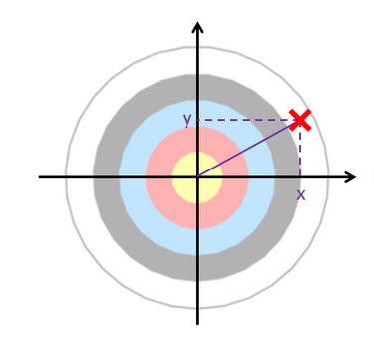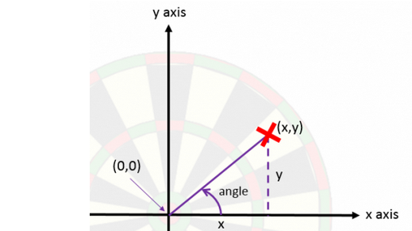

Then, determine whether the dart hits the board and output the following:

If distance > radius, “Outside of the dart board!” and Result: False

If distance < radius, “Hit the board!” and Result: True

For our program, we will be using the following scoring system:

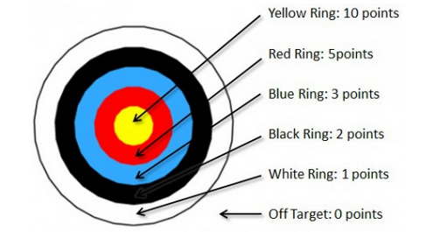

(Create your tuple for scores)

With the calculated distance, we can then decide the scores by using the following criteria:

* Distance between 0 – 3 (Yellow Ring) => 10 points
* Distance between 4 – 7 (Red Ring) => 5 points
* Distance between 8 – 11 (Blue Ring) => 3 points
* Distance between 12 – 15 (Black Ring) => 2 points
* Distance between 16 – 19 (White Ring) => 1 point
* Distance above 19 (Off Target) => 0 point

Finally, output your total score.

1. Write your program using loops.

**Sample Output:**

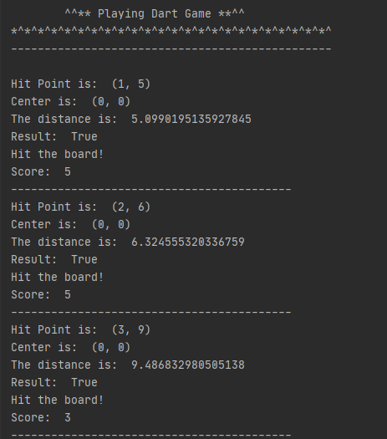

1. Modify your program by using map function, no loops.

**Sample Output:**

