PagerAdapter
1：FragmentPagerAdapter
Implementation of PagerAdapter that represents each page as a Fragment that is persistently kept in the fragment manager as long as the user can return to the page.
This version of the pager is best for use when there are a handful of typically more static fragments to be paged through, such as a set of tabs. The fragment of each page the user visits will be kept in memory, though its view hierarchy may be destroyed when not visible. This can result in using a significant amount of memory since fragment instances can hold on to an arbitrary amount of state. For larger sets of pages, considerFragmentStatePagerAdapter.
When using FragmentPagerAdapter the host ViewPager must have a valid ID set.
Subclasses only need to implement getItem(int) and getCount() to have a working adapter.
2：FragmentStatePagerAdapter
Implementation of PagerAdapter that uses a Fragment to manage each page. This class also handles saving and restoring of fragment's state.
This version of the pager is more useful when there are a large number of pages, working more like a list view. When pages are not visible to the user, their entire fragment may be destroyed, only keeping the saved state of that fragment. This allows the pager to hold on to much less memory associated with each visited page as compared to FragmentPagerAdapter at the cost of potentially more overhead when switching between pages.
When using FragmentPagerAdapter the host ViewPager must have a valid ID set.
Subclasses only need to implement getItem(int) and getCount() to have a working adapter.
3：PagerTitltStrip
效果图：

PagerTitleStrip上也可以滑动，点击title没反应。
布局如下，只要在pageradapter或其子类中实现getPageTitle()即可。
<android.support.v4.view.ViewPager
xmlns:android="http://schemas.android.com/apk/res/android"
android:id="@+id/pager"
android:layout_width="match_parent"
android:layout_height="match_parent">
<android.support.v4.view.PagerTitleStrip
android:id="@+id/pager_title_strip"
android:layout_width="match_parent"
android:layout_height="wrap_content"
android:layout_gravity="top"
android:background="#33b5e5"
android:textColor="#fff"
android:paddingTop="4dp"
android:paddingBottom="4dp" />
</android.support.v4.view.ViewPager>

4：PagerTabStrip
效果图：
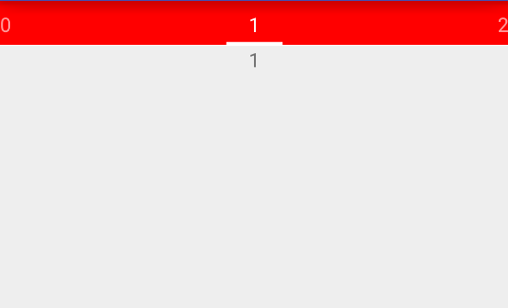
PagerTabStrip上也可以晃动，点击title有效果。
布局以及使用同PagerTitleStrip。

