Struts
1、加入包
获取路径：struts-2.3.24\apps\struts2-blank\WEB-INF\lib
2、配置web.xml如下：
<?xml version="1.0" encoding="UTF-8"?>
<web-app xmlns:xsi="http://www.w3.org/2001/XMLSchema-instance"
xmlns="http://xmlns.jcp.org/xml/ns/javaee"
xsi:schemaLocation="http://xmlns.jcp.org/xml/ns/javaee http://xmlns.jcp.org/xml/ns/javaee/web-app_3_1.xsd"
id="WebApp_ID" version="3.1">

<display-name>Chat</display-name>

<filter>
<filter-name>struts2</filter-name>
<filter-class>org.apache.struts2.dispatcher.ng.filter.StrutsPrepareAndExecuteFilter</filter-class>
</filter>

<filter-mapping>
<filter-name>struts2</filter-name>
<url-pattern>/*</url-pattern>
</filter-mapping>

<welcome-file-list>
<welcome-file>index.html</welcome-file>
</welcome-file-list>

<!-- Restricts access to pure JSP files - access available only via Struts
action -->
<security-constraint>
<display-name>No direct JSP access</display-name>
<web-resource-collection>
<web-resource-name>No-JSP</web-resource-name>
<url-pattern>*.jsp</url-pattern>
</web-resource-collection>
<auth-constraint>
<role-name>no-users</role-name>
</auth-constraint>
</security-constraint>

<security-role>
<description>Don't assign users to this role</description>
<role-name>no-users</role-name>
</security-role>
</web-app>

3、配置struts.xml：
<?xml version="1.0" encoding="UTF-8" ?>
<!DOCTYPE struts PUBLIC
"-//Apache Software Foundation//DTD Struts Configuration 2.3//EN"
"http://struts.apache.org/dtds/struts-2.3.dtd">

<struts>

<constant name="struts.action.extension" value="action,,"></constant>
<constant name="struts.devMode" value="true"></constant>
<constant name="struts.enable.DynamicMethodInvocation" value="true"></constant>

<package name="default" namespace="/" extends="struts-default">
<action name="test1" class="com.example.action.TestAction01">
<result>/index.jsp</result>
</action>
</package>

</struts>

4、配置文件作用解释：
1、web.xml:
<filter-name>struts2</filter-name>
<filter-class>org.apache.struts2.dispatcher.ng.filter.StrutsPrepareAndExecuteFilter</filter-class>
</filter>

<filter-mapping>
<filter-name>struts2</filter-name>
<url-pattern>/*</url-pattern>
</filter-mapping>
将收到的请求过滤到struts处理，“/*”即过滤所有，把所有请求都让struts处理。
2、struts.xml：
<constant name="struts.action.extension" value="action,,"></constant>请求扩展名
<constant name="struts.devMode" value="true"></constant>调试模式
<constant name="struts.enable.DynamicMethodInvocation" value="true"></constant>5可按形如：test!add访问

action格式1：name请求名，class请求处理类，method请求调用类中的什么方法，
<result>：name根据调用方法返回值调用相应的result，type：跳转方式：
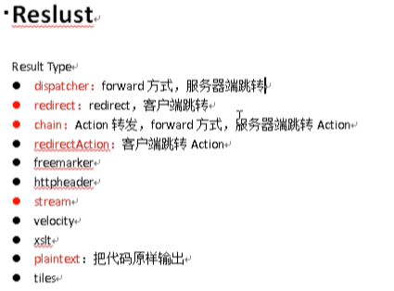
<action name="test1" class="com.example.action.TestAction01" method=”add”>
<result>/index.jsp</result>
</action>
action格式2：
<action name =”*_*” class=”com.example.action.{1}Action02” method=”{2}”>
<result>/{2}.jsp</result>
</action>

5、参数映射：
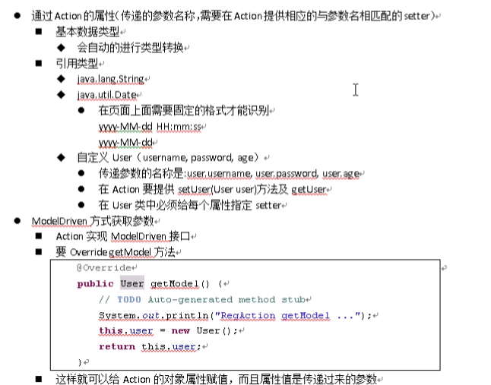

6、ActionSupport中获取request,response,session,application：
方式一：
public class TestAction01 extends ActionSupport {
private Map<String, Object> request;
private Map<String, Object> session;
private Map<String, Object> application;

public TestAction01() {
// TODO Auto-generated constructor stub
this.request = (Map<String, Object>) ActionContext.getContext().get("request");
this.session = ActionContext.getContext().getSession();
this.application= ActionContext.getContext().getApplication();
}

@Override
public String execute() throws Exception {
// TODO Auto-generated method stub
System.out.println("TestAction01 execute...");
request.put("reqAttr", "reqDirect");
session.put("sessionAttr", "sessionDirect");
application.put("applicationAttr", "applicationDirect");
return super.execute();
}
}
方式二：
public class TestAction03 extends ActionSupport {

private HttpServletRequest request;
private HttpServletResponse response;
private HttpSession session;
private ServletContext application;

public TestAction03() {
// TODO Auto-generated constructor stub
this.request = ServletActionContext.getRequest();
this.response = ServletActionContext.getResponse();
this.session = this.request.getSession();
this.application = ServletActionContext.getServletContext();
}

@Override
public String execute() throws Exception {
// TODO Auto-generated method stub
System.out.println("TestAction01 execute...");
this.request.setAttribute("reqAttr", "reqDirect");
this.request.setAttribute("sessionAttr", "sessionDirect");
this.request.setAttribute("applicationAttr", "applicationDirect");
PrintWriter out = this.response.getWriter();
out.write("responseAttr:responseDirect");
out.flush();
//out.close();
return super.execute();
}
}
方式三：
public class TestAction02 extends ActionSupport implements RequestAware, SessionAware, ApplicationAware{
private Map<String, Object> request;
private Map<String, Object> session;
private Map<String, Object> application;

public TestAction02() {
// TODO Auto-generated constructor stub
}

@Override
public String execute() throws Exception {
// TODO Auto-generated method stub
System.out.println("TestAction01 execute...");
request.put("reqAttr", "reqDirect");
session.put("sessionAttr", "sessionDirect");
application.put("applicationAttr", "applicationDirect");
return super.execute();
}

@Override
public void setApplication(Map<String, Object> application) {
// TODO Auto-generated method stub
this.application = application;
}

@Override
public void setSession(Map<String, Object> session) {
// TODO Auto-generated method stub
this.session = session;
}

@Override
public void setRequest(Map<String, Object> request) {
// TODO Auto-generated method stub
this.request = request;
}
}

5、注意点：
1、每次请求都会创建一个ActionSupport，所以是线程安全的。
2、action匹配：调用和action名称最接近的action
3、struts赋值不讲究参数顺序

6、问题解决
1、乱码解决：
