xmpp
1、A chat message can be of any of the five types defined in RFC 3921. Note that an app can only receive two types of messages:
- chat messages via /_ah/xmpp/message/chat/
- normal messages via /_ah/xmpp/message/chat/

2、通过MessageBuilder构建Message，见下图：
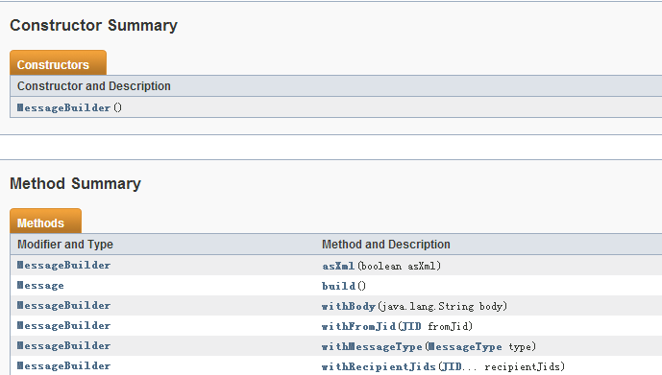
3、Message类详情如下图：
