ABS | 丙烯腈丁二烯苯乙烯共聚 |  | Acrylonitrile-butadiene-styrene
BR | 顺丁橡胶
CN | 硝化纤维素 |  | Cellulose nitrate
CPE | 氯化聚乙烯 |  | Chlorinated polyethylene
EP | 环氧树脂 | 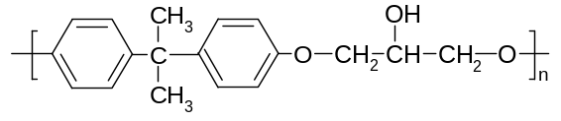 | Epoxy, epoxide
EPM | 乙烯-丙烯共聚物 | 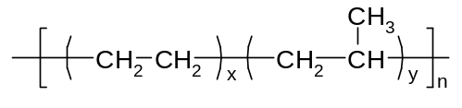 | Ethylene-propylene polymer
EVA | 乙烯-醋酸乙烯共聚物 | 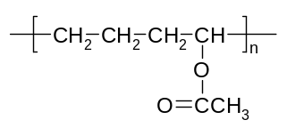 | Ethylene/vinyl acetate
HDPE | 高密度聚乙烯 | 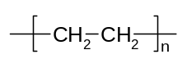 | High-density polyethylene plastics
HIPS | 高抗冲聚苯乙烯 | 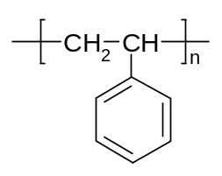 | High impact polystyrene
LCP | 液晶聚合物 |  | Liquid crystal polymer
LDPE | 低密度聚乙烯 |  | Low-density polyethylene plastics
LLDPE | 线性低密聚乙烯 |  | Linear low-density polyethylene
MF | 密胺-甲醛树脂 |  | Melamine-formaldehyde resin
NR | 天然橡胶 | 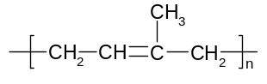 | Natural rubber
PA－mn | 聚酰胺(尼龙)、锦纶 | 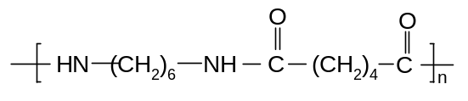 | Polyamide (nylon)
PAI | 聚酰胺-酰亚胺 |  | Polyamide-imide
PAN | 聚丙烯腈 | 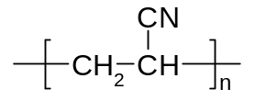 | Polyacrylonitrile
PB | 聚丁烯-[1] | 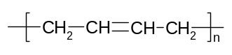 | Polybutene-1
PBT | 聚对苯二酸丁二(醇)酯 |  | Poly(butylene terephthalate)
PC | 聚碳酸酯 | 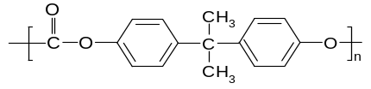 | Polycarbonate
PCTFE | 聚三氟氯乙烯 |  | Polychlorotrifluoroethylene
PE | 聚乙烯 |  | Polyethylene
PEEK | 聚醚醚酮 |  | Polyetheretherketone
PEO | 聚环氧乙烷 |  | Poly(ethylene oxide)
PES | 聚醚砜 |  | Poly(ether sulfone)
PET | 聚对苯二甲酸乙二(醇)酯  涤纶 | 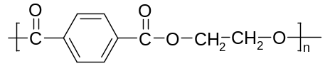 | Poly(ethylene terephthalate)
PF | 酚醛树脂 | 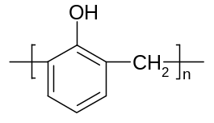 | Phenol-formaldehyde resin
PI | 聚酰亚胺 |  | Polyimide
PMMA | 聚甲基丙烯酸甲酯 | 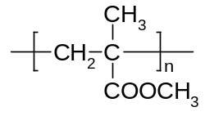 | Poly(methyl methacrylate)
POM | 聚甲醛 | 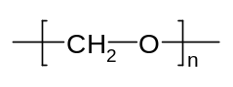 | Polyoxymethylene, polyacetal
PP | 聚丙烯 | 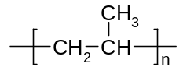 | Polypropylene
PPO | 聚苯醚 |  | Poly(phenylene oxide) deprecated
PPS | 聚苯硫醚 |  | Poly(phenylene sulfide)
PS | 聚苯乙烯 |  | Polystyrene
PSU | 聚砜 |  | Polysulfone
PTFE | 聚四氟乙烯 | 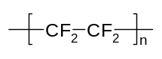 | Polytetrafluoroethylene
PUR | 聚氨酯 |  | Polyurethane
PVAC | 聚醋酸乙烯(酯) | 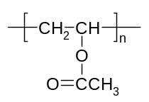 | Poly(vinyl acetate)
PVAl | 聚乙烯醇 | 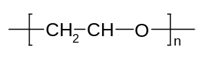 | Poly(vinyl alcohol)
PVB | 聚乙烯醇缩丁醛 |  | Poly(vinyl butyral)
PVC | 聚氯乙烯 | 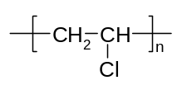 | Poly(vinyl chloride)
SBR | 丁苯橡胶(苯乙烯<25%) | 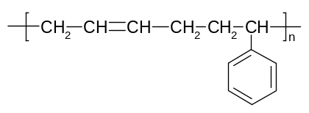 | Styrene butadiene rubber
SBS | 苯乙烯-丁二烯嵌段共聚 |  | Styrene-butadiene block copolymer
SiR | 聚硅氧烷 | 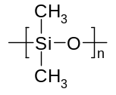 | Silicone rubber
PVDF | 聚偏二氟乙烯 | 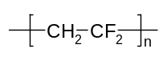 | Poly(vinylidene fluoride)
UF | 脲(甲)醛树脂 |  | Urea-formaldehyde resin
UHMWPE | 超高分子量聚乙烯 |  | Ultra-high molecular weight PE
UP | 不饱和聚酯 | 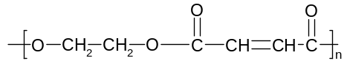 | Unsaturated polyester

