实验数据：

t/10s | P/Pa
1 | 0.0441
2 | 0.0414
3 | 0.041
4 | 0.0411
5 | 0.034
6 | 0.0306
7 | 0.0326
8 | 0.0257
9 | 0.026
10 | 0.0257
11 | 0.026
12 | 0.0285
13 | 0.024
14 | 0.0243
15 | 0.0265
16 | 0.0244
17 | 0.0256
18 | 0.0237
19 | 0.0232
20 | 0.0202
21 | 0.0209
22 | 0.0222
23 | 0.0261
24 | 0.0191
25 | 0.0166
26 | 0.0173
27 | 0.0155
28 | 0.0166
29 | 0.0151
30 | 0.0142
31 | 0.0154
32 | 0.0156
33 | 0.0178
34 | 0.0142
35 | 0.0139
36 | 0.0191
37 | 0.0133
38 | 0.013
39 | 0.0134
40 | 0.0127
41 | 0.0124
42 | 0.0133
43 | 0.0111
44 | 0.0123
45 | 0.0113
46 | 0.0113
47 | 0.0132
48 | 0.0113
49 | 0.0109
50 | 0.011
51 | 0.009
52 | 0.00107
53 | 0.00105
54 | 0.00108
55 | 0.00104
56 | 0.00106
57 | 0.00946
58 | 0.00948
59 | 0.0091
60 | 0.0092
61 | 0.009
62 | 0.00911
63 | 0.00249
64 | 0.00881
65 | 0.00893
66 | 0.00943
67 | 0.00877
68 | 0.00827
69 | 0.00906
70 | 0.00996
71 | 0.00893
72 | 0.00952
73 | 0.00922
74 | 0.00846
75 | 0.00949
76 | 0.00821
77 | 0.00842
78 | 0.0082
79 | 0.00736
80 | 0.00774
81 | 0.00773
82 | 0.00723
83 | 0.00785
84 | 0.00762
85 | 0.00895
86 | 0.00934
87 | 0.00758
88 | 0.00724
89 | 0.00751
90 | 0.00758
91 | 0.00789
92 | 0.00796
93 | 0.00671
94 | 0.00688
95 | 0.00703
96 | 0.00721
97 | 0.00754
98 | 0.00682
99 | 0.00756
100 | 0.00666

数据处理图：
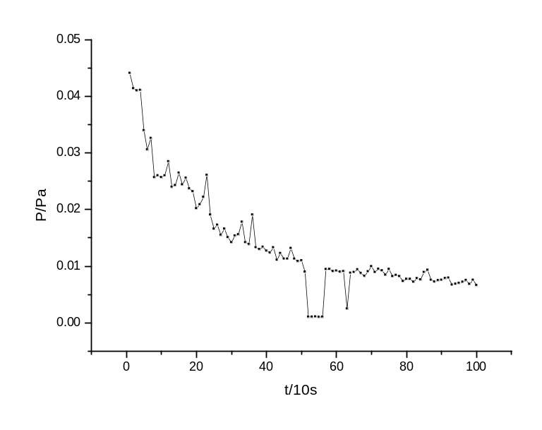
可以看出，随着时间的推移，真空泵中的压强逐渐震荡减小，真空度不断提高。
其原因是，机械泵工作的不连续性，使得气压波动很大。

