**Fixed Mindset:**

* Avoid challenges
* Give up easily
* Ignore useful negative feedback

**Growth Mindset:**

* Embrace challenges
* Learn criticism
* See effort as path of mastery

**Deep Learning:**

* Above the surface- Facts, Answers, and remember
* Below the surface- Big idea, Question, and Investigation

**Note making:**

* *Recognise* the main ideas
* *Decide* which information relevant
* *Use* your own words
* *Be brief*- use diagrams/mind map/flow charts
* *Record* details of the source

**Advantages of note making:**

* Sustain concentration
* Enhancing learning
* Build memory

**Methods of note making:**

Cornell style (Block):

* Divides the page into three chunks
  + Notes- Record lecture, Concise sentence and also abbreviations (during class)
  + Cues- Main ideas, questions that connect points, and diagrams (after class)
  + Summary- Top level main ideas for quick reference (after class)

Outline style (structured):

* 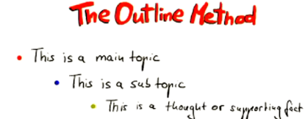Use numbers or bullet points to represent different topics and their subtopics it can include as much detail as in need

Table or charting style:

* Table style helps identify and compare information using grid format
* First Columns has the main concept
* Separate information into rows

Mapped style:

* Mapping is a visual approach to note-taking and can be used to integrate and process ideas as they develop
* 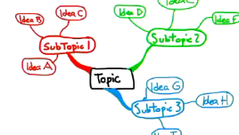Difficult to do during lecture because a speaker main be disorganized.

Sentence style (think what I do writing notes):

* Students record every new thought, fact or topic on a separate line.
* All information is recorded but it lacks clarification of major and minor topics.
* Immediate review is required and editing is required to organise notes

Decimal Line:

Thousands Hundreds Tens Units Ten**ths** Hundred**ths** Thousands**th**

Diving by decimal:

3.05 /5 =

*If you need to make 30 add an extra 0 in front.