1. C语言：内存分配---栈区、堆区、全局区、常量区和代码区

<https://blog.csdn.net/MQ0522/article/details/114823770>

1. 如果要交换实参的值，必须要传地址

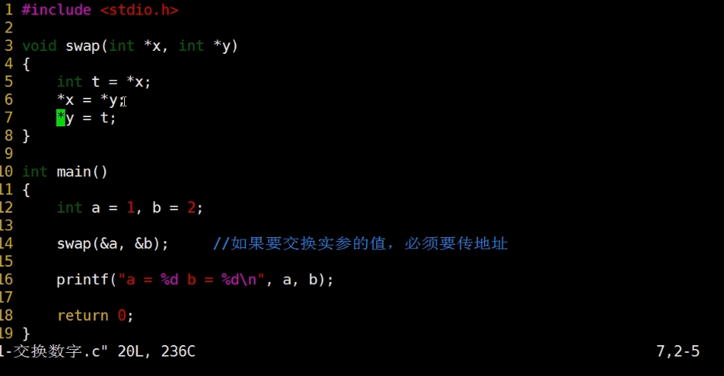

1. C语言：malloc函数用法

<https://blog.csdn.net/qq_42565910/article/details/90346236>

int main()

{

int *p = (int *)malloc(sizeof(int));

*p = 100;

free(p);

p = NULL;

return 0;

}

1. C语言右左法则：

<https://blog.csdn.net/newcong0123/article/details/51883352>

1. 数组指针与指针数组

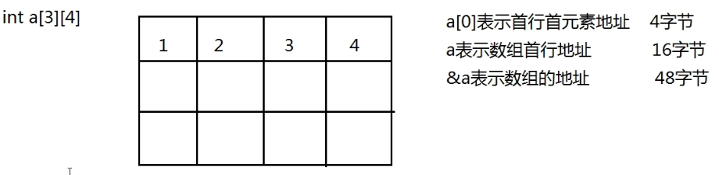

a[0]+1: 要加4个字节

a+1: 要加16个字节

&a: 要加48个字节

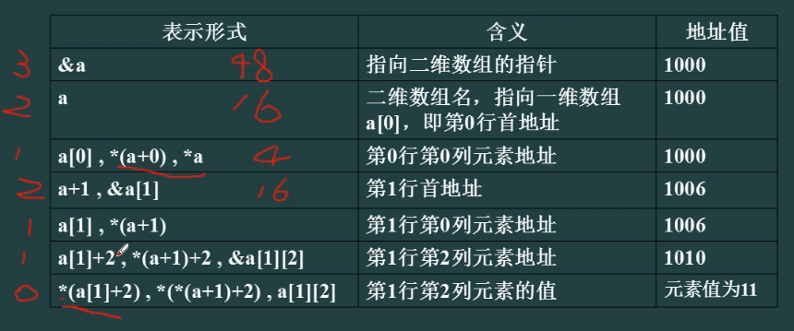

1，2，3对应一、二、三级地址

6、struct和typedef

1.struct student{

char name[10];

long PhoneNum;

char addr[20];

};

struct student stu1,stu2;

2.struct student{

char name[10];

long PhoneNum;

char addr[20];

}stu1,stu2;

3.typedef struct student{

char name[10];

long PhoneNum;

char addr[20];

}STU;

STU stu1,stu2;

7、typedef和define的区别

[(8条消息) define 与typedef的区别_typedef和define区别_编程小程的博客-CSDN博客](https://blog.csdn.net/qq_42795061/article/details/121691567?ops_request_misc=%257B%2522request%255Fid%2522%253A%2522168847800916800213040455%2522%252C%2522scm%2522%253A%252220140713.130102334..%2522%257D&request_id=168847800916800213040455&biz_id=0&utm_medium=distribute.pc_search_result.none-task-blog-2~all~top_positive~default-1-121691567-null-null.142%5ev88%5econtrol_2,239%5ev2%5einsert_chatgpt&utm_term=typedef%E5%92%8Cdefine%E5%8C%BA%E5%88%AB&spm=1018.2226.3001.4187)

一、struct和typedef

1.struct student{

char name[10];

long PhoneNum;

char addr[20];

};

struct student stu1,stu2;

2.struct student{

char name[10];

long PhoneNum;

char addr[20];

}stu1,stu2;

3.typedef struct student{

char name[10];

long PhoneNum;

char addr[20];

}STU;

STU stu1,stu2;

二、typedef和define的区别

[(8条消息) define 与typedef的区别_typedef和define区别_编程小程的博客-CSDN博客](https://blog.csdn.net/qq_42795061/article/details/121691567?ops_request_misc=%257B%2522request%255Fid%2522%253A%2522168847800916800213040455%2522%252C%2522scm%2522%253A%252220140713.130102334..%2522%257D&request_id=168847800916800213040455&biz_id=0&utm_medium=distribute.pc_search_result.none-task-blog-2~all~top_positive~default-1-121691567-null-null.142%5ev88%5econtrol_2,239%5ev2%5einsert_chatgpt&utm_term=typedef%E5%92%8Cdefine%E5%8C%BA%E5%88%AB&spm=1018.2226.3001.4187)