DeepPen-X
Rebuilding the IoV Security Boundary Around Autonomous Penetration Testing
DeepPen-X Technical White Paper

Abstract
According to the Upstream 2025 Global Automotive Cybersecurity Report, automotive-related CVEs surged from 24 in 2019 to 422 in 2024, with 979 publicly disclosed in total — vehicles have become one of the fastest-growing attack targets. Meanwhile, mainstream penetration approaches — manual bench testing, static scanners, and LLM-assisted review — all fail to produce verifiable conclusions.
DeepPen-X is a platform that rebuilds the IoV security boundary around autonomous penetration testing. Built on a deterministic evidence-gating architecture and a multi-agent collaborative closed loop, it forms an AI penetration-testing team capable of autonomously exploring attack surfaces, executing real attacks, and mining vulnerabilities on live vehicle devices — turning the manual pentester's craft into a replayable, auditable, and scalable automated campaign.
The platform holds one core principle: every vulnerability conclusion must carry proof. Every conclusion is anchored to artifact SHA-256 values, backed by a complete evidence trail, and must survive independent evidence adjudication before it stands — “inconclusive” is not an acceptable answer.
On production vehicle firmware and companion apps, DeepPen-X has dynamically discovered multiple classes of high-severity vulnerabilities through automated penetration testing, including hardcoded cloud credentials enabling fleet-wide data exposure, unauthenticated diagnostic and vehicle-control entry points, TLS certificate-validation bypasses, memory-safety defects in automotive protocol stacks, vulnerabilities in AI-powered vehicle-control features, and MQTT-protocol vehicle-control vulnerabilities.

Chapter 1 Overview

1.1 Platform Positioning
DeepPen-X targets IoV security testing by unifying “deterministic attack-surface recon + multi-agent autonomous penetration + independent evidence adjudication” into one closed-loop platform: the recon plane maps the attack surface completely, the penetration plane turns hypotheses into real vulnerabilities, and the adjudication plane guards the boundary of what counts as a conclusion.

1.2 Core Strengths at a Glance
- Three-plane architecture: strict separation across three planes — deterministic recon, multi-agent penetration, and independent adjudication — so discovery, verification, and judgment never overlap.
- Transactional reliability: every attack action is journaled before execution; crash recovery proceeds by side-effect class, and dangerous operations are never replayed automatically.
- Fully auditable: plans, tool calls, and rulings are persisted end to end; any conclusion can be replayed back to the raw tool output.
- Deterministic scoring: the unified scoring standard unified-risk-scoring-v1 guarantees that the same evidence always yields the same severity and score on repeated scans.
- Long-running autonomy: 24-hour active cycles, automatic device disconnect recovery, and safe continuation after context compaction support truly unattended long-running campaigns.
- Zero dependency supply chain: ELF deep analysis is built purely on the Python standard library — no IDA or Ghidra — behaves identically on macOS/Windows/Linux, and can be deployed in air-gapped environments.
- Data sovereignty: fully local deployment with no outbound data; tasks can be archived into standalone SQLite databases and shared separately without any credentials.
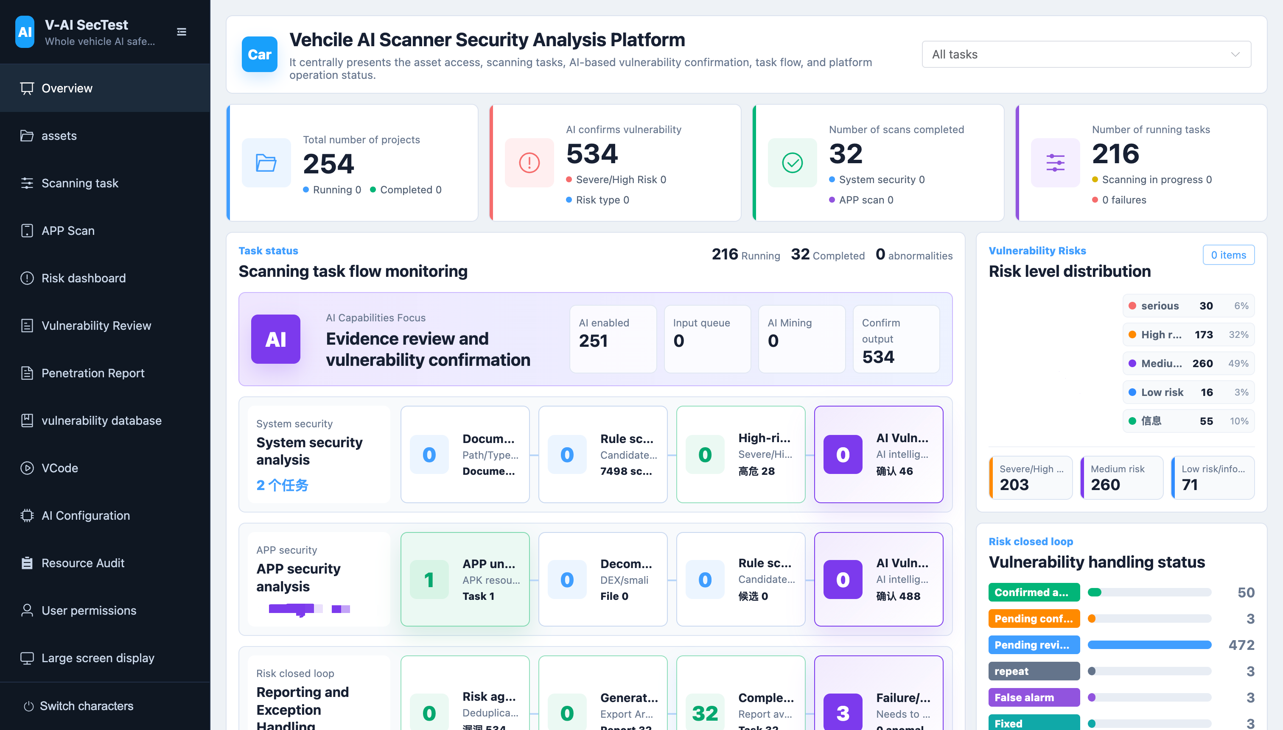

Chapter 2 Background and Challenges

2.1 The IoV Attack Surface and Industry Landscape
A modern vehicle is a distributed attack surface assembled from dozens of suppliers' Linux/QNX/Android ECUs, and the companion app has become a critical entry point into vehicle hardware: exposed services, hardcoded credentials, diagnostic entry points, and mobile-app exposure together form what a real attack bench looks like.
Industry data confirms the trend: automotive CVEs grew roughly 17x in five years (24 in 2019 to 422 in 2024), and attack vectors have shifted decisively from physical access toward remote and cloud entry points. The attack surface keeps expanding, while defenders' verification capability remains stuck in the era of “manual testing + scanners.”

2.2 Limitations of Existing Approaches
Approach | Fundamental limitation | Consequence
Manual bench penetration | Does not scale, cannot be replayed, leaves no auditable evidence | Conclusions are not reproducible; expertise leaves with people
Static scanners | No one can state the true-positive rate; findings remain “suspected” | Heavy manual triage; false positives and false negatives coexist
LLM-assisted review | Amplifies noise a hundredfold — a model can make any system() call read like an RCE | Conclusion credibility is further diluted

2.3 Design Goals
- Every claim is verifiable: evidence chains + hash anchoring + independent adjudication.
- Every action is replayable: plans, tool calls, and rulings are fully persisted.
- Every scan is reproducible: deterministic scoring — same evidence, same conclusion.
- Every campaign is scalable: from a single verification to 24-hour unattended penetration.

Chapter 3 Platform in Action

3.1 The Autonomous Penetration Kill-Chain Model
DeepPen-X abstracts a penetration campaign into five stages. The output of every stage is hash-anchored evidence, and no stage's conclusion may flow downstream without surviving independent adjudication:
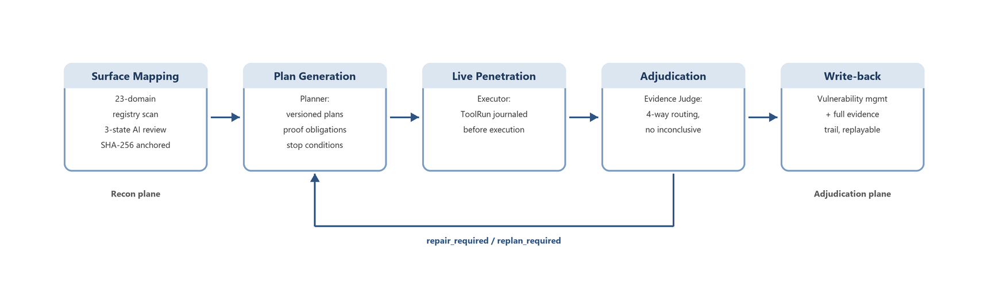

3.2 Case Study 1: One Instruction to Root Privilege Escalation (Fully Autonomous)
The auditor issues exactly one natural-language instruction, and nothing more:
“The adb device is connected. Find a way to escalate privileges to root and perform the escalation. All adb shell commands should be executed on the local machine, not in the target device's shell, unless absolutely necessary. Frida cannot be used; instead, analyze adbd, binary processes with root privileges, etc. Finally, provide me with a report.”

Stage 1: Surface Mapping (Recon)
The recon plane loads prioritized hypotheses anchored to artifact SHA-256 values with explicit confirm_requires checklists: an adbd process running with elevated privileges, and a candidate privileged helper binary whose input handling looks exploitable.

Stage 2: Plan Generation (Planner)
The Planner decomposes the objective into multiple escalation paths and emits an immutable, versioned plan with expected observables (the shell command id returning uid=0(root)) and explicit stop conditions. The operator's constraints are compiled into the plan: all adb shell commands run from the local machine, Frida is excluded, and analysis focuses on adbd and root-privileged binaries.

Stage 3: Live Penetration (Executor)
Facing the live device, the Executor connects over ADB from the host, enumerates and exercises the adbd attack surface, analyzes the privileged binary's interface, and drives the escalation path end to end until a root shell is obtained. Every attack action is journaled to the ToolRun ledger before execution. When the auditor force-kills the backend process mid-write, the platform recovers transactionally on restart: the interrupted non-idempotent write is marked unknown_side_effect, automatic replay is refused, and the campaign continues after reconciliation without replaying a single unsafe call.

Stage 4: Evidence Adjudication (Evidence Judge)
The Judge examines the claimed root escalation against raw tool results, finds the claim initially backed only by a prompt string, and routes to repair_required with a targeted directive: capture the actual id output and the complete escalation transcript. The Executor collects the evidence; the Judge accepts the finding.

Stage 5: Write-back and Reporting
The accepted finding is written back to vulnerability management transactionally, bound to the device fingerprint, with the complete evidence trail — attack plans, ToolRun ledger, Judge rulings — preserved for audit and replay. A structured report is then generated for the auditor.
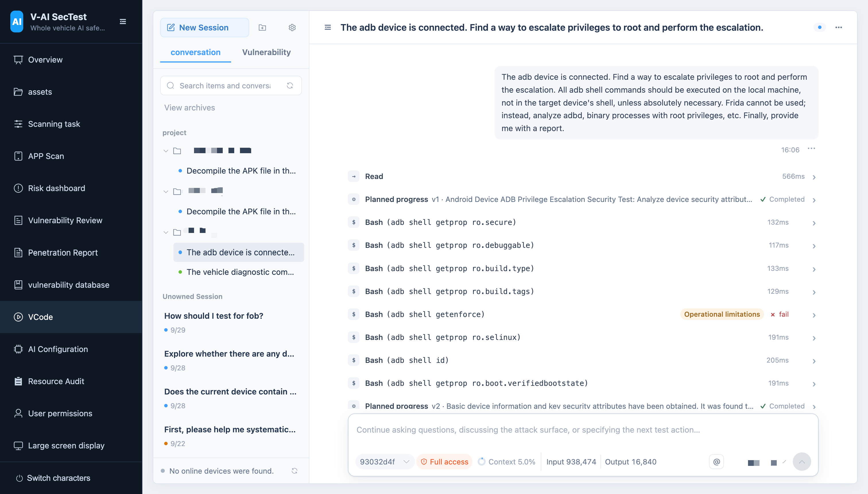
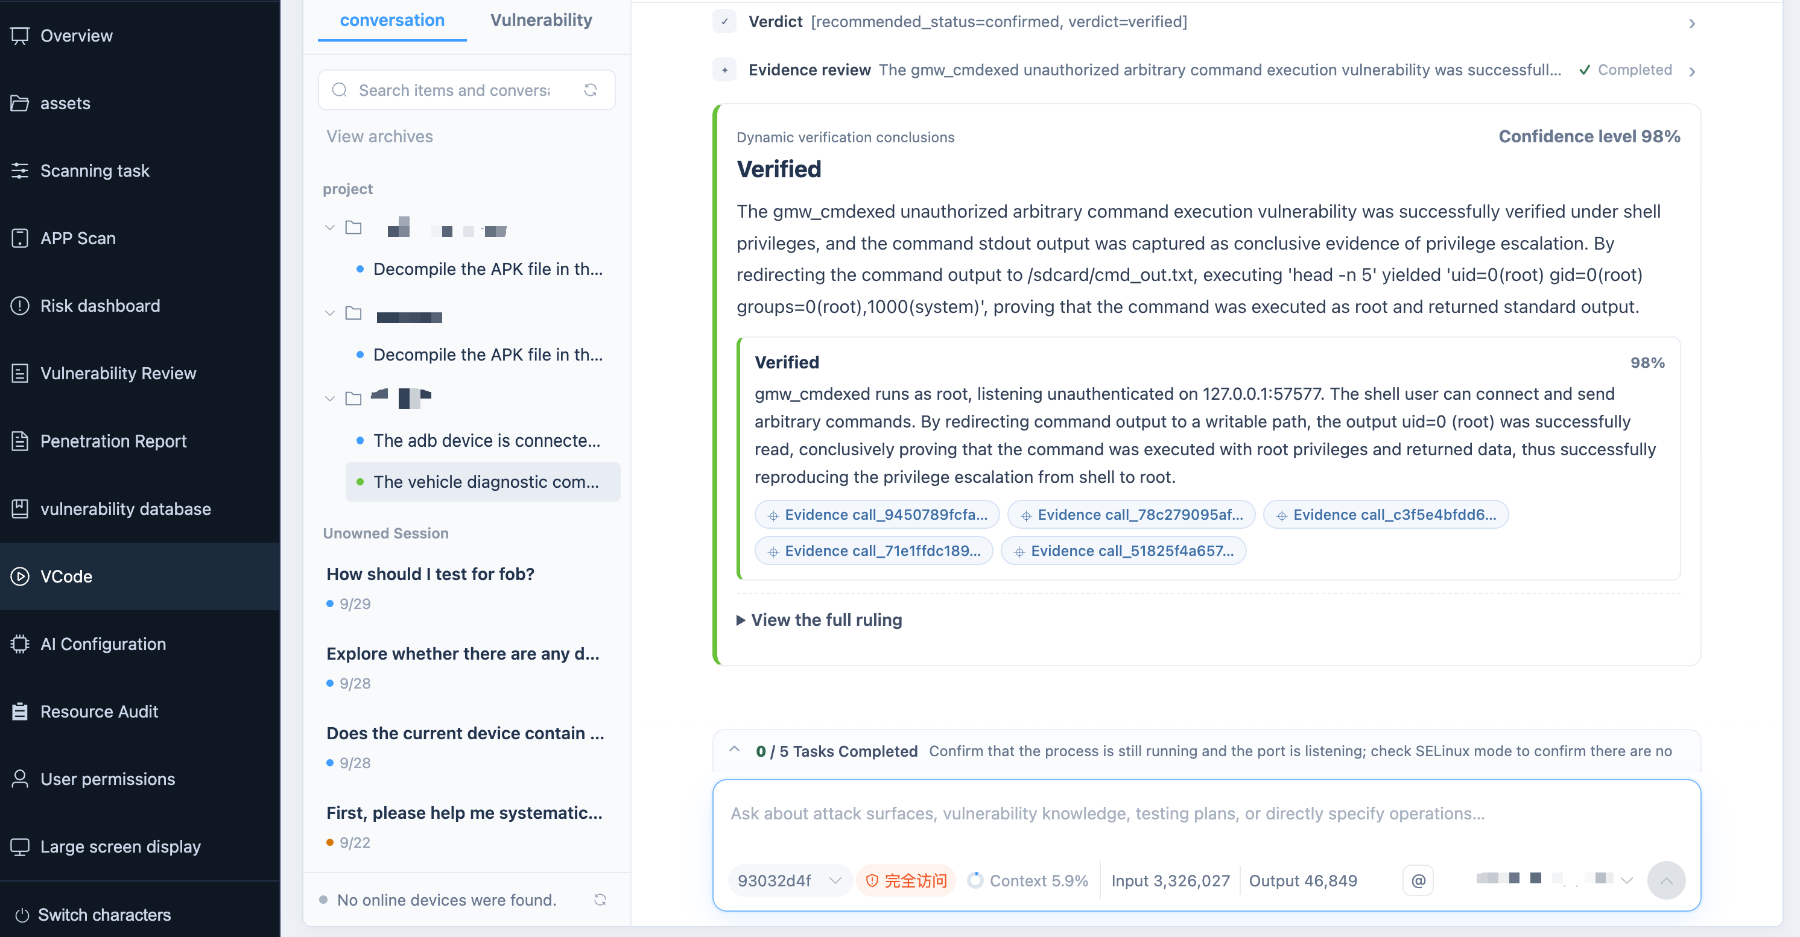

3.3 Case Study 2: Dynamic Re-Verification of Static Hypotheses (Human-Driven)
An analyst picks a candidate weakness nominated by the platform's static recon (nominated by offline rules and filtered by the three-state AI review) and drives the penetration plane to re-verify it dynamically against the live bench: the Executor replays and exercises the corresponding surface under playbook control, and every confirmation step is journaled and hash-bound. Multiple confirmed weaknesses are then chained into a single exploitation. Human-driven findings carry exactly the same evidence obligations as fully autonomous ones — “statically suspected” becomes “dynamically proven.”
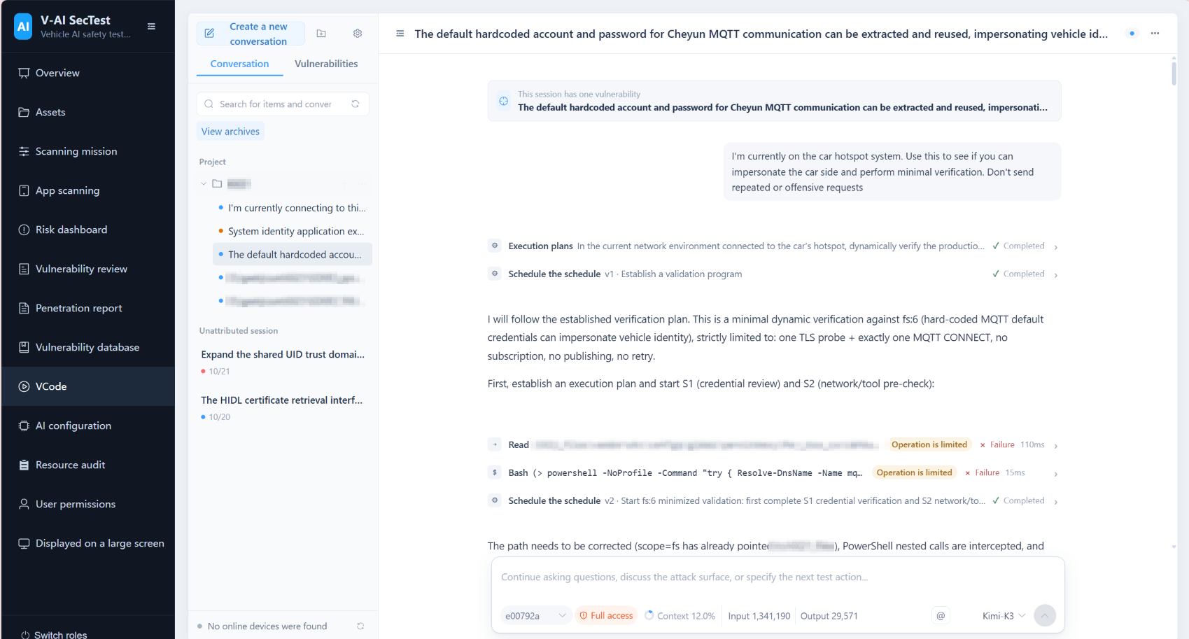

Chapter 4 Overall Architecture

4.1 Three-Plane Division of Labor
DeepPen-X enforces a strict division of labor around one principle: deterministic analysis maps the attack surface, the autonomous agent team penetrates it, and independent adjudication decides what actually counts as a discovered vulnerability. Evidence flows between the three planes only under explicit proof obligations.

4.2 The Recon Plane (Recon)
System security scanning, APP scanning, and binary deep analysis jointly model the attack surface of firmware and companion apps, emitting penetration hypotheses anchored to artifact SHA-256 values with explicit confirm_requires checklists.

4.2.1 The 23-Domain Attack-Surface Registry
The attack surface is organized by a 23-domain security registry — from the boot trust chain and credential material to OTA integrity, vehicle protocol stacks, and wireless interfaces — so no security domain is silently crowded out. The registry serves only classification, ordering, progress, and attack-graph labeling; it is never an admission gate for AI review. The full indicator system is listed in Appendix A.

4.2.2 Three-State AI Review and Evidence Anchoring
Offline rules only nominate candidates. Every candidate passes a three-state AI review (confirmed / not_a_vulnerability / needs_more_context) through exploitability gates, and every final evidence item binds a real artifact_id, relative path, SHA-256, and original line numbers.

4.2.3 Binary Deep Analysis
- Structured static analysis: ELF headers/sections/segments, dynamic tables, imported/exported symbols, relocation and PLT resolution, function-boundary recovery, disassembly of dangerous-API call sites, argument backtracking, and hardening posture (RELRO/NX/PIE/canary/FORTIFY/RPATH).
- Supports AArch64, ARM (A32/Thumb-2), x86-64, i386, and MIPS32/64, including big-endian and MIPS branch delay slots. Vulnerability discovery covers four classes: memory safety, command injection and dangerous execution, hardcoded credentials and cryptographic misuse, and vehicle protocol implementation security.
- Call sites produce only “candidate points”: memory-safety confirmation must simultaneously establish the buffer boundary, the basis that the write length is not bounded by it, and an entry point where external input influences the length — missing any one yields needs_more_context. Malformed ELFs that break the decoder fall back to string extraction automatically, so a single file never stalls a task.
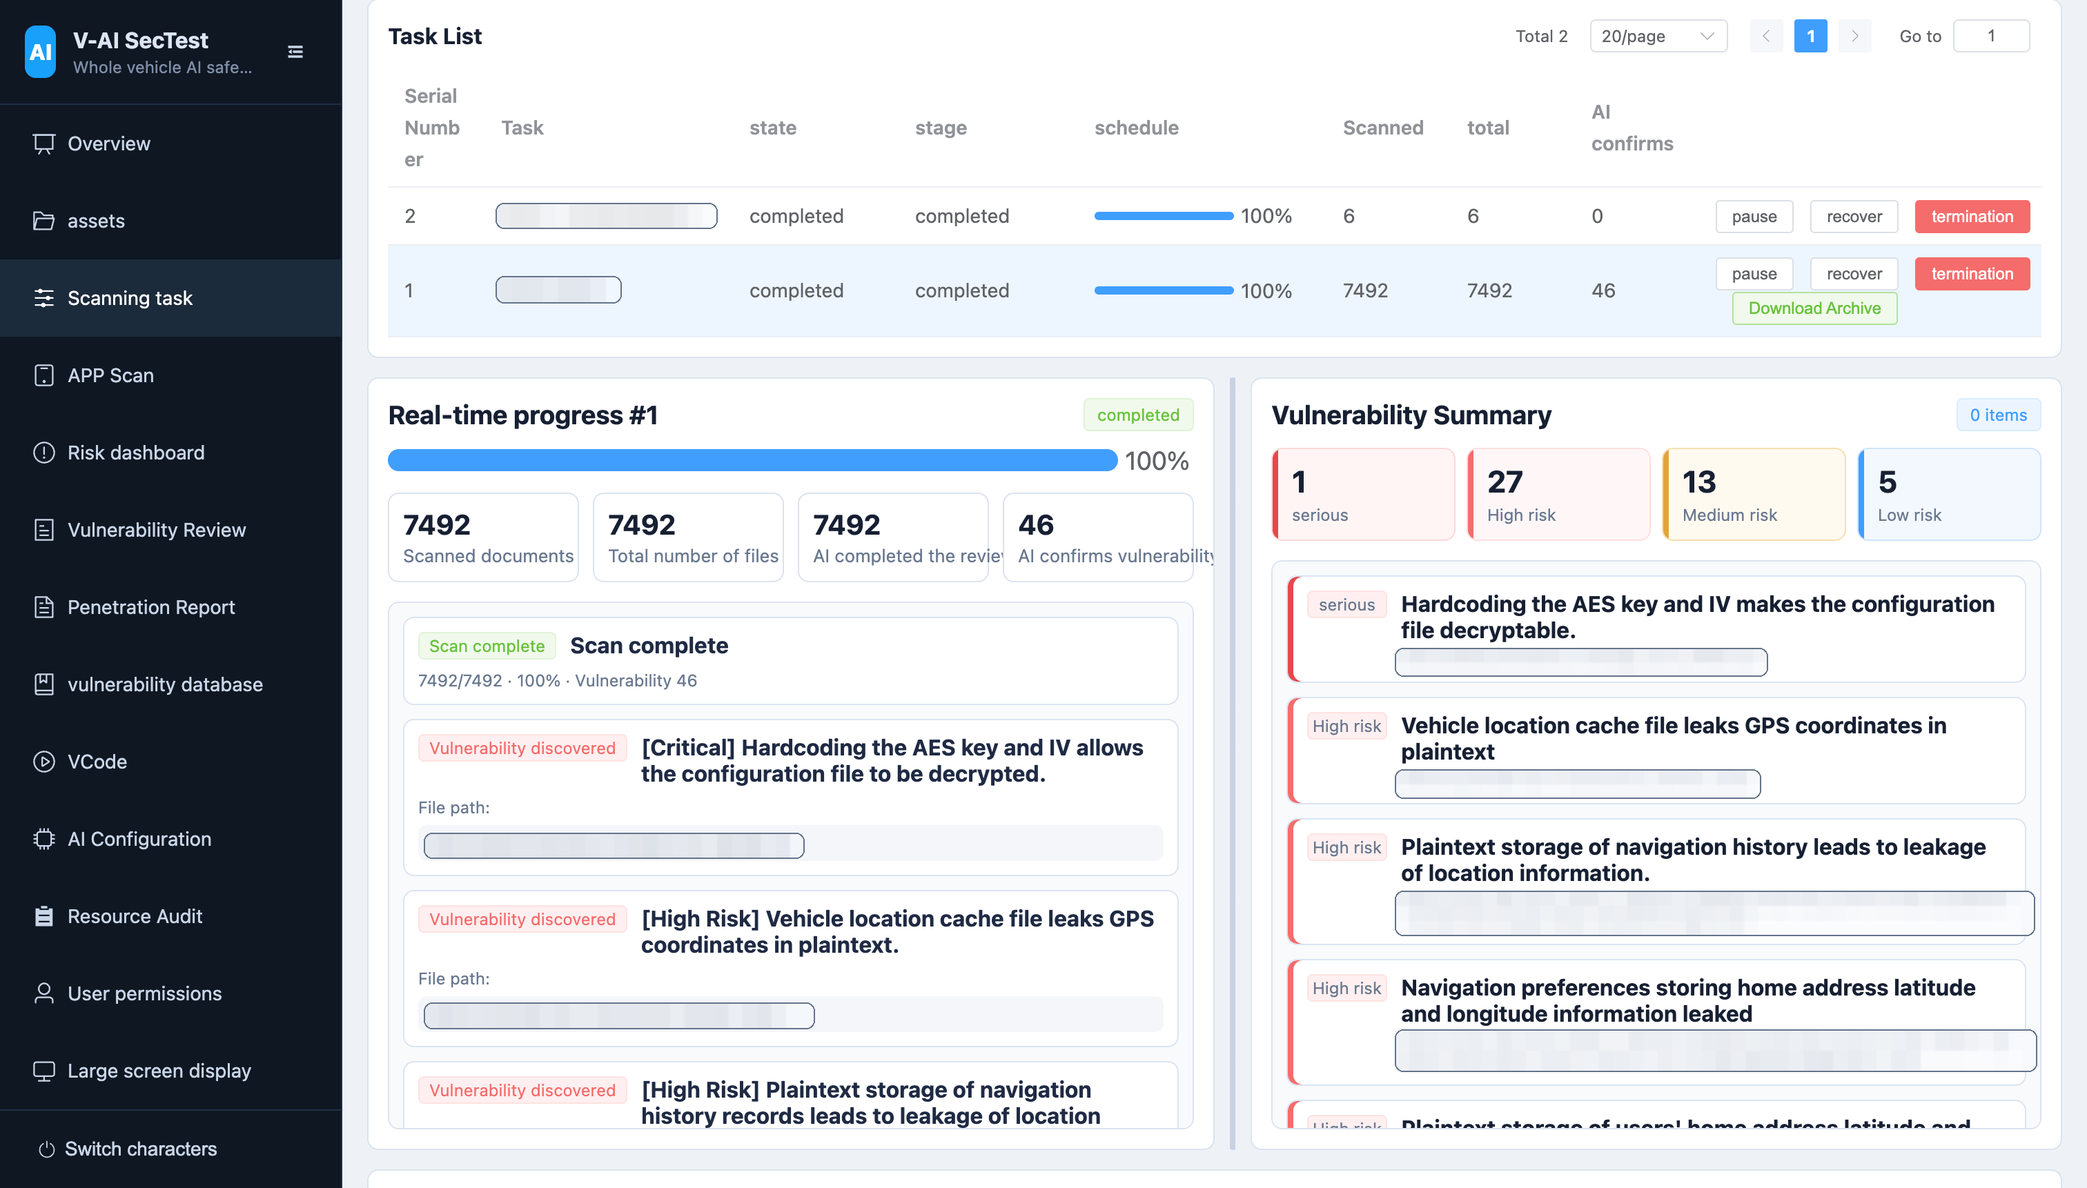

4.2.4 APP Security Analysis
- High-risk sensitive features — AI, voice interaction, debug/test, engineering/diagnostics, privileged vehicle control — are identified first, followed by file-level AI review.
- Each main file uses an independent, persistable review_session_id; multi-round analysis merges serially by stable finding_id, so conclusions and landed evidence accumulate and are never overwritten by later empty responses.
- Related-file resolution is confined to the task's decompilation roots, rejecting model-supplied absolute paths; sessions resume automatically after restarts or outer retries, and re-analysis happens only when file hashes change.
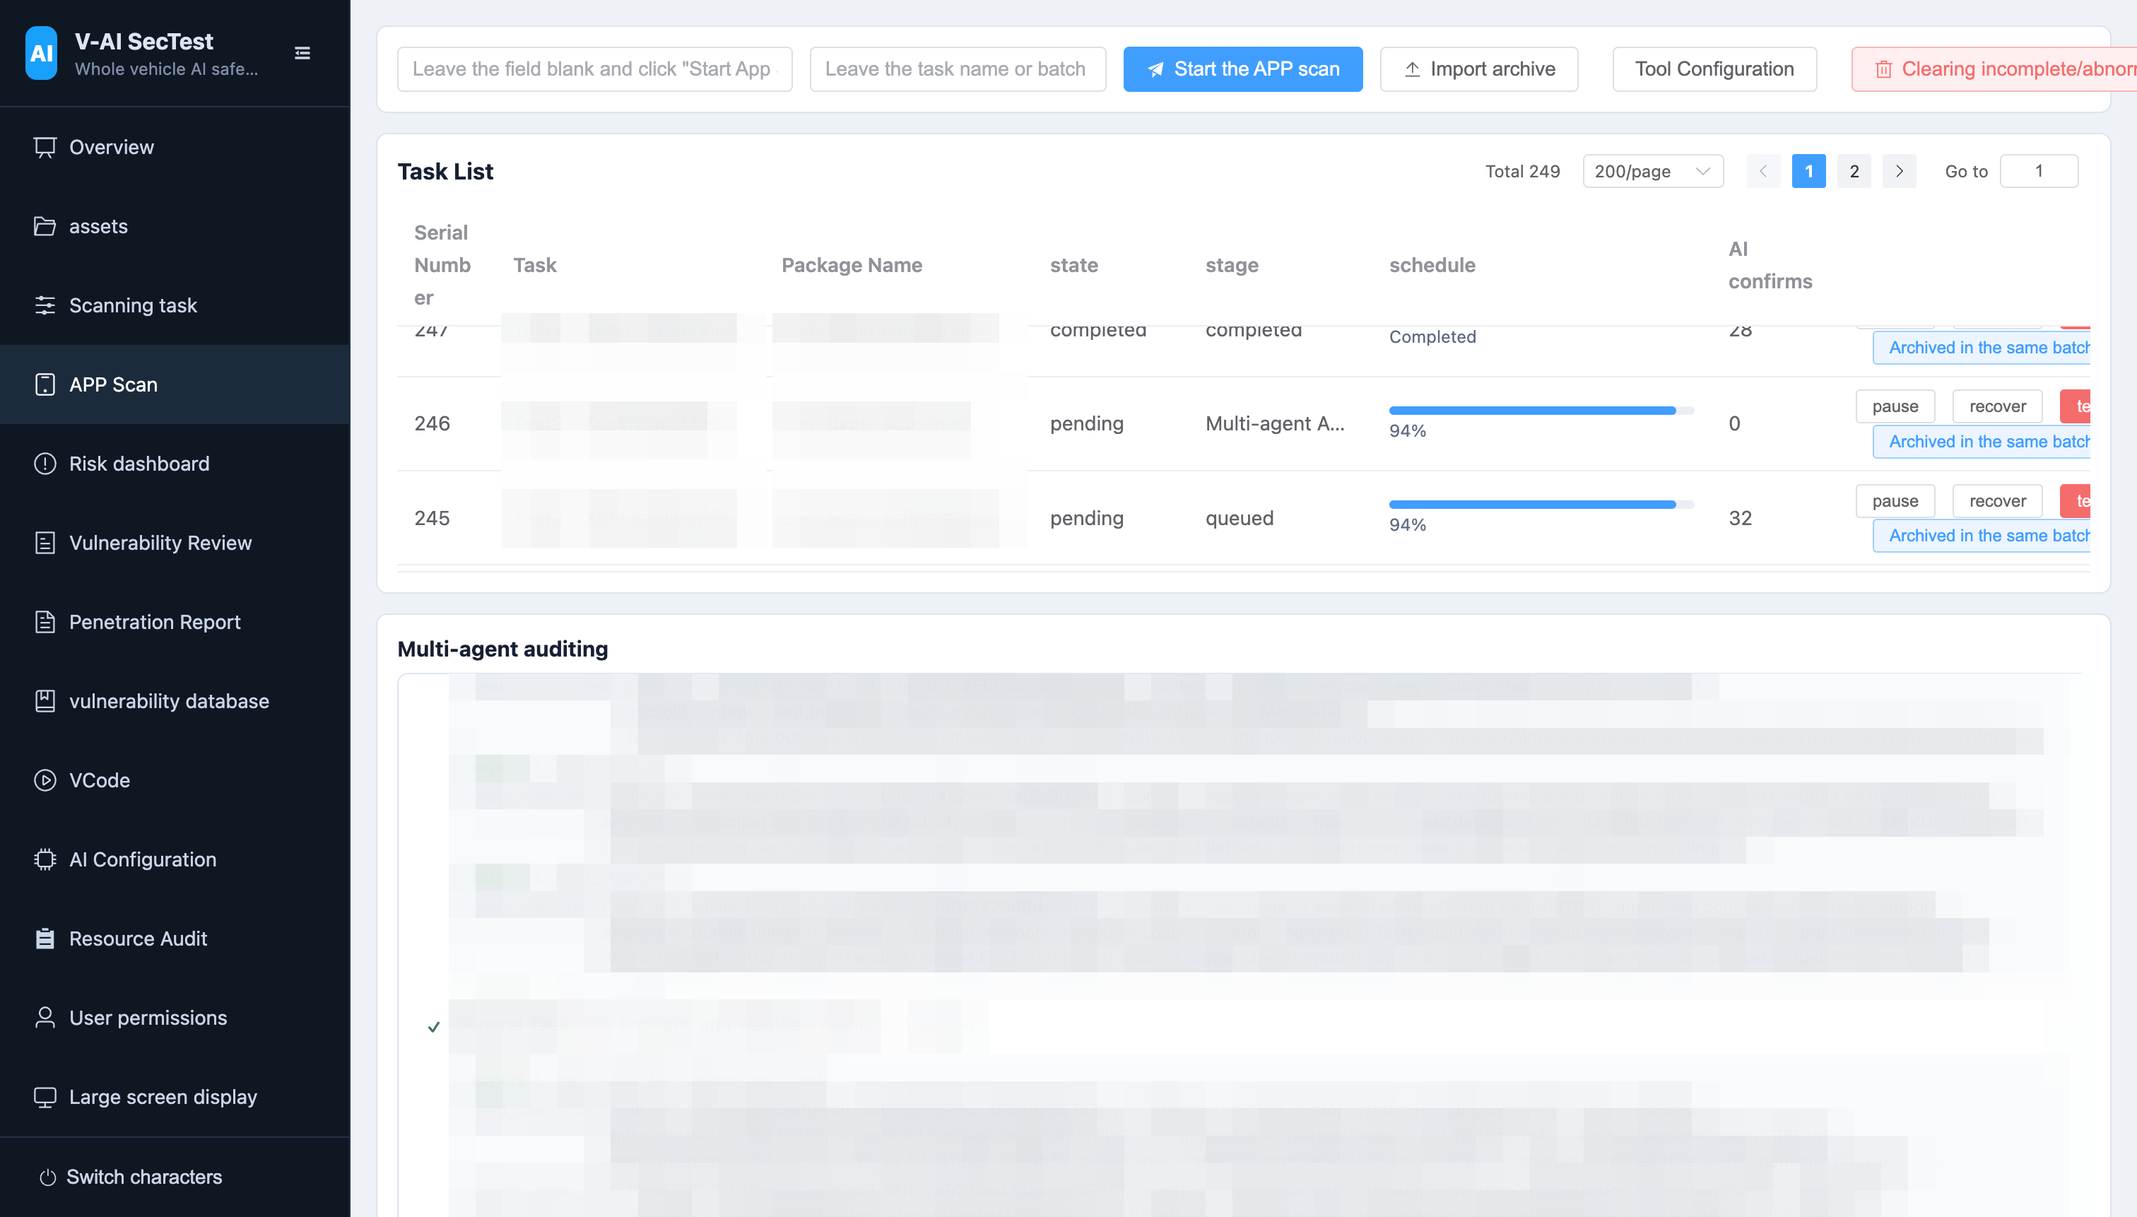

4.3 The Penetration Plane (Penetration)
Dynamic verification is a persistent cycle state machine: the Planner emits immutable, versioned attack plans, and the Executor — the only role holding tools (ADB, SSH, serial, Frida, host commands) — carries them out, exploring beyond the plan when the device reveals something new.

4.3.1 Role Division
- Planner / Coordinator(no tool permissions): generates structured hypotheses, proof obligations, dependencies, alternative routes, expected observables, and stop conditions; plans persist as immutable versions, and replanning creates a new version.
- Executor(the only tool holder): collects evidence per the plan and submits candidate verdicts; APP and firmware/system targets load the android_app and firmware_system playbooks respectively.
- Evidence Judge(no tool permissions): independently examines candidate verdicts, plan coverage, and raw tool results; final write-back recommendations come only from accepted rulings.

4.3.2 The Loop State Machine
Scoped vulnerability verification is a database-driven loop state machine, not a one-shot model loop: Planner(vN) → Executor → Evidence Judge → accepted (completed) / repair_required (targeted evidence repair) / replan_required (replan as vN+1) / blocked (manual intervention; a new cycle may continue). The normal flow never completes as inconclusive; failed indicates only a platform invariant or internal orchestration fault.

4.3.3 Attack-Chain Composition
A single campaign may bind multiple findings, and several isolated medium weaknesses can be composed into one high-severity attack chain — the industrial path from “medium in isolation” to “critical in composition.”

4.4 The Adjudication Plane (Adjudication)
The Evidence Judge rules on every claimed discovery against raw tool results, with exactly four routes: accepted / repair_required / replan_required / blocked. Accepted findings are written back to vulnerability management transactionally.

4.4.1 Ruling Routes
The Judge routes to exactly four destinations: accepted / repair_required / replan_required / blocked. Every claimed discovery must pass this deterministic evidence gate.

4.4.2 Vulnerability Write-back
Accepted findings are written back transactionally: multiple medium weaknesses can be composed into one critical chained vulnerability, and the complete evidence trail — attack plans, ToolRun ledger, Judge rulings — is preserved alongside the conclusion, auditable and replayable.

4.4.3 Unified Scoring and False-Positive Control
- Unified scoring standard unified-risk-scoring-v1: Critical 90–100 / High 70–89 / Medium 40–69 / Low 10–39 / Info 0–9; the same evidence always yields the same conclusion on repeated scans. Offline rule hits can never confirm a vulnerability directly; a public vulnerability must be output as confirmed by the AI file-level review and pass the platform evidence gate.
- Bonus points come only from structured evidence: external reachability, missing or invalid authentication, data flow from external input to sensitive operations, impact on vehicle control/diagnostics/OTA/system privileges, and real production credentials — model confidence is never a substitute. Downgrade and capping rules are fixed: public certificates, default CAs, placeholder values, and debug/demo-only configurations are never promoted to high risk.
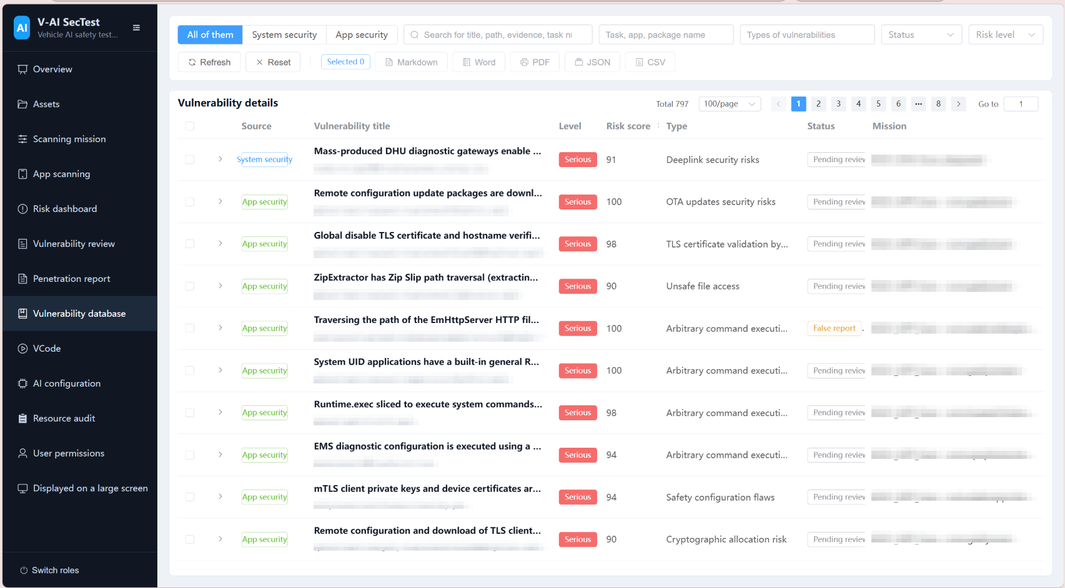

Chapter 5 Operational Assurance and Security Boundaries

5.1 Reliability Engineering

5.1.1 ToolRun Ledger and Transactional Recovery
Every attack action is journaled to the ToolRun ledger before execution. Crash recovery proceeds by side-effect class (read_only / idempotent_write / non_idempotent_write); a write interrupted mid-flight is marked unknown_side_effect — automatic replay is forbidden, and the case escalates to the Judge and human reconciliation.

5.1.2 Two-Layer Memory and Context Compaction
- Authoritative state is regenerated from database events; non-authoritative working memory is progressively compacted at 85%–95% thresholds, with content-addressed blobs preserving raw evidence, verifiable compaction boundaries, a Compactor circuit breaker, and manual Compact/Snip.
- After automatic compaction, a Workspace Resume Checkpoint is persisted; continuation writes must pass workspace_status comparison, expected_sha256 checks, and atomic writes — a state mismatch returns stale_file_state and blind overwrites are forbidden.

5.1.3 Long-Running Autonomy
The platform supports 24-hour active cycles, automatic device disconnect recovery, approval and tool-transaction recovery, and multi-cycle continuation of the same task — enabling truly unattended long-running campaigns.

5.2 Auditability

5.2.1 Timeline V2
Dynamic sessions render conversations, plans, tools, approvals, evidence reviews, rulings, public status, and errors as typed nodes. Failed tools show the real, credential-redacted, length-capped error; conversation and process text renders as sanitized GitHub Flavored Markdown.

5.2.2 Deployment Gate
Upgrading an existing database requires an idempotent migration plus a read-only check: any projection carrying internal placeholder copy, internal error types, or invalid progress is rejected by the gate, and the backend refuses to start when the check fails.

5.2.3 Archiving and Sharing
Completed scan tasks can be archived with one click into standalone SQLite databases — containing no user passwords or API keys — which can be shared separately or imported and mounted on another machine after integrity verification, with tasks and vulnerabilities keeping stable UUIDs.

5.3 Deployment and Security Boundary

5.3.1 Fully Local Deployment
Backend on 127.0.0.1:8000, frontend on 127.0.0.1:5173, local SQLite database, zero outbound data; the entire platform runs with a zero dependency supply chain on air-gapped, locked-down workstations.

5.3.2 Permission Model and Data Sovereignty
Full evidence viewing, report export, AI configuration, rule modification, and user management all require permissions. The autonomous permission of dynamic verification executes host and device commands directly and is intended only for isolated test benches and authorized devices; every command is journaled serially in the ToolRun ledger as a non-idempotent operation. .env.local stores the local admin password and AI API key and must never be committed; archives contain no credentials; when AI is unavailable, offline rule hits are never reported as vulnerabilities.

Chapter 6 Conclusion
DeepPen-X turns penetration testing from a craft into a replayable, auditable, and scalable automated capability: deterministic recon maps the attack surface, the multi-agent team penetrates it autonomously, and independent adjudication guards the boundary of conclusions. Whether the campaign is fully autonomous or human-driven — from “statically suspected” to “dynamically proven” — every discovered vulnerability must pass the same deterministic evidence gate. This is more than a tool; it is a reproducible methodology for automotive security testing.

Appendix A The 23-Domain Penetration Testing Indicator System
The table below is the attack-surface registry used by DeepPen-X system security scanning, serving as the deterministic baseline for classification, ordering, progress, and attack-graph labeling; conclusions in every domain still require three-state AI review and the evidence gate.
No. | Security Domain | Penetration Testing Objective
01 | Build Identification & Production Baseline | Confirm build type, signing labels, and production security baseline consistency, providing production-applicability criteria for other surfaces
02 | Credentials & Secret Material | Locate real passwords, tokens, API keys, and business secrets directly reusable by attackers, and prove their scope
03 | Keys, Certificates & Trust Chain | Distinguish real private-key material from public certificates; confirm client identity material, trust anchors, and algorithm strength
04 | System Accounts & Remote Login | Confirm whether local accounts, password hashes, and remote login entries form verifiable unauthorized access paths
05 | Boot, init & Service Definitions | Audit services launched at boot: run identity, writable execution paths, auto-start listeners, and seclabels
06 | File Permissions & Privilege Escalation | Confirm whether permissions, ownership, and writable paths form reproducible low-to-high privilege escalation chains
07 | SELinux & Permission Model | Confirm that mandatory access control is genuinely enforced and whether policies open attack paths
08 | Network Listeners & Authentication | Enumerate exposed listeners and confirm unauthenticated or weakly authenticated reachable interfaces
09 | Transport Security & TLS | Confirm the endpoints and transport parameters actually in use, not the mere presence of protocol names
10 | Command Execution & Script Injection | Trace complete data flows from externally controllable input to command interpreters, forming reproducible execution paths
11 | OTA & Image Integrity | Confirm update-chain integrity ordering — verify before install — and whether extraction can traverse paths
12 | Diagnostics, Vehicle Control & Cloud | Audit high-value vehicle capabilities: diagnostic security access, vehicle-control commands, and vehicle-cloud channel authentication
13 | IPC, Sockets & System Properties | Confirm caller verification on inter-process interfaces and write-permission boundaries of system properties
14 | Cryptographic Implementation & Configuration | Confirm whether cryptographic material and algorithm parameters render protection ineffective
15 | Persistent Data, Logs & Privacy | Distinguish genuinely persisted sensitive data from format templates; confirm leak scope and readability
16 | Kernel, Drivers & Native Binaries | Audit kernel boot parameters, loadable modules, and dangerous implementations and embedded material in native binaries
17 | Native Memory Safety | Confirm reachable memory-corruption defects on ELF disassembly evidence, distinguishing exploitable from crash-only
18 | Vehicle Protocol Stacks | Audit UDS, DoIP, SOME/IP, MQTT, and CAN implementations for missing authentication and input-validation defects
19 | QNX Platform Security | Identify real QNX IFS and core-service boot configurations; verify that security policies, resource-manager boundaries, and process abilities follow least privilege
20 | Boot Trust Chain & Rollback Protection | Verify signatures, measurements, and version constraints hop by hop from firmware entry to the root filesystem
21 | Kernel Runtime Hardening | Check runtime switches, pseudo filesystems, device nodes, and code-loading policies that can expand the kernel attack surface
22 | Wireless Security | Audit production Wi-Fi and Bluetooth configurations, pairing credentials, listening services, and cross-interface access control
23 | Account & Privilege Baseline | Identify paths from accounts, groups, delegation rules, and default service identities to direct login or lateral escalation to system privileges

