**TCP内核代码**

**tcp内核结构体**

tcp控制块（每个tcp连接，64字节）

|  |
| --- |
| C struct tcpcb {  /* Cache line 1 */  struct inpcb *t_inpcb; /* back pointer to internet pcb */  struct tcp_function_block *t_fb;/* TCP function call block */  void *t_fb_ptr; /* Pointer to t_fb specific data */  uint32_t t_maxseg:24, /* maximum segment size */  t_logstate:8; /* State of "black box" logging */  uint32_t t_port:16, /* Tunneling (over udp) port */  t_state:4, /* state of this connection */  t_idle_reduce : 1,  t_delayed_ack: 7, /* Delayed ack variable */  t_fin_is_rst: 1, /* Are fin's treated as resets */  t_log_state_set: 1,  bits_spare : 2;  u_int t_flags;  tcp_seq snd_una; /* sent but unacknowledged */  tcp_seq snd_max; /* highest sequence number sent;  * used to recognize retransmits  */  tcp_seq snd_nxt; /* send next */  tcp_seq snd_up; /* send urgent pointer */  uint32_t snd_wnd; /* send window */  uint32_t snd_cwnd; /* congestion-controlled window */  uint32_t t_peakrate_thr; /* pre-calculated peak rate threshold */  /* Cache line 2 */  u_int32_t ts_offset; /* our timestamp offset */  u_int32_t rfbuf_ts; /* recv buffer autoscaling timestamp */  int rcv_numsacks; /* # distinct sack blks present */  u_int t_tsomax; /* TSO total burst length limit in bytes */  u_int t_tsomaxsegcount; /* TSO maximum segment count */  u_int t_tsomaxsegsize; /* TSO maximum segment size in bytes */  tcp_seq rcv_nxt; /* receive next */  tcp_seq rcv_adv; /* advertised window */  uint32_t rcv_wnd; /* receive window */  u_int t_flags2; /* More tcpcb flags storage */  int t_srtt; /* smoothed round-trip time */  int t_rttvar; /* variance in round-trip time */  u_int32_t ts_recent; /* timestamp echo data */  u_char snd_scale; /* window scaling for send window */  u_char rcv_scale; /* window scaling for recv window */  u_char snd_limited; /* segments limited transmitted */  u_char request_r_scale; /* pending window scaling */  tcp_seq last_ack_sent;  u_int t_rcvtime; /* inactivity time */  /* Cache line 3 */  tcp_seq rcv_up; /* receive urgent pointer */  int t_segqlen; /* segment reassembly queue length */  uint32_t t_segqmbuflen; /* Count of bytes mbufs on all entries */  struct tsegqe_head t_segq; /* segment reassembly queue */  struct mbuf *t_in_pkt;  struct mbuf *t_tail_pkt;  struct tcp_timer *t_timers; /* All the TCP timers in one struct */  struct vnet *t_vnet; /* back pointer to parent vnet */  uint32_t snd_ssthresh; /* snd_cwnd size threshold for  * for slow start exponential to  * linear switch  */  tcp_seq snd_wl1; /* window update seg seq number */  /* Cache line 4 */  tcp_seq snd_wl2; /* window update seg ack number */   tcp_seq irs; /* initial receive sequence number */  tcp_seq iss; /* initial send sequence number */  u_int t_acktime; /* RACK and BBR incoming new data was acked */  u_int t_sndtime; /* time last data was sent */  u_int ts_recent_age; /* when last updated */  tcp_seq snd_recover; /* for use in NewReno Fast Recovery */  uint16_t cl4_spare; /* Spare to adjust CL 4 */  char t_oobflags; /* have some */  char t_iobc; /* input character */  int t_rxtcur; /* current retransmit value (ticks) */   int t_rxtshift; /* log(2) of rexmt exp. backoff */  u_int t_rtttime; /* RTT measurement start time */   tcp_seq t_rtseq; /* sequence number being timed */  u_int t_starttime; /* time connection was established */  u_int t_fbyte_in; /* ticks time when first byte queued in */  u_int t_fbyte_out; /* ticks time when first byte queued out */   u_int t_pmtud_saved_maxseg; /* pre-blackhole MSS */  int t_blackhole_enter; /* when to enter blackhole detection */  int t_blackhole_exit; /* when to exit blackhole detection */  u_int t_rttmin; /* minimum rtt allowed */   u_int t_rttbest; /* best rtt we've seen */   int t_softerror; /* possible error not yet reported */  uint32_t max_sndwnd; /* largest window peer has offered */  /* Cache line 5 */  uint32_t snd_cwnd_prev; /* cwnd prior to retransmit */  uint32_t snd_ssthresh_prev; /* ssthresh prior to retransmit */  tcp_seq snd_recover_prev; /* snd_recover prior to retransmit */  int t_sndzerowin; /* zero-window updates sent */  u_long t_rttupdated; /* number of times rtt sampled */  int snd_numholes; /* number of holes seen by sender */  u_int t_badrxtwin; /* window for retransmit recovery */  TAILQ_HEAD(sackhole_head, sackhole) snd_holes;  /* SACK scoreboard (sorted) */  tcp_seq snd_fack; /* last seq number(+1) sack'd by rcv'r*/  struct sackblk sackblks[MAX_SACK_BLKS]; /* seq nos. of sack blocks */  struct sackhint sackhint; /* SACK scoreboard hint */  int t_rttlow; /* smallest observerved RTT */  int rfbuf_cnt; /* recv buffer autoscaling byte count */  struct toedev *tod; /* toedev handling this connection */  int t_sndrexmitpack; /* retransmit packets sent */  int t_rcvoopack; /* out-of-order packets received */  void *t_toe; /* TOE pcb pointer */  struct cc_algo *cc_algo; /* congestion control algorithm */  struct cc_var *ccv; /* congestion control specific vars */  struct osd *osd; /* storage for Khelp module data */  int t_bytes_acked; /* # bytes acked during current RTT */  u_int t_maxunacktime;  u_int t_keepinit; /* time to establish connection */  u_int t_keepidle; /* time before keepalive probes begin */  u_int t_keepintvl; /* interval between keepalives */  u_int t_keepcnt; /* number of keepalives before close */  int t_dupacks; /* consecutive dup acks recd */  int t_lognum; /* Number of log entries */  int t_loglimit; /* Maximum number of log entries */  int64_t t_pacing_rate; /* bytes / sec, -1 => unlimited */  struct tcp_log_stailq t_logs; /* Log buffer */  struct tcp_log_id_node *t_lin;  struct tcp_log_id_bucket *t_lib;  const char *t_output_caller; /* Function that called tcp_output */  struct statsblob *t_stats; /* Per-connection stats */  uint32_t t_logsn; /* Log "serial number" */  uint32_t gput_ts; /* Time goodput measurement started */  tcp_seq gput_seq; /* Outbound measurement seq */  tcp_seq gput_ack; /* Inbound measurement ack */  int32_t t_stats_gput_prev; /* XXXLAS: Prev gput measurement */  uint8_t t_tfo_client_cookie_len; /* TCP Fast Open client cookie length */  uint32_t t_end_info_status; /* Status flag of end info */  unsigned int *t_tfo_pending; /* TCP Fast Open server pending counter */  union {  uint8_t client[TCP_FASTOPEN_MAX_COOKIE_LEN];  uint64_t server;  } t_tfo_cookie; /* TCP Fast Open cookie to send */  union {  uint8_t t_end_info_bytes[TCP_END_BYTE_INFO];  uint64_t t_end_info;  }; #ifdef TCPPCAP  struct mbufq t_inpkts; /* List of saved input packets. */  struct mbufq t_outpkts; /* List of saved output packets. */ #endif }; |

tcp头部结构体

|  |
| --- |
| C struct tcphdr {  u_short th_sport; /* source port */  u_short th_dport; /* destination port */  tcp_seq th_seq; /* sequence number */  tcp_seq th_ack; /* acknowledgement number */ #if BYTE_ORDER == LITTLE_ENDIAN  u_char th_x2:4, /* (unused) */  th_off:4; /* data offset */ #endif #if BYTE_ORDER == BIG_ENDIAN  u_char th_off:4, /* data offset */  th_x2:4; /* (unused) */ #endif  u_char th_flags; #define TH_FIN 0x01 #define TH_SYN 0x02 #define TH_RST 0x04 #define TH_PUSH 0x08 #define TH_ACK 0x10 #define TH_URG 0x20 #define TH_ECE 0x40 #define TH_CWR 0x80 #define TH_AE 0x100 /* maps into th_x2 */ #define TH_FLAGS (TH_FIN|TH_SYN|TH_RST|TH_PUSH|TH_ACK|TH_URG|TH_ECE|TH_CWR) #define PRINT_TH_FLAGS "\20\1FIN\2SYN\3RST\4PUSH\5ACK\6URG\7ECE\10CWR\11AE"   u_short th_win; /* window */  u_short th_sum; /* checksum */  u_short th_urp; /* urgent pointer */ }; |

struct inpcb是一种用于表示网络连接的结构体。它包含了与该连接相关的所有信息，如本地和远程IP地址、本地和远程端口号、状态等。该结构体通常用于创建、维护和管理TCP套接字。

|  |
| --- |
| C struct inpcb {  /* Cache line #1 (amd64) */  CK_LIST_ENTRY(inpcb) inp_hash; /* [w](h/i) [r](e/i) hash list */  CK_LIST_ENTRY(inpcb) inp_pcbgrouphash; /* (g/i) hash list */  struct rwlock inp_lock;  /* Cache line #2 (amd64) */ #define inp_start_zero inp_hpts #define inp_zero_size (sizeof(struct inpcb) - \  offsetof(struct inpcb, inp_start_zero))  TAILQ_ENTRY(inpcb) inp_hpts; /* pacing out queue next lock(b) */   uint32_t inp_hpts_request; /* Current hpts request, zero if  * fits in the pacing window (i&b). */  /*  * Note the next fields are protected by a  * different lock (hpts-lock). This means that  * they must correspond in size to the smallest  * protectable bit field (uint8_t on x86, and  * other platfomrs potentially uint32_t?). Also  * since CPU switches can occur at different times the two  * fields can *not* be collapsed into a signal bit field.  */ #if defined(__amd64__) || defined(__i386__)  volatile uint8_t inp_in_hpts; /* on output hpts (lock b) */  volatile uint8_t inp_in_input; /* on input hpts (lock b) */ #else  volatile uint32_t inp_in_hpts; /* on output hpts (lock b) */  volatile uint32_t inp_in_input; /* on input hpts (lock b) */ #endif  volatile uint16_t inp_hpts_cpu; /* Lock (i) */  u_int inp_refcount; /* (i) refcount */  int inp_flags; /* (i) generic IP/datagram flags */  int inp_flags2; /* (i) generic IP/datagram flags #2*/  volatile uint16_t inp_input_cpu; /* Lock (i) */  volatile uint8_t inp_hpts_cpu_set :1, /* on output hpts (i) */  inp_input_cpu_set : 1, /* on input hpts (i) */  inp_hpts_calls :1, /* (i) from output hpts */  inp_input_calls :1, /* (i) from input hpts */  inp_spare_bits2 : 4;  uint8_t inp_numa_domain; /* numa domain */  void *inp_ppcb; /* (i) pointer to per-protocol pcb */  struct socket *inp_socket; /* (i) back pointer to socket */  uint32_t inp_hptsslot; /* Hpts wheel slot this tcb is Lock(i&b) */  uint32_t inp_hpts_drop_reas; /* reason we are dropping the PCB (lock i&b) */  TAILQ_ENTRY(inpcb) inp_input; /* pacing in queue next lock(b) */  struct inpcbinfo *inp_pcbinfo; /* (c) PCB list info */  struct inpcbgroup *inp_pcbgroup; /* (g/i) PCB group list */  CK_LIST_ENTRY(inpcb) inp_pcbgroup_wild; /* (g/i/h) group wildcard entry */  struct ucred *inp_cred; /* (c) cache of socket cred */  u_int32_t inp_flow; /* (i) IPv6 flow information */  u_char inp_vflag; /* (i) IP version flag (v4/v6) */  u_char inp_ip_ttl; /* (i) time to live proto */  u_char inp_ip_p; /* (c) protocol proto */  u_char inp_ip_minttl; /* (i) minimum TTL or drop */  uint32_t inp_flowid; /* (x) flow id / queue id */  struct m_snd_tag *inp_snd_tag; /* (i) send tag for outgoing mbufs */  uint32_t inp_flowtype; /* (x) M_HASHTYPE value */  uint32_t inp_rss_listen_bucket; /* (x) overridden RSS listen bucket */   /* Local and foreign ports, local and foreign addr. */  struct in_conninfo inp_inc; /* (i) list for PCB's local port */   /* MAC and IPSEC policy information. */  struct label *inp_label; /* (i) MAC label */  struct inpcbpolicy *inp_sp; /* (s) for IPSEC */   /* Protocol-dependent part; options. */  struct {  u_char inp_ip_tos; /* (i) type of service proto */  struct mbuf *inp_options; /* (i) IP options */  struct ip_moptions *inp_moptions; /* (i) mcast options */  };  struct {  /* (i) IP options */  struct mbuf *in6p_options;  /* (i) IP6 options for outgoing packets */  struct ip6_pktopts *in6p_outputopts;  /* (i) IP multicast options */  struct ip6_moptions *in6p_moptions;  /* (i) ICMPv6 code type filter */  struct icmp6_filter *in6p_icmp6filt;  /* (i) IPV6_CHECKSUM setsockopt */  int in6p_cksum;  short in6p_hops;  };  CK_LIST_ENTRY(inpcb) inp_portlist; /* (i/h) */  struct inpcbport *inp_phd; /* (i/h) head of this list */  inp_gen_t inp_gencnt; /* (c) generation count */  void *spare_ptr; /* Spare pointer. */  rt_gen_t inp_rt_cookie; /* generation for route entry */  union { /* cached L3 information */  struct route inp_route;  struct route_in6 inp_route6;  };  CK_LIST_ENTRY(inpcb) inp_list; /* (p/l) list for all PCBs for proto */  /* (e[r]) for list iteration */  /* (p[w]/l) for addition/removal */  struct epoch_context inp_epoch_ctx; }; |

tcp_input.c

修改内核cc函数，打印struct tcpcb控制块相应参数

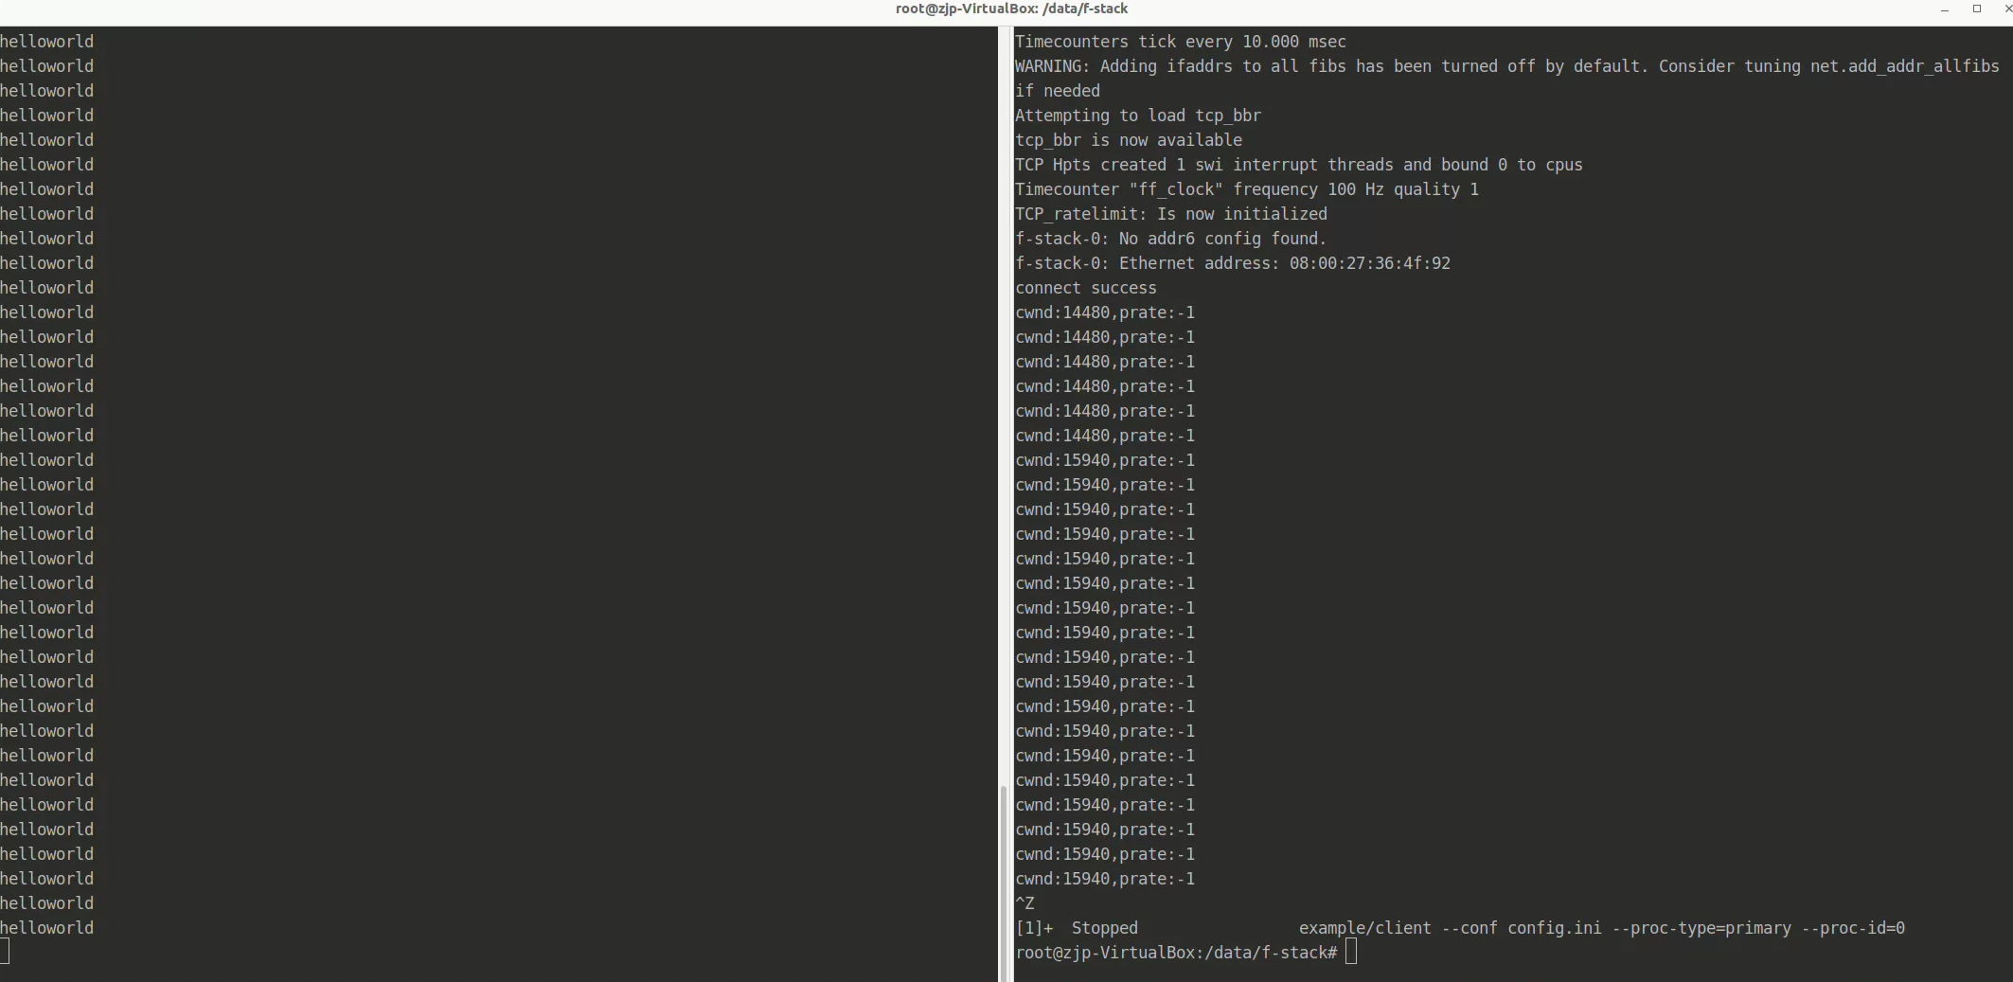

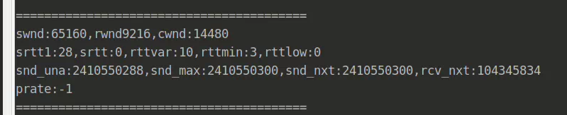

**tcp时间辍与报文长度**

*MSS就是TCP数据包每次能够传输的最大量。为了达到最佳的传输效能， TCP协议在建立连接的时候通常 要协商双方的MSS值，这个值TCP协议在实现的*

*时候往往用MTU值代替（需要减去IP数据包包头的大小20Bytes和TCP数据段的 包头 20Bytes ）所以往往 MSS 为 1460（ 如图1中红色方框所示的SYN包中的MSS值）。通讯双方会根据双方提供的 MSS 值得最小 值确定为这次连接的最大 MSS 值。*

*MSS为1460是由1500-20（IP头）-20（TCP头）计算出的。*

*实际场景下，TCP包头中会带有12字节的选项----时间戳。*

*这样，单个TCP包实际传输的最大量就缩减为1448字节。1448=1500-20（IP头）-32（20字节TCP头和12字节TCP选项时间戳）*

*原文链接：https://blog.csdn.net/hfhhgfv/article/details/86511432*

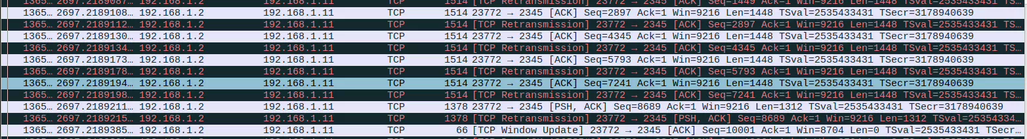

**tcp拥塞控制算法搭建**

流程参考：

[cc](https://uestc.feishu.cn/docx/CNefdcLGcovK5TxTsxUcG25Wnve?from=from_copylink) “算法部署”

pidcc.c

|  |
| --- |
| C 按照其流程完成算法部署后 1.修改f-stack/lib文件中的Makefile,加入你的cc_xxx.c文件，然后编译 2.重新编译APP，即example，不然直接运行会显示你新增的总赛控制算法报错，如下面小图所示 |



完成上述流程，拥塞控制算法成功部署，显示结果如下：

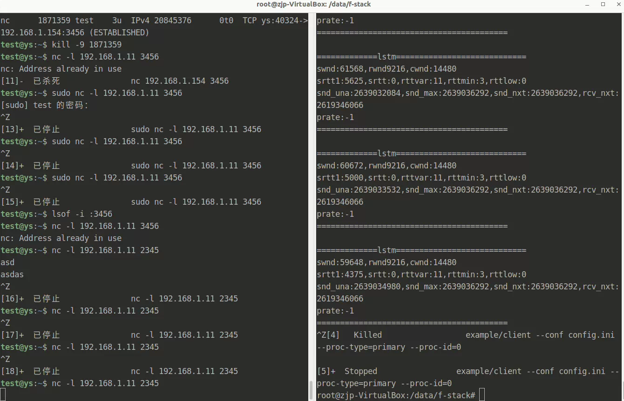

主机直连PING

