**Interactive Visualization Interface for 3D models**

Group member: Jin Wang, Tian Gao, Yu Shi, Garett Wirka, [Hoa Nguyen](https://canvas.unl.edu/groups/49642/users/31507)

**1. Introduction**

Measurement of plant morphological traits is a hot topic in plant science. With these measurements, plant scientists are able to perform a quantitative analysis of plants and eventually build the connection between genotype and phenotype. Moreover, the traits can help to measure the effects of various environmental conditions in which plants with the same genotype are growing. For example, plants growing in stressful conditions may have shorter leaves.

In this project, we plan to store the point cloud files in a database and present 3D models to visualize the plants. An interactive page will be developed so that the users can select parts of the plants that they are interested in and get the corresponding morphological traits.

2. Challenges

The significant challenges in this project are in two aspects. The first one will be creating the interactive 3D object on the webpage. We need to figure out which points are selected by checking which of them intersects the view frustum. The second challenge will be to separate different leaves in a user-selected space. In our project, the user will be able to select the leaf of interest with a rectangular selector. Every vertex in the selected area with the depth of the entire 3D model will be taken into account for surface area calculation. Hence, it is very likely that there are overlapped leaves in user-selected perspective. To make the calculation precise, we need to provide the surface area for each leaf at the user selected space.

3. Related Work

Traditionally, measuring plant morphological traits is time-consuming because it involves so much manual work. In the early age, people calculated the surface area of leaves by drawing the outlines [1]. This method was usually destructive, so important dynamic changes of plant architecture in different growth stages could not be observed.

Another widely used method is based on images. Though not so laborious, the image-based methods have their limitations. Images are the 2D projection of a 3D object. The information of depth gets lost after the process of the project. As a result, there will be an occlusion problem which causes an inaccurate result.

Due to the drawback of image-based approaches, 3D reconstruction such as Structure-from-motion become popular. Structure-from-motion (SFM) generates point cloud by capturing images of a 3D object at several positions. CMVS [2] and MVE [3] are two popular applications of SFM method.

In this project, all the 3D point clouds are generated by MVE.

4. Proposed Approaches

**4.1 Data Acquirement**

In this project, a special equipment (Fig. 1) is used to take images. A camera is fixed on a track and the plants are placed in the center. As the camera moves around the plants, images from different angles are taken (Fig. 2). In total, there will be 60 (1 camera) or 120 (2 cameras) images for one plant. After that, MVE is used to generate 3D models (Fig.3). These 3D models are stored in .ply files.

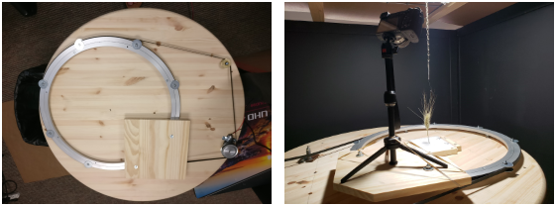

Fig.1 Image Acquirement Equipment

**4.2 Neo4j Database**

The database used in this project is Neo4j which is one of the most popular graph databases. Each node represents a 3D model, and the attributes include the information about the file (file path) and plants themselves (plant Id and date). The edges represent the time relationship of two nodes. For example, if there is an edge from node A to node B, B is another 3D model of the same plant, which generated in the next valid date (Fig. 4).

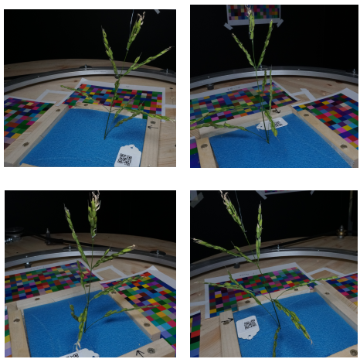

Fig.2 Images of A Rice

**4.3 Data Visualization**

Our method employs Web Graphics Library (WebGL) to visualize the 3D point cloud data. WebGL is a [JavaScript](https://en.wikipedia.org/wiki/JavaScript) [API](https://en.wikipedia.org/wiki/Application_programming_interface) for rendering interactive 2D and 3D graphics within any compatible [web browser](https://en.wikipedia.org/wiki/Web_browser) without the use of plugins. And WebGL is fully integrated with other [web standards](https://en.wikipedia.org/wiki/Web_API), allowing GPU-accelerated usage of physics and image processing and effects as part of the web page canvas. To visualize the dataset, we first load the ply file and store as a geometry object which contains the objects of Points and Faces. In the Points object, we can find the location information (x, y, z) and the color information (R, G, B) of each point. Then we can simply add the geometry to the scene to visualize the plant data and calculate the surface area based on Faces objects.

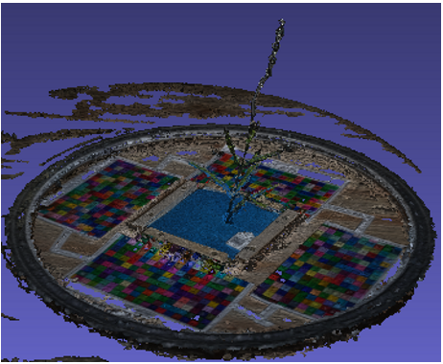

Fig.3 3D Model of A Rice

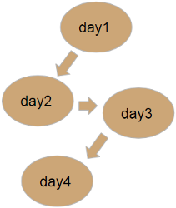

Fig.4 Neo4j Structure

In practice, scientists often use their domain knowledge to narrow their exploration of certain regions of interest. For example, some botanists may prefer studying the growth of plant leaves. So, we provide a function to let the user draw a rectangle to select a particular area that they are interested in. As shown in Fig.5, we project the 2D rectangle on the screen to the 3D world and change the point color if it locates within the selected view frustum.

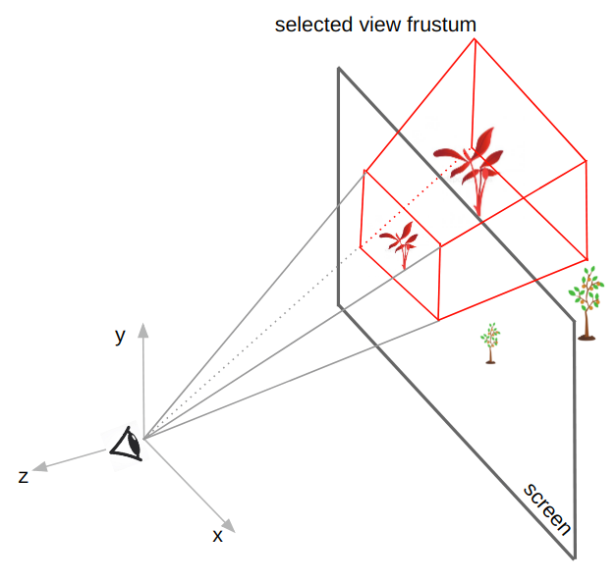

Fig.5 Project 2D rectangle to 3D world

**4.4 Surface Area Calculation**

The mesh of a 3D model consists of triangles. So the total surface area of an object can be calculated by summing up area of each triangle. The areas of triangles can be calculated using Heron’s Formula:

https://lh4.googleusercontent.com/T5TY7lQkro0KesfOyKlyE6bq1mpoM__IDCUBDZYi8zJqeicM1SeCZxpptzFf4y5YAiD_wohqnOF6B6AoYOMYrMs57n9gSnAtsh3UsA6_-6rv5pXcJpuXNZ-EyyAZfWVTMKrPnR6X

where a, b, c are the lengths of the three sides and s is the semi-perimeter of the triangle:

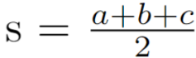

5. Results

Our web interface is available using this link: <http://odl.unl.edu/plantVis>. As shown in Fig.6, there is an input box at bottom left so that users are able to submit their query. When the user clicks the submit button, the query will be sent to the database and the corresponding plant will be visualized on the browser. When the user activates the drawing slide, a rectangle can be drawn to select a region. The selected points will be marked red and a message box will pop up showing the surface area.

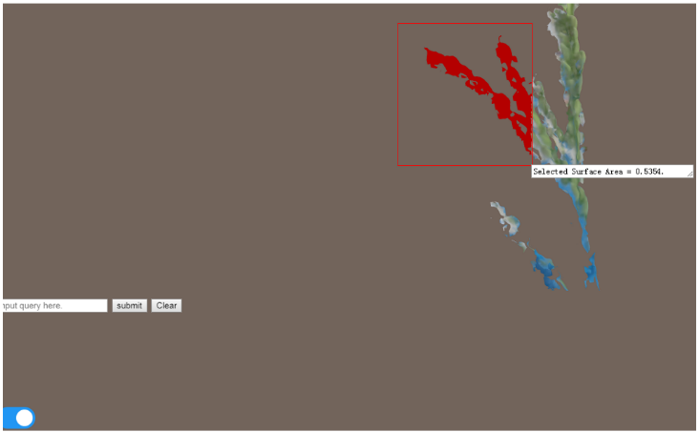

Fig.6 Interactive Web-based Interface

6. Evaluation

Since all the location information stored in the Points object is the relative distance, the surface area results are also relative. Therefore, in practice, a checkerboard will be generated with the plant as a reference so that we can calculate its real surface area. In our project, we also employ the checkerboard to evaluate accuracy. We firstly print a checkerboard and generate the 3D model of it. After loading it in the interface, we draw rectangles to select a region with different numbers of squares and record the surface area. Finally, we build a standard curve to evaluate the accuracy of our method. As Table.1 and Fig.7 shows, the R2 is the Square of Pearson correlation coefficient, and R2 = 0.9992 indicates that our method has a good linear correlation, which means our method is precise and reliable.

|  |  |  |  |  |  |
| --- | --- | --- | --- | --- | --- |
| Square Num | 1 | 2 | 3 | 4 | 6 |
| Surface Area | 0.0114 | 0.0229 | 0.036 | 0.0496 | 0.0731 |

Table.1 Surface Area of the Region

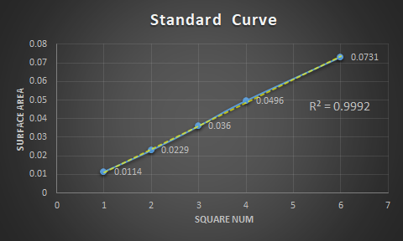

Fig.7 Standard Curve

7. Conclusion and Future Work

We proposed an end-to-end system that can interactively visualize any object in the real world. In our project, we focus on the plant data to study its growth.  The user interface can not only query the same plant by the date but also provides quantitative analysis capabilities that give the user a very accurate surface area result for the selected area.

There are still some issues with our interface. For example, the coordinates of the points in the point cloud are relative values. There might be overlapped area after selection. In the future, we will use references (e.g. checkerboard) to obtain the true value instead of relative ones. Some better algorithmic or mechanical approaches will also be added to the separate occluded area. A more complicated structure will be used so that more relationship can be represented (for example, different parts of one plant).

References

[1] Miller, E.C. Plant Physiology, with Reference to the Green Plant; McGraw-Hill Book Company, Incorporated: New York, NY, USA, 1938.

[2] Furukawa, Y., Curless, B., Seitz, S. and Szeliski, R. (2010). Towards Internet-scale multi-view stereo. 2010 IEEE Computer Society Conference on Computer Vision and Pattern Recognition.

[3] Fuhrmann, S., Langguth, F., Moehrle, N., Waechter, M. and Goesele, M. (2015). MVE—An image-based reconstruction environment. Computers & Graphics, 53, pp.44-53.