**FastEI Documentation**

***Release 1.0***

**Yang Qiong & Ji Hongchao**

**July 01, 2022**

1. **Quick** **FastEI overview**

FastEI is a tool for spectrum matching. It provides user-friendly interfaces to match unknown molecular electron ionization mass spectrum (EI-MS) using million-scale in-silico library.

This documentation gives a detail introduction to FastEI program, which describes the following:

• Install FastEI

• Quickly Start FastEI

1. **Install** **FastEI**

**2.1 Installation**

The setup file of FastEI includes an EXE file and three BIN files. They all created by Inno Setup, and it supports for all versions of Windows in use today. When the setup EXE file is double-clicked, the setup wizard will take care of the whole installation procedure.

**2.2 System Requirements**

If you want to run FastEI on your PC, the recommended system requirements are as follows:  
**Operating Systems**• Windows 7  
• Windows 10  
**Recommended Hardware**  
• Intel Core i5 or greater  
• 15 GB RAM or more  
• 5 GB hard drive space  
• monitor with 1024*×*768 pixels or higher  
If your PC does not have the recommended configuration, you can run FastEI, but it may take a little longer to open FastEI.

1. **Quickly Start FastEI**

This sub-section delivers you a brief introduction on how to use FastEI. If FastEI has been installed following the previous sub-section, it can be started by double clicking its icon on the desktop or single clicking from the start-menu of windows operation system. The Main Window of FastEI is shown below:

1. FastEI auto-loads a HNSW index, a Word2vec model and a database when users open the software. This database is based on sqlite to manage *in-silico* spectral data. These data can be replaced with users own constructed data according to users’ needs.

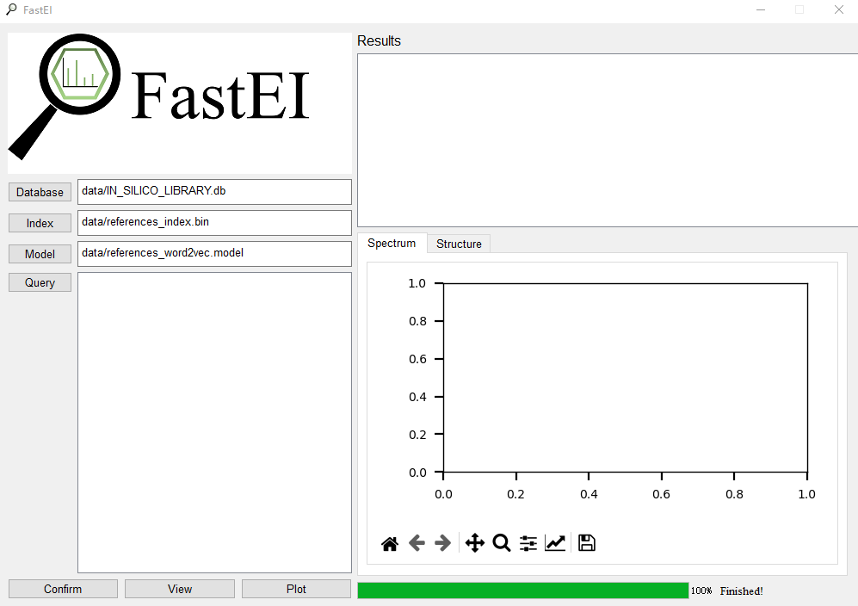

1. When click the **Query,** users can select and enter the experimental spectrum, which is needed to identify.

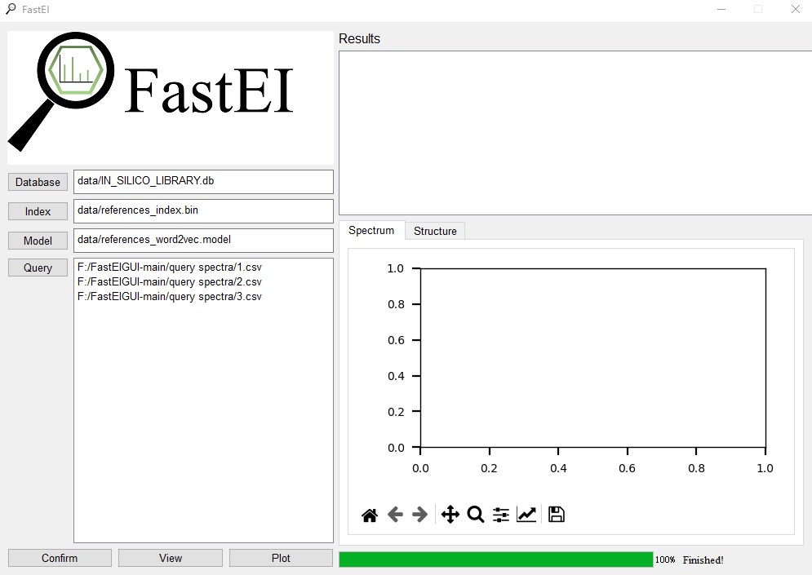

1. Users click the **Confirm**. The library matching will soon be finished.

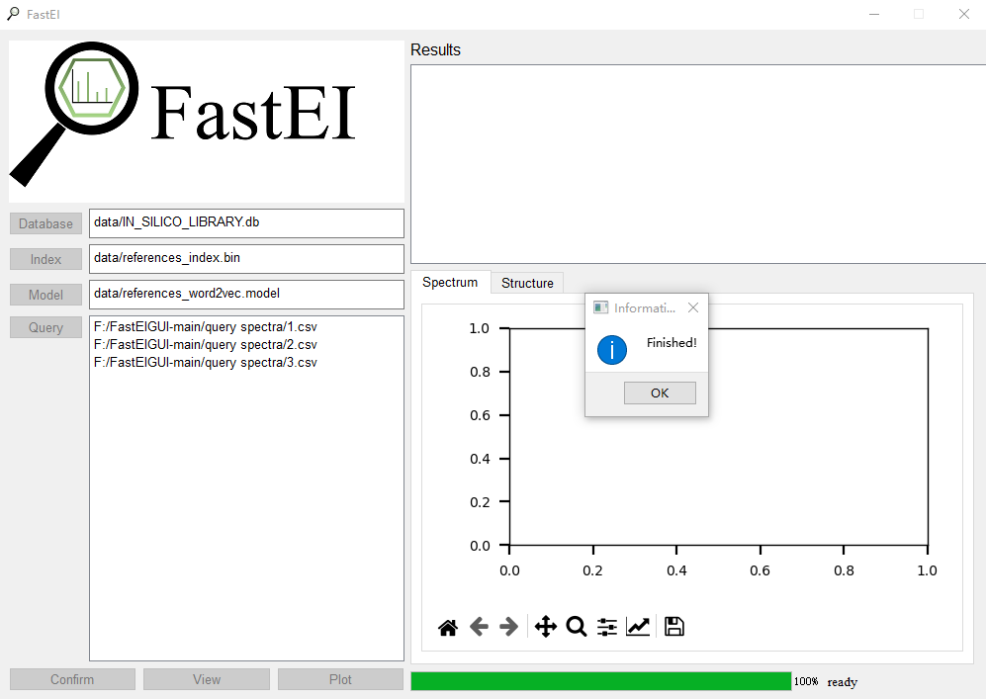

1. Users select one query spectrum and click the **View** to show the list of matched candidates of unknown compound.

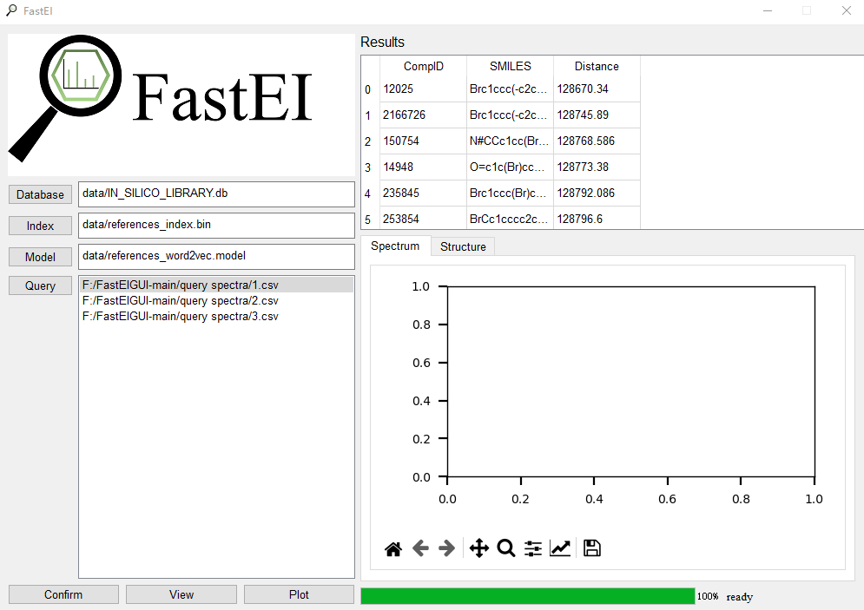

1. Users can select one of the candidates, and click the **Plot** to view the predicted spectrum of the candidate compared with the query spectrum on the right **Spectrum** area, and the molecular structure of the candidate on the right **Structure** area.

