**Assignment 1 Random Walk Analysis Report JinZhang**

**The following materials contain the evidences and Screen Shots of my conclusion about the Random Walk experiment.**

First, I modified the code from the git, change the code a little bit also implement the main function of the code. Then successfully passed the tests (Pic-1)

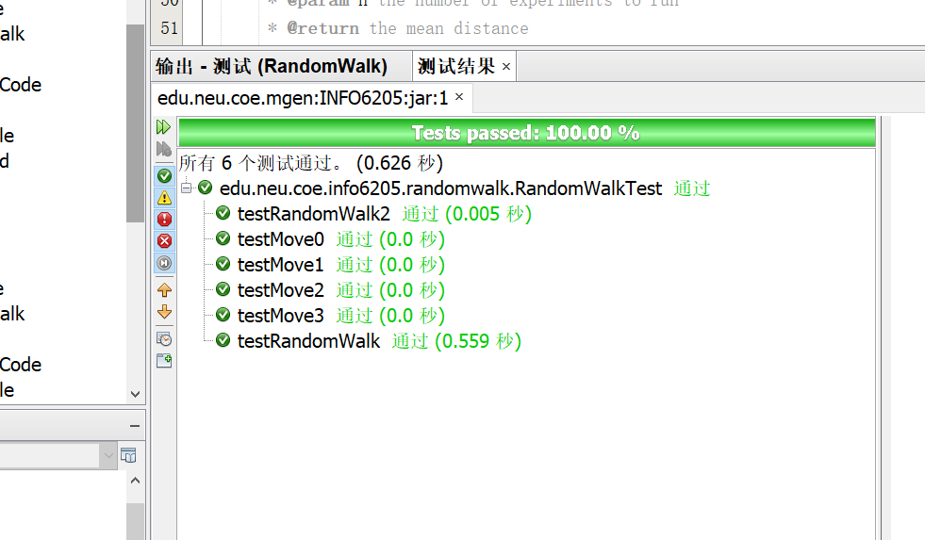

Pic-1

After that I began to figure out the relationship between d, landn though the experiment.

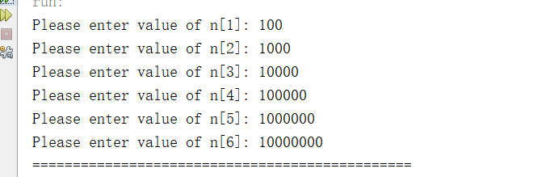

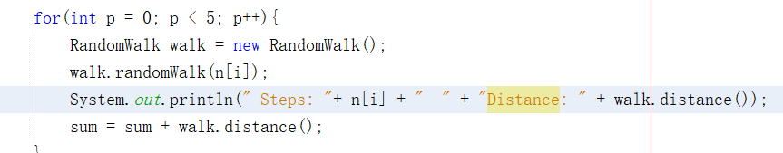

I run the experiment with six values of n and run each of these five times in the “for” loop.

Result of First Group Experiments (Pic-2)

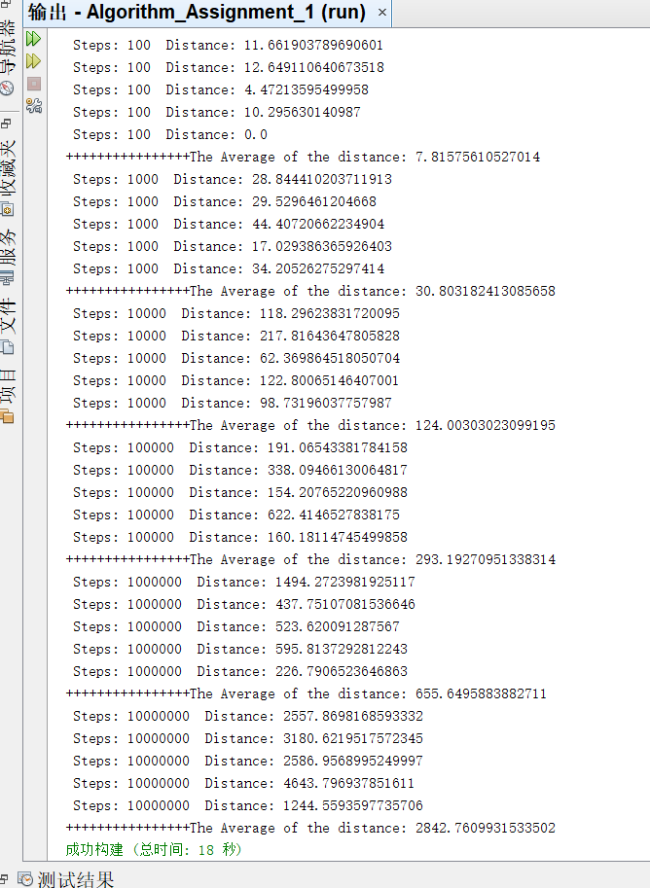

Pic-2

I use average of sum of the five distances which helps me discover the relationship between d, n and I (In my code the value of “I” is 1). Take look of the output the value of “d” approximately equals sqrt(n)*I. So, the conclusion about the relationship between d, n and l might be:

**d=I*sqrt(n)**

And I continuing to do the Second group (Pic-3) and the Third group(Pic-4) Experiments.

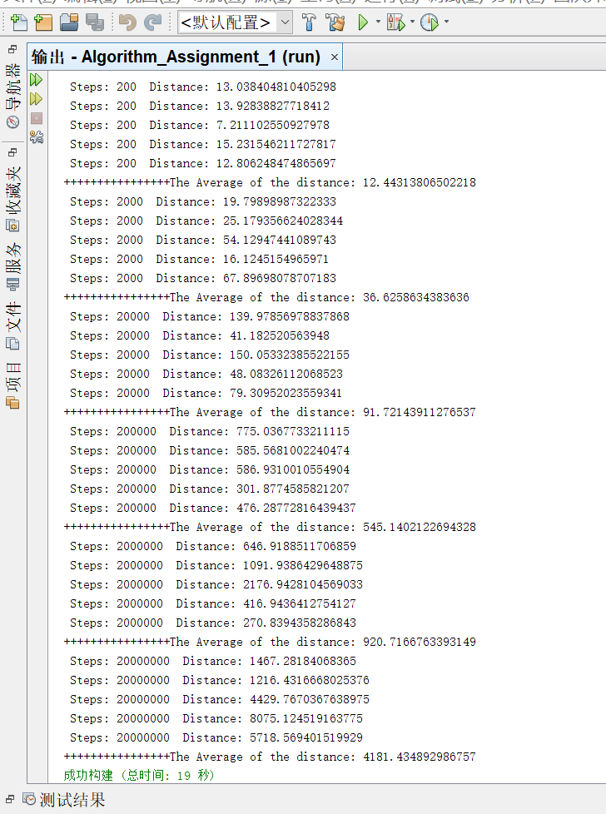

Pic-3

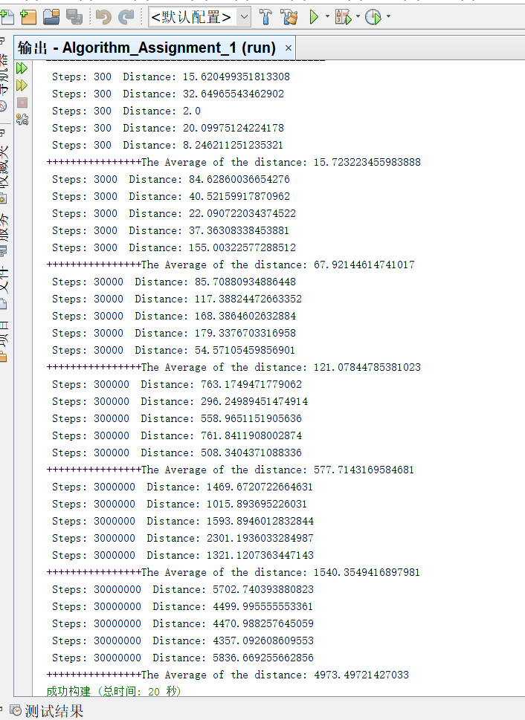

Pic-4

Although the result is not very accurate, this conclusion can generally be inferred.