**Assignment 2 Union-Find Analysis Report JinZhang**

I have Developed a ("union-find") Client Side implementation. Also tested 10 sets of outcomes to compare.

The screenshot **(Pic-1) & (Pic-2)** includes:

*The Average number of generated connections after running 100 times of count()*

*The Number of generated connections base on the formula n * 0.5 * Math.log(n)*

*The Relative Error between Them*

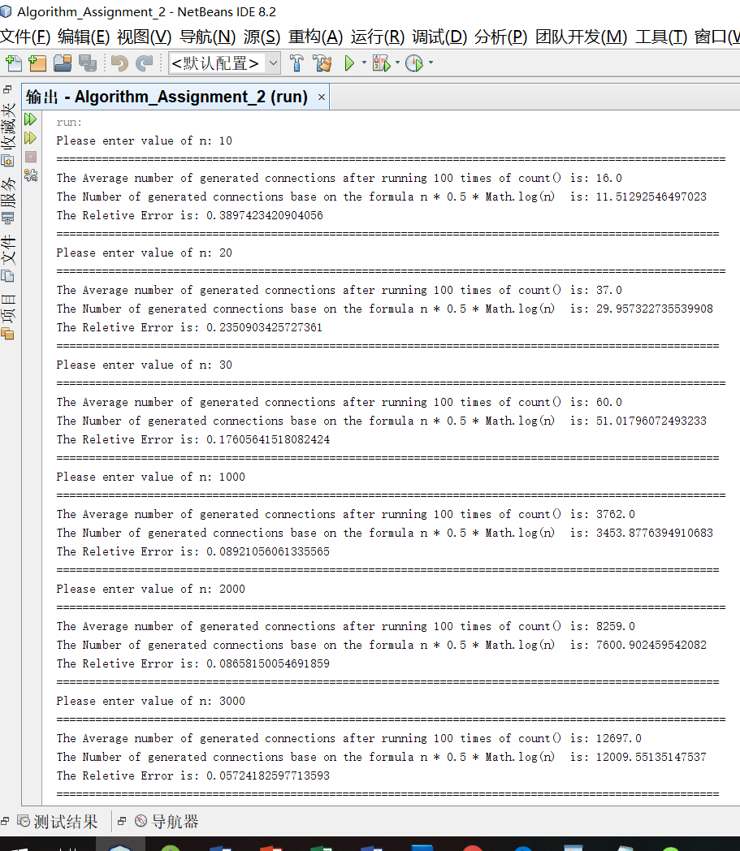

Pic-1

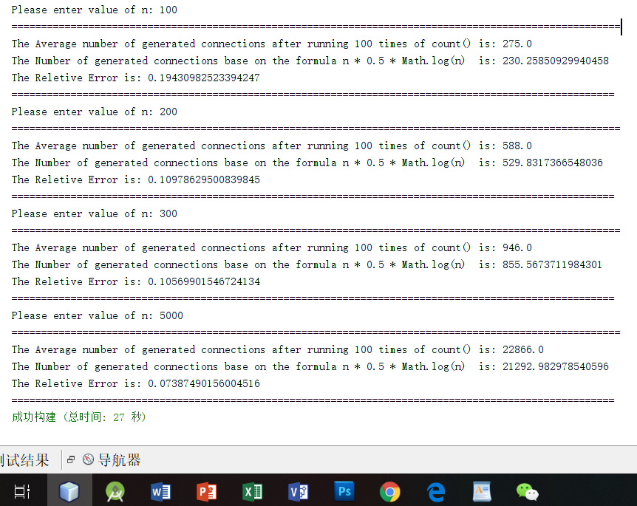

Pic-2

As we can see, the relative error of two outcomes is not too big. We can infer that the number of pairs approximately equals: **0.5 * n * ln(n).**