**Assignment 2 Union-Find Analysis Report JinZhang**

The running results of my program are shown in the screenshots below.

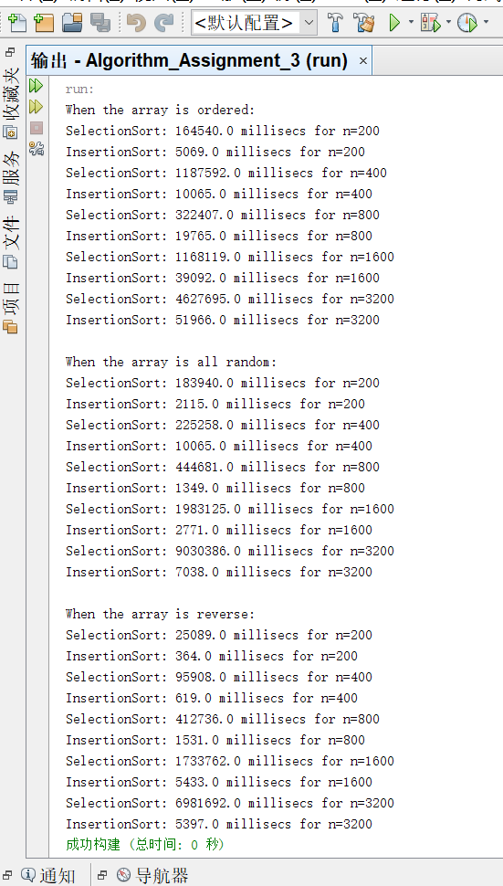

Based on these results, we can get that:

As for Selection Sort, the running time is insensitive to input data. Since whichever the type of input array is, the running time of the method doesn’t change almost.

On the other hand, the running time of the Insertion Sort is depended on the type of the input data. If the input array is already sorted, this method works better than that when the input array is random or reverse.