Retail Sales Data Engineering Project
Submitted By
Jina Bobby
Submitted To
NeoStats Analytics Labs Pvt. Ltd.
Date: 2/05/2026

1. Summary
This project presents an end-to-end Retail Sales Data Engineering solution designed to transform raw transactional retail data into actionable business insights. The pipeline leverages Python, Pandas, Jupyter Notebook, and Power BI to perform data ingestion, profiling, quality assessment, cleansing, transformation, and analytical processing.
The solution integrates multiple retail data sources, resolves data quality issues such as missing values, duplicates, and inconsistencies, and produces a curated dataset optimized for analytics. Key business metrics including revenue, customer activity, sales volume, product performance, and payment trends are generated through a structured ETL process. The processed data is visualized using interactive Power BI dashboards, demonstrating industry-standard data engineering practices and enabling data-driven business decision-making.
Overall, this project demonstrates how data engineering techniques can be used to convert raw data into a trusted analytical asset, enabling businesses to make informed decisions, improve operational efficiency, and better understand their sales performance.

2. Problem Statement
ABC Retail Solutions, a multinational retail company, operates across multiple cities through both online and offline sales channels. The organization collects transactional retail data from various systems; however, inconsistencies in the dataset such as duplicate transactions, missing values, inconsistent product naming conventions, invalid quantities, and varying date formats have created challenges in generating accurate business insights.Without a standardized and reliable data pipeline, the company faces difficulties in analyzing revenue trends, identifying bestselling products, monitoring category performance, and making data-driven business decisions.To improve reporting accuracy and operational efficiency, ABC Retail Solutions aims to build an end-to-end data engineering pipeline that ingests, cleans, transforms, and visualizes retail transaction data for business intelligence and reporting purposes.3. Dataset Description
Source workbook contains retail_data1, retail_data2, and product_details sheets. Key attributes include transaction information, customers, products, cities, payment methods, discounts, quantities, and payment status.

4. Data Profiling
- Profiling identified missing prices (404 records in retail_data1 and 405 records in retail_data2)
- duplicate transaction IDs
- negative/zero quantities
- category inconsistencies
- product naming inconsistencies
- date format inconsistencies.

5. Data Cleaning
- Missing Price Imputation:
A total of 809 missing price values were identified across the retail transaction datasets.
- Duplicate transaction records were removed after validation :
487 transaction identifiers appeared more than once in the dataset.
- Negative and zero quantities were excluded :
A total of 93 records contained invalid quantity values (0, -1, -2).
- Categories and product names were standardized.
- Date formats were normalized.

6. Data Transformation & Feature Engineering
After completing the data cleaning process, the retail datasets were transformed into a unified and analytics-ready format to support business intelligence and reporting requirements. The transformation phase focused on integrating data from multiple sources, generating meaningful business metrics, and creating additional features to facilitate deeper analysis.
Data Transformation Activities
- Consolidated retail_data1 and retail_data2 into a single unified transactional dataset.
- Standardized data formats and ensured consistency across all business entities.
- Validated business rules and removed records that could negatively impact analytical accuracy.

Revenue was calculated using:
Revenue = Price × Quantity × (1 - Discount).
Feature Engineering
To enhance analytical capabilities and support dashboard reporting, several derived features were generated from the transactional data:
- Revenue – Transaction-level sales value after discount adjustments.
- Month Name – Extracted from the transaction date to enable monthly trend analysis.
- Month Number – Created to ensure chronological sorting of monthly reports and visualizations.

7. Architecture
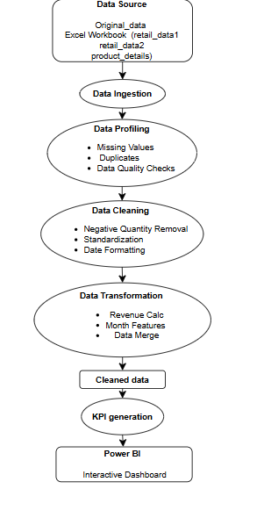
The architecture represents the complete data engineering workflow followed in this project. Retail sales data from multiple sheets (retail_data1, retail_data2, and product_details) is first ingested and profiled to identify data quality issues such as missing values and duplicates. The data is then cleaned through standardization, invalid record are removed, and date formatting. After cleaning, transformation processes including data merging, revenue calculation, and feature engineering are performed to create a curated analytical dataset. This processed data is used to generate key business metrics and is finally visualized through interactive Power BI dashboards to support data-driven decision-making and business analysis.

8. Key Performance Indicators
Total Revenue: ₹1.164 Billion
Total Orders: 7,914
Total Customers: 1,960
Average Order Value: ₹147.08K
The analysis reveals a strong overall business performance, with total revenue exceeding ₹1.16 Billion generated from 7,914 customer transactions. The business served 1,960 unique customers, demonstrating a broad customer base and healthy market reach.
The Average Order Value (AOV) of ₹147.08K indicates that customers make relatively high-value purchases, contributing significantly to overall revenue growth. Product-level analysis identified Laptop as the highest revenue-generating product, highlighting the importance of the Electronics category within the business portfolio.

9. Dashboard Overview
Power BI dashboards include Revenue Trend Analysis, Revenue by Category, Revenue by City, Top Products, Payment Analysis, Customer Distribution, Interactive Filters, and Drill-through capabilities.
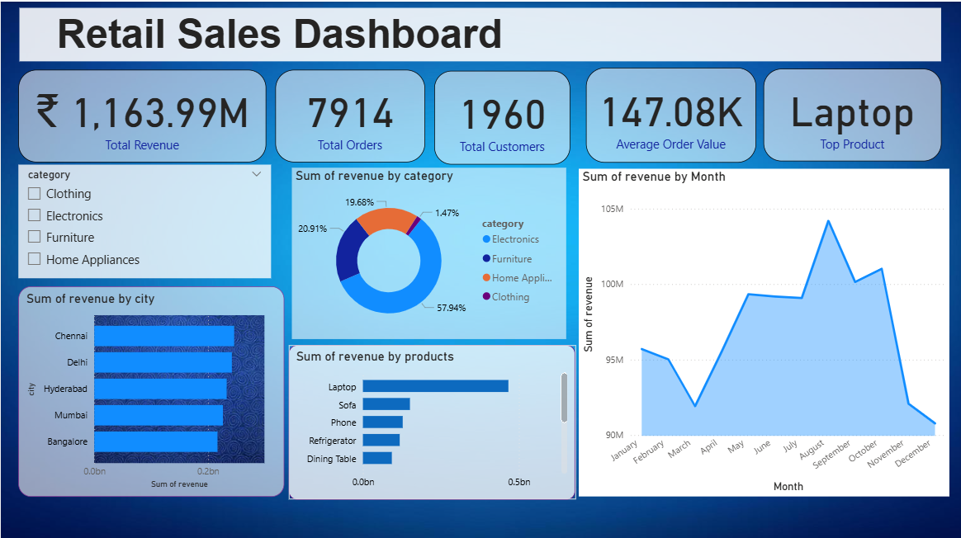
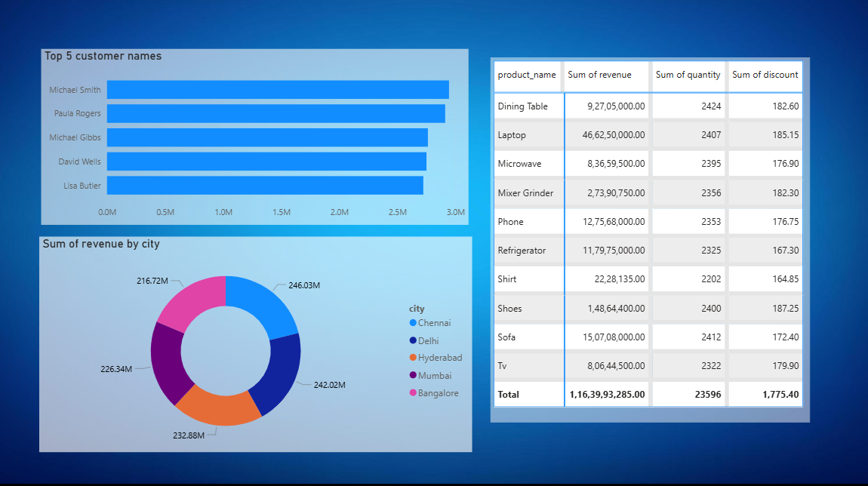

10. Key Business Insights
The analysis of the curated retail sales dataset revealed several significant business insights that can support strategic decision-making and future business planning.
Revenue and Category Performance
- The Electronics category emerged as the primary revenue driver, contributing approximately 58% of total business revenue. This indicates a strong customer preference for electronic products and highlights the category's critical role in overall business growth.
- In contrast, the Clothing category contributed the smallest share of revenue, accounting for less than 2% of total sales revenue, suggesting potential opportunities for product expansion, marketing initiatives, or pricing strategy improvements.
Product Performance Analysis
- Laptop was identified as the highest revenue-generating product, significantly outperforming other products across the portfolio.
- The dominance of Laptop sales indicates strong demand for premium electronic products and demonstrates their substantial contribution to overall revenue generation.
- Other products such as Sofa, Phone, Refrigerator, and Dining Table also showed strong performance and contributed significantly to total sales.
Regional Sales Analysis
- Chennai emerged as the top-performing city in terms of revenue generation, indicating a strong customer base and market presence in the region.
- Revenue distribution across Delhi, Hyderabad, Mumbai, and Bangalore was relatively balanced, suggesting healthy business penetration across major metropolitan markets.
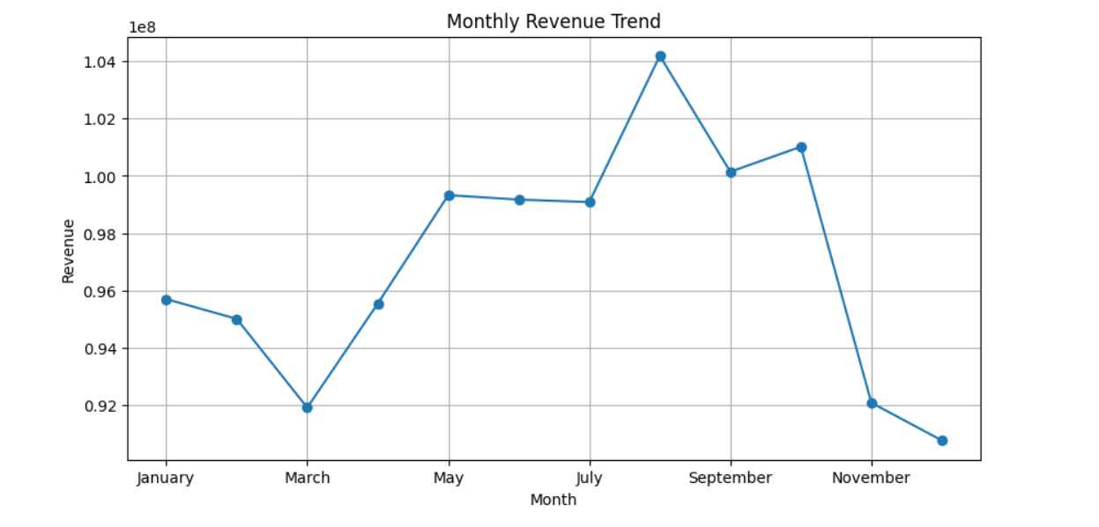
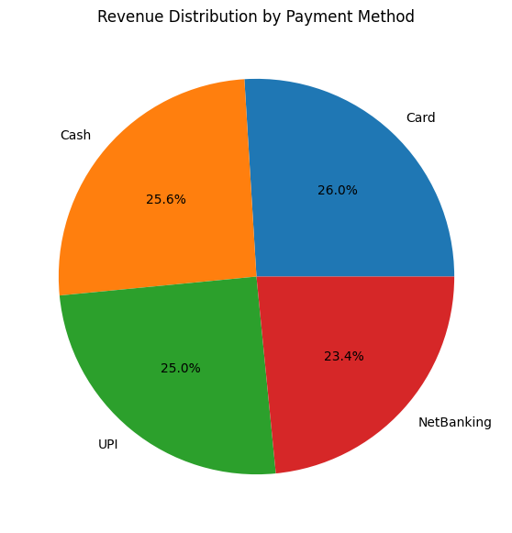
Payment Behavior Analysis
- Card payments accounted for the highest share of total revenue, making them the most preferred payment method among customers.
- Digital payment methods, including UPI and Net Banking, also contributed significantly, reflecting the growing adoption of cashless transactions in the retail sector.
Sales Channel Analysis
- Revenue generated through online and offline sales channels was relatively balanced, demonstrating the effectiveness of the organization's omnichannel retail strategy.
- The balanced performance of both channels suggests that customers actively engage with the business through multiple purchasing platforms.
Overall Business Observation
- The business demonstrated strong sales performance with revenue exceeding ₹1.16 Billion, supported by a diverse customer base of 1,960 unique customers and 7,914 successful transactions.
- The findings indicate that Electronics products, particularly Laptops, serve as the primary growth engine of the business, while regional and channel performance remains well distributed, reducing dependency on a single market segment.
- These insights can help stakeholders optimize inventory planning, strengthen high-performing categories, improve underperforming segments, and make informed data-driven business decisions.

11. Technology Stack
Python, Pandas, NumPy, Jupyter Notebook, Power BI, GitHub.

12. Future Scope
Integrate Azure Blob Storage, Azure Data Factory, Azure SQL Database, real-time streaming pipelines, automated orchestration, and cloud-native analytics.

13. Conclusion
This project successfully demonstrates the complete lifecycle of a modern data engineering solution, transforming raw retail sales data into a reliable and business-ready analytical asset. Through a structured ETL process involving data ingestion, profiling, cleansing, transformation, and feature engineering, the project addressed data quality challenges and ensured the accuracy and consistency of the final dataset.
By integrating multiple retail data sources and applying industry-standard data engineering practices, the solution enabled the generation of meaningful business metrics and insights. The interactive Power BI dashboards provided a comprehensive view of sales performance, customer behavior, product trends, payment patterns, and regional performance, allowing stakeholders to explore data and make informed decisions with confidence.
Beyond technical implementation, this project highlights the critical role of data engineering in converting fragmented and unstructured data into valuable business intelligence. The resulting solution not only improves data accessibility and analytical capabilities but also demonstrates how organizations can leverage data-driven insights to enhance operational efficiency, identify growth opportunities, and support strategic decision-making.
Overall, the project serves as a practical example of how a well-designed data pipeline can bridge the gap between raw data and actionable business outcomes, delivering both technical value and meaningful business impact.

