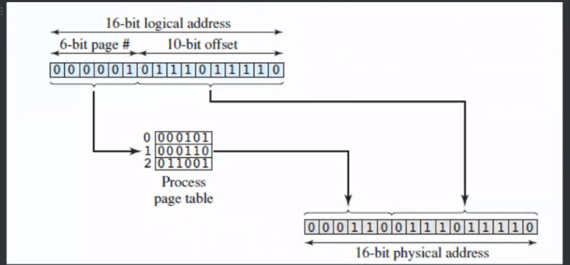

Offset<length

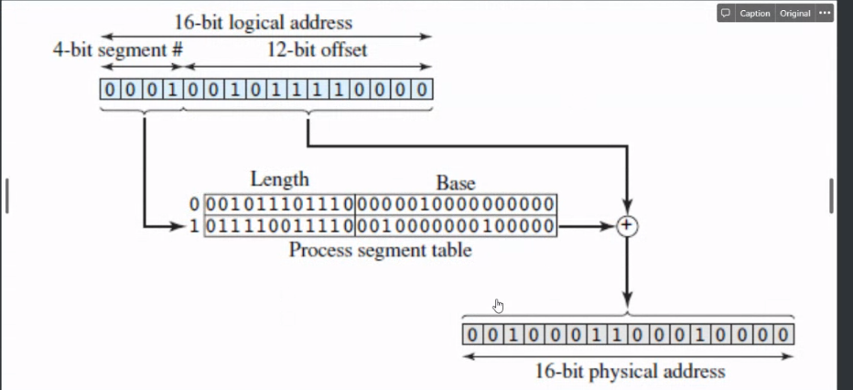

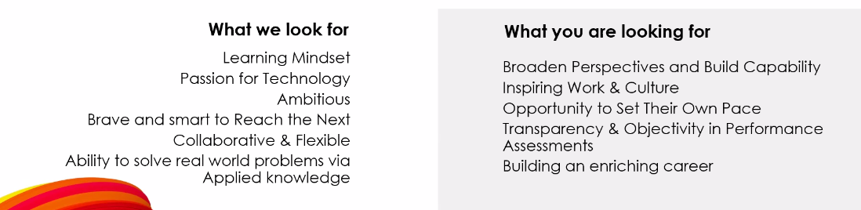

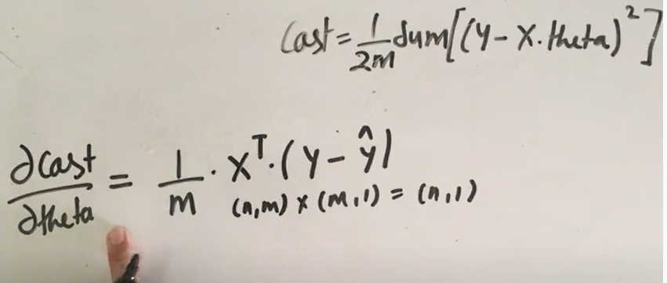

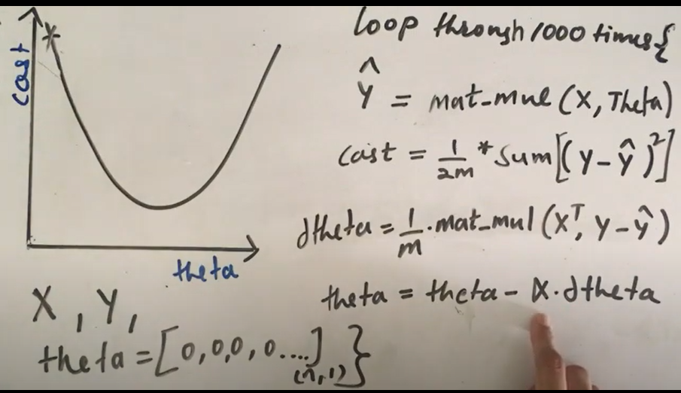

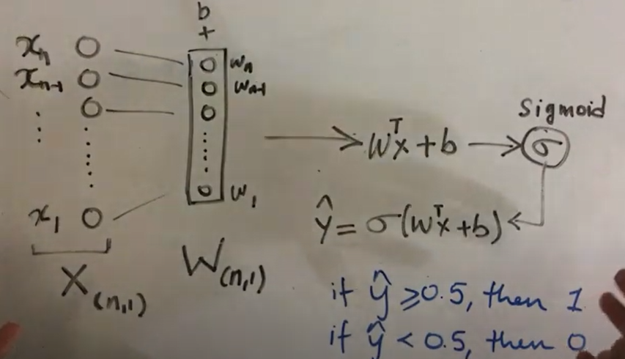

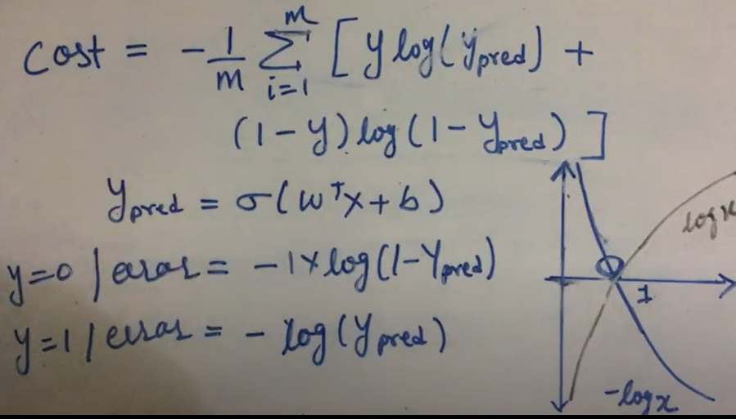

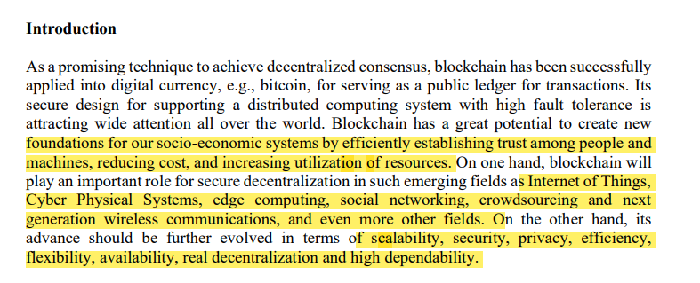

Theories of blockchain and distributed ledger technology

• Distributed consensus and fault tolerance mechanisms • Security, privacy and trust of blockchain and distributed ledger technology • Decentralization, scalability, and security tradeoff • Performance analysis and optimization • Simulation and performance evaluation techniques • Smart contract and chain code • Applications and services based on blockchain • Protocols and algorithms based on blockchain • Blockchain and Cryptocurrency • Blockchain in the Internet of things (IoT) • Blockchain in cyber physical systems • Blockchain in social networking • Blockchain in supply chain management • Blockchain in agriculture • Blockchain in connected and autonomous vehicles • Blockchain in crowdsourcing and crowdsensing • Blockchain in mobile cellular networks • Blockchain in edge and cloud computing • Blockchain in next generation communications and networks