# **PR-1**

## **Introduction to the basic network utility commands**

1. ipconfig: It shows the current IP address on which the user is connected.

C:\Users\Rahil>ipconfig

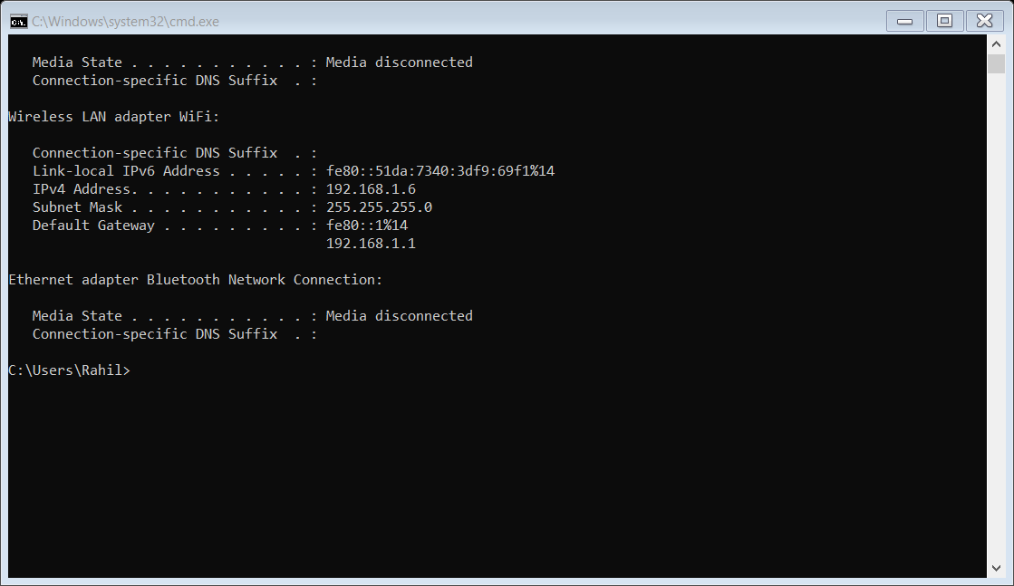

1. nslookup: To know the IP address of any website.

C:\Users\Rahil>nslookup google.com

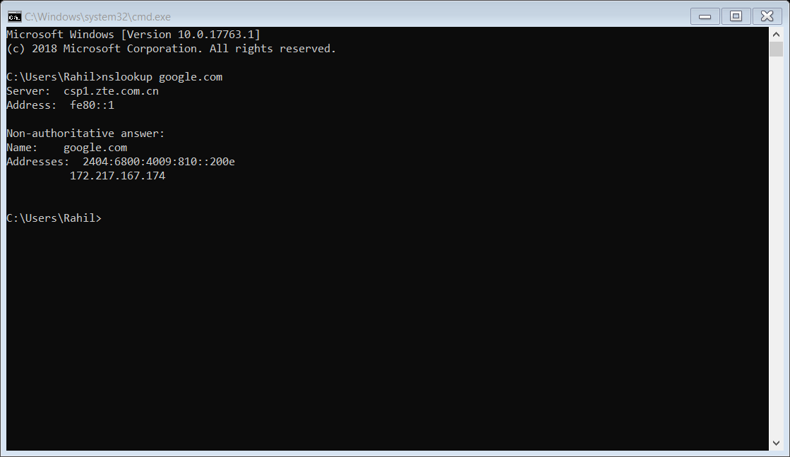

1. tracert: To trace the route of any site.

C:\Users\Rahil>tracert google.com

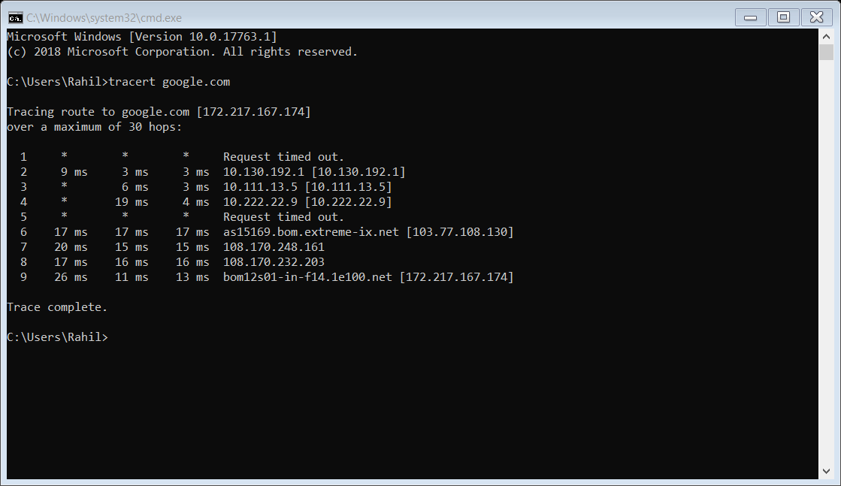

1. ping: To check the network/communication between the two sources.

C:\Users\Rahil>ping google.com

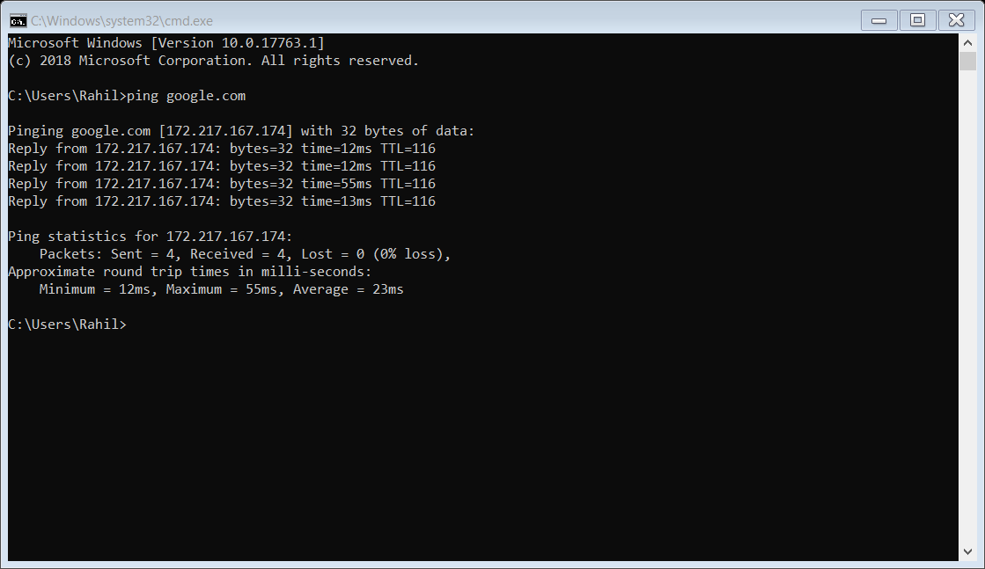

1. netstat -n: To check the users’ network status

C:\Users\Rahil>netstat -n

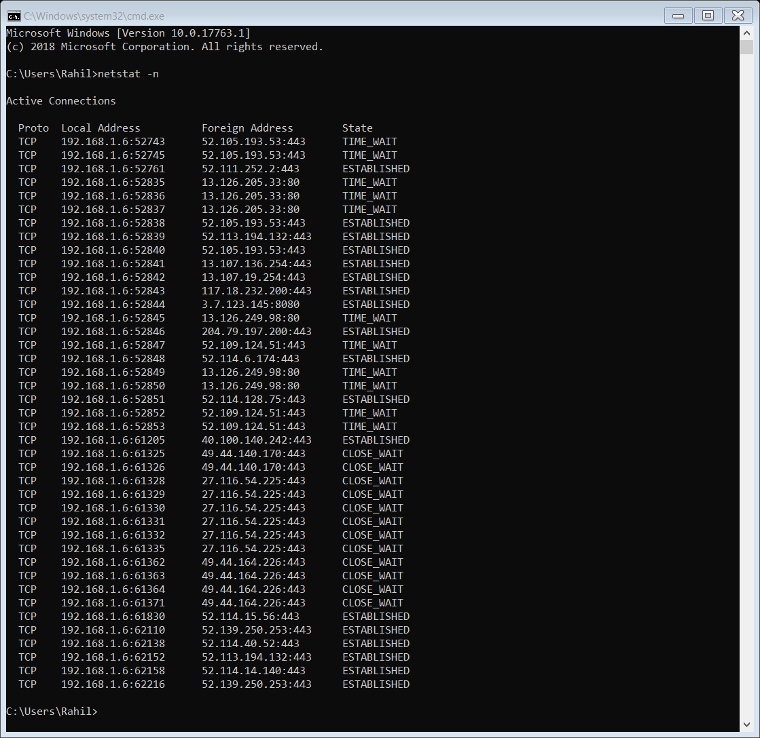

1. netstat -abn: To check the IP of various programs running on the source.

C:\Windows\system32>netstat -abn

[Note: It requires administrator permission]

## **PR-2**

## **Write a client-server C program for calculation of length of the string.**

**Steps:**

1. Pipe making at server.

2. Server will listen on pipe.

3. Take input of string.

4. String passing.

5. String will be received on server.

6. Display string on server

7. Server calculates the length of the string.

8. Length passing.

9. Display of length of string

**Program:**

# Server side

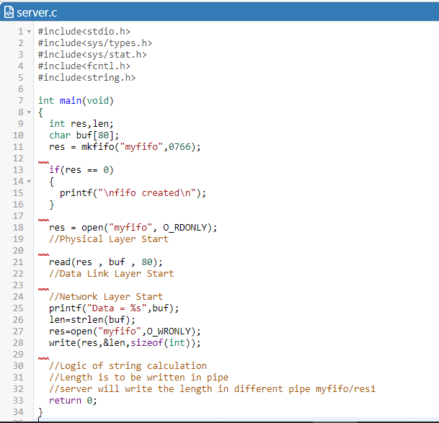

# Client side

**Output LINUX Terminal:**

# Server terminal

# **PR-3**

## **Write a C program for byte Stuffing.**

**Steps:**

1. pipe making(s)

2. server will listen on pipe(s)

3. user input of string(c)

4. perform stuffing. (c)

5. server receives data(s)

6. perform destuffing(s)

7. print de-stuffed data(s)

8. receives de-stuffed data(c)

9. print de-stuffed data(c)

**Program:**

# Server Side

# Client Side

**OUTPUT LINUX Terminal**

# Server Terminal

# Client Terminal

# **PR-4**

## **Write a C program for bit Stuffing.**

**Steps:**

1. pipe making(s)

2. server will listen on pipe(s)

3. user input of string(c)

4. perform stuffing. (c)

5. server receives data(s)

6. perform destuffing(s)

7. print de-stuffed data(s)

8. receives de-stuffed data(c)

9. print de-stuffed data(c)

**Program:**

# Server side

**OUTPUT LINUX Terminal**

# Server Terminal

# Client Terminal

# **PR-5**

## **Write a C program for Half Duplex by server and client terminal.**

**Program:**

# Server side

# Client Side

**OUTPUT LINUX Terminal:**

# Server Terminal

# Client Terminal

# **PR-6**

## **Write a C program for Cyclic Redundancy Code by server and client terminal.**

**Program:**

## Server Side:

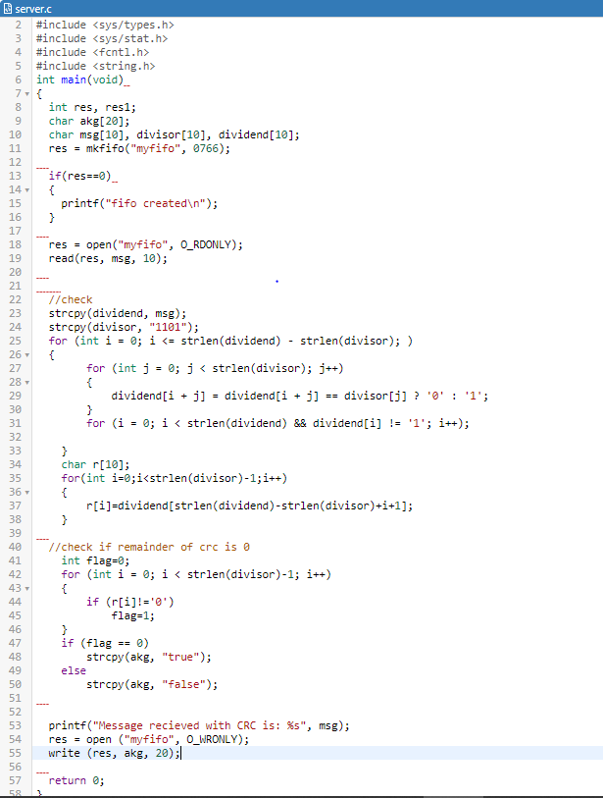

## Client Side:

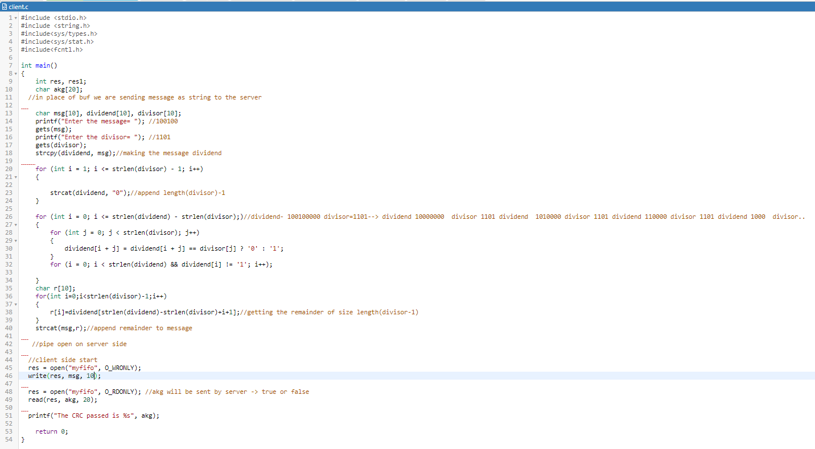

**OUTPUT LINUX Terminal:**

## Server Terminal:

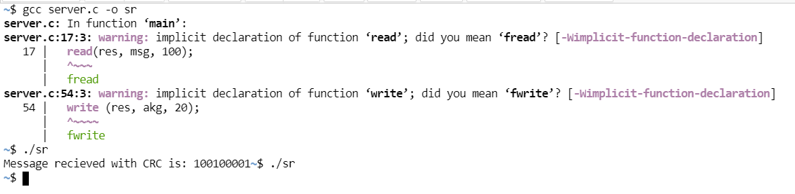

## Client Terminal:

