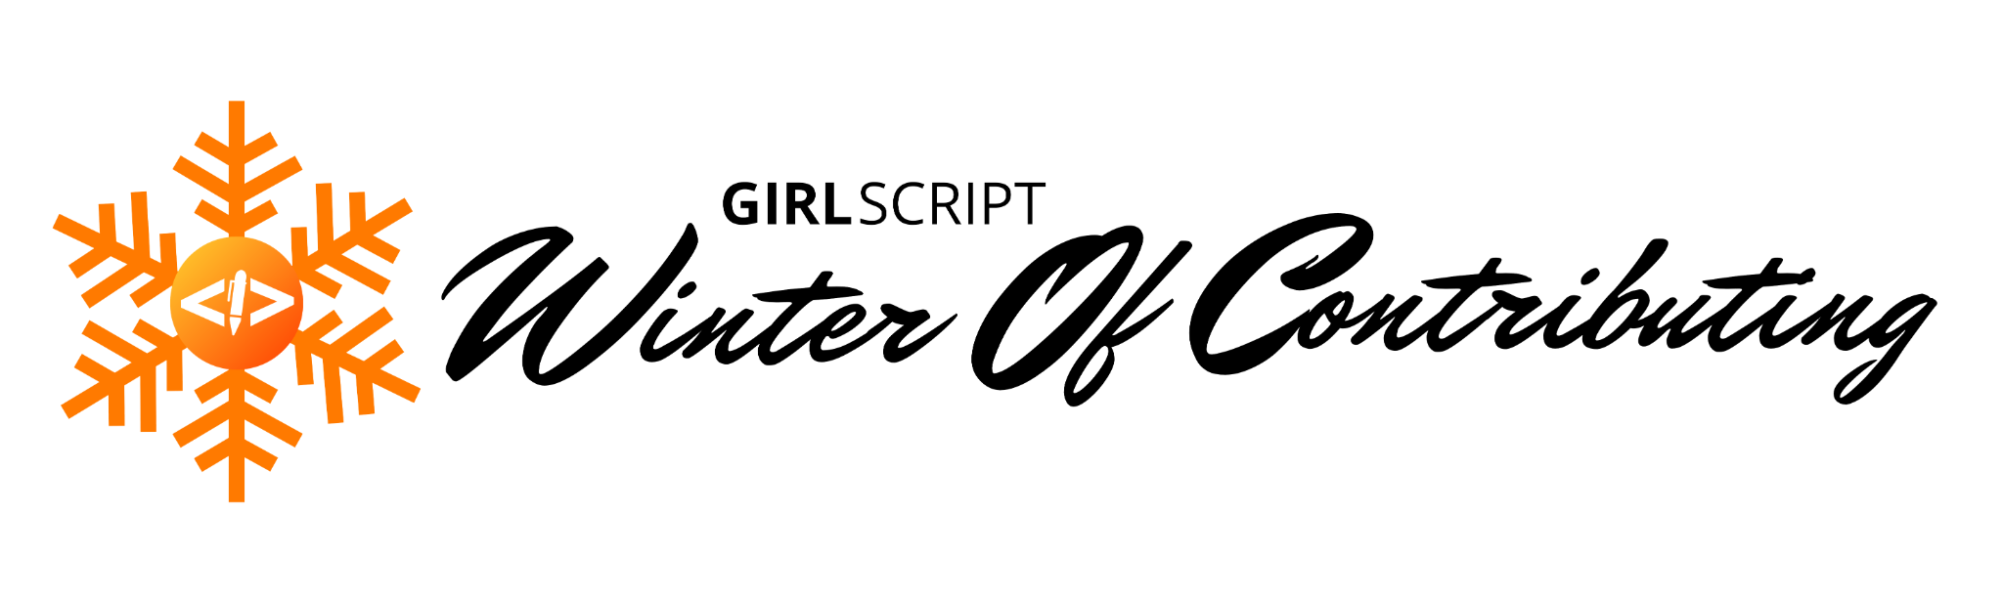

📌 **Code of Conduct** 📌

Read it carefully and fill in the details:

👉 Do not harass or insult other members. If such actions are reported to the organizers, then actions will be taken against the guilty. This includes threats, internet attacks, gender-based insults, and cyberbullying.

👉 Do not spam. Spamming is posting several messages at the same time. If any member is found spamming on this server, then he/she will face severe consequences. Spamming includes excessive caps, copy-pastes, picture/meme/link/GIF spam, reaction spam, and walls of text. Do not promote other Discord servers and any YouTube videos.

👉 Any promotional activity is not permitted without notifying the organizers.

👉 Every channel in the GWOC server is created for speciﬁc purposes. Make sure you convey the message in the right channel. Always keep within the designated topic of every channel.

👉 You can post your queries regarding the program only in the #general channel of the server.

👉 Once you have created a username for yourself, maintain the same throughout the program. If any member changes his/her username, then the username which is not registered with the organizing committee will cease to be a part of the program.

👉 If any participant leaves the program at any time before the conclusion in Dec 2021, then he/she will not be allowed to continue with the program.

👉 One cannot create ofﬁcial or unofﬁcial groups on Whatsapp, Signal, Telegram, and other social networking apps without the permission of the organizers.

👉 One cannot be disrespectful to other team members, organizers, sponsors, admins, mentors, and industry professionals.

👉 One cannot personally text anyone other than the team members without prior permission.

👉 You are expected to have a patient and a motivating nature throughout the program as that’s what open source is about.

👉 Always maintain good behavior by respecting your fellow teammates, mentors, admins, and the Organizing member.

**Strict adherence to the rules is advised. Any participant found violating the above guidelines will face necessary action and may be banned from participating in any future event organized by GirlScript.**

Please fill in the details: Name:

Email:

GitHub user name: Discord user name: Contact:

Signature: