这张照片显示的是2021年3月1日出现在犹他州骷髅谷的黄道光。昴宿星团在光柱顶部附近可见。火星就在其下方。资料来源：NASA/JPL-

**美国宇航局航天器前往木星的数据表明，火星可能正在向行星际空间脱落尘埃**

在黎明前或黄昏后抬头看夜空，你可能会看到一道微弱的光柱从地平线延伸上来。那发光的光柱就是黄道光，或者说是由绕着太阳运行的微小尘埃粒子云向地球反射的太阳光。天文学家长期以来一直认为，这些尘埃是由一些从远方冒险而来的小行星和彗星家族带入太阳系内部的。

但现在，朱诺号的科学家团队认为，火星可能是罪魁祸首。他们在3月9日的《地球物理研究杂志》上发表了他们的发现。朱诺号飞船上的一个仪器偶然检测到，在飞船从地球飞到木星的过程中，有尘埃颗粒砸向飞船。这些撞击为尘埃的起源和轨道演变提供了重要线索，解决了黄道光的一些神秘变化的问题。

虽然他们的发现有很大的意义，但已经花了多年时间研究各种宇宙碎片的科学家们原来并没有想到现在的结果。丹麦技术大学教授约翰-勒夫-约根森说："我从来没有想过我们本该从行星间的尘埃入手研究。"

约根森设计了四台恒星跟踪器，这是朱诺号磁力仪调查的一部分。这些机载相机每隔一刻钟就会拍下天空的照片，通过识别图像中的恒星图案来确定朱诺号在太空中的方位--这是一项对磁强计的准确性至关重要的工程任务。

但约根森希望他的相机也能捕捉到一颗未被发现的小行星。因此，他对一台相机进行了编程，以报告那些出现在多张连续图像中但不在已知天体目录中的东西。

他并没有报很大希望，因为天空中几乎所有的天体都已经在星表中出现过。不过，当相机开始向下传送数千张无法识别的天体图像时（条纹出现然后神秘消失）约根森和他的同事们都感到困惑。他说道"我们看着这些图像说，'这可能是什么？‘"。

约根森和他的团队考虑了许多合理的和一些不合理的原因。有一种令人不安的可能性，那就是星际相机在朱诺号上捕捉到了一个泄漏的燃料箱。"我们认为，'这真的有问题'，"约根森说。"图像看起来就像有人在窗外抖动一块布满灰尘的桌布。"

直到研究人员计算了图像中物体的明显尺寸和速度，他们才终于意识到了什么：尘粒以每小时约1万英里(或1.6万公里)的速度砸向朱诺号，削掉了亚毫米级的航天器碎片。位于马里兰州格林贝尔特的美国宇航局戈达德太空飞行中心，朱诺号磁力仪调查负责人、任务副首席调查员杰克-康纳尼说："尽管我们谈论的只是质量只有很小的物体，但这些尘埃加起来的质量却很厉害"。

结果发现，这些碎片的数据是从朱诺号广阔的太阳能电池板获取的。 也就是说这块太阳能电池板是有史以来最大、最灵敏的尘埃探测器，虽然他本不该是个尘埃检测器。

"我们追踪的每一块碎片都记录了行星间尘埃粒子的撞击，使我们能够编制出朱诺号沿途的尘埃分布，"康纳尼说。朱诺号于2011年发射。2012年在小行星带进行深空机动后，它于2013年返回内太阳系进行地球引力辅助，将航天器推向木星。

康纳尼和约根森注意到，大部分尘埃撞击记录在地球和小行星带之间，分布的空白与木星引力的影响有关。科学家们认为，这是一个根本性的相关性发现。在此之前，科学家们一直无法测量这些尘埃粒子在太空中的分布情况。专用的尘埃探测器的收集面积有限，因此对稀少的尘埃群体的敏感度有限。它们大多统计的是来自星际空间的数量更多、体积更小的尘埃粒子。相比之下，朱诺号广阔的太阳能电池板的收集面积是大多数尘埃探测器的1000倍。

朱诺号科学家确定，尘埃云的一端是地球轨道，因为地球的引力会吸走所有靠近地球的尘埃。约根森说："这就是我们看到的黄道光的尘埃"。

至于外缘，距离太阳约2个天文单位（AU）（1AU是地球和太阳之间的距离），它的终点就在火星之外。科学家报告说，在这一点上，木星引力的影响就像一道屏障，阻止尘埃粒子从太阳系内部穿越到深空。这种被称为轨道共振的现象也会以另一种方式发挥作用，即阻止源自深空的尘埃进入内太阳系。

约根森说，重力屏障的深刻影响表明，尘埃粒子处于围绕太阳的近乎圆形的轨道上。他说，"而我们所知道的唯一一个位于2AU的近乎圆形轨道的行星就是火星，所以自然而然地认为火星是这种尘埃的来源。"

在黎明前或黄昏后抬头看夜空，你可能会看到一道微弱的光柱从地平线延伸上来。天文学家长期以来一直认为，这些尘埃是由一些从远方冒险进入太阳系内部的小行星和彗星家族带来的。但现在，朱诺科学家团队认为，火星可能是罪魁祸首。

康纳尼说："我们测量的尘埃分布应该与已观测到的黄道光的变化相一致"。这是因为研究人员已经开发了一个计算机模型来预测尘埃云反射的光线：通过与模型中木星的引力相互作用，模型中的尘埃散射到一个比现实更厚的圆盘中。散射只取决于两个量：尘埃对黄道的倾角和其轨道偏心率。当研究人员插入火星的轨道，这个变量时，该模型分布准确地预测了黄道光在黄道附近变化的明显特征。康纳尼说："在我看来，这证实了我们确切地知道这些粒子在太阳系中是如何运行的，及它们的来源。"

虽然现在有很好的证据表明，火星，我们已知的尘埃最多的星球，是黄道光的来源，但约根森和他的同事们还无法解释这些尘埃是如何逃脱火星引力的控制的。他们希望其他科学家能够帮助他们。

同时，研究人员指出，找到太阳系中尘埃粒子的真实分布和密度，将有助于工程师设计出能够更好地抵御尘埃冲击的航天器材料。了解尘埃的精确分布也可以指导未来航天器的飞行路线设计，以避开最高浓度的粒子。微小的颗粒以如此高的速度飞行，可以从航天器上抠出多达1000倍质量的颗粒。

但朱诺号的太阳能电池阵列之所以没有受到伤害，是因为太阳能电池受到支撑结构的良好保护，不受阵列背面（或暗面）的冲击。

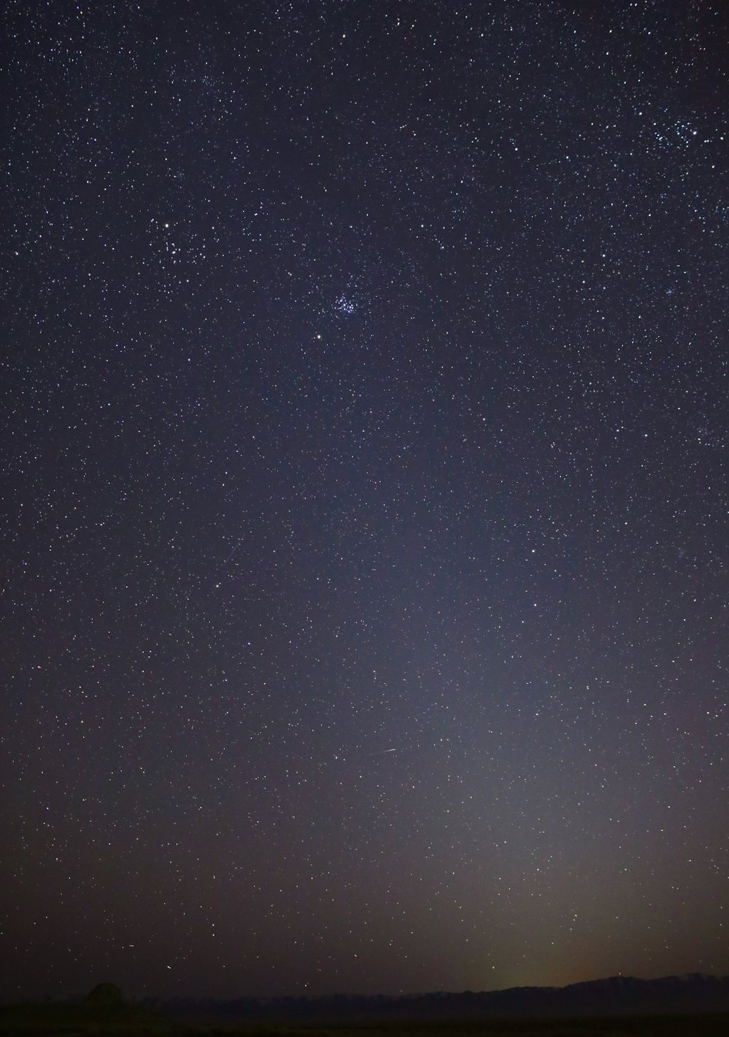

This photo shows the zodiacal light as it appeared on March 1, 2021, in Skull Valley, Utah. The Pleiades star cluster is visible near the top of the light column. Mars is just below that. Credit: NASA/JPL-Caltech [Full Image Details](https://www.jpl.nasa.gov/images/zodiacal-light)

**Data from the NASA spacecraft’s journey to Jupiter suggests that Mars may be shedding dust into interplanetary space.**

Look up to the night sky just before dawn, or after dusk, and you might see a faint column of light extending up from the horizon. That luminous glow is the zodiacal light, or sunlight reflected toward Earth by a cloud of tiny dust particles orbiting the Sun. Astronomers have long thought that the dust is brought into the inner solar system by a few of the asteroid and comet families that venture in from afar.

But now, a team of Juno scientists argues that Mars may be the culprit. They published their finding in a [March 9 paper](https://agupubs.onlinelibrary.wiley.com/doi/full/10.1029/2020JE006509) in the Journal of Geophysical Research: Planets. An instrument aboard the Juno spacecraft serendipitously detected dust particles slamming into the spacecraft during its journey from Earth to Jupiter. The impacts provided important clues to the origin and orbital evolution of the dust, resolving some mysterious variations of the zodiacal light.

**Get the Latest JPL News**

[**SUBSCRIBE TO THE NEWSLETTER**](https://www.jpl.nasa.gov/signup/)

Though their discovery has big implications, the scientists who spent years studying cosmic debris did not set out to do so. “I never thought we’d be looking for interplanetary dust,” said [John Leif Jørgensen](https://www.dtu.dk/english/service/phonebook/person?id=1197&tab=2&qt=dtupublicationquery), a professor at the Technical University of Denmark.

Jørgensen designed the four star trackers that are part of Juno’s magnetometer investigation. These onboard cameras snap photos of the sky every quarter of a second to determine Juno’s orientation in space by recognizing star patterns in its images – an engineering task essential to the magnetometer’s accuracy.

But Jørgensen hoped his cameras might also catch sight of an undiscovered asteroid. So he programmed one camera to report things that appeared in multiple consecutive images but weren’t in the catalog of known celestial objects.

He didn’t expect to see much: Nearly all objects in the sky are accounted for in the star catalog. So when the camera started beaming down thousands of images of unidentifiable objects – streaks appearing then mysteriously disappearing – Jørgensen and his colleagues were baffled. “We were looking at the images and saying, ‘What could this be?’” he said.

Jørgensen and his team considered many plausible and some implausible causes. There was the unnerving possibility that the star camera had caught a leaking fuel tank on Juno. “We thought, ‘Something is really wrong,’” Jørgensen said. “The images looked like someone was shaking a dusty tablecloth out their window.”

It wasn’t until the researchers calculated the apparent size and velocity of the objects in the images that they finally realized something: Dust grains had smashed into Juno at about 10,000 miles (or 16,000 kilometers) per hour, chipping off submillimeter pieces of spacecraft. “Even though we’re talking about objects with only a tiny bit of mass, they pack a mean punch,” said [Jack Connerney](https://science.gsfc.nasa.gov/sed/bio/john.e.connerney), Juno’s magnetometer investigation lead and the mission’s deputy principal investigator, who’s based at NASA’s Goddard Space Flight Center in Greenbelt, Maryland.

As it turned out, the spray of debris was coming from Juno’s expansive solar panels – the biggest and most sensitive unintended dust detector ever built.

“Each piece of debris we tracked records the impact of an interplanetary dust particle, allowing us to compile a distribution of dust along Juno’s path,” Connerney said. Juno launched in 2011. After a [deep-space maneuver](https://www.youtube.com/watch?v=iUBHRAJzIg0) in the asteroid belt in 2012, it returned to the inner solar system for an Earth gravity assist in 2013, which catapulted the spacecraft towards Jupiter.

Connerney and Jørgensen noticed that the majority of dust impacts were recorded between Earth and the asteroid belt, with gaps in the distribution related to the influence of Jupiter’s gravity. According to the scientists, this was a radical revelation. Before now, scientists have been unable to measure the distribution of these dust particles in space. Dedicated dust detectors have had limited collection areas and thus limited sensitivity to a sparse population of dust. They mostly count the more abundant and much smaller dust particles from interstellar space. In comparison, Juno’s expansive solar panels have 1,000 times more collection area than most dust detectors.

Juno scientists determined that the dust cloud ends at Earth because Earth’s gravity sucks up all the dust that gets near it. “That’s the dust we see as zodiacal light,” Jørgensen said.

As for the outer edge, around 2 astronomical units (AU) from the Sun (1 AU is the distance between Earth and the Sun), it ends just beyond Mars. At that point, the scientists report, the influence of Jupiter’s gravity acts as a barrier, preventing dust particles from crossing from the inner solar system into deep space. This same phenomenon, known as orbital resonance, also works the other way, where it blocks dust originating in deep space from passing into the inner solar system.

The profound influence of the gravity barrier indicates that the dust particles are in a nearly circular orbit around the Sun, Jørgensen said. “And the only object we know of in almost circular orbit around 2 AU is Mars, so the natural thought is that Mars is a source of this dust,” he said.

Look up to the night sky just before dawn, or after dusk, and you might see a faint column of light extending up from the horizon. Astronomers have long thought that the dust is brought into the inner solar system by a few of the asteroid and comet families that venture in from afar. But now, a team of Juno scientists argues that the planet Mars may be the culprit.

 Credit: NASA Goddard

“The distribution of dust that we measure better be consistent with the variation of zodiacal light that has been observed,” Connerney said. The researchers developed a computer model to predict the light reflected by the dust cloud, dispersed by gravitational interaction with Jupiter that scatters the dust into a thicker disk. The scattering depends only on two quantities: the dust inclination to the ecliptic and its orbital eccentricity. When the researchers plugged in the orbital elements of Mars, the distribution accurately predicted the telltale signature of the variation of zodiacal light near the ecliptic. “That is, in my view, a confirmation that we know exactly how these particles are orbiting in our solar system,” Connerney said, “and where they originate.”

While there is good evidence now that Mars, the dustiest planet we know of, is the source of the zodiacal light, Jørgensen and his colleagues cannot yet explain how the dust could have escaped the grip of Martian gravity. They hope other scientists will help them.

In the meantime, the researchers note that finding the true distribution and density of dust particles in the solar system will help engineers design spacecraft materials that can better withstand dust impacts. Knowing the precise distribution of dust may also guide the design of flight paths for future spacecraft in order to avoid the highest concentration of particles. Tiny particles traveling at such high velocities can gouge up to 1,000 times their mass from a spacecraft.

Juno’s solar arrays escaped harm because the solar cells are well protected against impact on the back – or dark – side of the array by the support structure.