**IT643: Software Design and Testing**

**Autumn 2024-25**

**Use Case Modeling - UML**

**Name :** Shah Jinansh

**Student id :** 202312065

[Q-1] Use case for library management system

**USE CASE (ISSUE BOOK)**

**Actors:**

1. **Student**: The entity that borrows books.
2. **Librarian**: The entity that manages the issue and return process.
3. **Library Management System**: The system that handles the transaction processes.

**Use Cases:**

1. **Registration/Login :** The process where a student can register or login into the system.
2. **Search Book :** The process where a book is searched by a student.
3. **Issue Book:** The process where a book is borrowed by a student.
4. **Return Book:** The process where a student returns a book.
5. **Pay Fine:** The process where a student pays for any overdue fines.

**Preconditions:**

1. The student must be registered in the library management system.
2. The book to be issued must be available and not currently issued to another student.
3. The student must not have overdue books or unpaid fines.
4. The system must be online and functional.

**Postconditions:**

1. The book is marked as issued in the system and assigned to the student.
2. The due date for the return of the book is set and recorded.
3. The student's record is updated to reflect the issued book.
4. The librarian is notified of the transaction for record-keeping and monitoring.

**Goal:**

* To allow registered students to borrow books from the library for a specified period, ensuring that all transactions are recorded and managed properly.

[Q-2]  The following text describes the process for managing employee training requests in the Work Hard Company, Ltd.

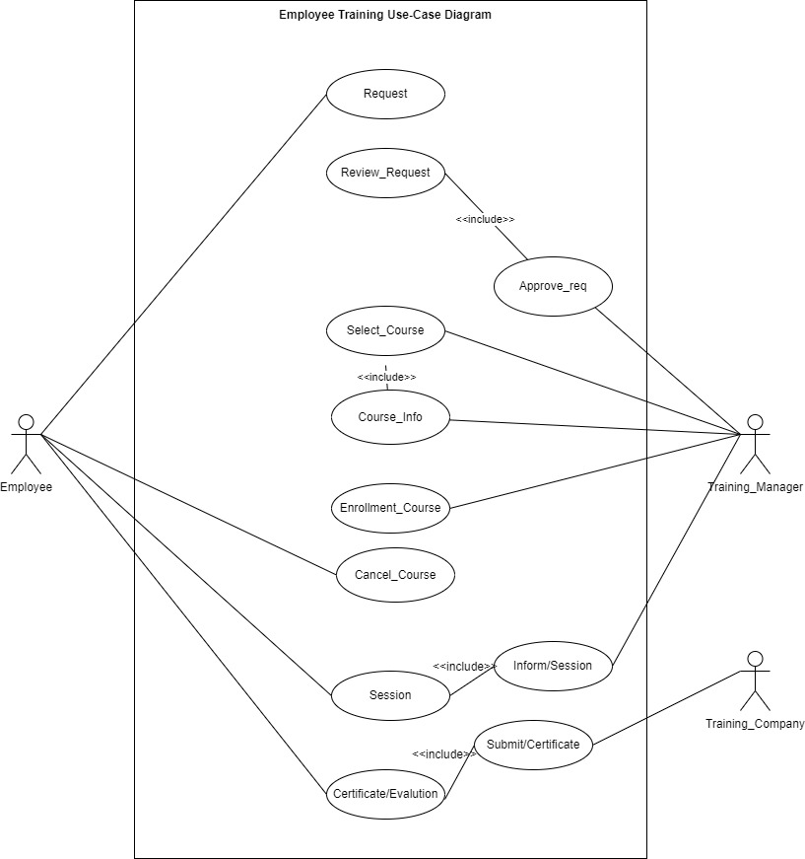

[Q-3] The following figure contains a set of different use cases and actors. Define relationshipsbetween them. Use the relationships to generalize, extend and include. You should also connect the actors to the use cases.

