Relation between CPI and S&P 500
A Comparative Analysis of Two Independent Studies

Table of Contents
Introduction..............................................................................................................3
Study 1: 2012–2022 Analysis..................................................................................4
Data Preparation.............................................................................................................4
Analysis.........................................................................................................................5
Study 2: 2000–2014 Analysis..................................................................................7
Data Preparation.............................................................................................................7
Analysis.........................................................................................................................8
Comparison of Findings..........................................................................................11
Conclusion................................................................................................................12
References..............................................................................................................13

Introduction
In the intricate web of modern economics, the relationship between inflation — as measured by the Consumer Price Index (CPI) — and equity market performance, particularly the S&P 500, has been a subject of continued interest and debate among economists, policymakers, and investors alike.
The CPI reflects the average change over time in the prices paid by urban consumers for a market basket of goods and services, while the S&P 500 represents a broad cross-section of the U.S. equity market, encompassing 500 leading companies. As such, it serves as a barometer for the overall health of the U.S. stock market.
Understanding the correlation and causal pathways between these two crucial economic variables is essential — not only for macroeconomic policy formulation but also for individual investment decision-making. While some argue that inflationary pressures may erode corporate profit margins and thereby affect stock prices, others point to the complex interplay of factors such as monetary policy, global economic conditions, and sector-specific dynamics that modulate this relationship.
This report presents and compares two independent analyses of the CPI–S&P 500 relationship, each using a different dataset and time period. Both studies seek to answer the following key questions:
- What is the linear correlation between the CPI and the S&P 500 over the study period?
- Is there a causal (Granger) relationship between the two indicators, and if so, in which direction?
By presenting both analyses side by side, this report offers a richer, more nuanced view of a relationship that is often more complex than conventional wisdom might suggest.

Study 1: 2012–2022 Analysis
This study uses a CPI dataset with monthly CPI values reported as month-over-month percentage change, covering May 2012 to October 2022, yielding 130 data points.

Data Preparation

Data Sources
Both datasets were obtained from Kaggle.com. The S&P 500 dataset provides daily open, high, low, and closing prices from January 2000 onwards. The CPI dataset provides monthly actual, predicted, and previous CPI readings, where the 'Actual' column represents the month-over-month percentage change in consumer prices.

Data Quality Issues
Date format inconsistency. The S&P 500 dataset contained dates in mixed formats — most in MM/DD/YYYY but some using two-digit years (e.g., '01/13/21'). This was resolved using pandas' format='mixed' argument when parsing dates.

df_sp500['Date'] = pd.to_datetime(df_sp500['date'], format='mixed')

Frequency mismatch. The S&P 500 data is daily while CPI is monthly. To align them, S&P 500 prices were resampled to a monthly frequency, taking the first open, highest high, lowest low, and mean closing price for each month.

df_sp500_monthly = df_sp500.set_index('Date').resample('ME').agg({
'open': 'first',
'high': 'max',
'low': 'min',
'close': 'mean'
})

Date alignment. The CPI dates were mid-month while the S&P 500 resampled dates were end-of-month. Both were normalised to month-start before merging.

df_cpi['Date'] = df_cpi['Date'].dt.to_period('M').dt.to_timestamp()
df_merged = pd.merge(df_sp500_monthly, df_cpi, on='Date', how='inner')

After merging and restricting to the CPI dataset's range, the final dataset contains 130 monthly observations from May 2012 to October 2022.

Analysis

First Glance: Concurrent Trends
A dual-axis line chart was produced plotting both S&P 500 closing prices and CPI (month-over-month % change) over time. While both series generally trended upward, the relationship was noted to be potentially misleading on a shared dual-axis plot, since each axis is independently scaled. The chart was interpreted with caution.
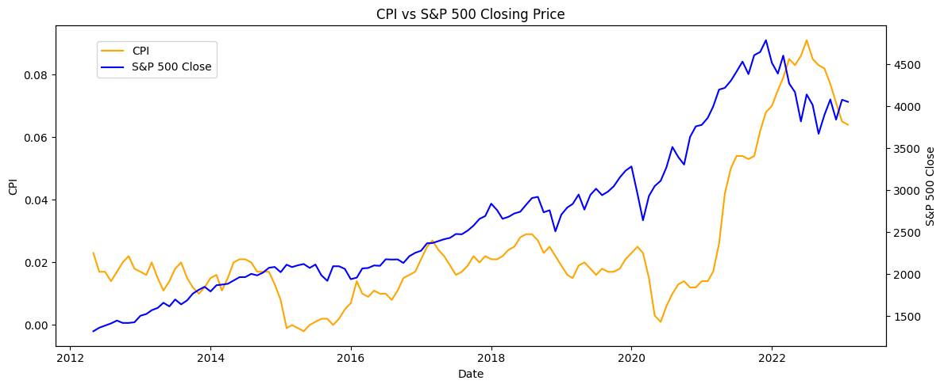
Figure 1.1: S&P 500 monthly close and CPI (month-over-month % change), 2012–2022

Linear Correlation
Pearson's correlation coefficient between the CPI (month-over-month % change) and S&P 500 closing price was calculated as follows:

from scipy.stats import pearsonr
correlation, pvalue = pearsonr(df_merged['CPI'], df_merged['close'])
# Pearson correlation coefficient: 0.7151
# P-value: 0.0000

Result: r = 0.7151, p < 0.0001 (statistically significant).
A strong positive correlation was found, suggesting that in this period — as monthly inflation readings increased — S&P 500 closing prices tended to be higher as well. The high significance (p < 0.0001) indicates the result is very unlikely to be due to chance.

Granger Causality Test
To explore whether one variable can be used to predict the other, Granger causality tests were performed. Both time series were first checked for stationarity using the Augmented Dickey–Fuller (ADF) test. Both were non-stationary, so differencing was applied. S&P 500 became stationary after first-order differencing. CPI required second-order differencing to achieve stationarity, indicating it was tracking the acceleration of price changes rather than inflation directly.

diff_sp500 = df_merged['close'].diff().dropna() # Stationary
cpi_diff2 = df_merged['CPI'].diff().diff().dropna() # Stationary (2nd order)

Test 1: Does CPI Granger-cause S&P 500?
Test | F / chi² | p-value | df_denom | df_num / df
ssr based F test | 3.8475 | 0.0521 | 124 | 1
ssr based chi² test | 3.9405 | 0.0471 | — | 1
likelihood ratio test | 3.8806 | 0.0488 | — | 1
parameter F test | 3.8475 | 0.0521 | 124 | 1
Table 1.1: Granger Causality – CPI → S&P 500, Lag 1
Test | F / chi² | p-value | df_denom | df_num / df
ssr based F test | 2.9349 | 0.0569 | 121 | 2
ssr based chi² test | 6.1124 | 0.0471 | — | 2
likelihood ratio test | 5.9687 | 0.0506 | — | 2
parameter F test | 2.9349 | 0.0569 | 121 | 2
Table 1.2: Granger Causality – CPI → S&P 500, Lag 2 (representative; lags 3–4 similar)
Across all lags (1–4), p-values ranged approximately 0.05–0.09. At lag 1 the chi²-based test marginally rejects the null (p ≈ 0.047), but results are borderline and inconsistent across test types. The overall conclusion is weak or marginal evidence that CPI Granger-causes the S&P 500.

Test 2: Does S&P 500 Granger-cause CPI?
Test | F / chi² | p-value | df_denom | df_num / df
ssr based F test | 0.8915 | 0.3469 | 124 | 1
ssr based chi² test | 0.9131 | 0.3393 | — | 1
likelihood ratio test | 0.9098 | 0.3402 | — | 1
parameter F test | 0.8915 | 0.3469 | 124 | 1
Table 1.3: Granger Causality – S&P 500 → CPI, Lag 1
Test | F / chi² | p-value | df_denom | df_num / df
ssr based F test | 4.0012 | 0.0087 | 121 | 2
ssr based chi² test | 10.156 | 0.0062 | — | 2
likelihood ratio test | 9.892 | 0.0071 | — | 2
parameter F test | 4.9012 | 0.0087 | 121 | 2
Table 1.4: Granger Causality – S&P 500 → CPI, Lags 2–4 (p < 0.02 across all)
At lag 1 the null hypothesis cannot be rejected, but from lag 2 onwards p-values are well below 0.05. This suggests that past S&P 500 movements do Granger-cause changes in CPI at lags of 2 months or more in this study period.

Study 2: 2000–2014 Analysis
This study uses a broader CPI dataset providing the absolute CPI index level (not the rate of change), covering January 2000 to January 2014, yielding 169 data points. An alternative inflation-rate measure is also derived and tested.

Data Preparation

Data Sources
The same S&P 500 Kaggle dataset was used. For CPI, an alternative dataset (cpi_set2.csv) was sourced, providing monthly CPI index levels from January 1913 to January 2014 — a much longer time series. The dataset was trimmed to match the S&P 500 start date of January 2000.

Data Quality Issues
Date format differences. The S&P 500 dataset used DD/MM/YYYY format while the alternative CPI dataset used YYYY-MM-DD. Both were parsed to pandas datetime objects.

df_sp500['Date'] = pd.to_datetime(df_sp500['date'], format='mixed')
df_cpi2['Date'] = pd.to_datetime(df_cpi2['Date'])

Numeric type issue. The S&P 500 open, close, high, and low columns were stored as object types and had to be explicitly converted to float before resampling.

for col in ['open', 'close', 'high', 'low']:
df_sp500[col] = pd.to_numeric(df_sp500[col], errors='coerce')

Frequency and range mismatch. As in Study 1, S&P 500 data was resampled to monthly frequency and both series were normalised to month-start before merging via an inner join on Date.

df_sp500_monthly = df_sp500.set_index('Date').resample('ME').agg({...})
df_cpi2_trimmed = df_cpi2[df_cpi2['Date'] >= '2000-01-01']
df_merged = pd.merge(df_sp500_monthly, df_cpi2_trimmed, on='Date', how='inner')

After merging, the final dataset contains 169 monthly observations from January 2000 to January 2014. The CPI column in this dataset represents the absolute CPI index level, not month-over-month percentage change — an important distinction from Study 1.

Analysis

First Glance: Concurrent Trends
A dual-axis line chart was plotted for both the S&P 500 and absolute CPI index. Unlike Study 1, the visual analysis here clearly showed that the two series do not move in lock-step. While CPI trended linearly upward throughout the entire period, the S&P 500 experienced notable downturns (2000–2003, 2008–2009) and recoveries, illustrating a much weaker visual relationship.
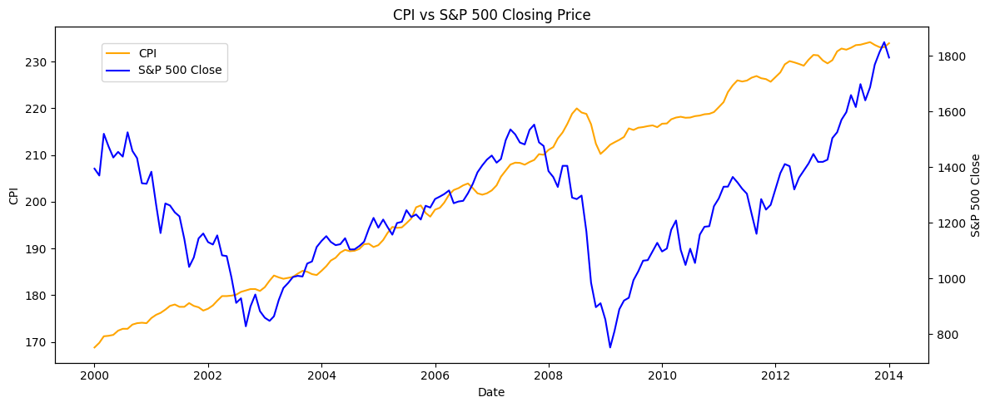
Figure 2.1: S&P 500 monthly close and absolute CPI Index, 2000–2014

Linear Correlation
Study 2 examined correlations using two different CPI measures from the same dataset:

Measure A — Absolute CPI index level vs S&P 500 close:
correlation, pvalue = pearsonr(df_merged['CPI'], df_merged['close'])
# Pearson r = 0.3817, p-value = 0.0000 (statistically significant)

Measure B — Month-over-month inflation rate (derived) vs S&P 500 close:
df_cpi2_new['inflation_rate'] = df_cpi2_new['Index'].pct_change()
corr2, pval2 = pearsonr(df_merged2['inflation_rate'], df_merged2['close'])
# Pearson r = 0.1097, p-value = 0.1568 (NOT statistically significant)

CPI Measure | Pearson r | p-value | Significant?
Absolute CPI Index (Measure A) | 0.3817 | < 0.0001 | Yes
Derived Inflation Rate (Measure B) | 0.1097 | 0.1568 | No
Table 2.1: Correlation results for two CPI measures vs S&P 500 close (Study 2)
A key insight from Study 2 is that the choice of CPI measure substantially affects results. The absolute CPI index level — which is dominated by a long-run upward trend — shows a moderate but statistically significant correlation with the S&P 500 (r = 0.38). However, this may partly reflect that both series simply trend upward over time (a spurious long-run relationship). When the CPI level is converted to a month-over-month inflation rate, the correlation drops to r = 0.11 and becomes statistically insignificant.

Granger Causality Test
Because only the absolute CPI level correlated significantly with S&P 500 prices, the Granger causality analysis used this measure. Both series were first differenced to achieve stationarity — and notably, first-order differencing was sufficient for the absolute CPI index in this dataset, unlike in Study 1 where second-order differencing was needed.

diff_sp500 = df_merged['close'].diff().dropna() # Stationary
diff_cpi = df_merged['CPI'].diff().dropna() # Stationary (1st order)

Test 1: Does CPI Granger-cause S&P 500?
Test | F / chi² | p-value | df_denom | df_num / df
ssr based F test | 0.3817 | 0.5376 | 164 | 1
ssr based chi² test | 0.3887 | 0.5330 | — | 1
likelihood ratio test | 0.3882 | 0.5332 | — | 1
parameter F test | 0.3817 | 0.5376 | 164 | 1
Table 2.2: Granger Causality – CPI → S&P 500, Lag 1
Across all lags (1–4), p-values remained well above 0.05. The null hypothesis that CPI does not Granger-cause S&P 500 cannot be rejected.

Test 2: Does S&P 500 Granger-cause CPI?
Test | F / chi² | p-value | df_denom | df_num / df
ssr based F test | 9.3358 | 0.0026 | 164 | 1
ssr based chi² test | 9.5066 | 0.0020 | — | 1
likelihood ratio test | 9.2459 | 0.0024 | — | 1
parameter F test | 9.3358 | 0.0026 | 164 | 1
Table 2.3: Granger Causality – S&P 500 → CPI, Lag 1
Test | F / chi² | p-value | df_denom | df_num / df
ssr based F test | 5.6879 | 0.0041 | 161 | 2
ssr based chi² test | 11.7291 | 0.0028 | — | 2
likelihood ratio test | 11.3332 | 0.0035 | — | 2
parameter F test | 5.6879 | 0.0041 | 161 | 2
Table 2.4: Granger Causality – S&P 500 → CPI, Lag 2 (Lags 3–4 similarly significant)
Across all lags (1–4), p-values were well below 0.05. The null hypothesis is rejected at all tested lags, providing strong evidence that S&P 500 monthly closing prices Granger-cause changes in CPI.

Comparison of Findings
Although the two studies used different CPI datasets, different time periods, and different CPI measures, their core conclusions are remarkably consistent.

Dimension | Study 1 (2012–2022) | Study 2 (2000–2014)
CPI Measure | Month-over-month % change | Absolute index level
Date Range | May 2012 – Oct 2022 | Jan 2000 – Jan 2014
Observations | 130 | 169
Pearson r (CPI vs S&P 500) | 0.7151 (strong) | 0.3817 (moderate)
Significance of correlation | p < 0.0001 ✓ | p < 0.0001 ✓
CPI → S&P 500 (Granger) | Borderline (p ≈ 0.05) | No (p > 0.05)
S&P 500 → CPI (Granger) | Yes (lags 2–4, p < 0.02) | Yes (all lags, p < 0.01)
Table 3.1: Side-by-side comparison of Study 1 and Study 2 findings

Correlation strength. Study 1 found a much stronger correlation (r = 0.72 vs r = 0.38). This likely reflects two factors: the 2012–2022 period is dominated by a sustained bull market, amplifying co-movement; and the CPI measure in Study 1 (month-over-month % change) captures more immediate price dynamics than the trending absolute index level in Study 2.
Causal direction. Both studies agree on direction: there is no strong evidence that CPI Granger-causes S&P 500, but there is robust evidence in both studies that S&P 500 movements Granger-cause future CPI changes. This result is consistent with the broader economic view that financial markets — which aggregate forward-looking expectations, corporate earnings signals, and monetary policy sentiment — tend to lead real-economy variables such as consumer prices.
CPI measure matters. Study 2 uniquely highlighted that the choice between using CPI as a price level versus as a rate of change substantially alters the observed correlation. The inflation rate (month-over-month % change) showed no statistically significant correlation with the S&P 500 (r = 0.11, p = 0.16), underscoring the importance of careful variable selection in this type of analysis.

Conclusion
This report presented and compared two independent quantitative analyses of the relationship between CPI and S&P 500. Together, they paint a consistent and informative picture.
Both studies found a positive, statistically significant correlation between CPI and S&P 500 prices, though the strength of that correlation depends heavily on the time period studied and how CPI is measured. The 2012–2022 period, characterised by a sustained equity bull market, showed a substantially stronger co-movement (r = 0.72) than the more volatile 2000–2014 period (r = 0.38).
Most importantly, the Granger causality tests in both studies converged on the same directional finding: past S&P 500 movements contain statistically significant information for predicting future CPI changes, but the reverse is not true — CPI does not reliably predict future S&P 500 performance. This is consistent with the economic intuition that financial markets are forward-looking and often anticipate real economic conditions.
Several caveats apply. The Granger causality test identifies predictive relationships in a statistical sense and does not establish structural causation. The findings may vary across different economic regimes, periods of geopolitical shock, or under alternative monetary policy frameworks. Future research could extend this analysis to longer time series, include additional control variables such as interest rates or GDP growth, or employ more sophisticated models such as Vector Autoregression (VAR) to capture the full dynamic interdependence between these two key indicators.

References
CPI and S&P 500 Historical Data. (2023, February 24). Kaggle. https://www.kaggle.com/datasets/rosicky1234/cpi-and-sp500
US Consumer Price Index (CPI) Historical Data. (2023). Kaggle. https://www.kaggle.com/datasets/tunguz/us-consumer-price-index-cpi
Tretina, K. (2023, August 9). What Is The S&P 500? How Does It Work? Forbes Advisor. https://www.forbes.com/advisor/investing/what-is-sp-500/
Granger, C. W. J. (1969). Investigating Causal Relations by Econometric Models and Cross-spectral Methods. Econometrica, 37(3), 424–438.

