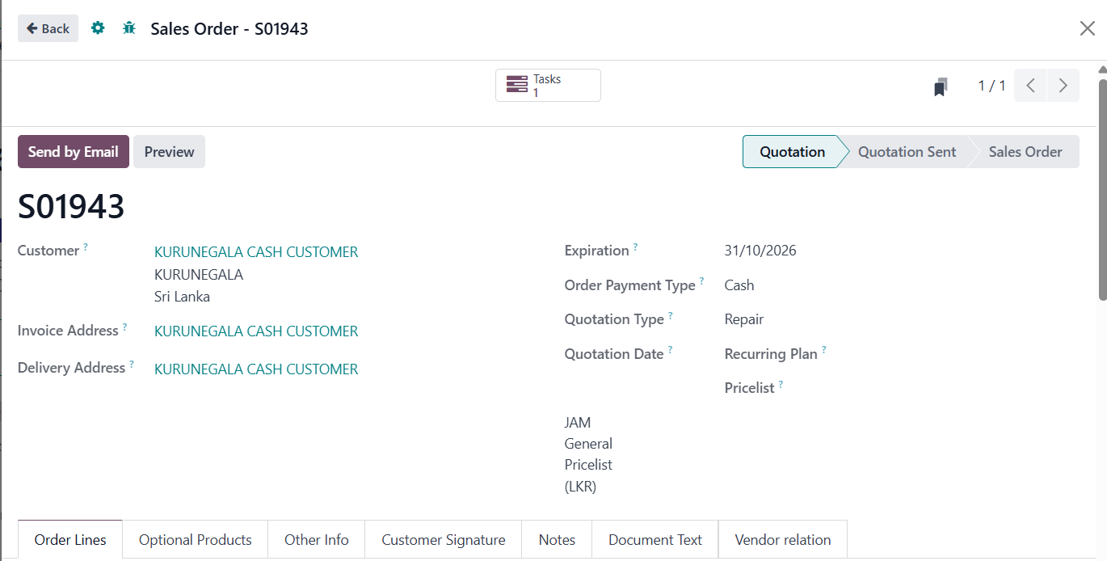
1
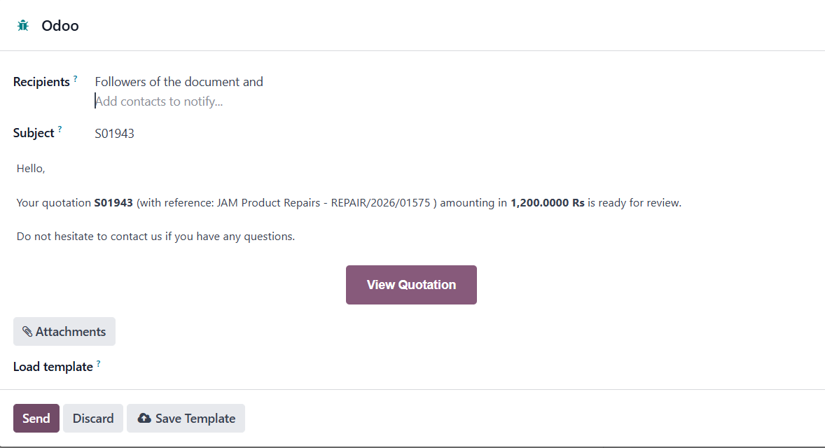
2
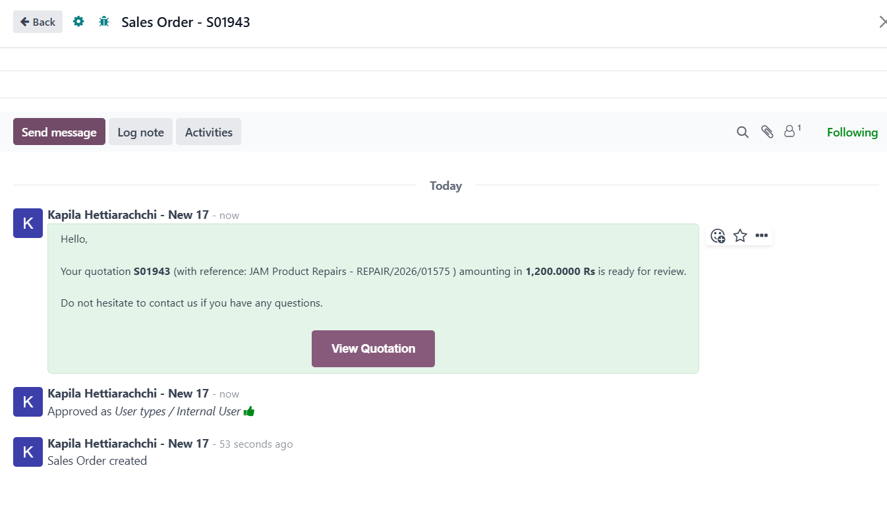
3
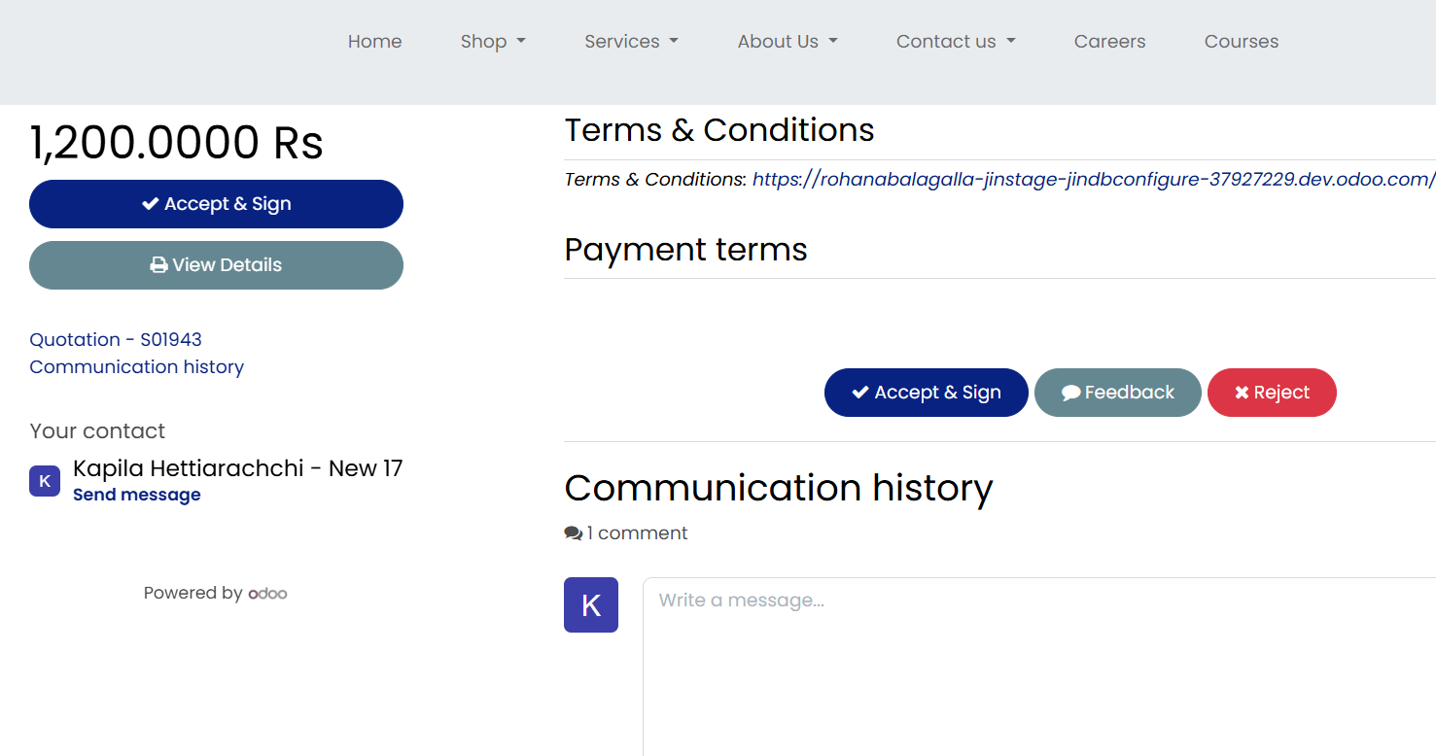
4
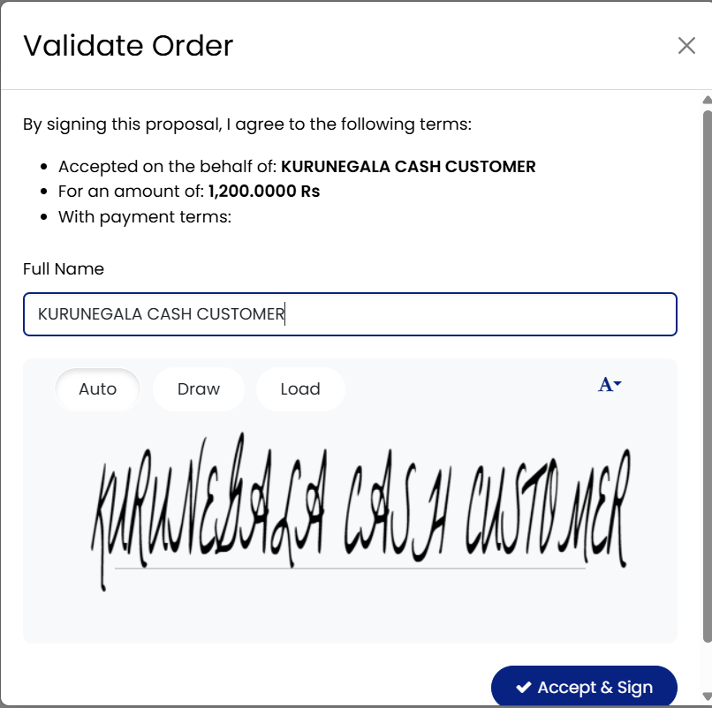
5

- After the quotation is created during the repair process, the "send by email" (Image1) button must be clicked.
- After that, you need to click the "Send" button.
- The subsequent step is not included in the .json file provided to you.
- To do this, I need to open the sales order in a separate location. When scrolling, the "View Quotation" button will be displayed.(Image 3). Clicking on it opens the form shown in Image 4. Click on either of the "Accept & Sign" buttons found there.
- Also, click the "Accept & Sign" button on the form that appears next, and return to the sales order form.

