Assignment no :- 01
CREATE AN ACCOUNT IN AWS AND CONFIGURE A BUDGET SOLUTION.
Step-1: At first open the aws cosole.
Step-2: Then tap on the top right corner account section .
Step-3: Then open the “Billing and cost Management”.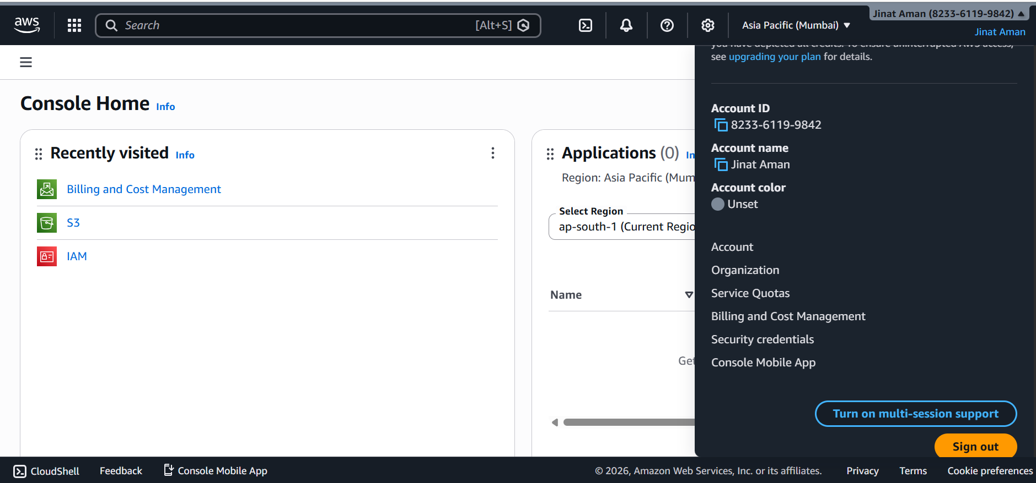Step-4: After that go to “Budgets and Planning” form the right side top down search Menu bar. Then “click on Budgets”. 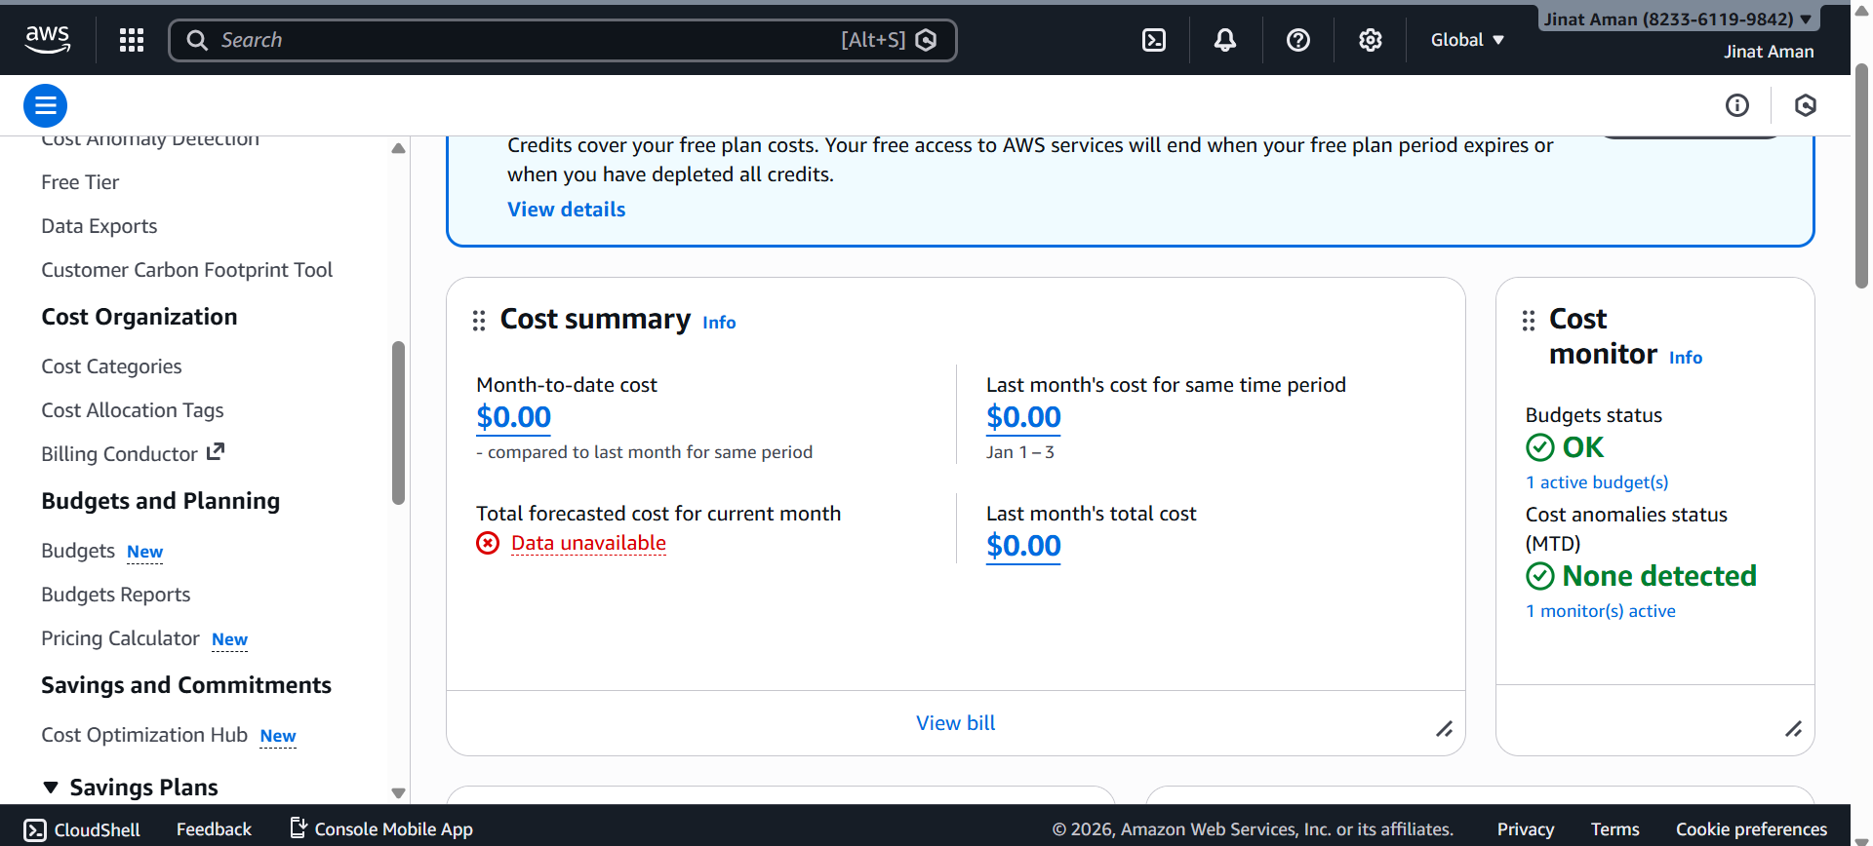Step-5:Now click on “create Budget”.
Step-6: Then, there are two options are available “used template”, “customize”. So We need to choose second one.: Then all the other field remain same. And press “next”.
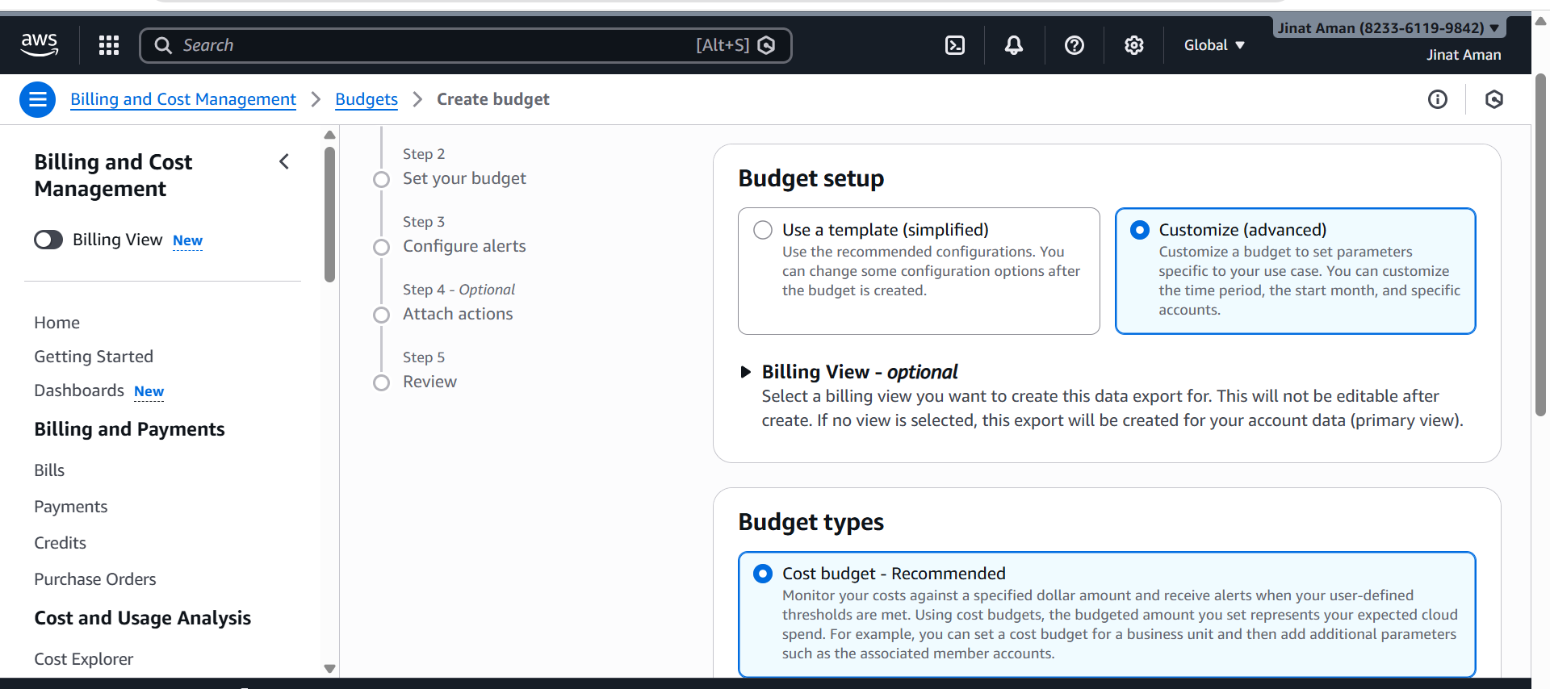Step-8: In this page we need to set our “Budget name”,” Period”, “Budget renewal type” manually.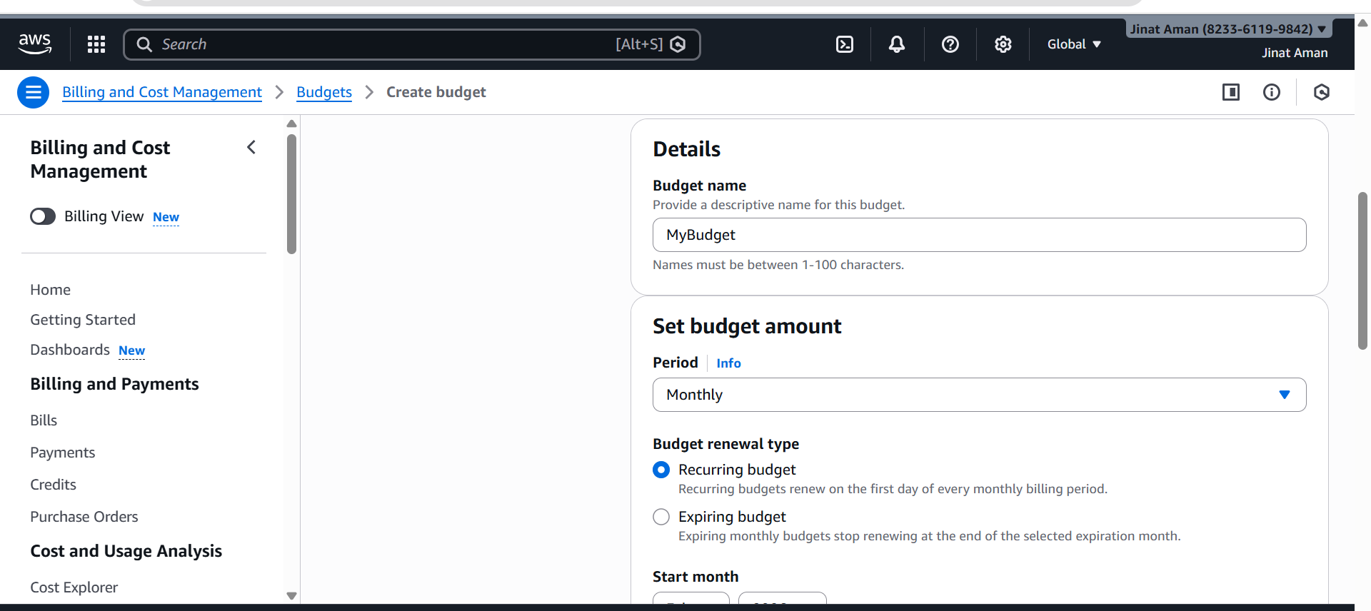Step-9:Then set a amount and press next. 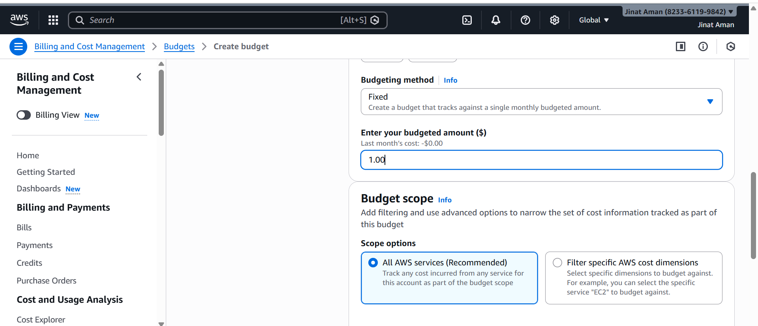Step-10: Then we need to “ add an alert”.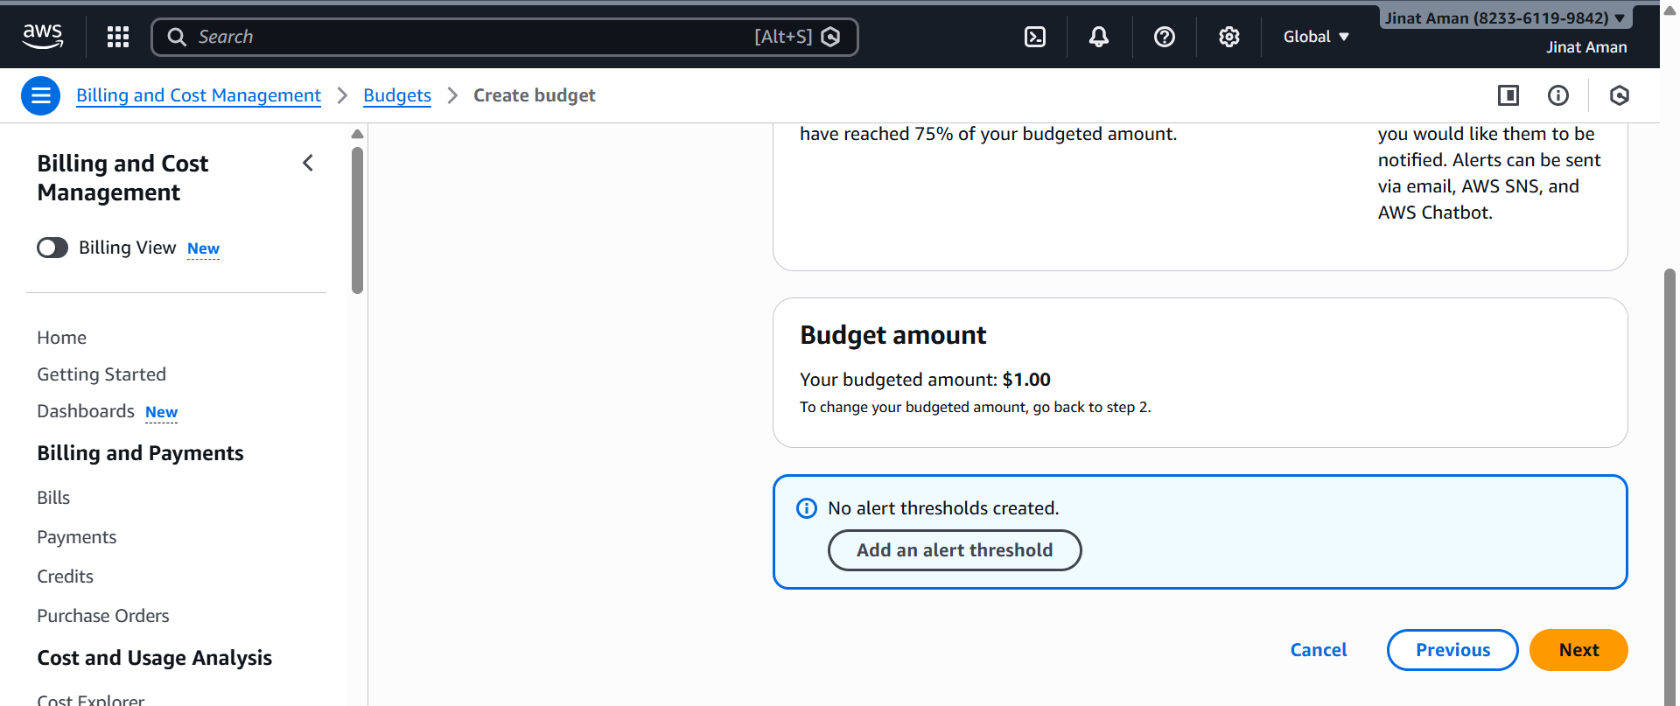Step-11: in the alert page we need to set a “Threshold” and “recipient mail”. then press Next. 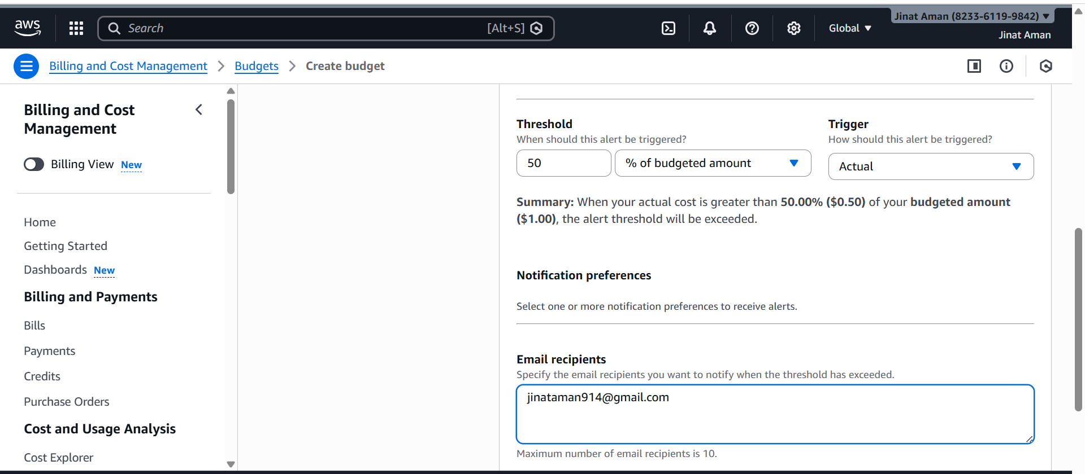
Step-12: Then in the “Review” section final look over all the things. 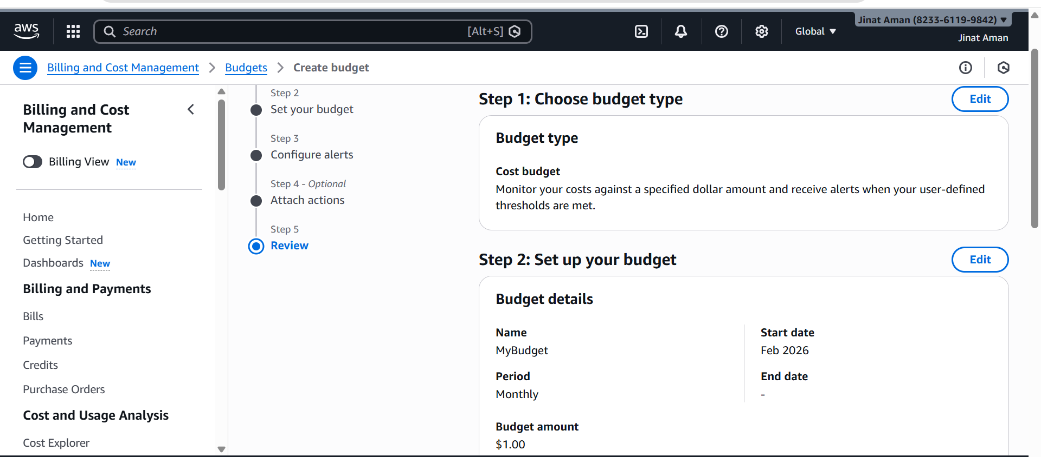Step-13: Then finally click on “Create Budget”. An our budget is created. 