Name: Jinat Aman Roll. No: BTECH/CSE/23/078
AssignmentNo.:08

Problem Definition: - Deploy a project from a local machine to GitHub and vice versa.

Step-1: Create a new Public GitHub Repository. Click on ‘Create a new repository’ to proceed. Then give the repository name (AWS-repo).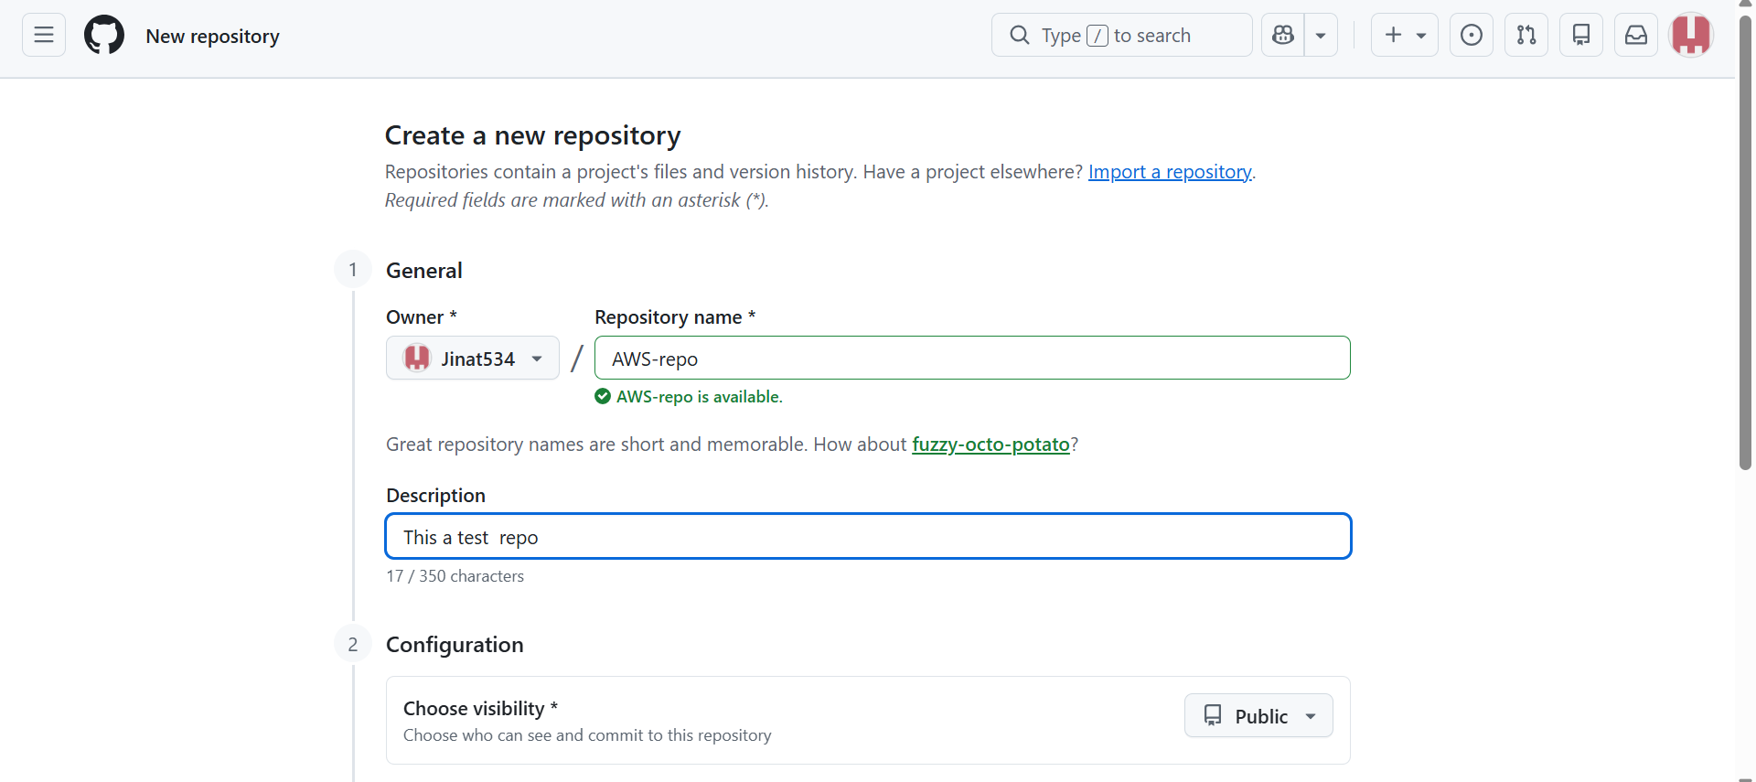

Step-2. Go to Settings -> Developer settings. 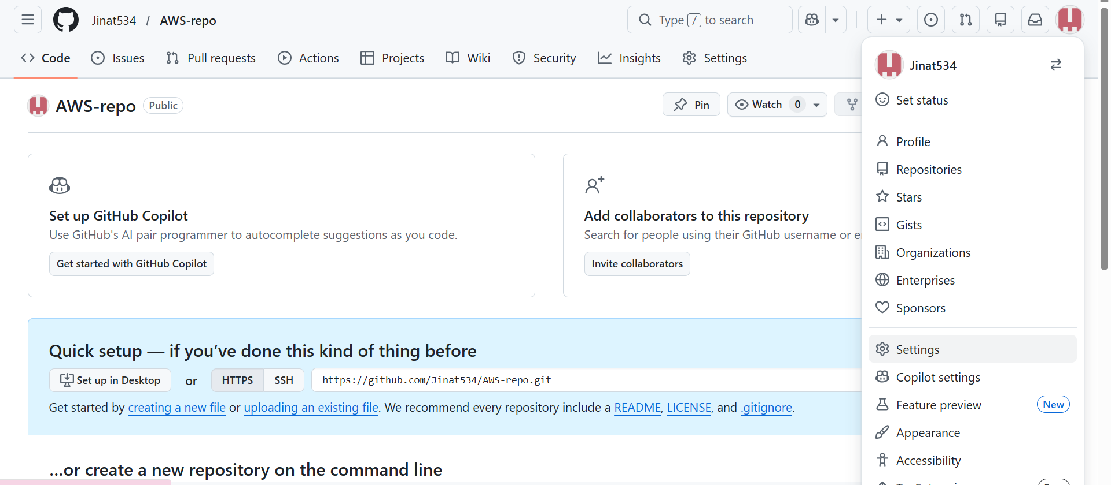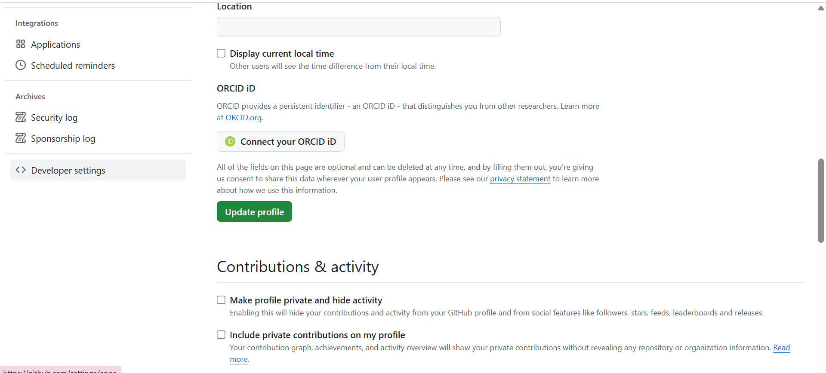
Step 3: Now, click on the Personal access tokens dropdown and then click on "Tokens(classic)". 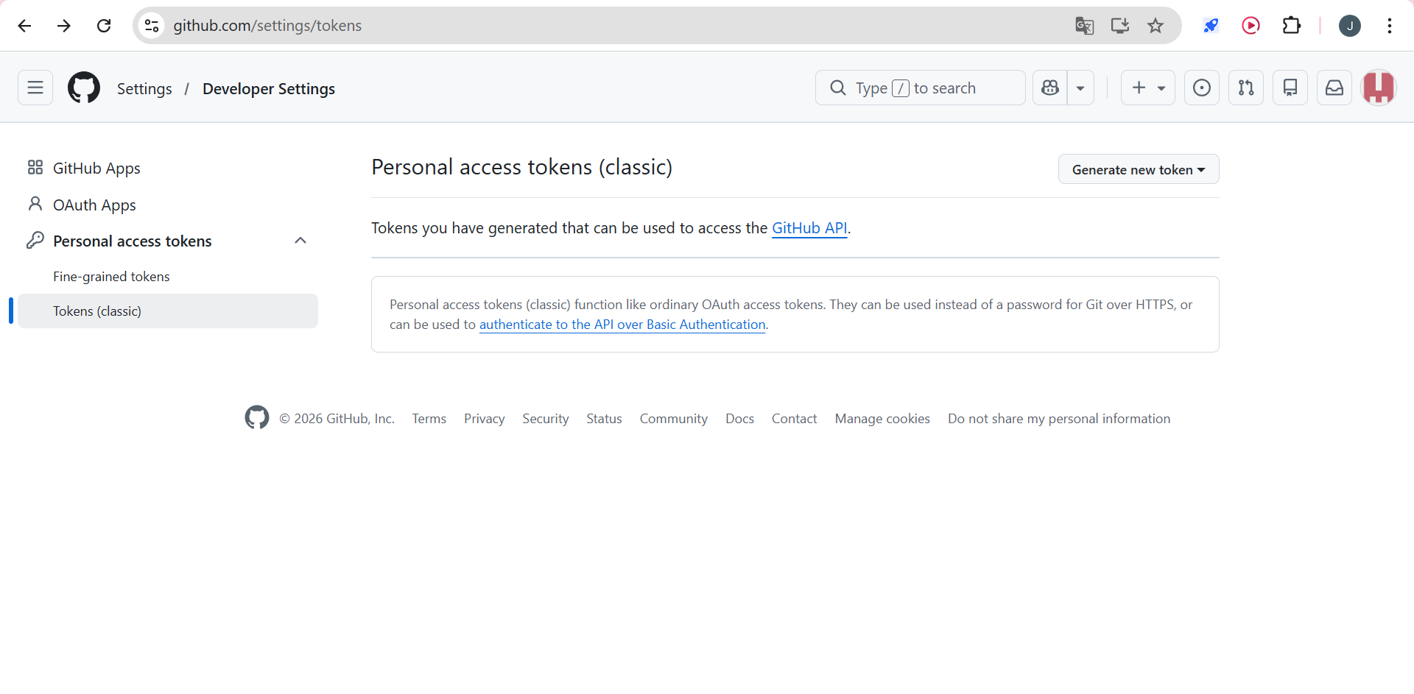Step-4: Now click on Generate new tokens and then Generate new token(classic). 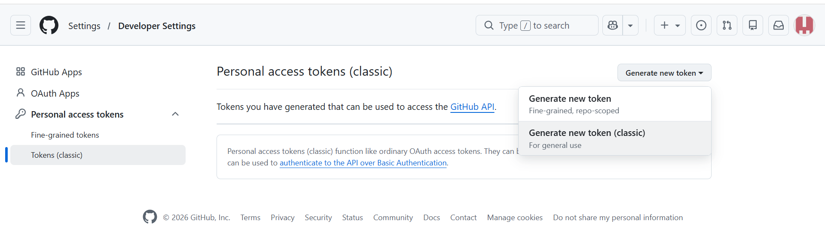Step-5: Set Note, Expiration Date for as long as possible, and select all scopes. Then generate a token. 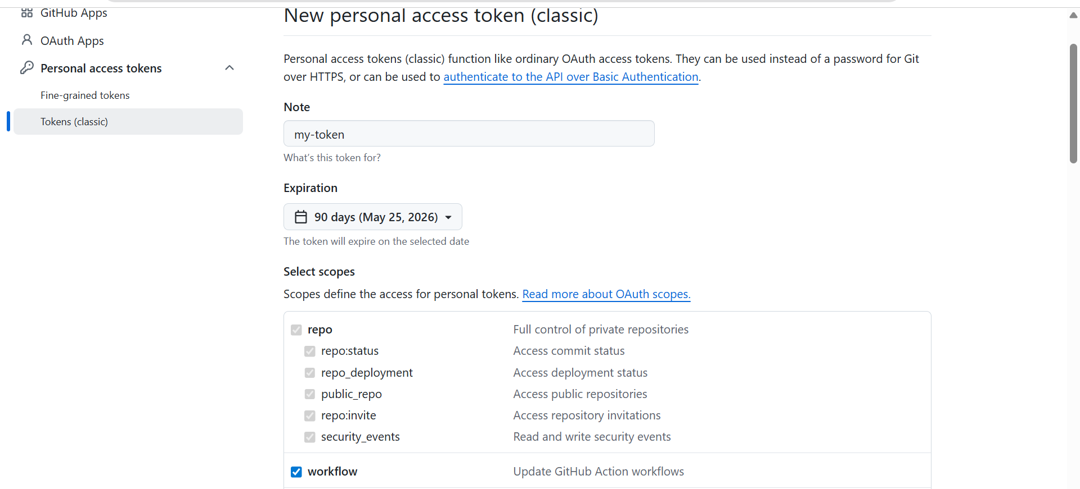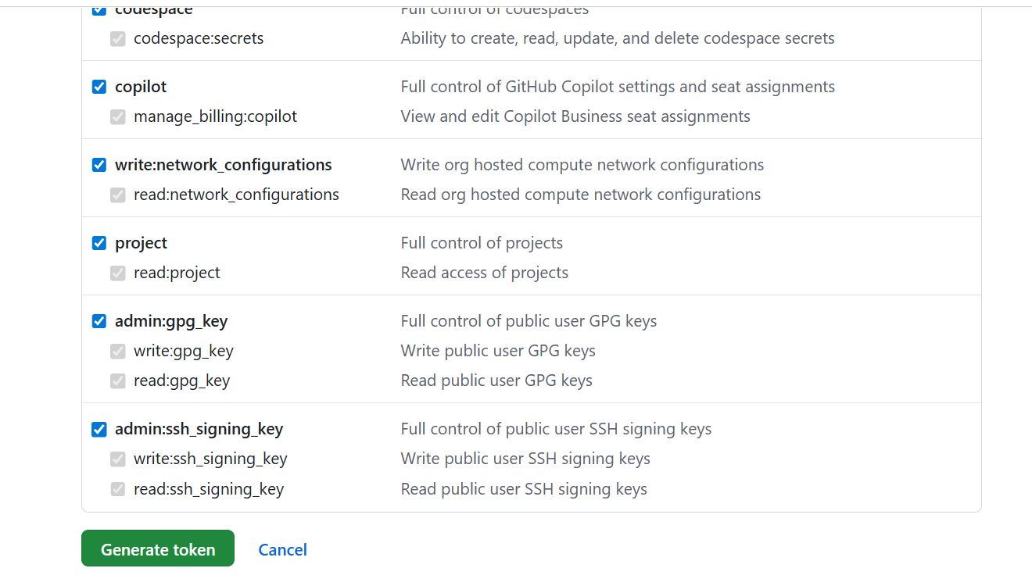Step-6: After generating the token, click on the copy option for copying the path and save it in a text document.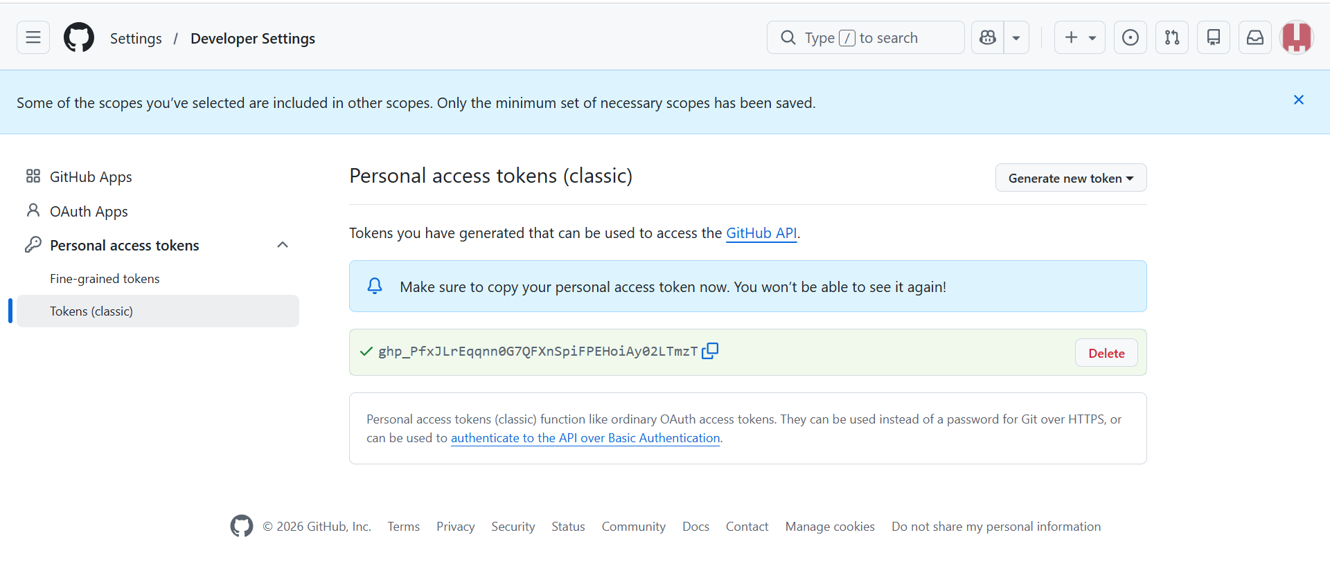Step-7: Go to the folder containing your project files. Right-click and select ‘Open Git Bash Here’ from the pop-up menu.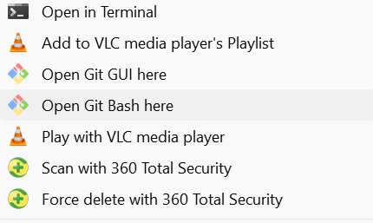
Step-8: Run the following commands: 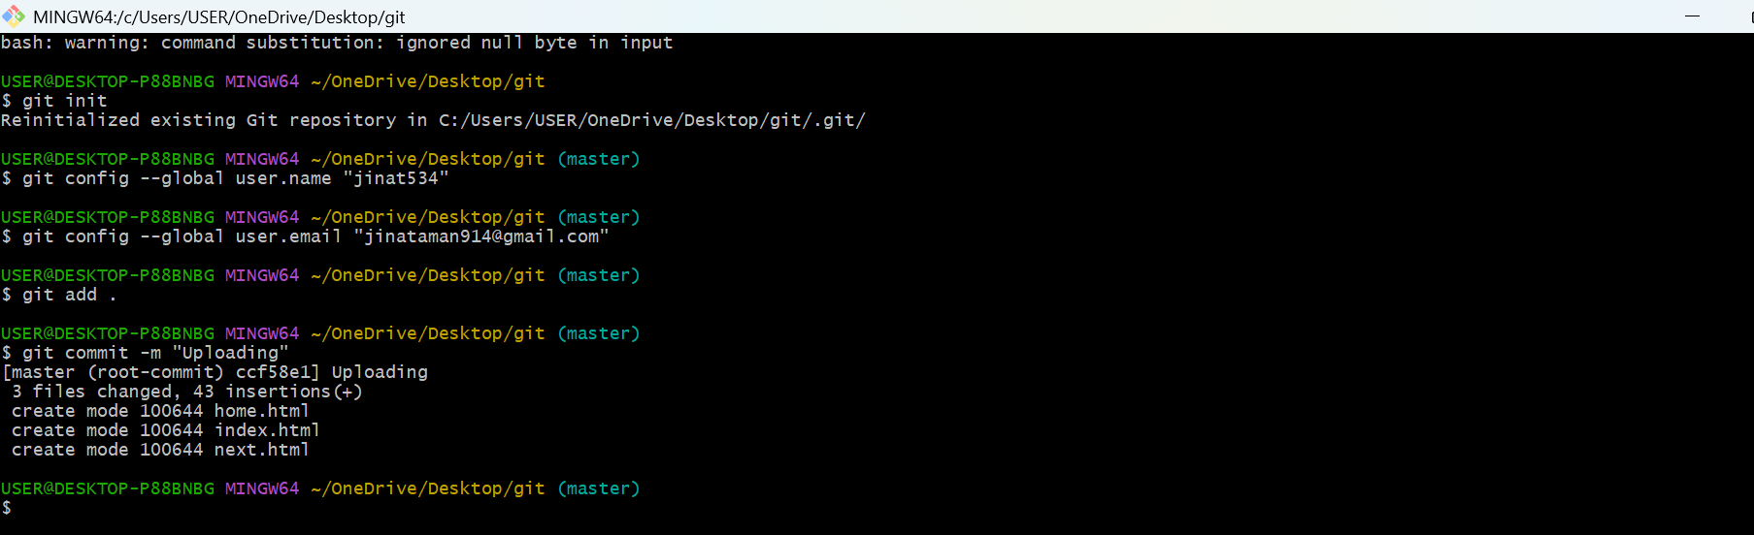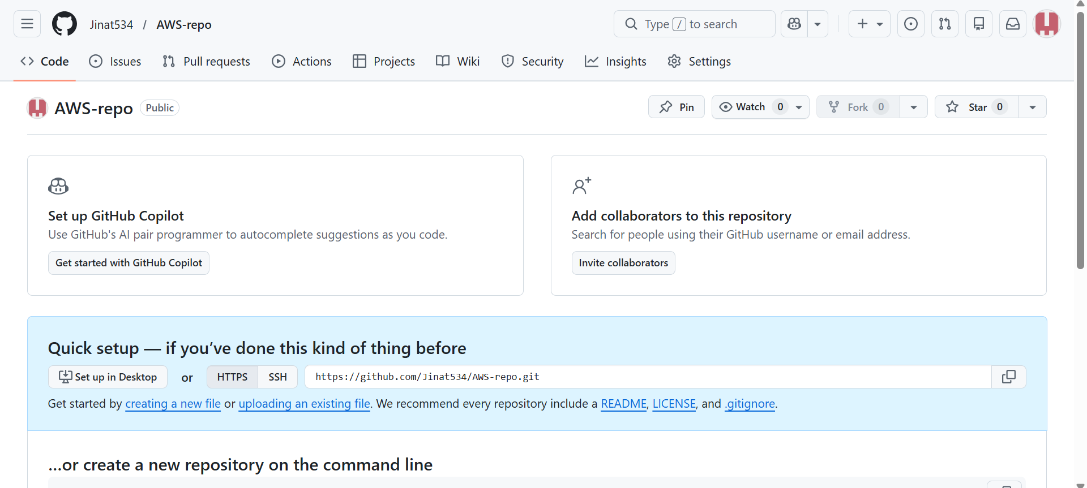 Step-9: After the last command, a new connection to the GitHub window opened. Go to the token portion and paste the copied path during token generation, and paste it in text document. Click on Sign In.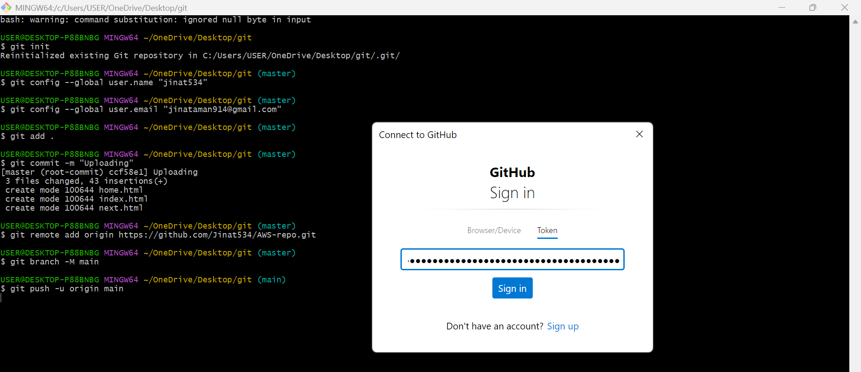Step-10: Open the repository and see all files have been successfully added. Now, click on code and copy the clone HTTPs. 