- Data Transformation

- Logarithmic Transformation
- Square Root Transformation
- Binning
- Scaling

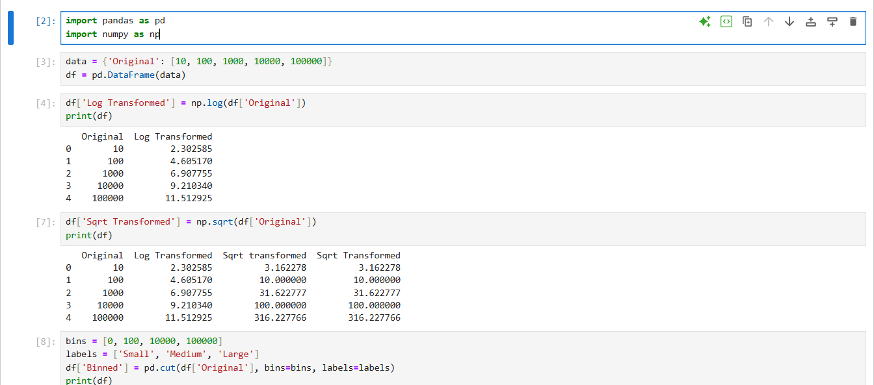

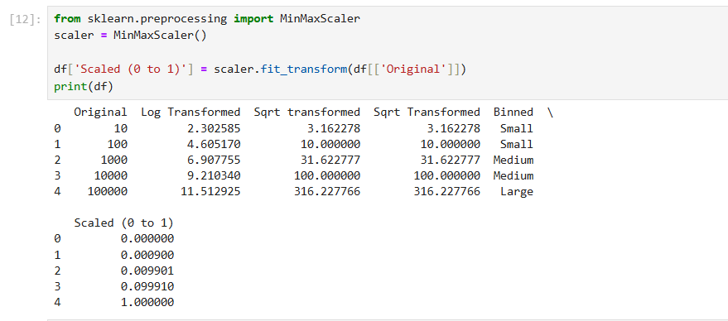

2. Normalization
- Min-Max Scaling
- Z-Score Normalization

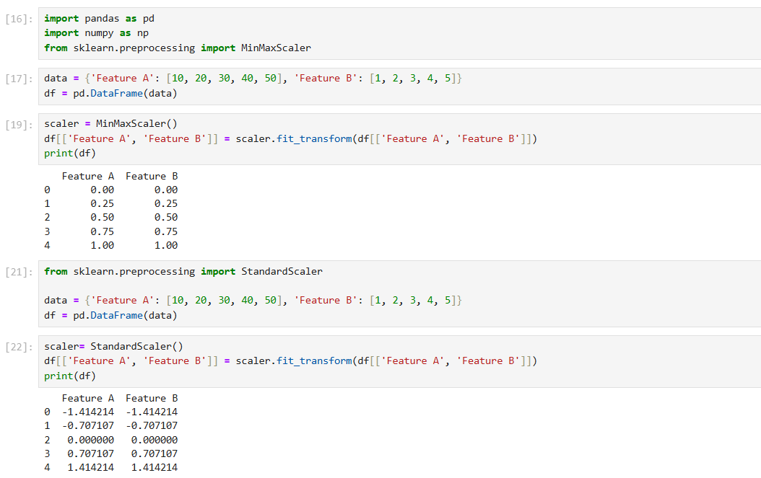

Case Study: Predicting House Prices
