Lutian, Erzhad Dominic S. IT-3A IT 314

Documented Result of Data Transformation and Normalization

- Data Transformation
Data transformation, mentioned in the PDF file, involves modifying the format, structure, or content of data to enhance its quality or to ensure it can be efficiently processed by algorithms. Common transformations include:
- Logarithmic transformation which is applied to manage skewed data by reducing the impact of large values and amplifying smaller ones.
import numpy as np
import pandas as pd

# Example data
data = {'Original': [10, 100, 1000, 10000, 100000]}
df = pd.DataFrame(data)
# Applying log transformation
df['Log Transformed'] = np.log(df['Original'])
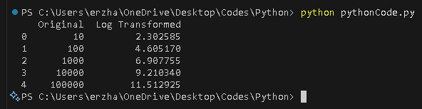
print(df)

- Square root transformation which is used to lessen the effect of high variance within a dataset.
import numpy as np
import pandas as pd

# Example data
data = {'Original': [10, 100, 1000, 10000, 100000]}
df = pd.DataFrame(data)
# Apply square root transformation
df['SquareRoot_Transformed'] = np.sqrt(df['Original'])

# Display the result

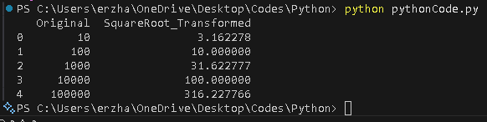
print(df)

- Binning which is the process of dividing continuous data values into discrete categories or intervals.

import pandas as pd

# Example dataset
data = {'Age': [5, 12, 17, 24, 35, 45, 52, 63, 70, 85]}
df = pd.DataFrame(data)

# Define the bin edges
bins = [0, 12, 19, 35, 60, 100]

# Define the bin labels
labels = ['Child', 'Teen', 'Young Adult', 'Adult', 'Senior']

# Apply binning
df['Age_Group'] = pd.cut(df['Age'], bins=bins, labels=labels, include_lowest=True)

# Display the result
print(df)

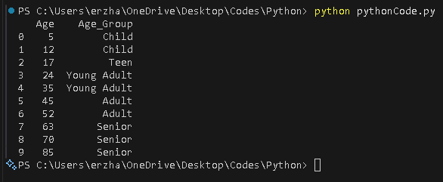
- Scaling involves modifying the range of data values, so they fall within a specific interval, while keeping the relative differences between them intact.
import pandas as pd
from sklearn.preprocessing import MinMaxScaler, StandardScaler

# Example dataset
data = {'Score': [23, 45, 67, 89, 120]}
df = pd.DataFrame(data)

# --- Min-Max Scaling (scales data to a range between 0 and 1) ---
min_max_scaler = MinMaxScaler()
df['MinMax_Scaled'] = min_max_scaler.fit_transform(df[['Score']])

# --- Standard Scaling (scales data to have mean 0 and standard deviation 1) ---
standard_scaler = StandardScaler()
df['Standard_Scaled'] = standard_scaler.fit_transform(df[['Score']])

# Display the result
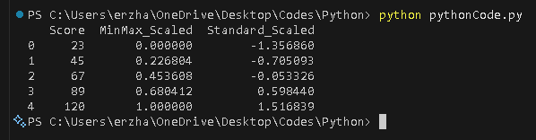
print(df)

- Normalization
Normalization is the technique used to rescale data so that it fits within a specific range, typically 0 to 1, without changing the relationships between the values. It’s often used to prepare data for machine learning algorithms that are sensitive to the magnitude of features.

- Example of Min-Max Scaling:
import pandas as pd
from sklearn.preprocessing import MinMaxScaler

# Example data
data = {'Feature A': [10, 20, 30, 40, 50],
'Feature B': [1, 2, 3, 4, 5]}
df = pd.DataFrame(data)
# Applying Min-Max Scaling
scaler = MinMaxScaler()
df[['Feature A', 'Feature B']] = scaler.fit_transform(df[['Feature A', 'Feature B']])
print(df)
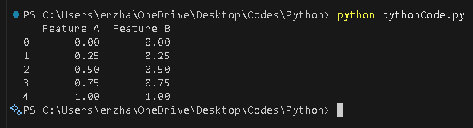

- Example of Z-Score Normalization:
import pandas as pd
from sklearn.preprocessing import StandardScaler

# Example data
data = {'Feature A': [10, 20, 30, 40, 50],
'Feature B': [1, 2, 3, 4, 5]}
df = pd.DataFrame(data)

# Applying Z-Score Normalization
scaler = StandardScaler()
df[['Feature A', 'Feature B']] = scaler.fit_transform(df[['Feature A', 'Feature B']])
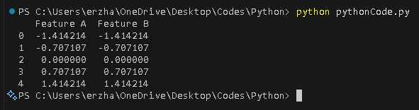
print(df)

Case Study: Predicting House Prices
Suppose we have a dataset with various features such as square footage, number of bedrooms, and price. These features may be on different scales, which can cause issues for algorithms like linear regression. To address this, we need to apply normalization to bring the features to a common scale.
import pandas as pd
from sklearn.datasets import fetch_california_housing
from sklearn.model_selection import train_test_split
from sklearn.preprocessing import MinMaxScaler
from sklearn.linear_model import LinearRegression

# Example data
data = {'Feature A': [10, 20, 30, 40, 50],
'Feature B': [1, 2, 3, 4, 5]}
df = pd.DataFrame(data)

# Loading dataset
housing_data = fetch_california_housing()
X = housing_data.data
y = housing_data.target

# Splitting the data
X_train, X_test, y_train, y_test = train_test_split(X, y,
test_size=0.2, random_state=42)

# Applying Min-Max Scaling
scaler = MinMaxScaler()
X_train_scaled = scaler.fit_transform(X_train)
X_test_scaled = scaler.transform(X_test)

# Linear regression model
model = LinearRegression()
model.fit(X_train_scaled, y_train)
score = model.score(X_test_scaled, y_test)

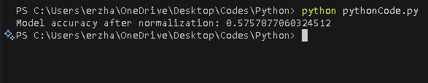
print(f"Model accuracy after normalization: {score}")

In this case, normalizing the features using Min-Max scaling improves the model’s performance by ensuring that no feature dominates the learning process due to its scale.

