TOONG, JUSTINE A. BSIT – 3A
IT 314 – DATA ANALYTICS DATA TRANSFORMATION AND NORMALIZATION

1. Data Transformation
Data transformation refers to changing the format, structure, or values of data to improve its quality or make it easier for algorithms to process.
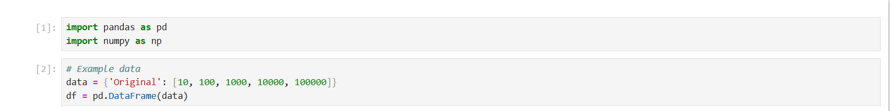
Common transformation includes:

Logarithmic Transformation
Square Root Transformation
Binning
Scaling

Log transformation is a data preprocessing technique that applies the logarithm function to data values to address issues like skewness and heteroscedasticity in machine learning.

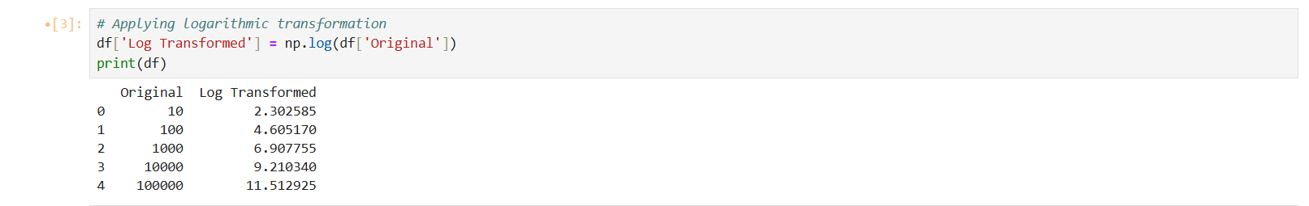

Square Root Transformation
Square root transformation is a data preprocessing technique that replaces each value in a dataset with its square root. It is used to reduce right skewness, compress larger values, and make the distribution of count data more symmetric.
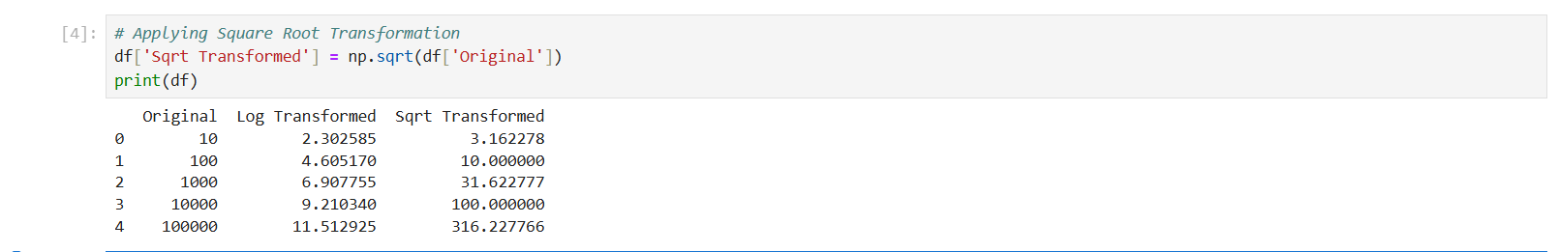

Binning
Binning, also known as discretization or bucketing, is a data preprocessing technique in machine learning that transforms continuous numerical variables into discrete categorical features.
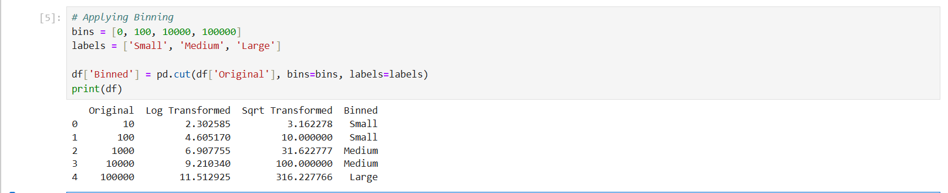

Scaling
Scaling in machine learning is a crucial preprocessing step that transforms numerical features to a common scale, preventing features with larger ranges from dominating the model.
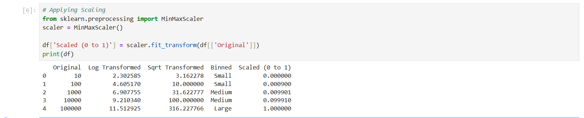

2. Normalization
Min-Max Scaling
Z-Score Normalization

Normalization in machine learning is a data preprocessing technique that scales numerical features to a common range, ensuring no single feature dominates due to its scale.

Two common methods for normalization are:

Min-Max Scaling
Min-max scaling is a data preprocessing technique that transforms features by rescaling them to a fixed range, usually between 0 and 1.
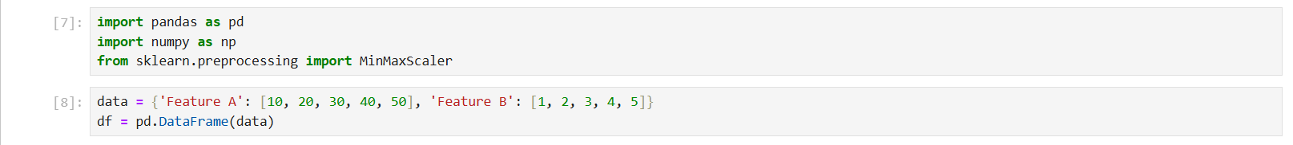
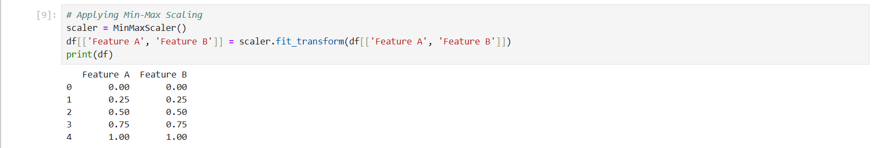

Z-Score Normalization
Z-Score is a standardized value that measures how many standard deviations a data point is from the mean of its dataset.
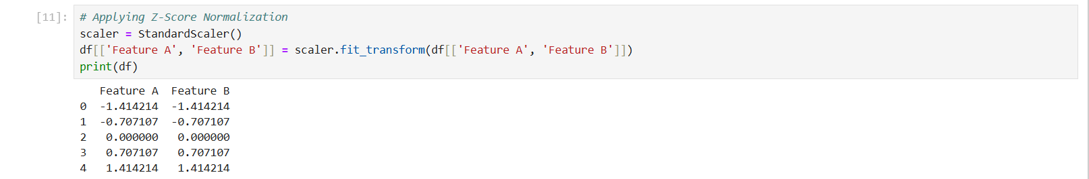

Case Study: Predicting House Prices
