**Republic of the Philippines**

**Western Mindanao State University**

**College of Computing Studies**

**Department of Information Technology**

**Zamboanga City**

**TechWeave**

**GoProject: A Project Tracker for Learners**

# In partial fulfillment of the requirements in

# IT 314 – Systems Integration and Architecture 1

Submitted by:

Claro, Neal Jean L.

Enriquez, John Paul I.

Imar, Ar-rauf Jaddani

Sali, Rhadzmiel B.

Submitted to:

Mr. John Paul Ing Arip

Instructor

Date of Submission:

October 2025

**Problem Statement**

Each student has developed different approaches in proceeding with their projects. Some students are remarkable for having work ethics and passion for finishing their projects on time without stress and failure, but for some, it is different. Time and time again, when proceeding with a project, students would commonly encounter a hubris that leaves them stagnant for a while, or until their projects’ due time is passed. This is especially common in college, where students are facing early adulthood and keeping track of what’s necessary.

In order to solve this issue, we will build a system that keeps track of projects, project steps, expense and tasks. A worthy learner’s tool to track the projects’ direction and needs.

**Objectives**

1. To design a user-friendly interface that allows students to create, view, and update their project progress.
2. To implement task management features that let users break down projects into smaller steps, assign deadlines, and monitor completion.
3. To integrate expense tracking so learners can manage project-related costs and budget allocation.
4. To provide progress visualization tools (e.g., timelines, charts, or status indicators) that help learners see their overall advancement.
5. To enable reminders and notifications that alert learners of upcoming deadlines or pending tasks.
6. To allow categorization and prioritization of tasks so students can focus on the most critical project requirements.
7. To generate reports or summaries of project progress, expenses, and milestones for easy reference and evaluation.
8. To provide collaborative experience of projects, so students can train themselves to work with teams.

**Scope**

The system is web based, it will allow learners to create, manage, and track their academic or personal projects. Users can add project details, break them down into tasks, assign deadlines, and track expenses related to each project. The system will include progress visualization tools such as status indicators and timelines to help users monitor their advancement. Notifications and reminders will be available to ensure users stay updated on deadlines.

**Limitations**

•Expense tracking will be limited to manual entry and basic summaries without integration to external financial platforms or payment systems.

•The notification system will be limited to in-app or email reminders; SMS and push notifications will not be implemented.

•Data storage will be restricted to project-related information only; external file attachments or large media uploads will not be supported.

**Target Users / Beneficiaries**

•Students - The primary users

•Teachers – Will have convenient process of checking with their students’ progress.

**Technologies and tools to use:**

|  |  |  |  |
| --- | --- | --- | --- |
| **Database** | **APIs** | **Programming languages** | **Frameworks** |
| * MongoDB | * REST API * EmailJS / SendGrid | * Python * JavaScript / TypeScript * Laravel | * Backend Frameworks:   + Django REST Framework (Python) * Frontend Frameworks:   + React.js   + Vue.js   + Angular |

**GoProject 8 Practical Modules**

1. **User Management Module**

- Handles user login, user profile and registration.

* User registration & authentication
* Role management (Student / Teacher)
* Profile editing (name, email, course, etc.)
* Password reset / Email verification

1. **Project Management Module**

- Core module where users create and manage projects.User registration & authentication.

* Create, edit, and delete projects
* Add project descriptions, start/end dates, and objectives
* Assign team members (for collaborative projects)
* Mark project status (e.g., Not Started, In Progress, Completed)

1. **Task Management Module**

- Lets users break a project into smaller, trackable tasks.

* Add, edit, and delete tasks
* Set deadlines and priorities (High, Medium, Low)
* Mark tasks as completed
* Assign tasks to specific team members

1. **Expense Tracking Module**

- Tracks project-related expenses and helps manage budgets.

* Add and categorize expenses (materials, printing, transport, etc.)
* Show total expenses per project
* Generate simple expense summaries

1. **Progress Visualization Module**

- Displays visual progress indicators for easy understanding.

* Progress bars for projects
* Task completion charts (e.g., Pie or Bar charts)
* Timeline or Gantt-style progress view

1. **Notification and Reminder Module**

- Keeps users updated about upcoming deadlines and overdue tasks.

* Email or in-app notifications for approaching deadlines
* Reminders for pending tasks or overdue projects

1. **Reporting and Analytics Module**

- Generates summaries and reports for project progress and expenses.

* Downloadable progress reports (PDF/CSV)
* Summaries per project (status, % complete, total expenses)
* Teacher dashboard for viewing students’ progress

1. **Collaboration Module**

- Allows team-based project tracking and communication.

* Invite members to a project
* Assign roles within the project (leader, member)
* Activity logs (who did what)
* Comment or discussion section per project

**GoProject Use Case Diagram**

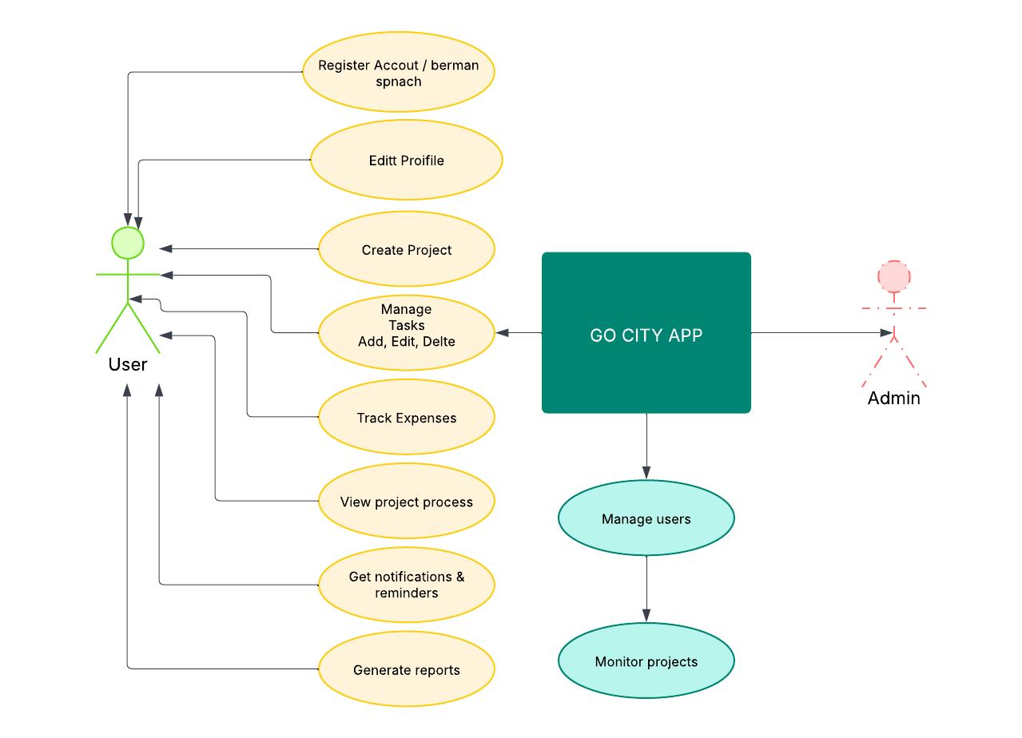

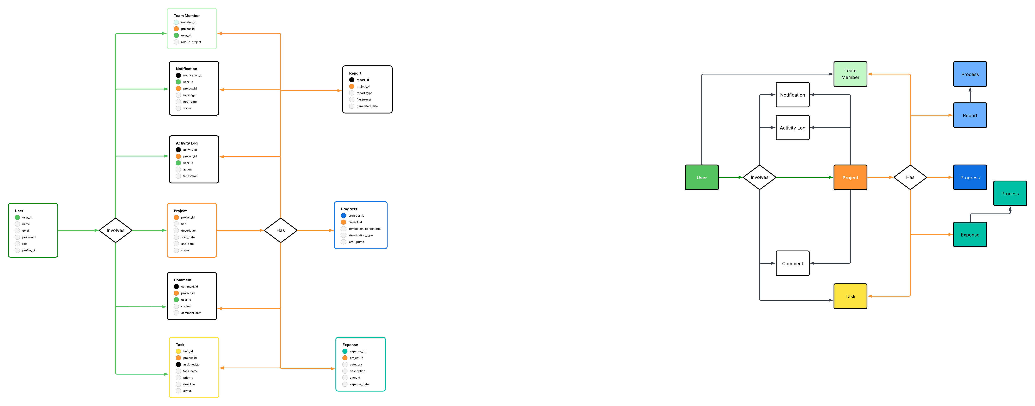**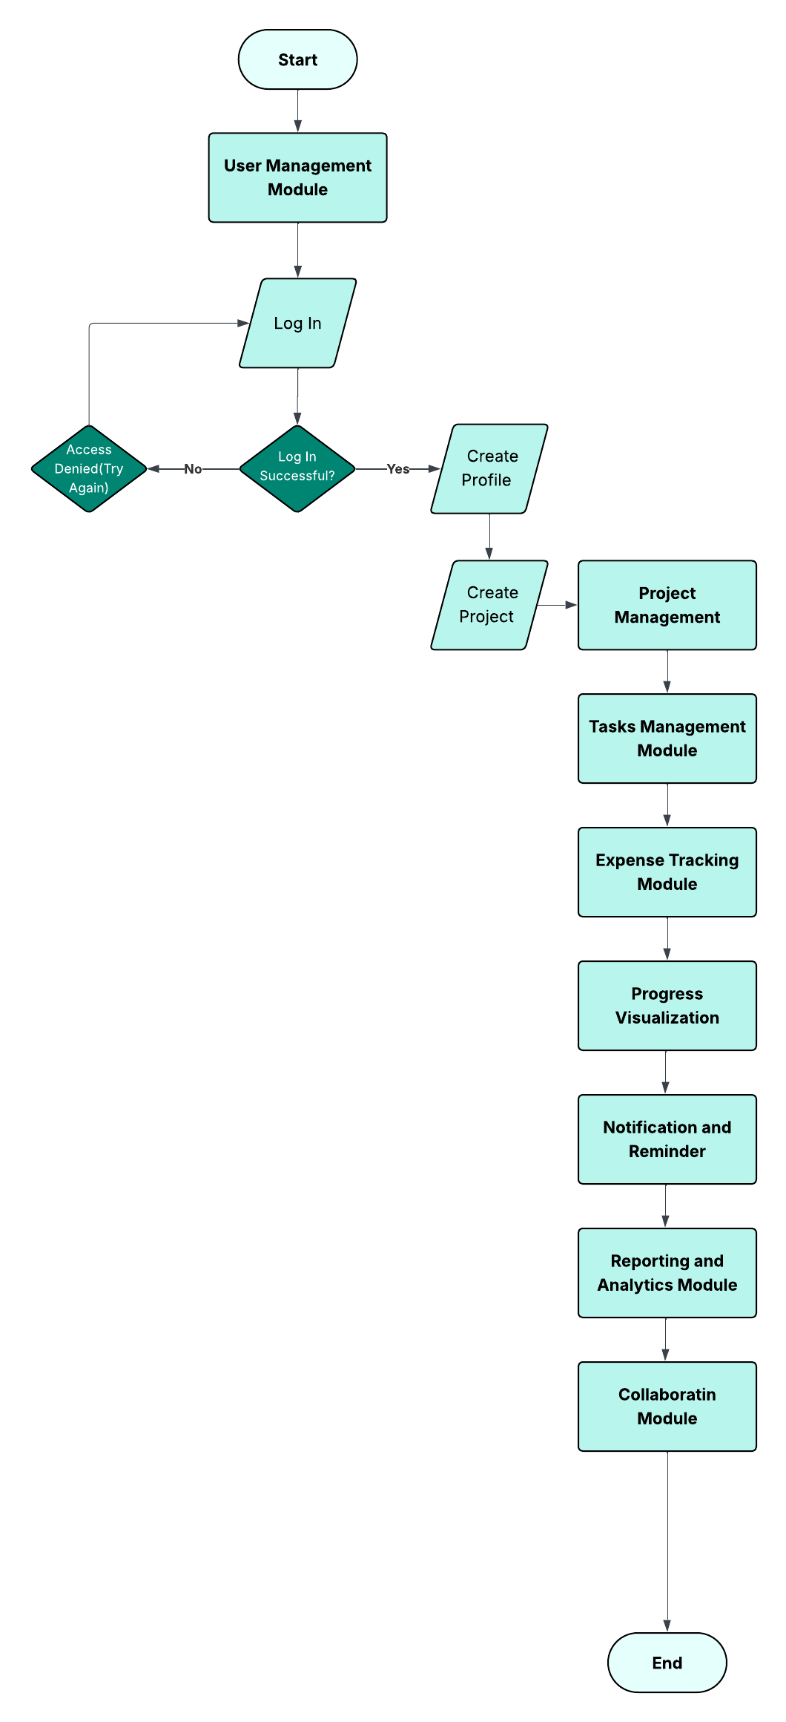GoProject Data Flow Diagram / Flowchart**

Overall Process/Structure:

**GoProject Entity Relationship Diagram (ERD)**

