Manual
Table of Contents
1. Introduction 1
1.1. What is DendriX 1
1.2. Software functionality 2
1.3. DendriX architecture 4
1.4. DendriX Directory Structure 8
2. Getting Started 9
2.1. Instructions to run the code 9
2.2. Visualization 12
2.2.1. Using VisIt 12
2.2.2. Using ParaView 13
2.3. Running in Parallel with MPI 14
2.3.1 Run on local machine 14
2.3.2 Run on high-performance computing (HPC) clusters 15

1. Introduction

1.1. What is DendriX
DendriX is a software to simulate both 2D and 3D Li-dendrite growth in Li-ion batteries. An integrated algorithm involving adaptive mesh refinement (AMR), hybrid MPI-OpenMP parallelization scheme, finite volume method (FDM) and implicit solver is employed to efficiently solve fully coupled nonlinear phase-field equation, Li+ ion transport equation and charge conservation equation. Numerical tests and simulations on single and multi-dendrite growth both in 2D and 3D were demonstrated and validated. The developed tool will provide a more flexible, maintainable, and extendable platform over existing commercial software packages, such as COMSOL and MOOSE. It can benefit both industry and academia in understanding the new knowledge in Li dendrite and the resulting thermal-runaway and/or safety issues and facilitating the design of battery systems to mitigate the Li-dendrite behaviors.

1.2. Software functionality
DendriX can simulate both 2D and 3D Li-ion dendrite growth in Li-ion batteries during a battery charge cycle with different input files defining all relevant parameters during simulation. The main functionalities of DendriX are described below:
- Users can choose to simulate 2D or 3D Li-ion dendrite growth by using corresponding input files (input_2d or input_3d). Single dendrite or multi dendrites can be simulated for both 2D and 3D cases, which can investigate the effects of space among dendrites.
- Users can switch between running in parallel with MPI or without MPI for 2D case. For 3D case, the option of running in parallel with MPI/OpenMP is also available. To run in parallel with MPI, users only need to configure GMakeMPI.mak to users’ MPI installation and can easily build the executable with MPI = t (i.e., true) in the GNUmakefile. If users want to run without MPI, just simply set the MPI = False by typing “make MPI = False. To run in parallel with MPI/OpenMP for 3D case, user can compile by setting OMP = t in the GNUmakefile.
- Users can decide to use combinations of FDM and CDS or liner solver to solve c⁺ (Equation (2)) and electric equation (Equation (3)). It is worth playing around with the input files to see what effect different numerical algorithms have on the Li-ion dendritic patterns.
- The number of levels of refinement can be set through the input file. With the same domain size and cell number, the larger level of refinement will refine the grid more. For instance, for the 2D case, with domain size and cell number as 5.12 and 256, the finest grid size for level 2 and level 3 are 0.01 and 0.005, respectively. Therefore, the larger number of refinement levels, the more computation cost is required. Users can select the appropriate level number depending on the simulation requirements such as accuracy and available computation resources.
- Users can control adaptive mesh refinement by controlling several parameters in the input files. For example, “regrid_int” can be used to control when to regrid the simuation (i.e., frequency in time steps). “cluster_min_eff” is real number between 0 and 1, with the value approaches to 1, more and smaller grids can be generated.
- DendriX is equipped with initial calculation and normal calculations by setting appropriate values of “dt01” and “dt08”, respectively, where “dt01” is much smaller than “dt08” to make sure that initial protuberant can become more mature in initial calculation phase, which is useful when the size of the protuberant is extremely small.
- The shape and size of protuberant can be set in input files, which can be used to investigate the effects of shape and size of protuberant on the dendritic pattern and length of dendrite.
- Different plot modes are provided to users. The default plot mode 0 is to plot all the three fields (phase, concentration, and electric fields) at user-specified output intervals, while plot mode 1 is to plot only phase fields. Plot mode 1 is very useful for 3D case, in which file sizes are usually extremely large. With the plot files available, users can analyze with common visualization software like ParaView and VisIt.

1.3. DendriX architecture
The developed tool was built on the Fortran version of the BoxLib [15, 16] software framework, which employs an algorithm of massively parallel block-structured adaptive mesh refinement (Para-AMR). In particular, a Fortran interface source tree is included in the make system of different platforms (e.g., Gfortran and Intel), which include base library, linear solvers, and phase field associated codes.
Base Library contains source code for basic functionalities, for instance, basic data structures and containers such as Box and MultiFab (Fortran array box). These data structures can be employed to represent block-structured mesh data in a distributed memory environment. Moreover, algorithms on how to operate the data in single level and between levels are also included. In addition, functions for defining boundary conditions are provided as well. For more details of these basic functionality, users can refer to [15, 16].
Phase field associated codes are used to solve the governing equations for the Li-ion dendrite growth simulation, which are defined as follows:
(1)
(2)
(3)
Where Equation (1) is the non linear phase field equation for Bulter-volmer reaction (Li⁺ reduction). ξ is phase field order parameter, $h\left(ξ\right)=ξ^{3}(6ξ^{2}-15ξ+10)$ is interplating function, η_{a} is the activation overpotential, L_{σ} and L_{η} are the interface mobility and the reaction-related constant. Equation (2) describes the species diffusion in the electrodeposition system. D^{eff} is the effective diffusion coefficient and is interpolated by $D^{eff}=D^{e}h\left(ξ\right)+D^{s}(1-h(ξ))$, where De and D^{s} are M^{n+} (e.g., Li⁺) diffusion coefficients in the electrode (which is almost zero) and the electrolyte solution, respectively. The last term is associated with electrochemical reaction rate and describe the accumulation/consumption of cation M^{n+} because of the electrochemical reaction on the electrode surface. Equation (3) is a Posisson eqation, which depicts the charge conservation in the system by introducing a source term I_{R} representing the charge that enters or leaves because of electrochemical reaction. σ^{eff} denotes the effective conductivity depending on the phase order parameter through $σ^{eff}=σ^{e}h\left(ξ\right)+σ^{s}(1-h\left(ξ\right))$, where σ^{e} and σ^{s} signify the conductivities of electrode and electrolyte solution, respectively. For details of three equation deriviation, reviewers can refer to [2].
The numerical algorithm in solving the above coupled three governing equations include two parts. The first derivative with respect to x (y or z) are solved using center discretization scheme (CDS). While finite volume method (FVM) is used to discretize the divergence operator (∇). For instance, the variables in one grid cell including phase field, concentration and electric potential were fixed into the cell center and the divergence of the variable can only be varied with the influence of fluxes from each wall (4 in 2-D, 6 in 3D) of the cell. The divergence operator can be calculated by Equation (4) for the Equation (3), if the six fluxes are F_{x+} F_{x-} F_{y+} F_{y-} F_{z+} and F_{z-}.
(4)
Where the flux F_{x+} in x⁺ direction can be obtained by
(5)
The first order marching scheme was used to solve the first time derivative of a variable (e.g.,ξ).
(6)
A linear solver that solve linear systems as defined in Equation (7) is provided as a alternative to the above mentioned numerical algorithm (CDS and FVM) for the Equation (2) and (3).
(7)
Where α, β and RHS can be adjusted based on the problems in hand. θ can be c⁺ or Φ. 5-point (7-point in 3D) Laplacian is employed to discreatize Laplacian term in the lelf-hand-side. A fully implicit method is adopted to discretize the time derivative.
Adaptive mesh refinement (AMR) is used to refine or coarsen the target grids by considering the characteristics of dendritic microstructure. Specifically, because the phase changes the fastest at the solid-liquid interface, the grids nearby will be selected as the target grids to be refined. A method [17-19] by accounting the magnitude of the variable gradient is employed to tag the potential grids due to it is simple to implement.
(8)
Where ε_{c} and ε_{Φ} are weighted coefficients for the concentration of c⁺ and electric potential, respectively. γ is a threshold value which can be found by numerical tests.
To reduce the regriding time during a simulation, a dynamic regriding algorithm was employed. This can be done by skipping certain time steps by comparing the maximum advancing velocity of phase field with a reference velocity [19]. In this case, the regriding time step is much larger than the simulation time step.
(9)
Where $v_{r}=\frac{dx}{dt}$ depicts the reference velocity, and $v_{max}=max⁡[\frac{1}{\left|∇ξ\right|}\frac{∂ξ}{∂t}]$ denotes the maximum phase advancing velocity. N_{r} is the reference number.
A hierarchical structure consisting of different set of patch-boxes at each grid level can be generated after the adaptive mesh refinement. To construct, partition and dispatch the computing work on each grid level based on the layout of the patch boxes, a method called as single program with multiple data (SPMD) is employed. In this method, each processor has its own but distinct array of patch-boxes and the data associated with phase filed, concentration field and electric field will then be constructed accordingly on each processor. Related data is communicated at each time step either through commnicating and updating the data within one processor or between different processors at the external boundaries of each patch box through ghost cells or between different grid levels (fine grid and coarse grid ) to implement restriction and interpolation at the interior boundaries.
A hierarchical programming approach for multi core architectures is developed based on both hybrid MPI [20] and OpenMP [21] parallelism for three-dimensional (3D) problems. OpenMP directives are added to loops (i/j/k) to thread the code. To run with OpenMP, OMP = t in makefile need to be set. Moreover, OMP_NUM_THREAD enviroment variable need to be set properly in order for thread to work.

1.4. DendriX Directory Structure
PhaseField is the base directory in a hierarchy of subdirectories that support parallel, blocked-structured AMR applications in Fortran90. A schematic of the PhaseField directory structure is illustrated in Figure 1.1.
- Src/
PhaseField source code. The Fortran90 source code is contained in one directory. LinearSolvers contains source code for various linear solvers in Fortran.
- Tools/
“F_mk/” contanins the generic Makefiles that store the Fortran90 compliation flags for various platforms, while “F_scripts” include simple scripts that are useful for building, runing, and maintaining codes in Fortran90.
- Works/
The subdirectory contains the source code for solving the governing equations of the Li-ion dendrite growth simulation.
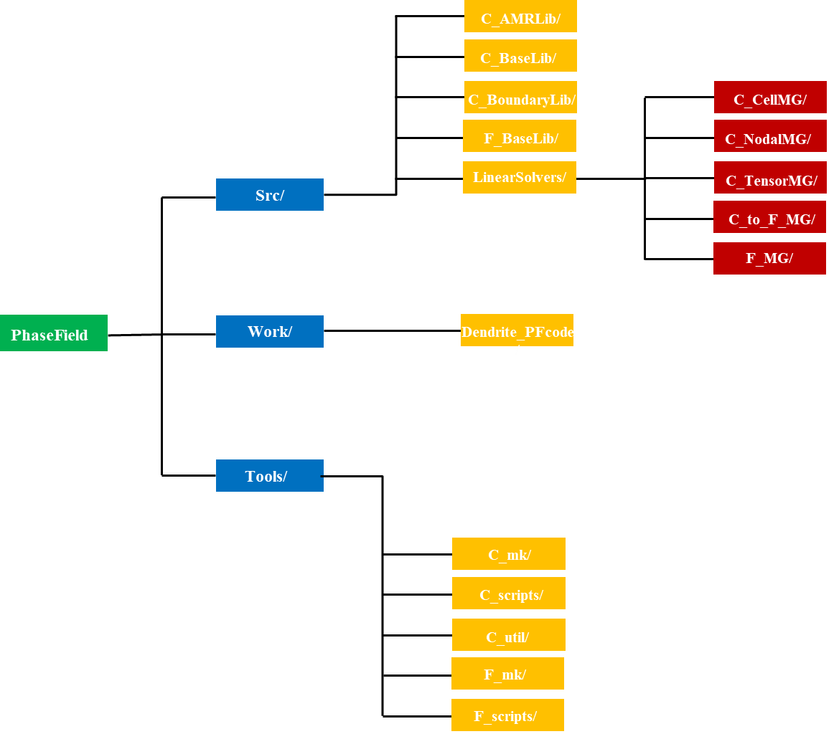
Figure 1. PhaseField directory structure.

2. Getting Started

2.1. Instructions to run the code
In the Dendrite_PFcode directory, you will see the following files:
- GNUmakefile
This contains compiler settings and directories required by the make system to build the code.
- BOXLIB_HOME
Change this to point to the PhaseField home directory. Alternatively, you can define BOXLIB_HOME as an environment variable on your system.
- NDEBUG(‘T’ or ‘<blank>’) for TRUE or FALSE
Represents “not debug”. If ‘t’, modifies compiler flags to build a more optimized version of the code. The program will run faster but have fewer runtime error checks.
- MPI (‘t’ or ‘<blank>’)
Indicate whether you want to executable to by MPI-compatible. MPI must be installed on your machine in order to use this, and you must modify some of the make scripts, as will be discussed later.
- OMP (‘t’ or ‘<blank>’)
Turns on OpenMP compiler flags to compile in any OpenMP directives in the code. We will discuss OpenMP further in Section.
- PROF (‘t’, or ‘<blank>’)
Turns on timer compilation flags. Timers are useful for optimizing code since they can tell you what subroutines are taking the most time and require more optimization.
- COMP (‘gfortran or Intel’)
The Fortran compiler. Supported options include gfortran and Intel. For gfortran, both mpich and openmpi can be used and need to set building command in the GMakeMPI.mak, respectively, which can be found in Tools/F_mk. For Intel, impi should be used and its building command can be set in the GMakeMPi.mak as well.
- MKVERBOSE (‘t’ or ‘<blank>’)
Verbosity of compile-time output.
- GPackage.mak
List of local files need to be included in the build. The GNUmakefile points to this.
- main.f90, init_phi.f90, advance.f90, write_plotfile.f90, normal.f90, pf_utility.f90, phase_field.f90,solute_field.f90, temperature_field.f90, potential_field.f90, flow_field.f90.
Source code that is not within the PhaseField/Src/ tree. Note that if file that exists in the BoxLib/Src/ tree also exists in the local directory, the local copy takes precedence as long as the GNUmakefile lists your local directory as a VPATH_LOCATIONS before the PhaseField source code directory, PhaseField/Src/F_baseLib.
- Inputs_2d, inputs_3d
Input files to customize the simulation parameters.
To build the code, go to the Dendrite_PFcode directory, and simply type “make”. An executable will appear that has some indication (but not complete) about what setting you used in the GNUmakefile. For example, if you build without mpi (set through GNUmakefile) using gfortran, you will have an executable named as “main.Linux.gfortran.exe”, while if you build with mpi, an executable “main.Linux.gfortran.mpi.exe will be built. To run the code, simply type, for example for a build without mpi:
The program will start running and there will be a series of plotfiles, e.g., den00000000, den00001000, etc., in the run directory. You can visualize the data and make animations using VisIt and ParaView; refer to Section 2.2.

2.2. Visualization

2.2.1. Using VisIt
First, download and install VisIt from https://visit-dav.github.io/visit-website/index.html. To open a single plotfile, run VisIt, then select “File” “Open file …”, then select the Header file associated the plotfile of interest (e.g., Den00000000/Header).
- To view the data, select “Add” Pseudocolor” “Phase_field”, then select “Draw”
- To view the grid structure, select “subset” “levels”. Then double click the text “Subset – levels”, enable the “Wireframe” option, select “Apply”, select “Dismiss”, and then select “Draw”.
- To save the image, select “File” “Set save options”, then customize the image format to your linking, then click “save”.
One such image is shown in Figure 2(a).
In 3D, you must select “Add” Contour” “Phase_field”, then select “Draw”. You can left click and drag over the image to rotate the image to generate something similar to Figure 2(b).
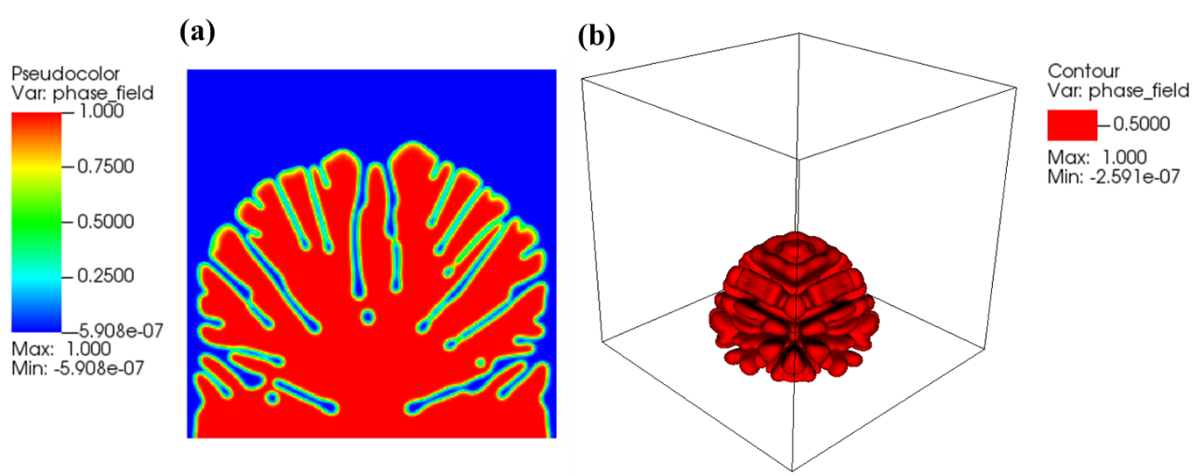
Figure 2. (a) 2D image generated with VisIt. (b) 3D image generated using VisIt.

2.2.2. Using ParaView
ParaView as one of the world’s leading open-source post-processing visualization tool can also be used to visualize Li-dendrite fields. To do this, paraView should be downloaded from https://www.paraview.org/. The steps needed to visualize the related fields are as follows:
- Open a file of interest (e.g., den00096000), select AMRex/BoxLib Grid Reader from the floating window.
- Check the interested type of field (e.g., phase_field), then click the “Apply” button in the Properties menu.
- Select Representation type (e.g., Surface) and corresponding item (e.g., phase_field) from the “coloring”.
Then you can see the image similar to Figure 3(a). For 3D, use the following steps to plot the contour plot.
- Open a file of interest (e.g., den00096000), select AMRex/BoxLib Grid Reader from the floating window.
- Check the interested type of field (e.g., phase_field), then click the “Apply” button in the Properties menu.
- Select Representation type (e.g., Surface) and corresponding item (e.g., phase_field) from the “coloring”.
- Right click on the plot file name in the Pipeline Brower, choose “Cell Data to Point Data” from “Add Filter”.
- Select “Contour” and enter appropriate value (e.g., 0.5) in the “Isosurfaces menu”, then click “Apply” in the Properties menu.
One such contour plot is depicted in Figure 3(b).
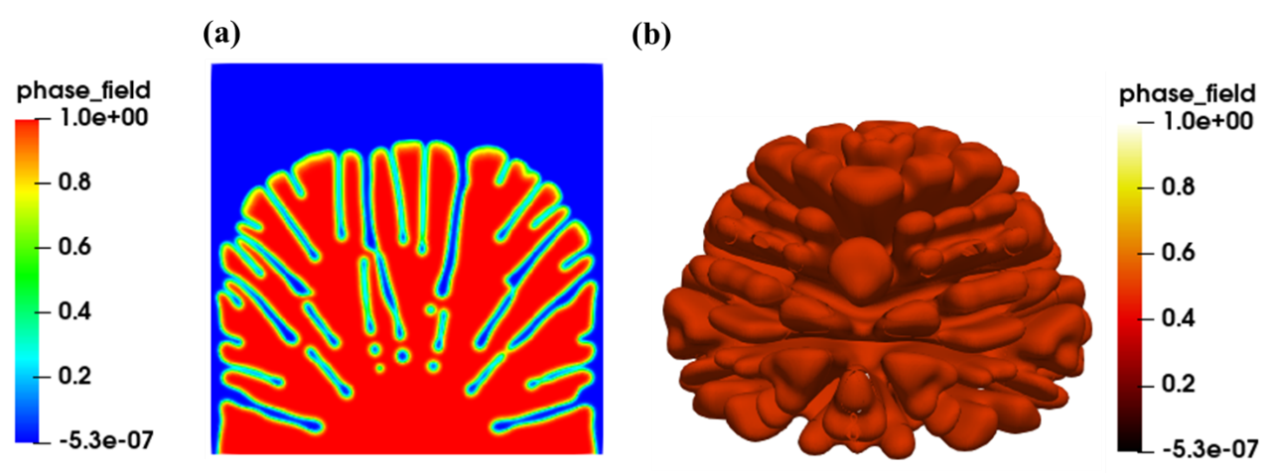
Figure 3. (a) 2D image generated with ParaView. (b) 3D image generated using ParaView.

2.3. Running in Parallel with MPI
We will now demonstrate how to run the code using MPI parallelism.

2.3.1 Run on local machine
On your local machine, if you have MPI installed, you must first configure PhaseField/Tools/F_mk/GMakeMPI.mak to your MPI installation. One such configuration is shown in Figure 4.
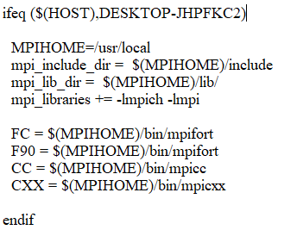
Figure 4. configuration in your local machine for MPI parallelism, where my local machine name is DESKTOP-JHPFKC2.
Then, you can simply build the executable as described before, but with MPI = t in the GNUmakefile. Alternatively, you can override the settings in GNUmakefile at the command line using e.g., “make MPI=t”. An executable named main.Linux.gfortran.mpi.exe will be built. Then you can run the program in parallel using ,e.g.,
Where “-n 2” is number of processors you used in the simulation.

2.3.2 Run on high-performance computing (HPC) clusters
To run parallel on HPC clusters, first copy the PhaseField source code into your preferred directory such as home or scratch directory. To build the executable with parallelism, appropriate compilers need to be loaded. In the great lake HPC clusters of university of Michigan (UMICH), you can load the modules using either of the commands:
As in the local machine, you must configure PhaseField/Tools/F_mk/GMakeMPi.mak to the MPI installation. For instance, for openmpi/3.1.6, the following configuration is used:
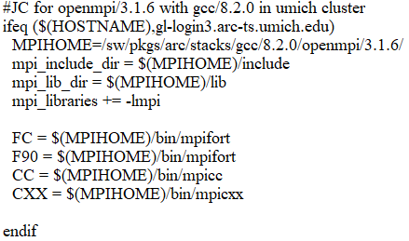
Where MPIHOME is the location where openmpi/3.1.6 is installed.
For impi/2021.5.1, the following configuration should be used:
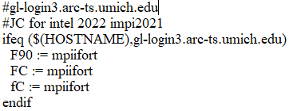
In addition, the following two changes need to be made for Intel and impi complier:
In PhaseField/work/Dendrite_PFcode/GNUmakefile: COMP = Intel
In PhaseField/Tools/F_mk/Comps/Linux_intel.mak, depending on which version of Intel is install in HPC clusters, _comp should be changed to appropriate version. Here I changed from Intel16 to Intel 18:
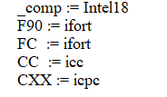
Finally, you can also install mpich in the HPC cluster in directories such as your home directory. Similarly, you need to configure PhaseField/Tools/F_mk/GMakeMPi.mak to the MPI installation. For example:
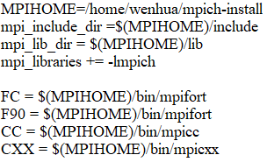
Where MPIHOME indicates where the mpich is installed. It is to be noted that GCC compiler is used together for mpich. This is in PhaseField/work/Dendrite_PFcode/GNUmakefile: COMP = gfortran

