**Background**

This research is about promoting fairness in a network, which is measured by diversity. We design an algorithm to simulate the network of board of directors. We transform such network into an undirected bipartite graph, where two sets of nodes represent directors and boards, and the connections between them are established if a director serves in a board.

**Data**

1. Two Real Networks

* Boardex:
  + Description: we used the sample data, which only looking at the small isle of Jersey. (2000-2015)
  + Source: <https://wrds-www.wharton.upenn.edu/pages/about/data-vendors/boardex/>
  + Data dictionary: https://metalib.ie.edu/ayuda/Varios/BoardExWRDSDataDictionary.pdf
* Boards and Gender:
  + Description: it collects 384 public limited companies in Norway (Allmennaksjeselskap or ASA), which are bound by the gender representation law.
  + Source: <http://www.boardsandgender.com/data.php>

2. Tables:

The overview of the table we used in these two networks is shown in Table 1. We used org_summary in *Boardex* and Two-mode network in *Boards and Gender.*

|  |  |  |
| --- | --- | --- |
| board_id | director_id | gender |

table 1: database from board of director network

**Algorithm**

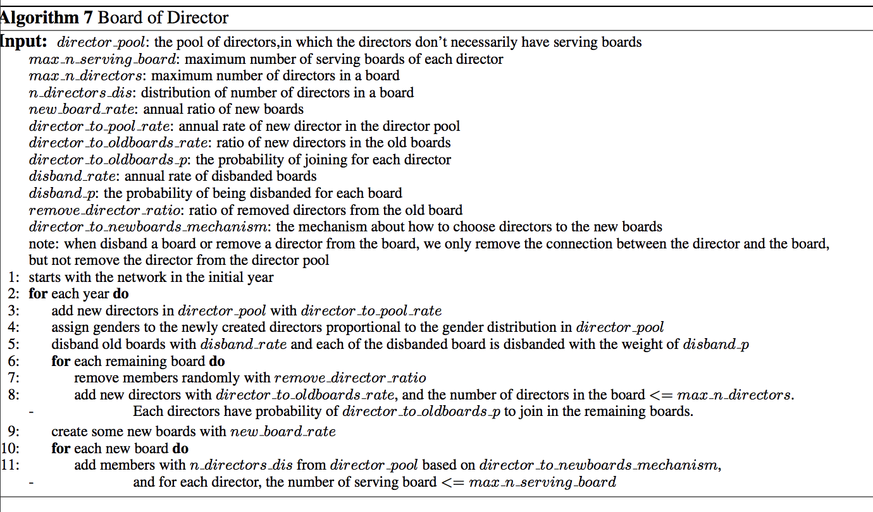

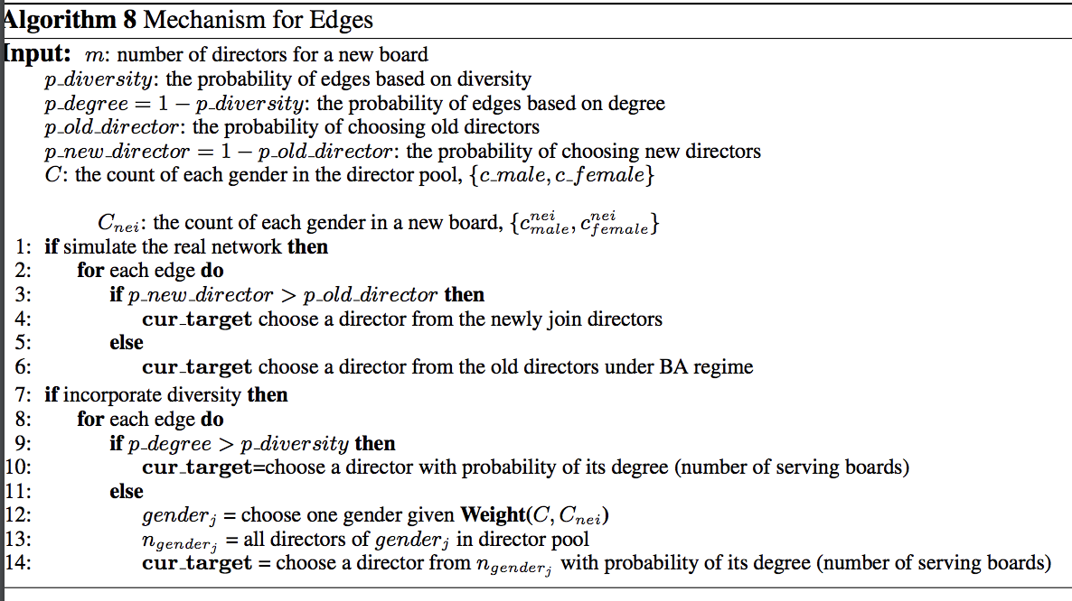

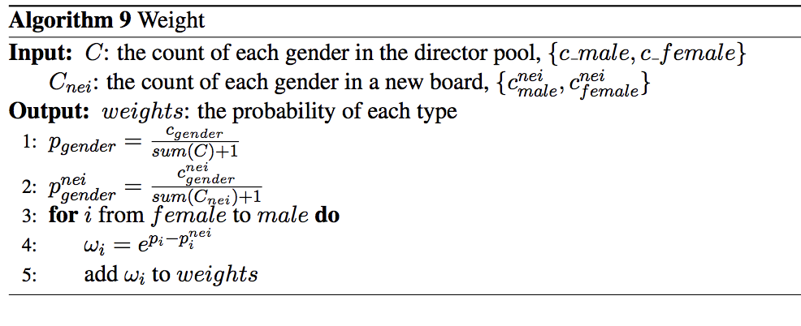

**Data Analysis of Boardex**

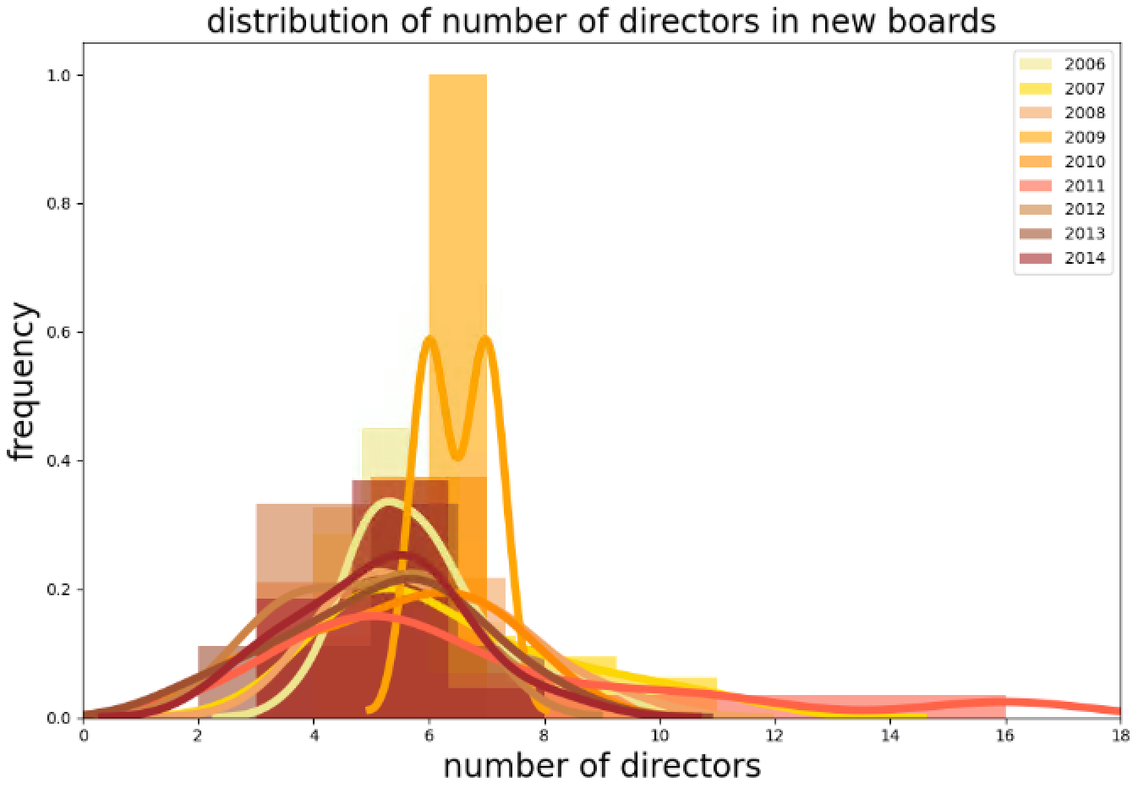 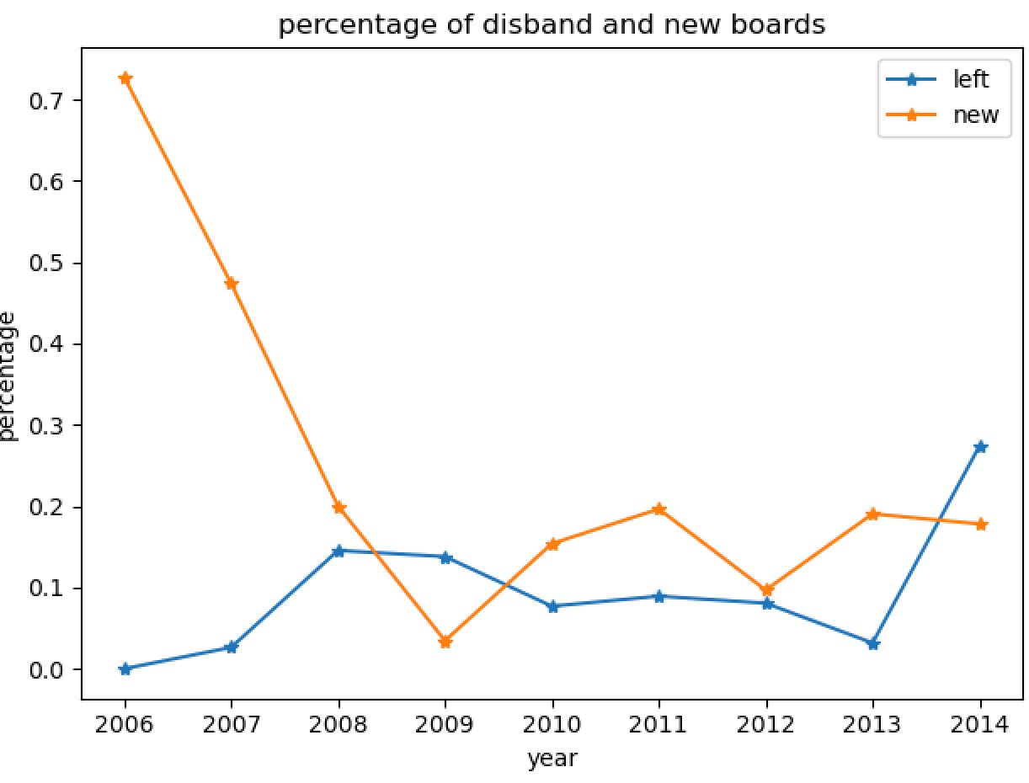

max_n_director

p_director_to_oldboard

disband_rate

new_board_rate

n_directors_dis

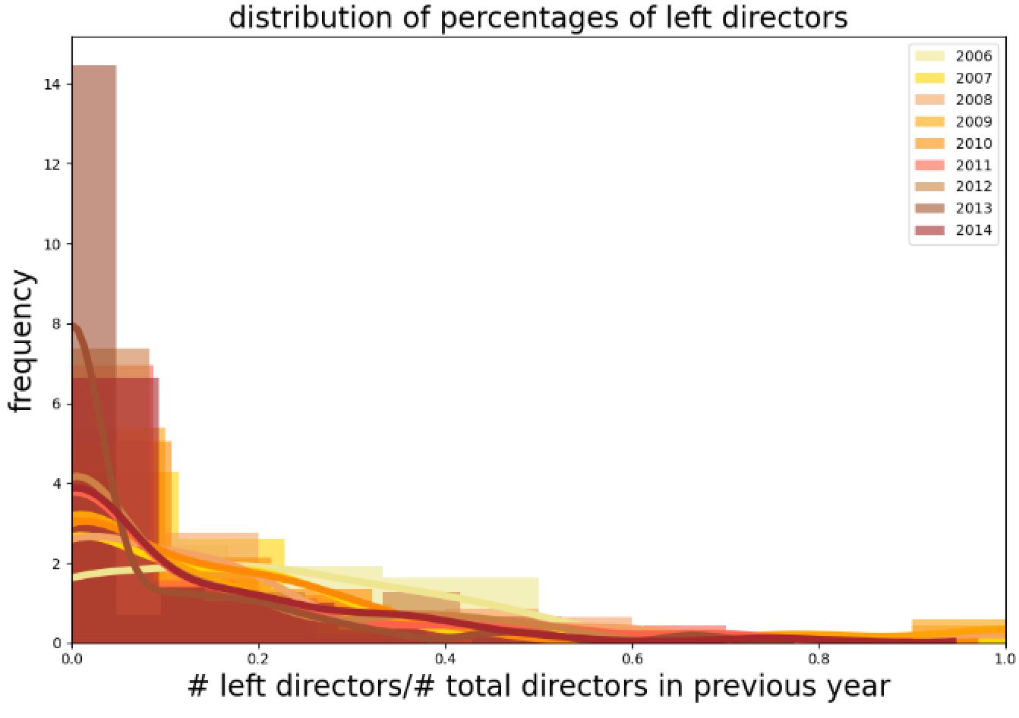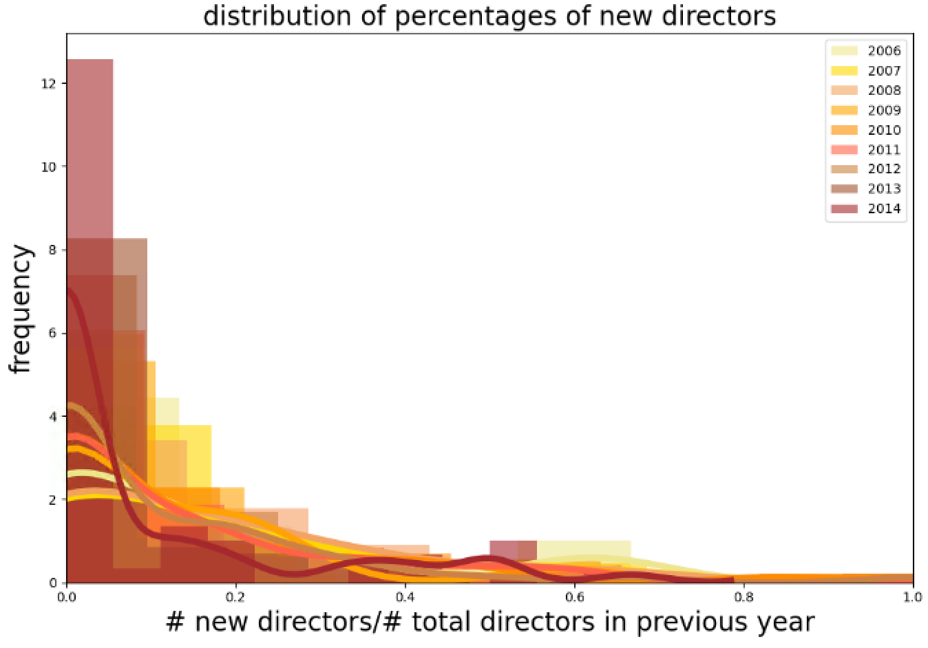

remove_director_ratio

director_to_oldboard_rate

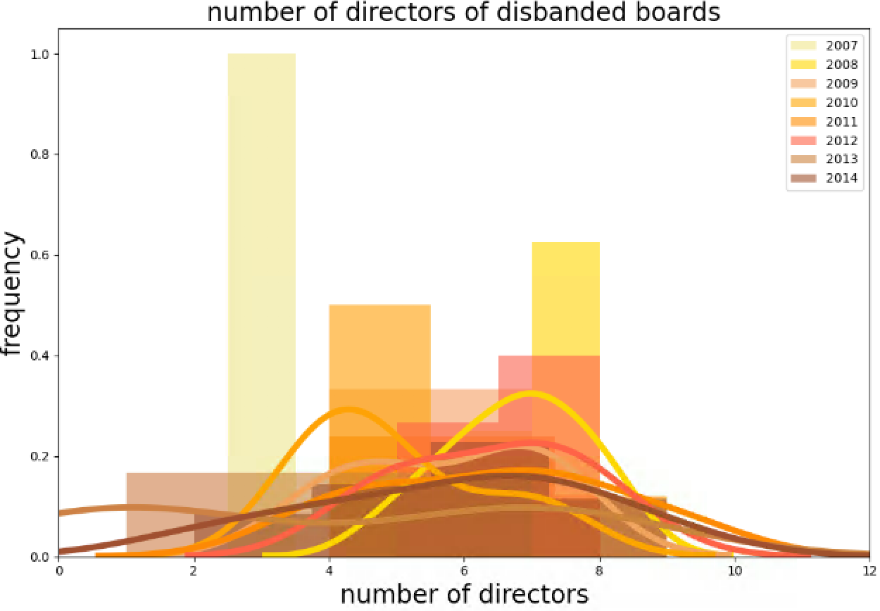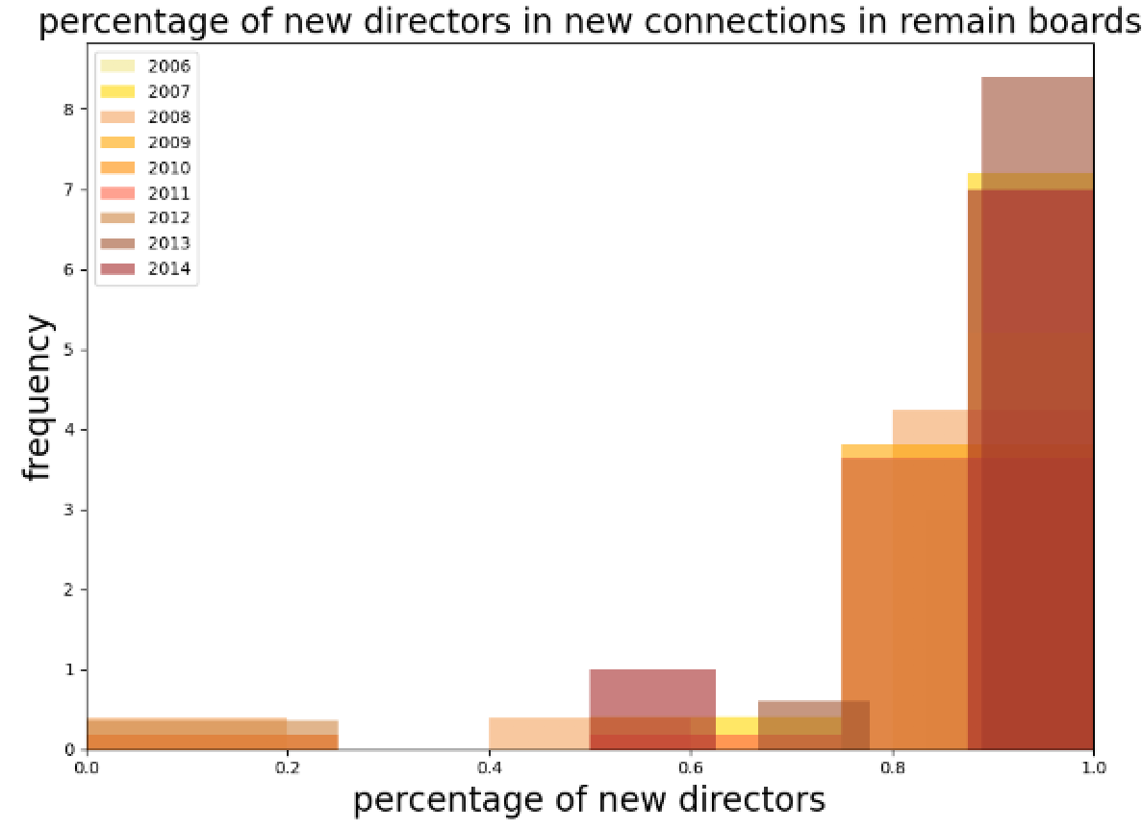

director_to_oldboard_p

disband_p

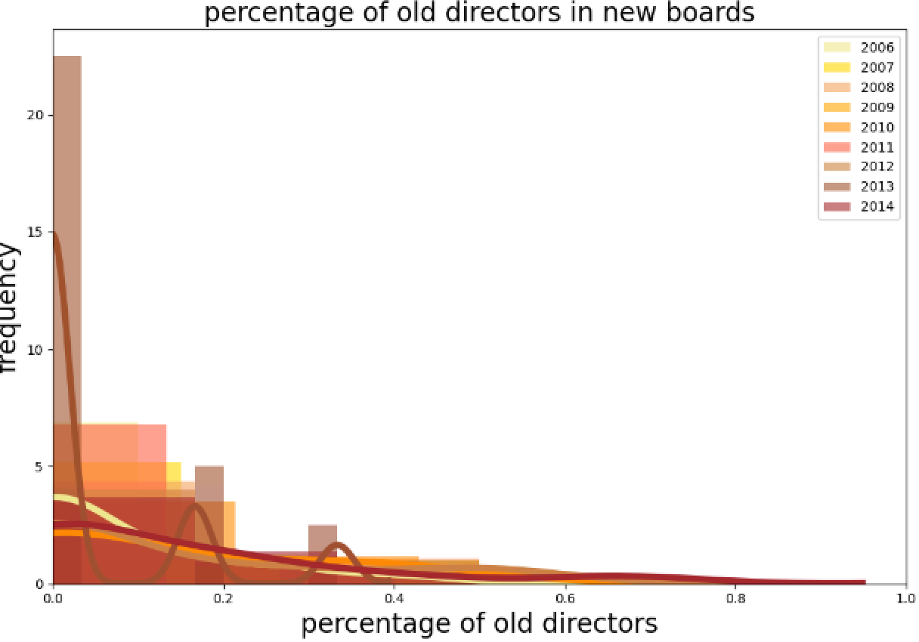

p_old_director

p_new_director

**Experiment**

* We compared the synthetic networks in 2006, 2010, 2014 with the real network in the corresponding year.
* We show the degree distribution of different genders under different mechanism in different years, where the degree means the connections from a director to each director in the belonging board. The frequency is normalized by the number of males/females. We include the nodes exist ever in the real/synthetic network respectively and assign the remove ones with degree of 0.

|  |  |  |  |
| --- | --- | --- | --- |
| year | 2006 | 2010 | 2014 |
| Simulate real network |  |  |  |
| degree based |  |  |  |
| diversity based |  |  |  |

**Conclusion**

* Gender diversity results in larger degree in the minority class (female) and more females involve in each board
* Our edge mechanism results in the spread out degree in the network

**Future Works**

* Validate the algorithm using Board and Gender data
* How initial female proportion plays a role in the evolvement of the network
* How preference level of diversity affects the overall diversity of the network