EEG Spectral Band Analysis in Mental Health: Insights from Explainable AI in Functional Connectivity
Jing Chang and Amir Assadi
University of Wisconsin, Madison, WI 53706, USA
jchang234@wisc.edu, ahassadi@wisc.edu
Abstract. This study investigates the functional connectivity in the theta (4-8 Hz) and beta (13-30 Hz) EEG spectral bands in individuals with ADHD using Explainable Artificial Intelligence (XAI). We compare connectivity patterns between ADHD and non-ADHD groups using XAI-created functional connectivity graphs across different emotional states. Through the computation of functional connectivity matrices, Independent Component Analysis (ICA), and the creation of emotion distance matrices, our analysis reveals notable differences in EEG connectivity, particularly in the theta and beta bands. These findings enhance our understanding of ADHD's neurobiological underpinnings and suggest potential biomarkers for future clinical applications.

- Introduction
  - Background on ADHD
Attention-Deficit/Hyperactivity Disorder (ADHD) is a neurodevelopmental disorder characterized by persistent inattention, hyperactivity, and impulsivity. It affects children, adolescents, and adults, with implications for cognitive function, emotional regulation, and social interactions. The need for effective diagnostic and therapeutic interventions is growing, driving research into the disorder's neurobiological foundations.
  - EEG and Spectral Bands in ADHD
Electroencephalography (EEG) is a non-invasive technique widely used in ADHD research to explore brain activity patterns. In ADHD, two spectral bands—theta (4-8 Hz) and beta (13-30 Hz)—are particularly significant. The theta/beta ratio has emerged as a potential biomarker, with ADHD patients often showing an elevated ratio compared to non-ADHD individuals. This ratio is associated with attention, cognitive control, and arousal regulation. Anomalies in these bands may reflect ADHD's impact on neural networks involved in cognitive and emotional processing.
  - Functional Connectivity in ADHD
Functional connectivity refers to the statistical dependencies between neural signals from different brain regions, providing insights into the brain's dynamic communication networks. In ADHD, altered connectivity, especially in frontal and parietal regions, has been linked to deficits in attention, impulse control, and emotional regulation. This study uses XAI to analyze these patterns through functional connectivity matrices, emphasizing the theta and beta bands' contributions.
  - Study Objectives
This study aims to:
• Examine functional connectivity in ADHD and non-ADHD groups, focusing on the theta and beta bands.
• Use Independent Component Analysis (ICA) and XAI-created graphs to reveal patterns in connectivity during different emotional states.
• Analyze emotion distance matrices to identify differences between ADHD and non- ADHD groups, providing insights into the disorder's neurobiological aspects.
- Methods
  - EEG Data Acquisition and Preprocessing
The data is made publicly available by authors [1] who have provided details. In summary, data were acquired from EEG recordings of individuals grouped into ADHD and non-ADHD categories. A subset of subjects was selected for each emotional state (angry, happy, neutral, sad) to analyze their brain connectivity patterns. EEG data were collected using standard protocols, capturing brain activity across multiple channels. The raw EEG data underwent preprocessing, including filtering to remove noise and artifacts [1], which enhance the accuracy of functional connectivity calculations. This preprocessing step was crucial for focusing the analysis on frequency bands relevant to ADHD. The data in [1] is in MATLAB. We took further steps to save the data in CSV with organized directories for this article.
  - Functional Connectivity Analysis
Computation of Functional Connectivity Matrices: The functional connectivity matrices were computed using Pearson correlation, measuring statistical dependencies between EEG signals from different channels. This step resulted in connectivity matrices representing the interrelationships within and between brain regions.
Application of Independent Component Analysis (ICA): To extract independent neural components, ICA was applied to the EEG data. These components reflect distinct patterns of brain activity, serving as nodes in the subsequent graph analysis.

  - XAI Graph Creation and Analysis
Using the selected ICA components, XAI graphs were constructed for each emotional state and frequency band. The edges of these graphs represent coherence values between pairs of components, highlighting the functional connectivity patterns in the brain. Different graphs were created for ADHD and non-ADHD groups, focusing on the theta and beta bands' coherence.
  - Statistical Analysis
The XAI graphs were analyzed to identify differences in connectivity patterns between ADHD and non-ADHD groups. Additionally, emotion distance matrices were computed to capture the dissimilarities in connectivity across emotional states. Statistical measures were used to quantify these differences, providing a basis for interpreting the findings in the context of ADHD.
- Results
  - Functional Connectivity Patterns
Functional connectivity analysis revealed distinct patterns in the theta and beta bands between the ADHD and non-ADHD groups. The ADHD group showed increased theta-band connectivity, particularly in frontal regions, consistent with previous findings on elevated theta/beta ratios in ADHD. Beta-band connectivity patterns also differed, suggesting alterations in cognitive control networks. In addition, XAI graph distances in other bands could be used to differentiate between ADHD and non-ADHD emotion processing.
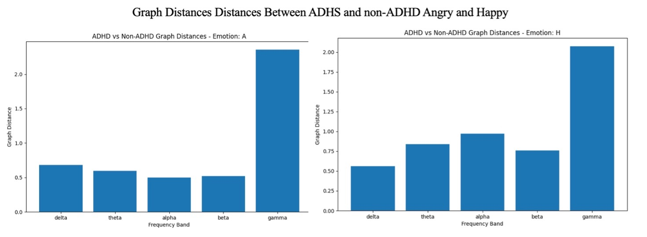
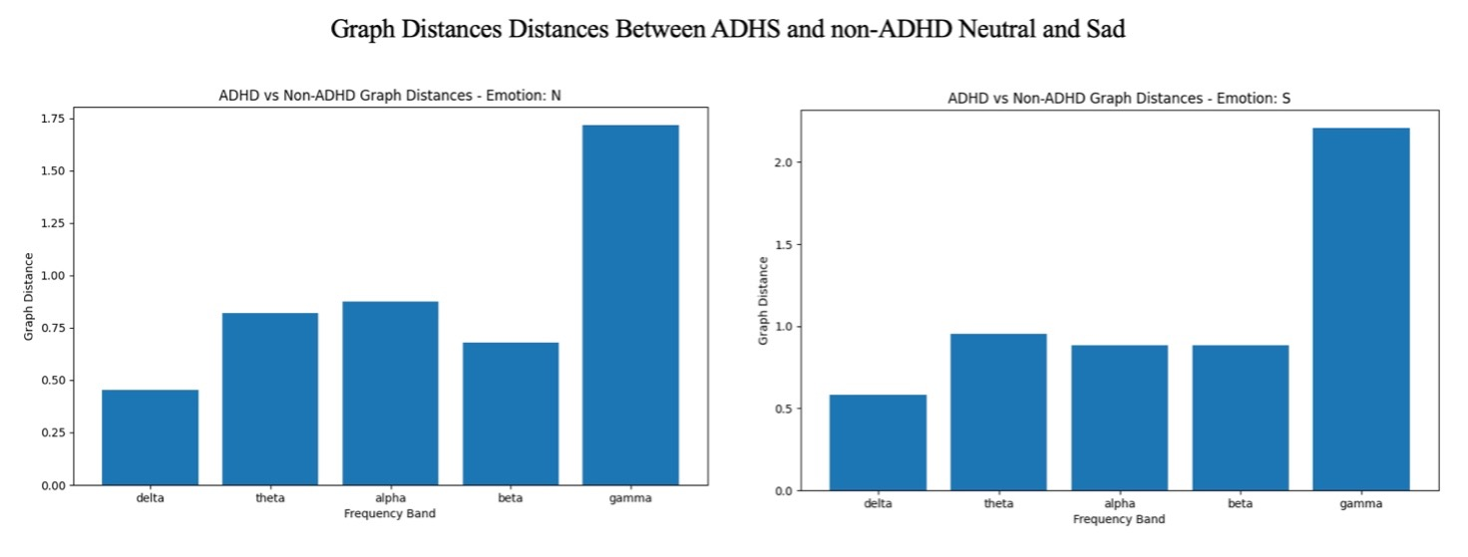
  - XAI Graph Analysis
XAI Graphs Visualization: The XAI graphs, generated through independent component analysis (ICA) for each emotion and frequency band, provide a detailed visualization of the connectivity patterns between critical brain regions. These graphs illustrate how neural components interact within different spectral bands (theta, beta) for each emotional state, offering insights into the functional organization of the brain in ADHD. In the ADHD group, the graphs showed unique connectivity features that were not as prominent in the non-ADHD group, particularly in the theta and beta bands. These visualizations serve as a valuable tool for identifying the neural circuits that may be dysregulated in ADHD, highlighting the differences in how emotional processing and cognitive control manifest in affected individuals.
Comparison of ADHD and Non-ADHD Graphs: The XAI graphs for each emotion and frequency band highlighted differences between the ADHD and non-ADHD groups. In the theta band, the ADHD group exhibited more dispersed connectivity, indicating potential dysregulation in attention-related networks. In contrast, beta-band graphs showed reduced connectivity in ADHD, possibly reflecting impairments in cognitive control and emotional regulation.
Focus on Theta and Beta Band Differences: The coherence values in the XAI graphs confirmed that theta and beta bands were key differentiators between ADHD and non- ADHD individuals. These findings support the hypothesis that ADHD is characterized by alterations in neural oscillatory dynamics.
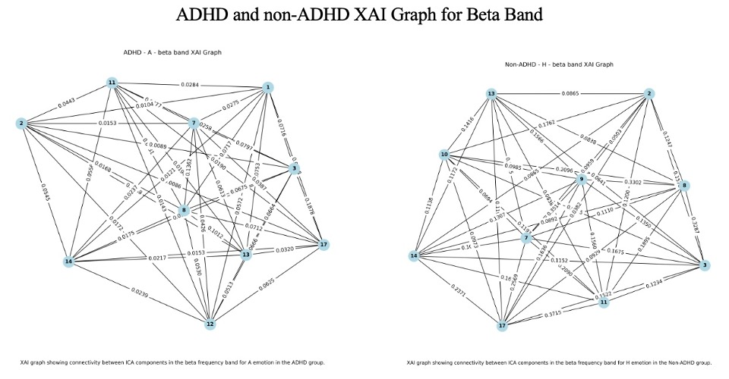
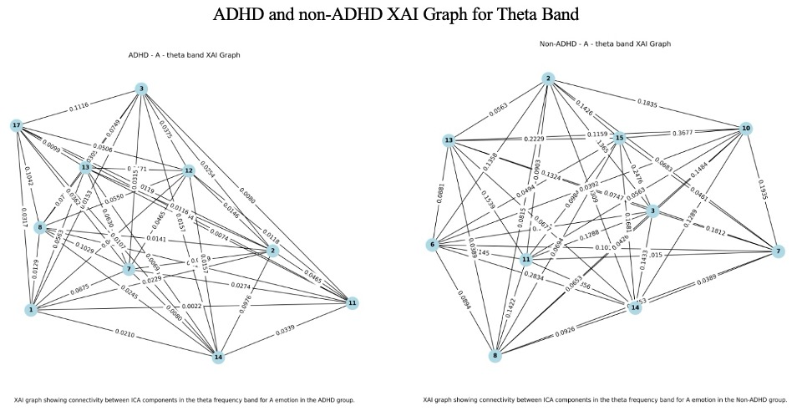
  - Emotion Distance Matrices
The computation of graph distances between the ADHD and non-ADHD groups reveal key differences in brain connectivity patterns across various emotions and frequency bands. For each emotion, the ADHD group exhibited altered connectivity structures, with graph distances indicating a departure from typical connectivity observed in non-ADHD individuals. These variations were most significant in the theta and beta bands, suggesting that ADHD is associated with altered neural oscillatory behavior. Specifically, the ADHD group showed an increased theta-band connectivity and disrupted beta-band connectivity. This finding aligns with existing research on the theta/beta ratio in ADHD, reinforcing the idea that differences in oscillatory patterns can reflect underlying cognitive and attentional deficits. The emotion distance matrices revealed notable differences between ADHD and non-ADHD groups. The ADHD group exhibited a less distinct separation of emotional states, indicating potential difficulties in emotional processing. These differences were particularly pronounced in the beta band, aligning with the literature on ADHD's impact on emotional regulation.
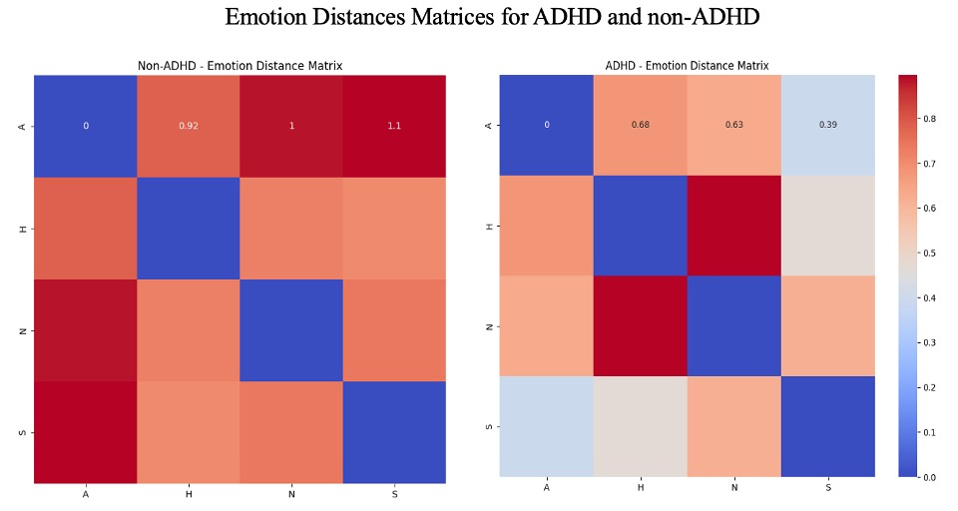
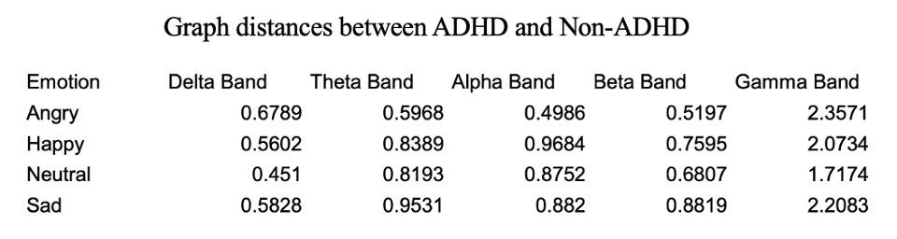
- Discussion
  - Interpretation of Functional Connectivity Result
The observed differences in the theta and beta bands' functional connectivity between ADHD and non-ADHD groups align with the established literature. Elevated theta-band connectivity in ADHD suggests disrupted attentional processes, while alterations in beta-band connectivity point to impaired cognitive control.
  - Emotional Processing in ADHD
The XAI graph analysis and emotion distance matrices provide insights into the emotional processing difficulties in ADHD. The lack of distinct connectivity patterns for different emotional states in the ADHD group indicates a possible deficit in the neural mechanisms underlying emotional differentiation.
  - Implications for ADHD Neurobiology
These findings support the cortical arousal hypothesis in ADHD, where abnormal neural oscillatory patterns reflect dysregulated arousal and cognitive control processes. The observed connectivity patterns may indicate neurodevelopmental differences in ADHD, contributing to its characteristic symptoms.
  - Potential Clinical Applications
• Biomarker Development: The differences in theta and beta band connectivity could serve as potential biomarkers for ADHD, aiding in diagnosis and treatment planning.
• Neurofeedback Interventions: These findings have implications for neurofeedback therapies, suggesting targeted modulation of theta and beta bands to improve attention and emotional regulation in ADHD.
  - Limitations and Future Directions
While this study provides valuable insights, it is limited by its sample size and cross-sectional design. Future research should include larger, longitudinal datasets to explore how functional connectivity patterns in ADHD evolve over time and with interventions. Incorporating other neuroimaging modalities could further elucidate the neurobiological underpinnings of ADHD.
- Conclusion
This study demonstrates that functional connectivity, particularly in the theta and beta spectral bands, differs significantly between individuals with ADHD and non-ADHD controls. Using XAI, we identified specific neural oscillatory patterns and emotional processing differences, contributing to the understanding of ADHD's neurobiology. These findings highlight the potential for developing EEG-based biomarkers and personalized neurofeedback interventions to support ADHD diagnosis and treatment.
Acknowledgement - We thank the authors [1] for making their data available and their comprehensive analysis that inspired our functional connectivity approaches.

References
- Arns M, Conners CK, Kraemer HC. A decade of EEG Theta/Beta Ratio Research in ADHD: a meta-analysis. J Atten Disord. 2013 Jul;17(5):374-83. doi: 10.1177/1087054712460087. Epub 2012 Oct 19. PMID: 23086616.
- Comon, P., & Jutten, C. (2010). "Handbook of Blind Source Separation: Independent Component Analysis and Applications." Academic Press.
- Cortese S, Kelly C, Chabernaud C, Proal E, Di Martino A, Milham MP, Castellanos FX. Toward systems neuroscience of ADHD: a meta-analysis of 55 fMRI studies. Am J Psychiatry. 2012 Oct;169(10):1038-55. doi: 10.1176/appi.ajp.2012.11101521. PMID: 22983386; PMCID: PMC3879048.
- Dini, H., Farnaz.Ghassemi & Sendi, M.S.E. "Investigation of Brain Functional Networks in Children Suffering from Attention Deficit Hyperactivity Disorder. " Brain Topography, 33, 733–750 (2020). https://doi.org/10.1007/s10548-020-00794-1
- Douw L, Schoonheim MM, Landi D, van der Meer ML, Geurts JJ, Reijneveld JC, Klein M, Stam CJ. Cognition is related to resting-state small-world network topology: an magnetoencephalographic study. Neuroscience. 2011 Feb 23;175:169-77. doi: 10.1016/j.neuroscience.2010.11.039. Epub 2010 Dec 3. PMID: 21130847.
- Geerligs, L., & Tsvetanov, K. A. (2019). "The use of partial correlation to assess direct connectivity changes in aging." Neuroimage, 193, 71-84. https://doi.org/10.1016/j.neuroimage.2019.02.025
- Hyvärinen, A., & Oja, E. (2000). "Independent component analysis: Algorithms and applications." Neural Networks, 13(4-5), 411-430. https://doi.org/10.1016/S0893-6080(00)00026-5
- Liu, T., et al. (2020). "Using coherence analysis to examine the functional connectivity in resting-state EEG signals." Journal of Neural Engineering, 17(3), 036011. https://doi.org/10.1088/1741-2552/ab7fc74o
- Preti, M. G., Bolton, T. A., & Van De Ville, D. (2017). "The dynamic functional connectome: State-of-the-art and perspectives." NeuroImage, 160, 41-54. https://doi.org/10.1016/j.neuroimage.2017.01.007
- Rubia K (2018) Cognitive Neuroscience of Attention Deficit Hyperactivity Disorder (ADHD) and Its Clinical Translation. Front. Hum. Neurosci. 12:100. doi: 10.3389/fnhum.2018.00100

