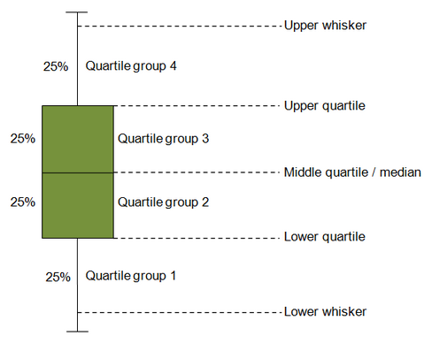

In our case, time.in.paper and last.click.time, the height of the boxes are different, which suggests differences between groups. I think this also indicates the Green-xx correction is needed.