For instance (leaking nodes)

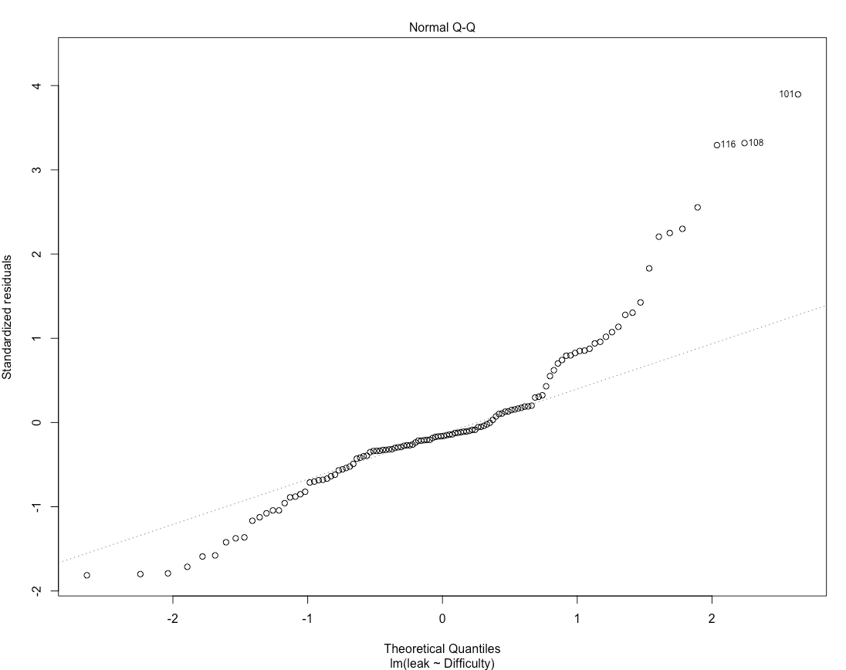

The Q-Q plot of leaking nodes shows obvious right-skewed (more probabilities in the left tail and less probabilities in the right tail compared with Normal distribution). Transformation is needed.

A member from the family of power transformations is chosen automatically by the Box-Cox procedure.

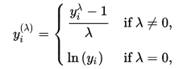

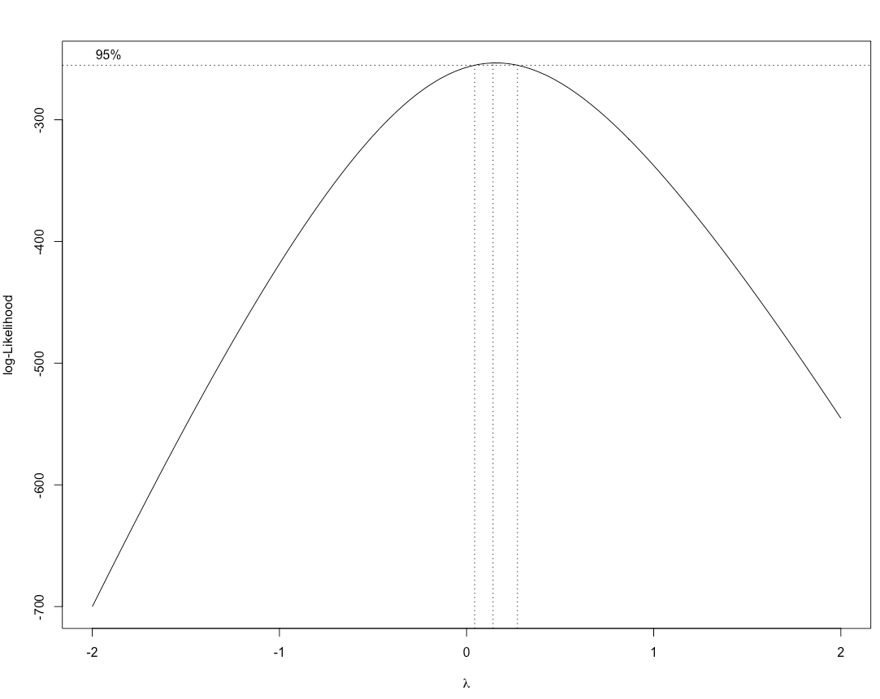

The Box-Cox normality plot shows that the maximum value of the correlation coefficient is near $λ=0$ (for other ontology, the maximum value is near $λ=0.5$, so $\sqrt{Y}$ is used). Thus, log transformation is applied. (I delete 2 zero values, since I think they’re outliers, won’t effect the results)

From the QQ-norm plot (after transformation), the error distribution is approximately normal (slightly heavy-tailed).

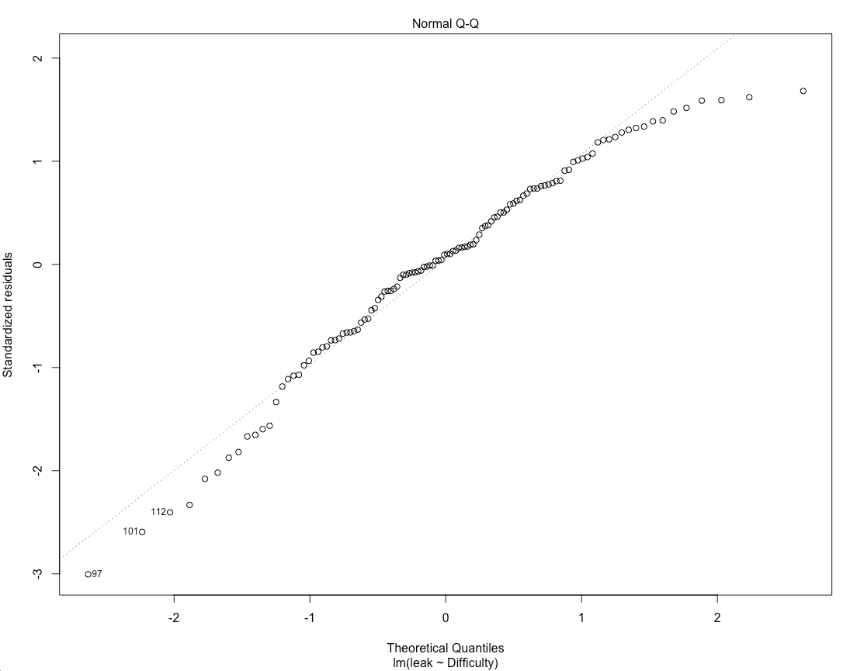

From the box plots we can see the median values (the black line), the vertical size of the box is the interquartile range, sort of like standard deviation.