**作业信息:**

**Python基础 第二天作业2023.8.7**

1. **字符串拼接**

通过字符串拼接的方式，打印出QYTANG'day 2014-9-28。不要忘记中间的空格。

str_1 = "QYTANG'day" + " " + "2014-9-28"  
print(str_1)

1. **通过切片创建子字符串**

现在有个字符串word = " scallywag"，创建一个变量sub_word，通过切片的方式获得字符串"ally"，将字符串的内容赋予sub_word。

作业标准:

word = "scallywag"  
subword = word[2:6]  
print(subword)

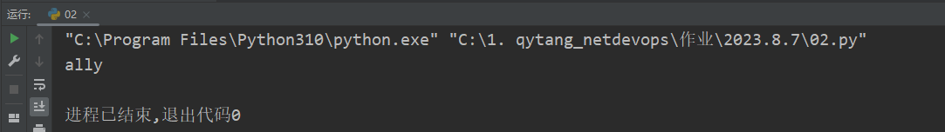

1. **创造自己的语言 我们将在英语的基础上创建自己的语言：在单词的最后加上-，然后将单词的第一个字母拿出来放到单词的最后，然后在单词的最后加上y，例如，Python，就变成了ython-Py**

提示:试着用切片的方式完成这个小游戏。

while True:  
 word = input('请输入一个单词：')  
 if word.isalpha():  
 first_char = word[0]  
 second_to_last_char = word[1:]  
 output = second_to_last_char + '-' + first_char + 'y'  
  
 print(output)  
 break  
 else:  
 print('重新输入')

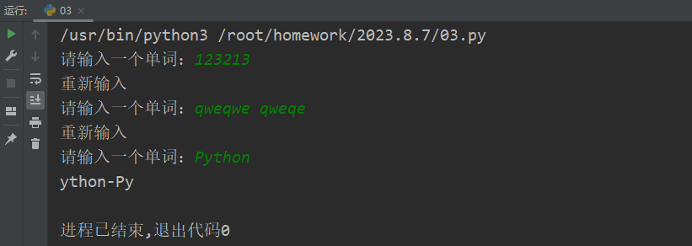

1. **完成课堂作业(1)**

补齐被删除的代码

文本

最终打印效果:

department1 = 'Security'  
department2 = 'Python'  
depart1_m = 'cq_bomb'  
depart2_m = 'qinke'  
COURSE_FEES_SEC = 456789.12456  
COURSE_FEES_Python = 1234.3456  
  
line1 = 'Department1 name:%-11sManager:%-12sCOURSE FEES:%-14.2fThe End!'%(department1,depart1_m,COURSE_FEES_SEC)  
line2 = 'Department2 name:%-11sManager:%-12sCOURSE FEES:%-14.2fThe End!'%(department2,depart2_m,COURSE_FEES_Python)  
  
# line1 = 'Department1 name:{:<11}Manager:{:<12}COURSE FEES:{:<14.2f}The End!'.format(department1,depart1_m,COURSE_FEES_SEC)  
# line2 = 'Department2 name:{:<11}Manager:{:<12}COURSE FEES:{:<14.2f}The End!'.format(department2,depart2_m,COURSE_FEES_Python)  
  
length = len(line1)  
print('='*length)  
print(line1)  
print(line2)  
print('='*length)

电子设备的屏幕

department1 = 'Security'  
department2 = 'Python'  
depart1_m = 'cq_bomb'  
depart2_m = 'qinke'  
COURSE_FEES_SEC = 456789.12456  
COURSE_FEES_Python = 1234.3456  
  
# line1 = 'Department1 name:%-11sManager:%-12sCOURSE FEES:%-14.2fThe End!'%(department1,depart1_m,COURSE_FEES_SEC)  
# line2 = 'Department2 name:%-11sManager:%-12sCOURSE FEES:%-14.2fThe End!'%(department2,depart2_m,COURSE_FEES_Python)  
  
line1 = 'Department1 name:{:<11}Manager:{:<12}COURSE FEES:{:<14.2f}The End!'.format(department1,depart1_m,COURSE_FEES_SEC)  
line2 = 'Department2 name:{:<11}Manager:{:<12}COURSE FEES:{:<14.2f}The End!'.format(department2,depart2_m,COURSE_FEES_Python)  
  
length = len(line1)  
print('='*length)  
print(line1)  
print(line2)  
print('='*length)

1. **完成课堂作业(2)**

str1 = 'Port-channel1.189 192.168.189.254 Yes CONFIG up'  
import re  
ip_pattern = r'\d{1,3}.\d{1,3}.\d{1,3}.\d{1,3}'  
ip = re.search(ip_pattern, str1).group(0)  
print('=================================================')  
line1 = '{:<8}: {}'.format('接口', 'Port-channel1.189')  
line2 = '{:<8}: {}'.format('IP地址', ip)  
line3 = '{:<8}: {}'.format('状态', 'up')  
print(line1)  
print(line2)  
print(line3)

