Supporting Information for

**Complex seismic anisotropy and mantle dynamics beneath Turkey**

Awad A. Lemnifi1, 2, Abdelsalam Elshaafi2, Özgür Karaoğlu3, Mohamed K. Salah4 , Nassib Aouad1, Cory A. Reed5, and Youqiang Yu6

1Mining Engineering, Missouri University of Science and Technology, Rolla, Missouri, USA

2Department of Earth Sciences, Faculty of Sciences, Benghazi University, Libya

3Eskişehir Osmangazi University, Department of Geological Engineering, 26040 Eskişehir, Turkey

4Department of Geology, American University of Beirut, Riad El Solh 1107 2020, Beirut, Lebanon

5Geology and Geophysics program, Missouri University of Science and Technology, Rolla, Missouri, USA

6State Key Laboratory of Marine Geology, Tongji University, Shanghai 200092, China

**Contents of this file**

SI 1 Table _S1.txt

SI 2 Table_S2.txt

SI 3 Table_S3.txt

SI 4 Figures S1 to S6

**Introduction**

This supporting information contains shear wave splitting (SWS), and data for the receiver function beneath Turkey. The resulting database is presented in three forms, including 1) 9084 quality A and B individual SWS measurements from each of the event-station pairs. The measurements are given in the table “Table_S1.txt”; 2) station averaged SWS measurements which are given in the table “Table_S2.txt”, and 3) crustal anisotropy measurements given in the table “Table_S3.txt. This supporting information also contains the plots for the Station-averaged fast orientations stations used in the study, and Azimuthal variations of shear-wave splitting of some example stations that show unsystematic, systematic, and limited variations (unknown layers of an anisotropy) variations of the baczk-aziumth with Φ in the study area.

SI 1. Table_S1.txt Individual shear wave splitting measurements.

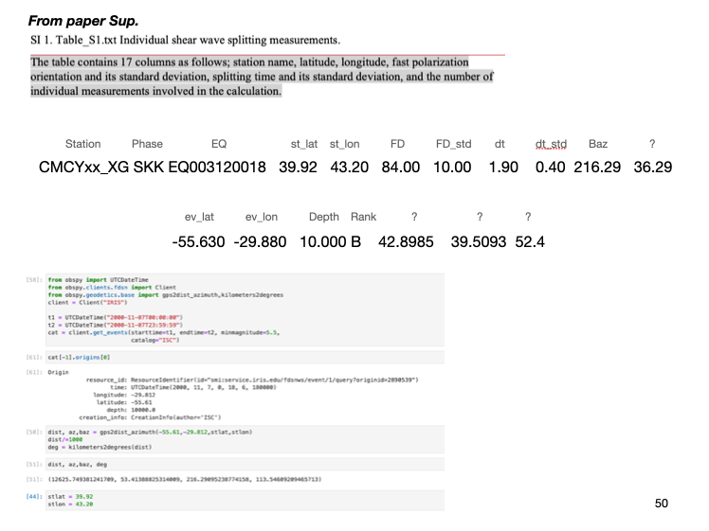

The table contains 17 columns as follows; station name, latitude, longitude, fast polarization orientation and its standard deviation, splitting time and its standard deviation, and the number of individual measurements involved in the calculation.

SI 2. Table_S2.txt Station-averaged shear wave splitting measurements.

The table contains eight columns as follows; station name, latitude, longitude, fast polarization orientation and its standard deviation, splitting time and its standard deviation, and the number of individual measurements involved in the calculation.

SI 3. Table_S3.txt crustal anisotropy measurements.

The table contains eight columns as follows; latitude, longitude, fast polarization orientation and its standard deviation, splitting time and its standard deviation, and the number of individual measurements involved in the calculation.