Trade tension casts shadow over flow of Chinese students

* Chinese students faced rising visa refuslas and limits on study fields
* Number of new interntional students in the U.S. has declined

When the new semester is around the corner, Chinese students and scholars seeking to study in the U.S. may find it is harder than before to obtain a U.S. visa.

Recently Chinese students and scholars have encountered an increase in visa refusals and duration limits of their visas, China’s Ministry of Education released a warning statement in June, reminding “the need to strength risk assessment before studying abroad.”

In fact, before the trade war escalating with multi-rounds of tariffs, the Trump administration vowed in 2017 to consider restrictions on foreign students from designated countries in the fields of STEM – science, technology, engineering and mathematics.

The international students enrollment in the U.S. showed the first drop since 2007, according to data from Institute of International Education (IIE).

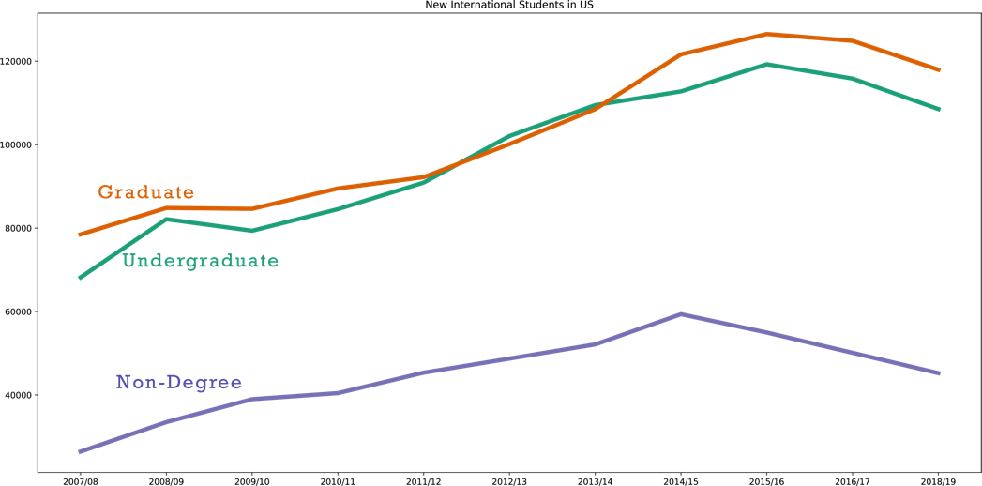

Graphic1: NewIntStudents

Last June, the U.S. Statement made it clear that it would limit the visas for Chinese students studying science and engineering, which are the most popular study fields of Chinese students.

(to add a pie chart)

Graphic2：Fields of Study of Chinese Students in the U.S.

China has been the top place of origin for international students in the U.S. they contribute nearly US$13 billion to the American economy each year, according to NAFSA: Association of International Educators.

However, with the tension extending to academic field and multiple choices for study abroad, the growth of Chinese students going to the U.S. has been declined in recent years.

Graphic4: line chart of Chinese students’ growth

以下为新增：

Even they successfully get the visa, international students, including those from China, who want to work in the U.S. after graduation, may find their wings are clipped due to duration limit of their visas and a new interpretation of employers obligations issued by U.S. Citizenship and Immigration Services (USCIS).

A Chinese graduate student majored in computer science in New York said that unlike the previous STEM students who can get five years F-1 visa, many of her classmates and herself only got one-year student visa, which cannot cover the whole master program.

The explanation issued by USCIS last April applies to optional practical training, known as OPT, which enables international students to work in the U.S. after graduation for one year or three years at most for those majored in STEM, spelling out that students cannot work at the employers’ client sites, making it harder to find a suitable job.

The country’s “Buy American and Hire American” executive order implemented in 2017, also raised concerns that if the OPT program will be canceled entirely in the future.

<https://www.whitehouse.gov/presidential-actions/presidential-executive-order-buy-american-hire-american/>