3. Per-ID evidence
Count tag-positive frames within the recent windows
2. Tag detector
Pad person crops by 10%; check crops as batch
1. Person + Tracker
Read frame; detect people and maintain track IDs

4. Staff status
Confirm with 3/15 votes; refresh or expire status
5. Position
Use current person box:
$x=(x_{1}+x_{2})/2 ;y=y_{2}$
6. Results
Live preview + mp4 + csv (Staff ID / frame / x / y / time)

$$x$$
$$y$$
$$\left(0,0\right)$$
X: 450.0
Y: 620.0
Bottom centre of “person” bounding box (staff)

Training Validation
Training Validation
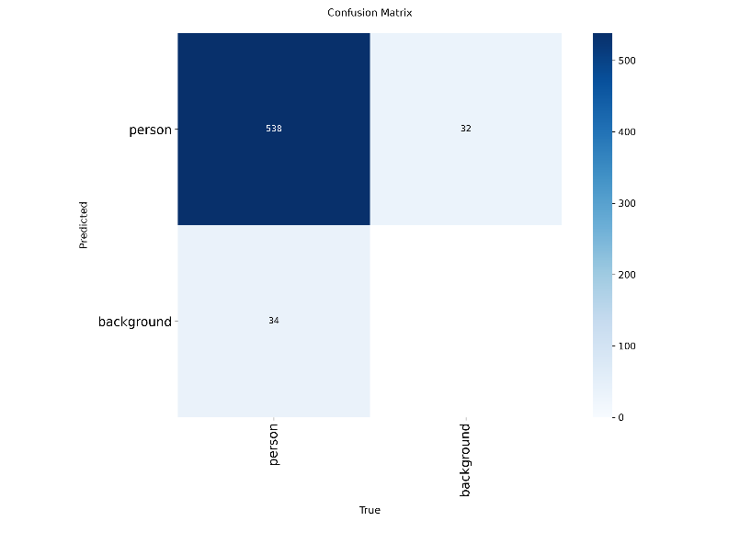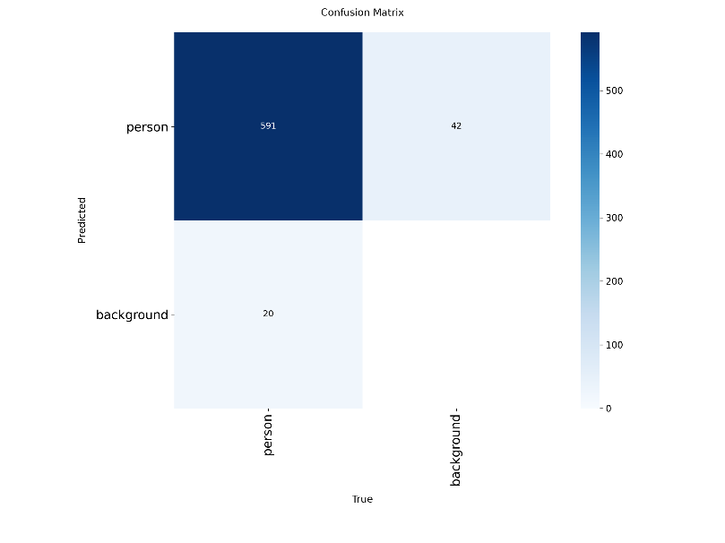
mAP vs Epoch
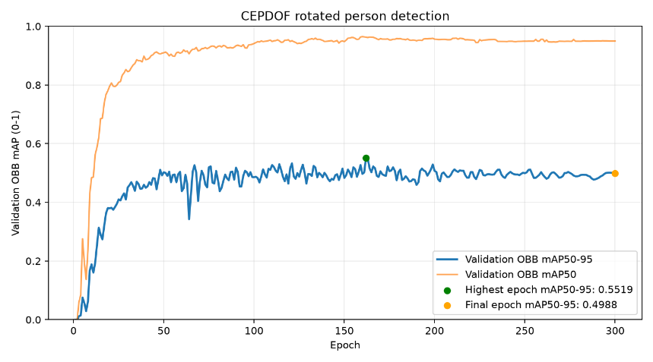

Training Validation
Training Validation
