Staff detection
The solution combines two fine-tuned YOLO26n detectors with ByteTrack: one detects people and the other detects staff tags. It detects the required visual feature, which is the staff tag, and combines evidence from multiple frames to reduce isolated false detections. The system provides a live preview, an annotated output video, and a CSV file containing staff coordinates for each frame.
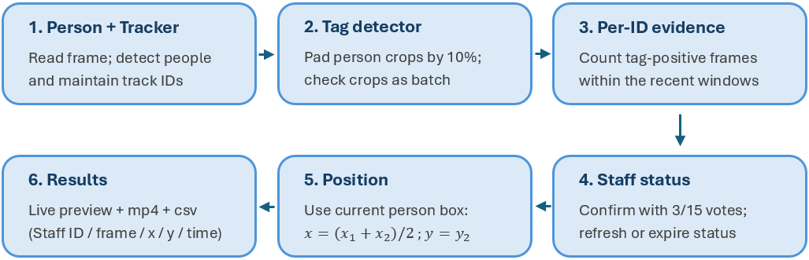
Figure 1: Flow diagram.

Methodology and development
Data preparation:
Selected video frames were labelled with person bounding boxes and grouped into consecutive time blocks. Whole blocks were assigned to fixed training, validation, and test sets in an approximate 60/20/20 ratio using random seed 123. A separate staff-tag dataset was created from person crops with visible tags labelled, keeping each crop in the same set as its original frame. Additional images for retraining came only from training blocks, while validation and test sets remained unchanged to keep evaluation images separate from training.
Tag learning:
The models were fine-tuned from pretrained weights using rotated and flipped images to account for different angles in overhead views. Visible tags were labelled as staff_tag, while manually reviewed crops without visible tags served as negative examples. To prevent negatives from dominating training, all positive images were kept, and negatives were reduced to maintain a 1:4 positive-to-negative ratio. Validation and test sets remained complete and unchanged.
Targeted improvement:
Poor tag detection led to adding more images with visible tags and creating a tool to find objects incorrectly detected as tags. Its purpose is to find tag-like false alarms, review them, then add confirmed negatives to a later training set, helping the model learn what to ignore. For example, an additional 17 hard-negative crops were added to the training set of datasets v1.1 to train the latest tag model, best_tag_v1.2.pt.
Tracking and thresholds:
ByteTrack was used and tuned to use lower-confidence person detections to help maintain tracking when detections became weak. In testing, it lost track of people more often but processed at higher FPS (average 21.5 FPS). BoT-SORT with ReID was tested and able to maintain identities more consistently but processed at lower FPS (average 8 FPS). Raising the tag confidence threshold reduced false alarms but caused longer periods when staff were not recognized. The main pipeline therefore uses standard bounding boxes and tuned ByteTrack settings to prioritize processing speed.

Key logic and outputs
A new ID needs at least 3 accepted tag detections within 15 frames; the frames need not be consecutive. While enough votes remain, expiry is refreshed to the current frame plus 45. One fresh positive can also refresh an active staff ID. Thus, the hold is not strictly 45 frames after the last positive.
Table 1: List of some key default parameters.
Component | Defaults in the latest script version
Person detector | best_v1.2.pt; confidence 0.10; image size 640
Tag detector | best_tag_v1.2.pt; confidence 0.50; image size 640
Temporal rule | 3 positives / 15 frames; staff hold 45 frames
Runtime / tracker | CUDA when available, otherwise CPU; custom ByteTrack YAML
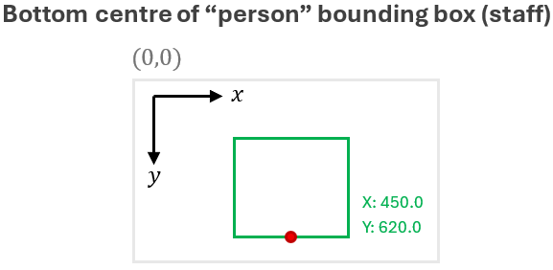
Figure 2. Coordinate convention.
Green staff boxes show ID, retained peak tag confidence and X/Y. Optional thin red “person” boxes help diagnosis (--person-show). FPS and current-frame person/staff counts are displayed. Each displayed staff occurrence writes staff ID, frame, x, y, time; frame numbering starts at 1 and time uses the source FPS. Held staff status can produce rows without a fresh tag detection.

Evidence, limitations and next improvement
The tag model’s mAP50 detection score improved from 0.295 in v1.1 to 0.682 in the final version after retraining with hard-negative crops. The final person model achieved an mAP50 of 0.581. These scores measure the individual models’ detection performance, rather than the accuracy of the complete staff-tracking system. Supporting evaluation plots are included in the appendix.
Blocked views, small or distorted people, hidden tags, and ID changes can cause missed detections or assign staff status to the wrong person. Each frame is processed only once, so later staff confirmation cannot update earlier frames. Future work includes more varied training data, testing new videos not used for training or tuning, and exploring other preprocessing methods. Equirectangular conversion and upscaling were tested but not adopted because the conversion cropped out image content, while upscaling did not recover missing detail.

Appendices
Appendix A: Output video screenshot with detected staff.

Appendix B: Output CSV for the detected staff ID / frame / x / y / time.
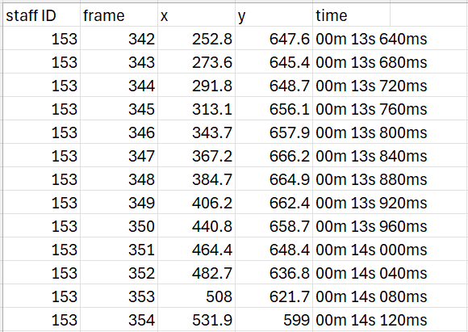
Appendix C: Training validation for “person” model (best_v1.2.pt).
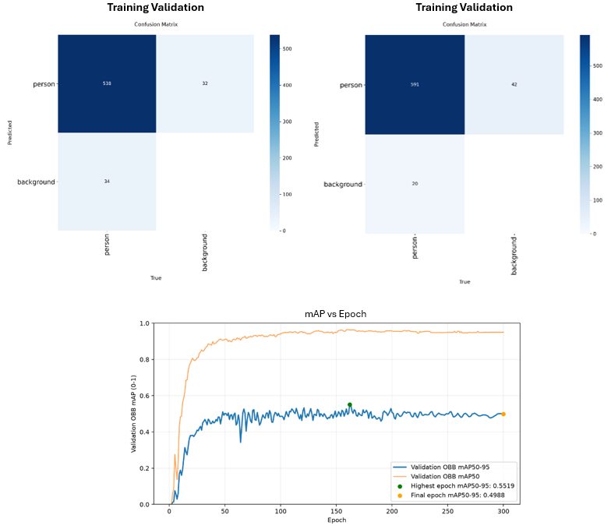
Appendix D: Training validation for “staff tag” model (best_tag_v1.2.pt).
